Smart Parking System: ParkSense

Project | Smart Parking System
Team name | MFRMYR
Milestone | M1 - Proposal and Architectural Requirements
Instructor / TA | Dr. Nada Mahmoud Hassan / Eng. Mohamed Fareh
Date | October 23, 2026
Team members

# | Name | Student ID
1 | Farida Ahmed | 231014770
2 | Mira Atef | 231005027
3 | Rokaya Hamdy | 231006586
4 | Mohamed Shahin | 231006169
5 | Ronnie Sameh | 231005375
6 | Youssef Mahmoud | 231006058
Contribution table

Member | Contribution
Ronnie Sameh | Section 1 (System overview), References
Mohamed Shahin | Section 2 (Stakeholders and Concerns)
Mira Atef | Section 3 (Context diagram)  Section 4 (Functional requirements, MoSCoW, Prototype scope)
Farida Ahmed | Section 5 (Quality attribute scenarios)
Youssef Mahmoud | Section 6 (Constraints)
Rokaya Hamdy | Section 7 (Utility tree and ASRs)

Project Idea: Smart Parking System

The Smart Parking System is a platform that helps drivers find, reserve and pay for parking in busy urban and institutional areas, removing the need to circle looking for a free space. It supports three distinct user roles: drivers, who search for lots with live availability, reserve a spot, pay online and receive notifications; parking lot administrators and operators, who monitor occupancy on a web dashboard, configure pricing and manage lots; and IoT parking sensors, which send live occupancy updates.

The system integrates with external services, including a payment gateway, a navigation API and an SMS/notification gateway. It is split into independently deployable parts: a mobile/web client, an admin dashboard, a reservation and payment backend, and an event-ingestion service for sensor data. Its architecture is shaped by competing quality attributes. Strong consistency (never double-booking a spot) must be balanced against availability and fault tolerance during failures or network partitions, and real-time performance must be balanced against security (PCI-DSS-compliant payments).
The scope is realistic for a 5-person team. The prototype is a vertical slice covering search, reservation, sandbox payment, notifications and the operator dashboard, with sensors, gates and the payment gateway simulated.

System Overview

Problem Statement
Finding a parking spot in busy urban and institutional areas is a persistent challenge for drivers. Individuals often waste significant time and fuel driving in circles to locate vacant spaces, contributing directly to traffic congestion, heightened air emissions, and driver frustration.
Traditional parking lots lack real-time monitoring infrastructure, meaning drivers only discover whether a spot is available after physically arriving at the location.

Proposed Solution & Target Users
The Smart Parking System is an enterprise-grade software solution engineered to streamline parking discovery, reservations, and management. The system supports three distinct user roles:
    - Drivers/End Users: Interact via a mobile or web client to view real-time parking availability, reserve spaces in advance, initiate digital payments, and receive navigation guidance.
    - Parking Lot Administrators: Monitor lot occupancy through a centralized web dashboard, configure pricing rates, manage physical spot mappings, and review operational audit logs and reports.
    - IoT Sensor Devices & External Services: Embedded parking spot sensors transmit live occupancy updates via lightweight IoT protocols, while external payment gateways and navigation APIs process financial transactions and routing.

Architectural Interest
This system presents compelling architectural challenges. It demands a hybrid architectural style that bridges high-throughput, low-latency IoT ingestion pipelines (handling real-time sensor updates across hundreds of concurrent slots) with a secure, transactional backend handling user reservations and financial clearances under strict PCI-DSS constraints. Key architectural trade-offs involve balancing real-time consistency (ensuring a reserved spot is never double-allocated) against system availability and fault tolerance during network partition events.

Stakeholders and Concerns

Stakeholder | Role/Responsibility | Key Concerns
Driver/End User | Uses the mobile or web application to view real-time parking availability, reserve a space, pay, and receive guidance. | Accurate and up-to-date availability; fast search and booking; easy-to-use interface; secure payments; reliable booking confirmations.
Parking Lot Administrator | Manages parking spaces, monitors occupancy, configures rates, and reviews operational reports. | Reliable dashboard; accurate sensor information; secure administrator access; efficient space and rate management; useful reports.
IoT Parking Sensors | Detects whether parking spaces are free or occupied and sends status updates to the system. | Accurate detection; stable connectivity; timely data transmission; handling disconnected or malfunctioning sensors.
Payment Gateway | Processes digital payments for parking reservations. | Secure transactions; reliable API integration; correct payment status; protection of payment data; compliance with applicable payment standards.
Navigation Service | Provides directions from the driver's location to the selected or reserved parking spot. | Accurate location and route information; dependable API connection; timely responses.
Notification Service/SMS Gateway | Sends booking confirmations, cancellation updates, payment-status alerts, and reminders through in-app notifications or SMS. | Reliable delivery; timely alerts; integration availability; handling third-party service failures and delivery delays.

- System Context (C4 Level 1)
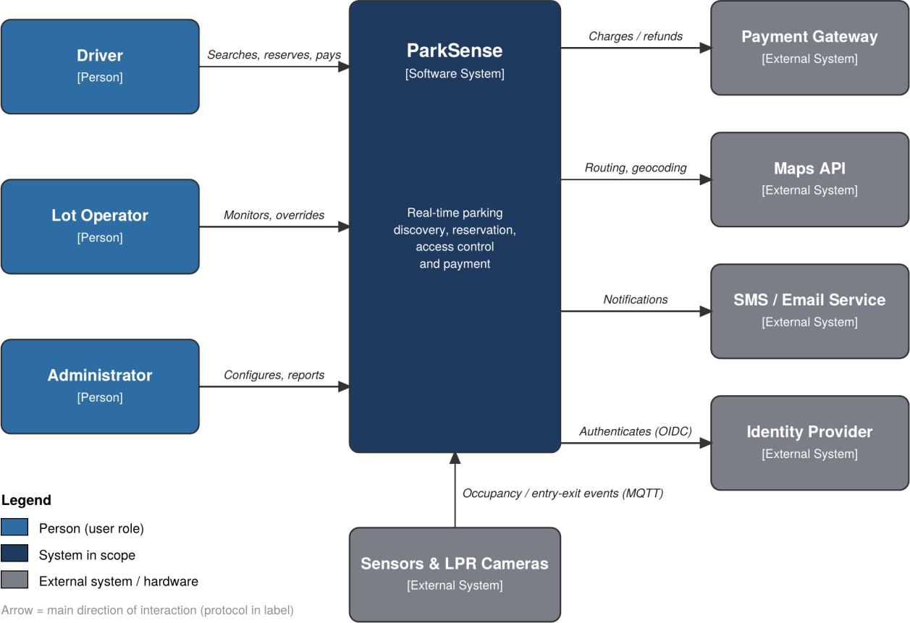
Figure 1 - C4 Level 1 context diagram of ParkSense.

Functional Requirements
The following table lists the 15 functional requirements and their prototype coverage. The prototype focuses on the search, booking, payment and parking management flow.

ID | Functional requirement | MoSCoW | Prototype
FR-01 | The system shall allow drivers to log in and access their bookings. | Must | Yes
FR-02 | The system shall display nearby parking lots with live availability and prices. | Must | Yes
FR-03 | The system shall allow drivers to reserve available parking spots. | Must | Yes

ID | Functional requirement | MoSCoW | Prototype
FR-04 | The system shall allow drivers to cancel or extend their bookings. | Should | Yes
FR-05 | The system shall allow drivers to pay online for parking. | Must | Yes (sandbox)
FR-06 | The system shall support automatic gate access using a QR code or license plate. | Must | Yes (simulated)
FR-07 | The system shall update parking occupancy from IoT sensor events. | Must | Yes (simulated)
FR-08 | The system shall send booking confirmations and reminders to drivers. | Should | Yes (email/log)
FR-09 | The system shall provide navigation guidance to the selected parking lot. | Should | No (deep link only)
FR-10 | The system shall provide operators with a live dashboard and manual override. | Must | Yes
FR-11 | The system shall allow administrators to manage lots, pricing and users. | Must | Partial (lots, pricing)
FR-12 | The system shall generate occupancy and revenue reports. | Should | No
FR-13 | The system shall support dynamic pricing based on parking demand. | Could | No
FR-14 | The system shall offer monthly parking permits to drivers. | Could | No
FR-15 | The system shall support EV charging and loyalty points. | Won't | No

Points to discuss
- Core flow: Search (FR-02) → Reserve (FR-03) → Pay (FR-05) → Gate opens (FR-06). Every Must story supports this flow.
- Real time: FR-07 feeds FR-02 and FR-10, So sensor events must reach the app and dashboard within seconds.
- Simulated parts: Sensors, cameras and gates (FR-06, FR-07) and the payment gateway (FR-05) are simulated or sandboxed in the prototype.
- Scope cut: Navigation is a deep link only (FR-09); reports (FR-12) and the Could/Won't stories are left out.

Quality Attribute Scenarios
Eight scenarios in the six-part form, covering seven quality attributes: performance, consistency/integrity, availability (two scenarios), security, modifiability, scalability and usability. Every response measure is testable
QAS-1 - Live search (Performance)

Source | Driver using the mobile application
Stimulus | Searches for nearby parking lots
Artifact | Search and availability service
Environment | Normal operation, 500 concurrent users
Response | Returns a list of lots with live availability and price
Response measure | 95% of searches finish in under 1 s and 99% in under 3 s, measured in a load test

QAS-2 - No double booking (Consistency/Integrity)

Source | Two drivers
Stimulus | Both try to reserve the last free spot at the same moment
Artifact | Reservation service and database
Environment | Normal operation, peak load
Response | Only one reservation is confirmed; the other driver is told the spot is taken and is shown other lots
Response measure | 0 double bookings in a test of 1,000 simultaneous attempts on 100 spots; 95% of responses within 3 s

QAS-3 - Service failure (Availability)

Source | Infrastructure fault
Stimulus | One backend service instance crashes
Artifact | Reservation service
Environment | Peak hours, 500 concurrent users
Response | Requests move to a healthy instance, and the failure is logged and alerted
Response measure | Recovery within 30 s; 0 confirmed reservations lost; 99.5% monthly booking availability

QAS-4 - Sensor failure (Availability/Fault tolerance)

Source | IoT parking sensor
Stimulus | The sensor becomes Malfunctioning or Disconnected (T-4).
Artifact | Sensor service and availability data
Environment | Normal operation,500 concurrent users.
Response | The spot is flagged as unknown and cannot be booked, and the Administrator is alerted. Other spots keep updating, and the spot returns to normal when the sensor recovers.
Response measure | The spot is flagged within 30 s and the Administrator is alerted within 60 s. No bookings are accepted on a flagged spot, and other spots still update within 2 s (T-5).

QAS-5 - Access control (Security)

Source | Malicious user, or an attacker with a forged or expired token
Stimulus | Requests another user's bookings or payment records
Artifact | API gateway and authorization layer
Environment | Normal operation
Response | Request is rejected, logged and alerted; no card data is stored by the system (T-1)
Response measure | 100% of 50 test requests return 401/403; log entry within 5 s; 0 card numbers found in a database scan

QAS-6 - Replace payment provider (Modifiability)

Source | Business owner
Stimulus | Requests switching to a different payment gateway
Artifact | Payment integration module
Environment | Development, before release
Response | A new adapter is written and configured; no other service changes (T-7)
Response measure | Done in 5 person-days or less; only the payment adapter changes; all regression tests pass

QAS-7 - City-wide growth (Scalability/Performance)

Source | IoT sensors in 100 lots
Stimulus | Update rate grows tenfold, to 2,000 events per second
Artifact | Event ingestion pipeline and availability data
Environment | Peak hour
Response | Ingestion scales by adding instances, with no redesign (T-9)
Response measure | 95% of sensor updates reach the app within 2 s (T-5); 0 events lost; scaling needs configuration only

QAS-8 - First-time use (Usability)

Source | First-time driver
Stimulus | Wants to find a lot, reserve and pay
Artifact | Mobile and web application interface
Environment | Normal operation, no instructions given
Response | Completes the flow without help, with clear feedback at each step
Response measure | At least 9 of 10 test users succeed in 90 s or less, with at most 1 error

Constraints

Type | ID | Constraint
Technical | T-1 | Must integrate with an external payment gateway (Visa, Mastercard, wallet) and must not store card data.
Technical | T-2 | Must encrypt all user and payment data with AES-256 and use TLS for all traffic.
Technical | T-3 | Must require 2FA for admin logins, with session timeout and role-based access control.
Technical | T-4 | Must ingest spot status from IoT sensors and tolerate Working, Malfunctioning, and Disconnected states.
Technical | T-5 | Must push availability updates to clients in under 2 seconds (e.g., WebSockets/SSE/MQTT).
Technical | T-6 | Must support 500 concurrent users, with actions completing within 3 seconds.
Technical | T-7 | Must integrate a payment gateway, maps API, and SMS/push service, without core booking depending on their uptime.
Technical | T-8 | Must comply with data-protection law (e.g., GDPR) and show a privacy notice before registration.
Technical | T-9 | Must allow new lots or cities to be added without code changes.
Technical | T-10 | Must run on a free cloud tier, with daily backups.
Technical | T-11 | Must be built as at least two independently deployable parts.
Business | B-1 | Must not include sensor, camera, or wiring work; sensors are assumed to exist.
Business | B-2 | Must exclude AI parking prediction, license-plate recognition, subscriptions, and citywide traffic integration from this release.
Business | B-3 | Must keep rates and offers configurable, since lot owners set them.
Organizational | O-1 | Must be delivered by a six student team.
Organizational | O-2 | All work submitted via GitHub; architecture documented with C4 / 4+1 views and ADRs; diagram sources kept in the repository.
Legal/Regulatory | L-1 | Comply with Egypt's Personal Data Protection Law (No. 151 of 2020): minimal collection of location and plate data, consent, retention limits.

- Architecturally Significant Requirements (ASRs)

Utility tree
Each leaf is a scenario rated (Business value, Architectural Risk/Difficulty) as High/Medium/Low.

Quality attribute | Scenario | (Value, Risk/Difficulty)
Consistency/Integrity | QAS-2: No double booking under concurrent attempts | (H, H)
Availability | QAS-4: Detect a malfunctioning or disconnected sensor within 30 seconds, flag its spot as unknown, and alert the administrator within 60 seconds, while other spots continue updating within 2 seconds under 500 concurrent users. | (H, H)
Availability | QAS-3: Cloud failover within 30 seconds, with 99.9% monthly availability | (H, M)
Scalability/Performance | QAS-7: Process 2,000 events/s, with 95% visible within 3 seconds | (H, H)
Performance | QAS-1: 95% of requests completed within 500 ms at 500 concurrent users | (M, M)
Security | QAS-5: Deny 100% of unauthorized requests and store no card data | (H, H)
Modifiability | QAS-6: Replace payment provider within 5 person-days | (M, H)
Usability | QAS-8: 9 out of 10 users reserve and pay within 90 seconds | (M, L)

Prioritized requirements

Rank | Requirement | Related Scenario | Business value | Architectural impact | ASR?
1 | Prevent double booking | QAS-2 | H | H | Yes
2 | Sensor failure detection and fault tolerance | QAS-4 | H | H | Yes
3 | Real-time sensor event processing at scale | QAS-7 | H | H | Yes
4 | Security and data protection | QAS-5 | H | H | Yes
5 | Replaceable external integrations | QAS-6 | M | H | Yes
6 | Cloud failover and service availability | QAS-3 | H | M | No
7 | Search response time | QAS-1 | M | M | No
8 | Reservation and payment usability | QAS-8 | M | L | No
9 | Supporting functional features | FR-09,FR-12  to FR-15 | L | L | No

  - Justification of the top five ASRs

ASR-1 No double booking (QAS-2):
- It's the central promise of a reservation system: if a booking is confirmed, the spot should be guaranteed.
- Incorrect bookings can cause disputes, inconvenience, refunds, and loss of trust.
- Concurrent requests can arrive at the same time, so simply checking whether a spot is available before saving the reservation isn't enough.
- The architecture must define how conflicting requests are handled, such as through database transactions, locking, or another concurrency-control strategy.

ASR-2 Sensor Failure Detection and Fault Tolerance (QAS-4):
- A malfunctioning or disconnected sensor can provide inaccurate or outdated parking availability information.
- Affected parking spots must be flagged as unknown within 30 seconds and made unavailable for new bookings to prevent reservations based on unreliable information.
- The administrator must be alerted within 60 seconds so that the sensor can be inspected and restored.
- The failure of one sensor should not interrupt the operation of other parking spots, which must continue updating within 2 seconds.
- The architecture must support sensor health monitoring, failure detection, safe handling of uncertain availability, administrator notifications, and recovery when the sensor becomes operational again.

ASR-3 Real-time ingestion at scale (QAS-7):
- Outdated availability could cause drivers to travel to lots that are already full.
- Multiple parking lots can generate many sensor events simultaneously.
- As the system grows, the volume of incoming events increases.
- Delayed or lost events can make the information shown to users unreliable.

ASR-4 Security and data protection (QAS-5):
- A driver must not be able to view another driver's private bookings or payment records.
- Administrators need stronger access controls because they can manage parking lots, users, and prices.
- Payment information and personal data require careful protection.
- A security breach can damage user trust and create legal or financial consequences.

ASR-5 Replaceable integrations (QAS-6):
- Changing a payment provider shouldn't require rewriting the entire reservation system.
- A third-party service can fail even when your own application is working correctly.
- The project needs to keep its core booking logic independent of particular providers.
- Using well-defined interfaces and an interchangeable integration design can reduce the effort required to replace external services.

References
- L. Bass, P. Clements and R. Kazman, Software Architecture in Practice, 4th ed. Boston, MA, USA: Addison-Wesley, 2021.
- S. Brown, "The C4 model for visualising software architecture," c4model.com. [Online]. Available: https://c4model.com
- P. Kruchten, "The 4+1 view model of architecture," IEEE Software, vol. 12, no. 6, pp. 42-50, Nov. 1995.
- ISO/IEC 25010:2011, Systems and software engineering - Systems and software Quality Requirements and Evaluation (SQuaRE) - System and software quality models.
- Arab Republic of Egypt, Personal Data Protection Law No. 151 of 2020.
- R. Kazman, M. Klein and P. Clements, "ATAM: Method for architecture evaluation," CMU/SEI-2000-TR-004, Software Engineering Institute, 2000.

