Muhamad Rokhul Affan

202051119

**Class Mahasiswa.java**

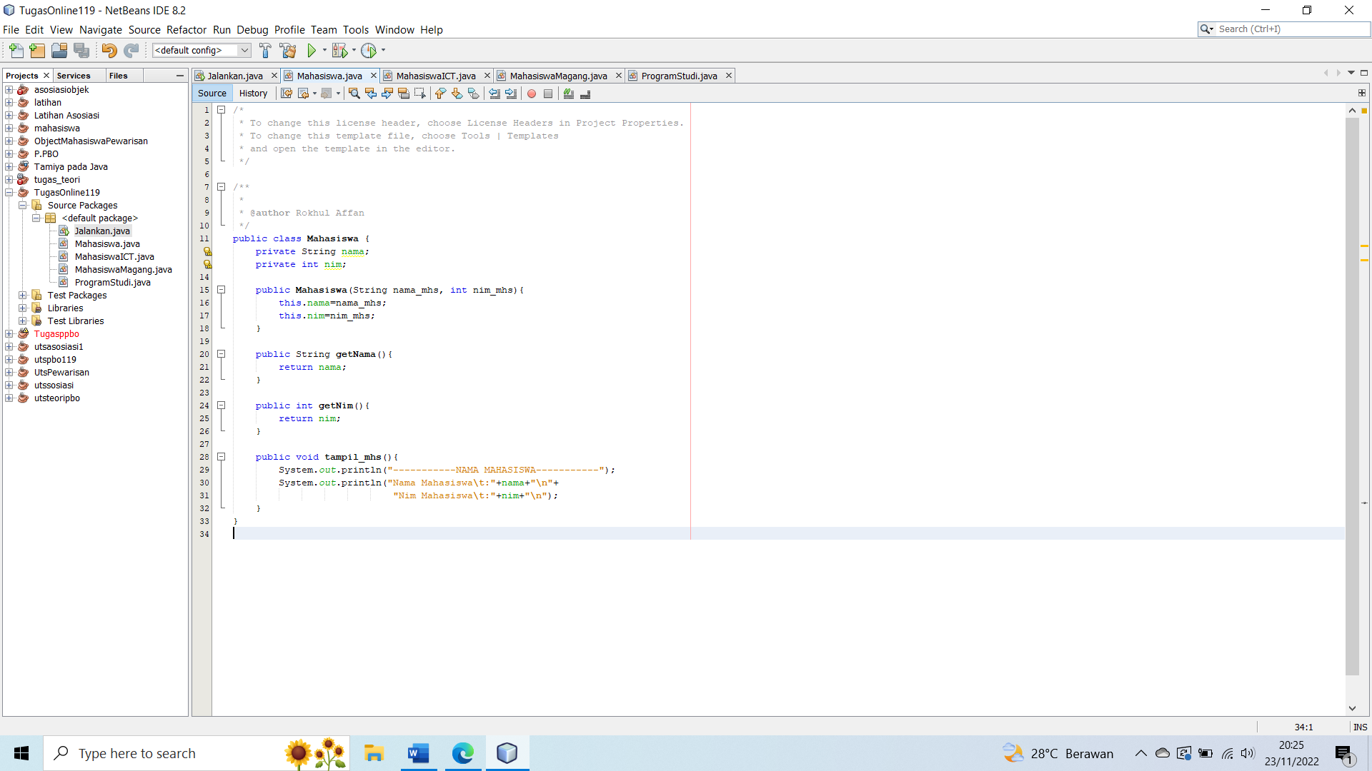

**Class MahasiswaICT.java**

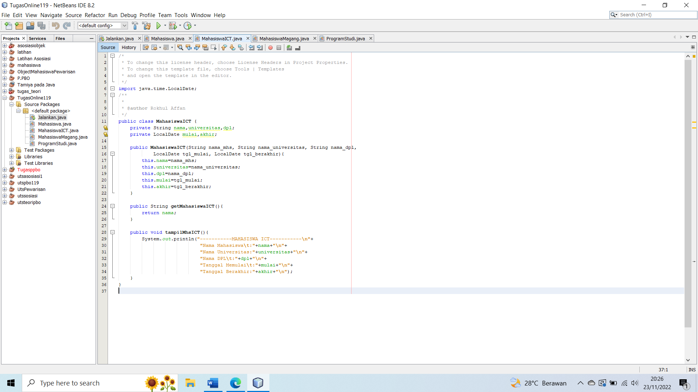

**Class MahasiswaMagang.java**

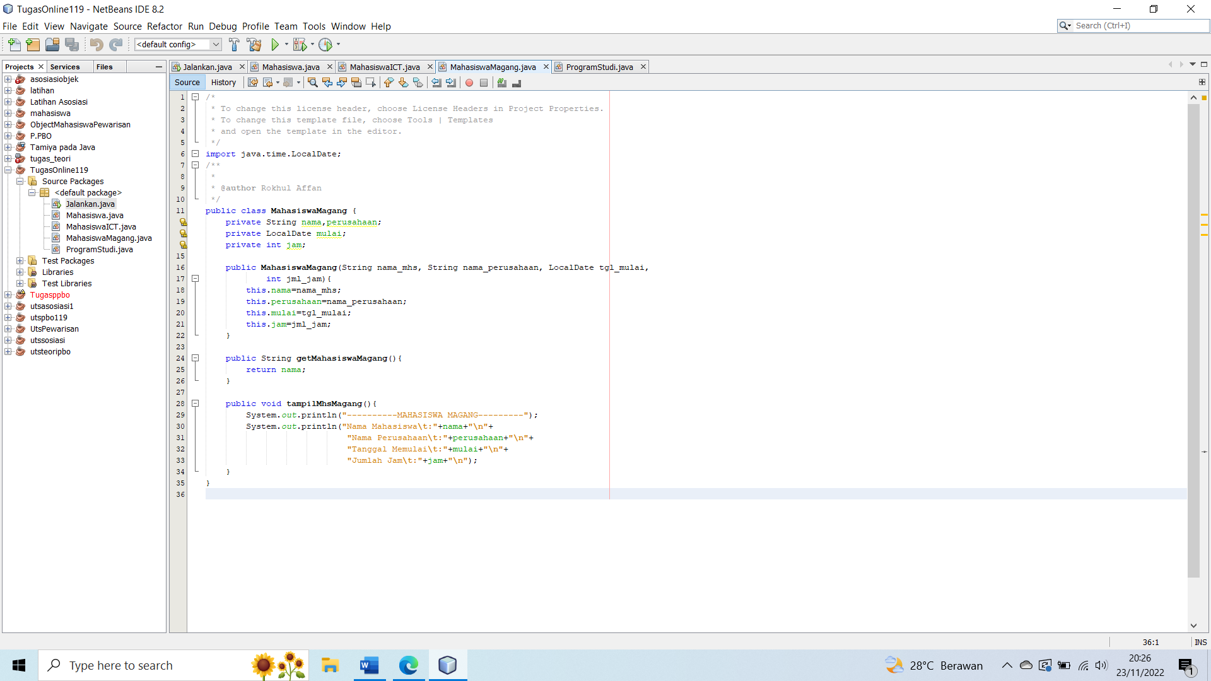

**Class ProgramStudi.java**

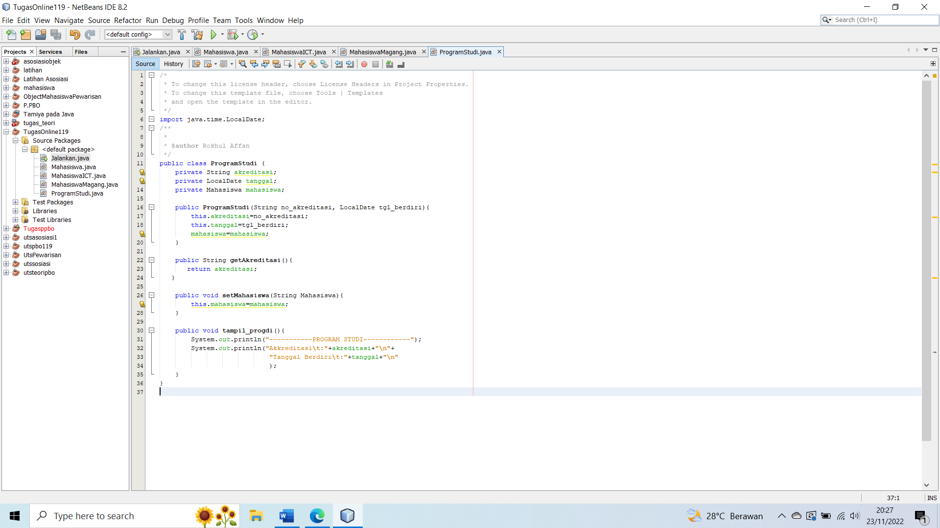

**Main Class Jalankan.java**

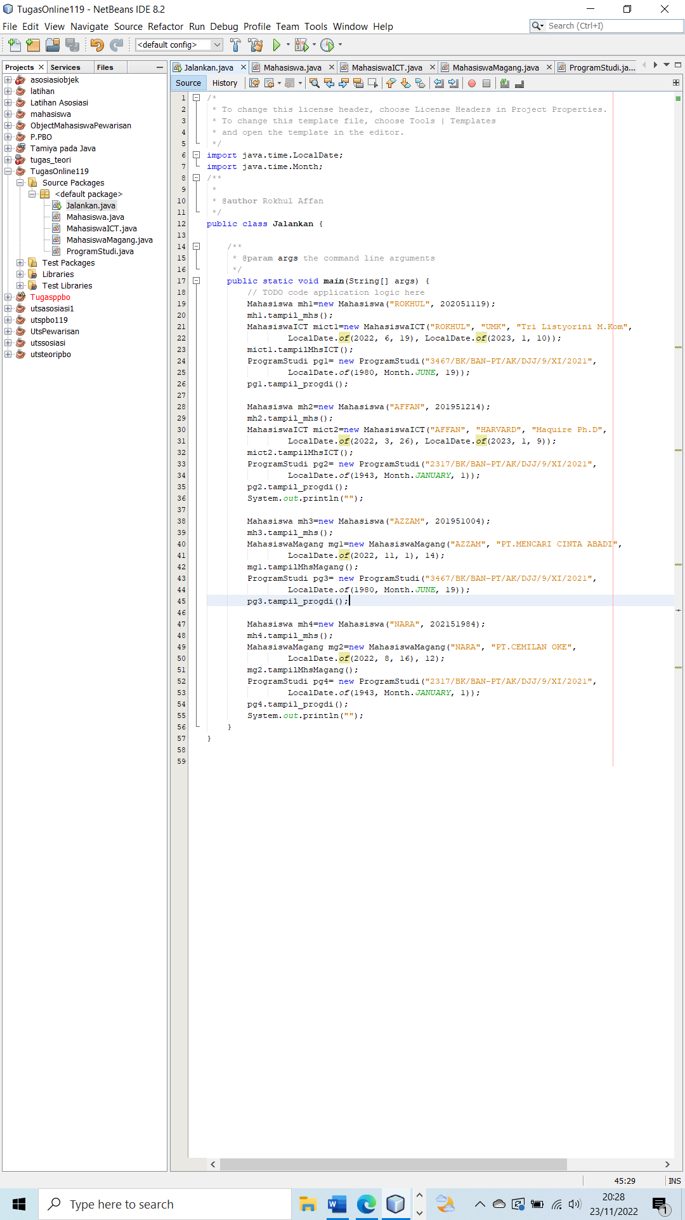

**Output**

