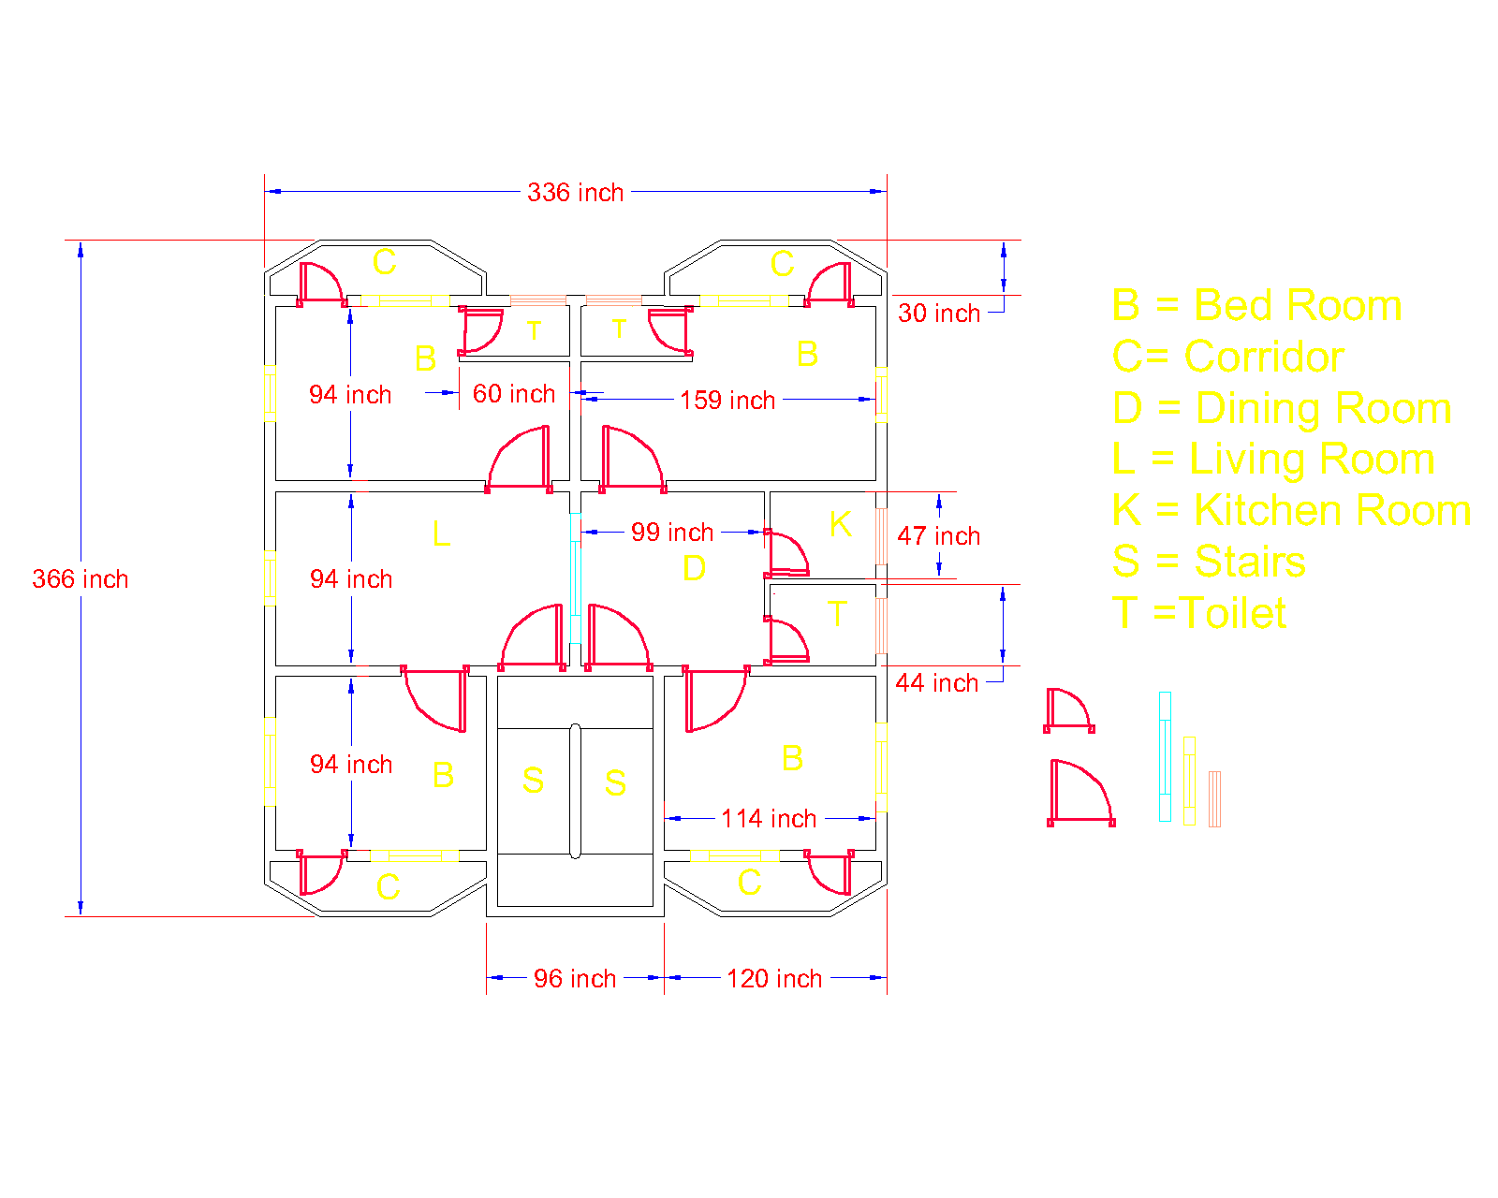

A simple report on the project:

Measurements: inches

Length and width of the house: 28 fit (336 inches) and 28 fit (336 inches)

Total bed rooms: 4

Length of all bed rooms: 7.8 fit (94 inches)

Width of 2 bed rooms is same: 13.25 fit (159 inches)

Width of another 2 bed rooms: 9.5 fit (114 inches)

Length and width of living room: 7.8 fit (94 inches) and 13.25 fit (159 inches)

Length of dining room: 8.25 fit (99 inches)

Length of kitchen: 4 fit (48 inches)

4 corridors length and width are: 2.5 fit (30 inches) and 10 fit (120 inches)

2 same measured toilets width: 5 fit (60 inches)

1 large toilets length: 3.6 fit (44 inches)

Length of stairs room: 8 fit (96 inches)

There are 6 main gates (used in room) and 8 small gates (used in corridors, kitchen and toilets)

There are 9 long windows (used in main room) and 4 short windows (used in toilets and kitchen)

Length of large doors: 32 inches

Length of short doors: 22 inches

Length of large windows: 44 inches

Length of short windows: 32 inches

Length of a large sized gate (set between leaving and dining room) : 5.83 fit (70 inches)