Mohammad Rahman

HW#2

September 5, 2014

2.

Define and declare area, width, and length as integer

Calculate area: Area = width \* length

Display “What is the room’s width?”

Input width.

Display “What is the room’s length?”

Input length

Print area

3. The output of the program is-

0  
100

4. The output of the program is-

Be careful  
This might/n be a trick question

5.

In line 1, the comment should be written as **/\*………………..\*/**

In line 4, there should not be ; (semi colon) after the function main( )

In line 5, it should be opening bracket “{“ instead of closing bracket “}”

In line 6, there should be “;” after c and the inline comment should start with “//” instead of “\\”

Each line from 7 to 9 should end with a “;”

In line 10, “<<” should be used instead of “<” and “Cout” should be spelled all lowercase “cout”.

In line 12, it should be closing bracket “}” instead of opening bracket “{”

6. 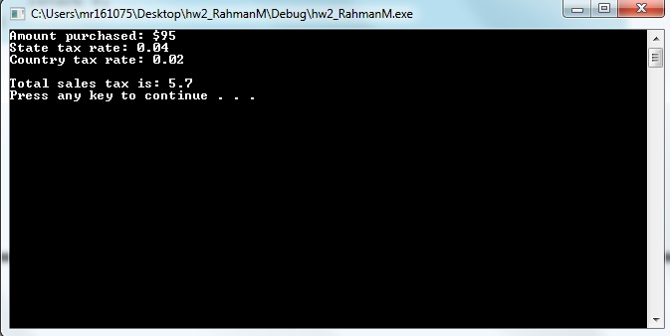

7.

