GTU Department Of Computer Engineering

CSE 222 / 505 – Spring 2023

Homework 1

Ahmet CEBECİ

1901042708

1. – System Requirement

Operating System must have JDK ( Java Development Kit ) 11 and JRE ( Java Runtime Enviroment) 11 or higher.

There should be enough space for storing datas.

1. 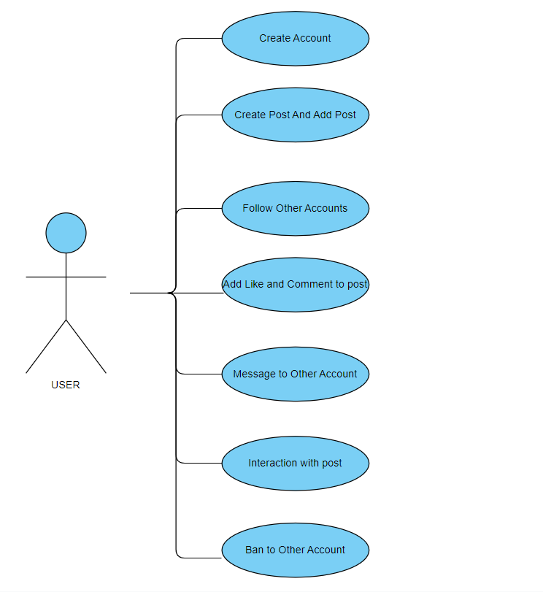– Use Case Diagrams

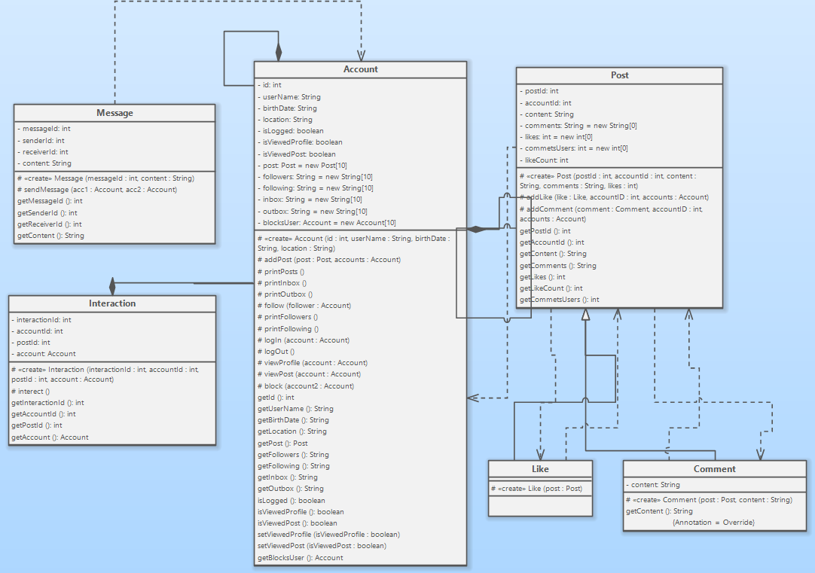3- Class Diagrams

4- Problem Solution Approach

Problem: design and implement basic social media software that provides sharing posts with people.

Solution: The account object is created first. Stores user information in this object (username, date of birth, location, posts, follower account, follower account). Accounts can follow each other, so they increase the number of followers or the number of following. You can view the profiles of the following accounts and view their posts. They can like and comment on these posts if they want. User can send messages to the following accounts. Messages are stored in the inbox of the receiving account and in the outbox of the sending account. The user can interact with the post of another account, it can be as a like or comment. The interaction information of each post (the number of likes / comments, the accounts that like / comment, the content of the comments) can be viewed by all users. And finally, unwanted accounts can be banned. In this way, messages cannot be received from unwanted accounts and those accounts cannot view your profile.

1. – Test Cases
2. Create accounts
3. Log in accounts
4. Create Posts
5. Add post to accounts
6. Account follows other account
7. View Profile and Post
8. Add Like and Comment to Post
9. Account sends message other account
10. Print Inbox and Outbox
11. Interaction with the post
12. Account bans other account
13. metin içeren bir resim

    Açıklama otomatik olarak oluşturuldu– Running Command And Result

Scenario 1:

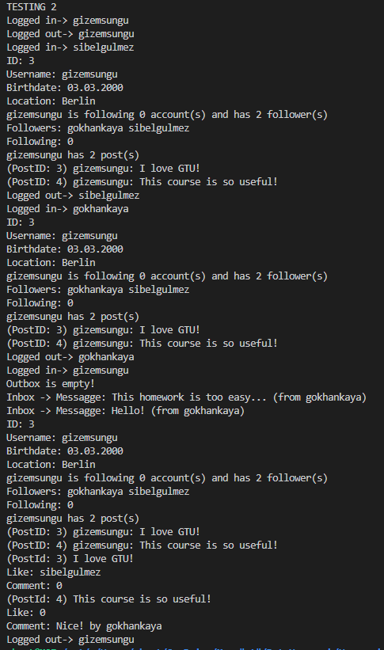Scenario 2:

Scenario 3:

