KINETIC MODEL
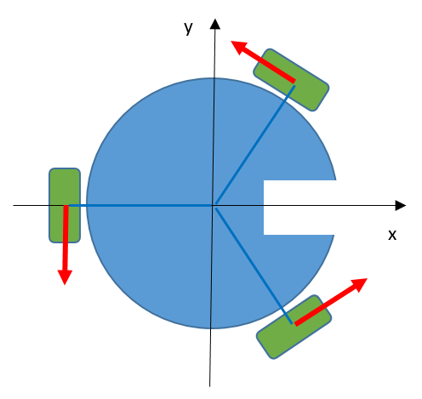
For simplicity, the thrower is pointing on positive x axis direction.
M1
M2
M3
The motors turn counterclockwise, so the velocity of each one points as shown in the diagram (red arrows).
The motors (and so the wheels) are separated 120° from each other forming an equilateral triangle.
Decomposing each force in their horizontal (x) and vertical (y) components, can be calculated:

And putting that into:

In matrix is shown as:

And finally inverting it:

To obtain the forces to be applied to the motors depending on the movement that the robot has to perform.

