FieldSense — Example Scenarios Q1–Q18
Actual system answers captured from the running Docker UI (sample-v1, as-of 2026-10-17T00:00:00Z).
Screenshots show the live FieldSense copilot response for each scenario step.

How to read this report
Each section includes: (1) the scenario question as asked, (2) the official expected answer summary from the challenge brief, (3) the actual system summary returned by FieldSense, and (4) a browser screenshot of the UI answer (tables, charts, maps, cards).
Part A uses Michael Turner unless noted. Part B switches demo users. Q12–Q15 apply shared corrections; Q11/Q16 test private memory isolation.

Q1 — Michael Turner

Question asked
Is WELL-0001 producing oil right now? When was it last inspected, and by whom? Show me its status card.

Expected (challenge brief)
Expected: Not producing. INS-0001-0203 on 15 Oct 2026 by Ryan Brooks (drone). ΔT 3.2 °C below T200. CTX-0001-003 planned shut-in. Recorded status active (stale).

Actual system answer
WELL-0001 is not producing based on the latest inspection INS-0001-0203 on 2026-10-15 by Ryan Brooks (drone). ΔT=3.2 °C vs threshold 15.0 °C. Recorded status `active` appears out of date. Context: Well shut in from 7 Oct for planned rod string replacement. Work order not yet in the maintenance system. Expected back online around 20 Oct. (CTX-0001-003).
Visual / kind: status_card

UI screenshot
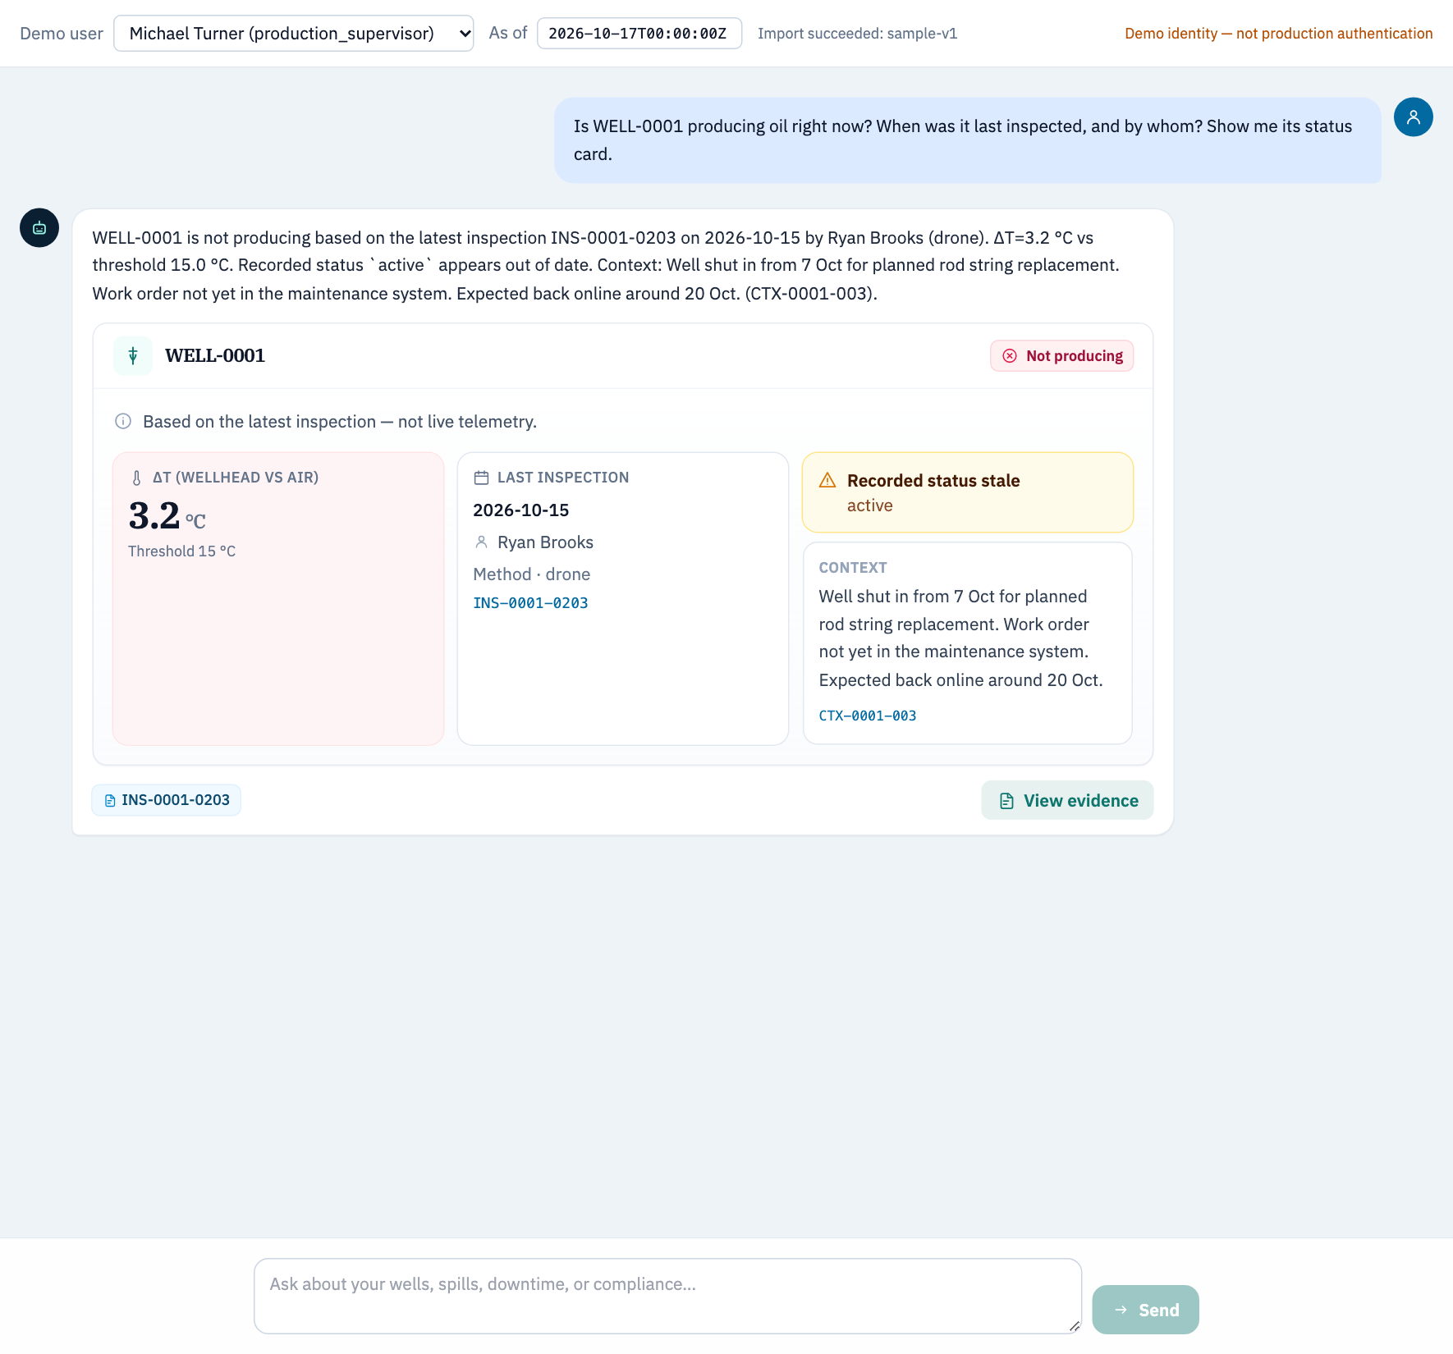
Figure: Q1 — FieldSense UI response

Q2 — Michael Turner

Question asked
Which wells in Northeast Block 8 are not producing oil right now, and why? Show them in a table.

Expected (challenge brief)
Expected table: WELL-0164, WELL-0170, WELL-0172, WELL-0175 (four T200 wells).

Actual system answer
There are 4 wells in Northeast Block 8 that are not producing based on the latest inspection at/before 2026-10-17. 2 well(s) have no recorded reason (WELL-0164, WELL-0175); suggest a field check — do not invent a cause.
Visual / kind: table

Result rows (system data)
reason | delta_c | asset_id | well_type | recorded_status | latest_inspection | inspector_observation | recorded_status_stale
No recorded reason — suggest a field check (do not invent a cause). | 4.1 | WELL-0164 | T200 | active (out of date) | {"notes": "Pump jack not moving.", "method": "manual", "inspected_at": "2026-10- | Pump jack not moving. | True
Repair MNT-0170-031: Walking beam bearing wear | 2.9 | WELL-0170 | T200 | down | {"notes": "", "method": "drone", "inspected_at": "2026-10-15T14:15:00+00:00", "i |  | False
Repair MNT-0172-028: Flowline corrosion pinhole leak | 5.7 | WELL-0172 | T200 | active (out of date) | {"notes": "No stroke observed during flight.", "method": "drone", "inspected_at" | No stroke observed during flight. | True
No recorded reason — suggest a field check (do not invent a cause). | 0.4 | WELL-0175 | T200 | active (out of date) | {"notes": "", "method": "drone", "inspected_at": "2026-10-15T08:00:00+00:00", "i |  | True

UI screenshot
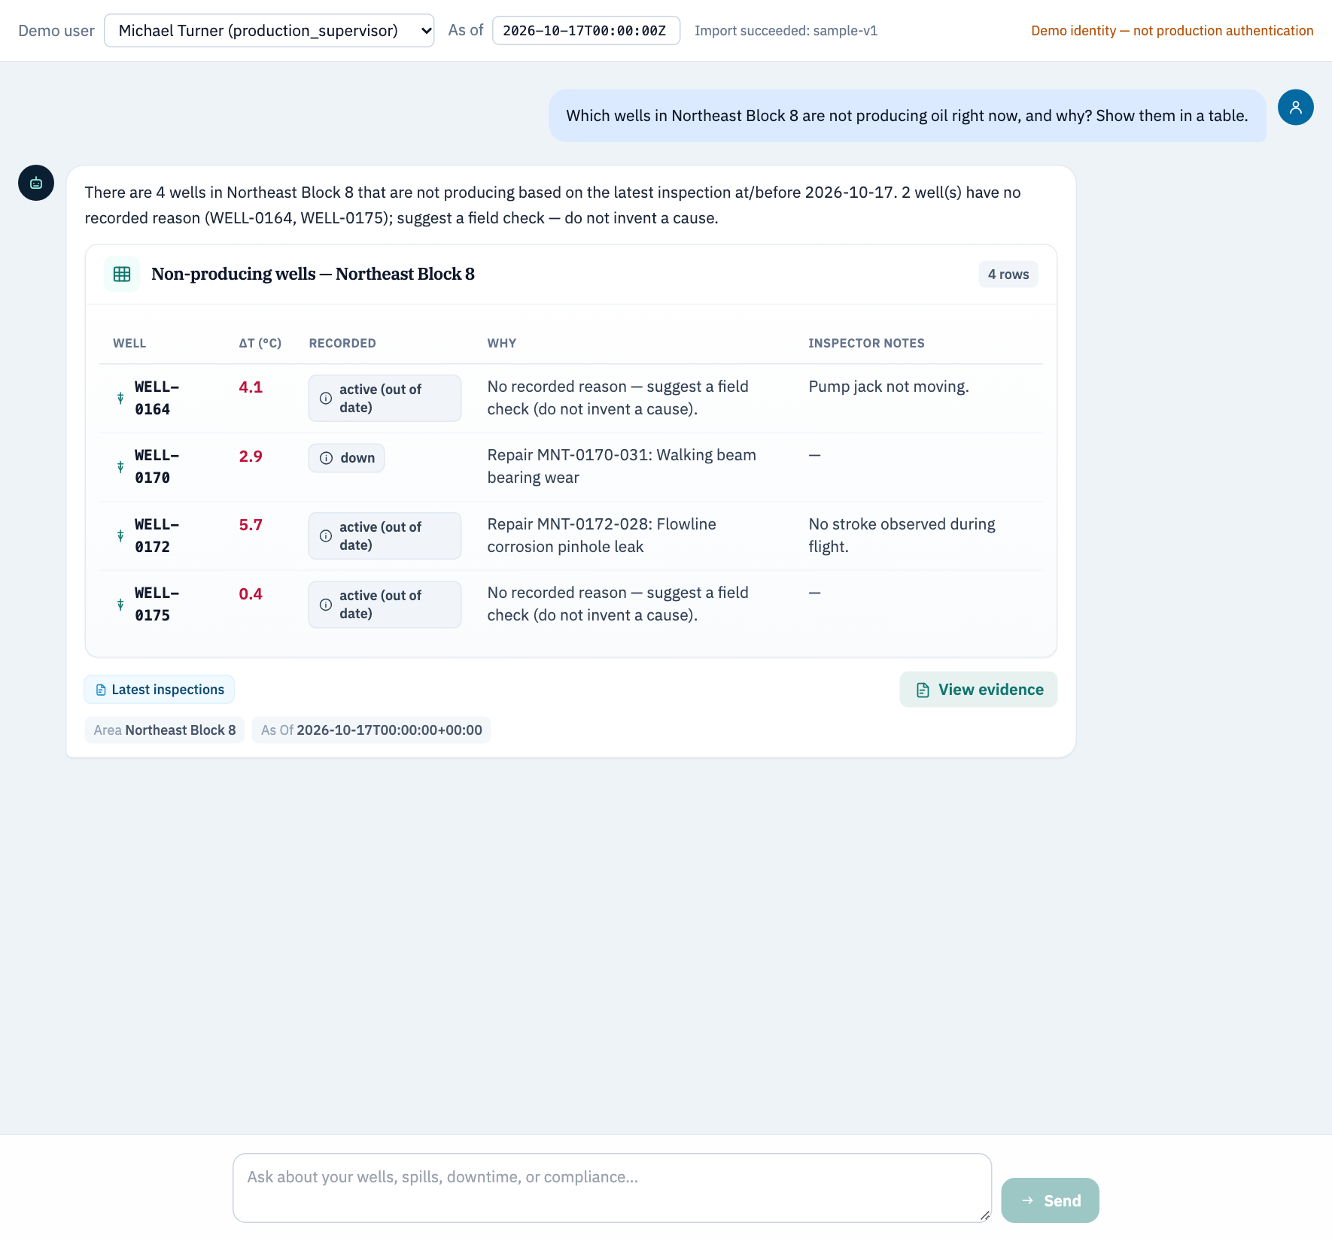
Figure: Q2 — FieldSense UI response

Q3 — Michael Turner

Question asked
Show a line chart of WELL-0001's wellhead temperature against air temperature for the last 13 weeks, and mark when it was not producing oil.

Expected (challenge brief)
Expected: 13 readings; not producing on 8 Oct and 15 Oct 2026.

Actual system answer
13 readings from 2026-07-23 to 2026-10-15. Not producing on: 2026-10-08, 2026-10-15.
Visual / kind: line_chart

Result rows (system data)
status | delta_c | inspected_at | inspection_id | ambient_temp_c | wellhead_temp_c
producing | 28.1 | 2026-07-23T11:30:00+00:00 | INS-0001-0191 | 33.1 | 61.2
producing | 26.2 | 2026-07-30T10:30:00+00:00 | INS-0001-0192 | 32.0 | 58.2
producing | 29.9 | 2026-08-06T15:30:00+00:00 | INS-0001-0193 | 35.1 | 65.0
producing | 26.6 | 2026-08-13T09:30:00+00:00 | INS-0001-0194 | 34.0 | 60.6
producing | 23.0 | 2026-08-20T14:15:00+00:00 | INS-0001-0195 | 36.3 | 59.3
producing | 26.8 | 2026-08-27T13:45:00+00:00 | INS-0001-0196 | 34.4 | 61.2
producing | 30.7 | 2026-09-03T13:00:00+00:00 | INS-0001-0197 | 34.5 | 65.2
producing | 25.6 | 2026-09-10T07:30:00+00:00 | INS-0001-0198 | 27.2 | 52.8
producing | 22.4 | 2026-09-17T15:30:00+00:00 | INS-0001-0199 | 31.2 | 53.6
producing | 22.1 | 2026-09-24T15:00:00+00:00 | INS-0001-0200 | 23.6 | 45.7
producing | 27.4 | 2026-10-01T09:45:00+00:00 | INS-0001-0201 | 23.0 | 50.4
not_producing | 3.2 | 2026-10-08T10:45:00+00:00 | INS-0001-0202 | 20.2 | 23.4
not_producing | 3.2 | 2026-10-15T09:45:00+00:00 | INS-0001-0203 | 22.4 | 25.6

UI screenshot
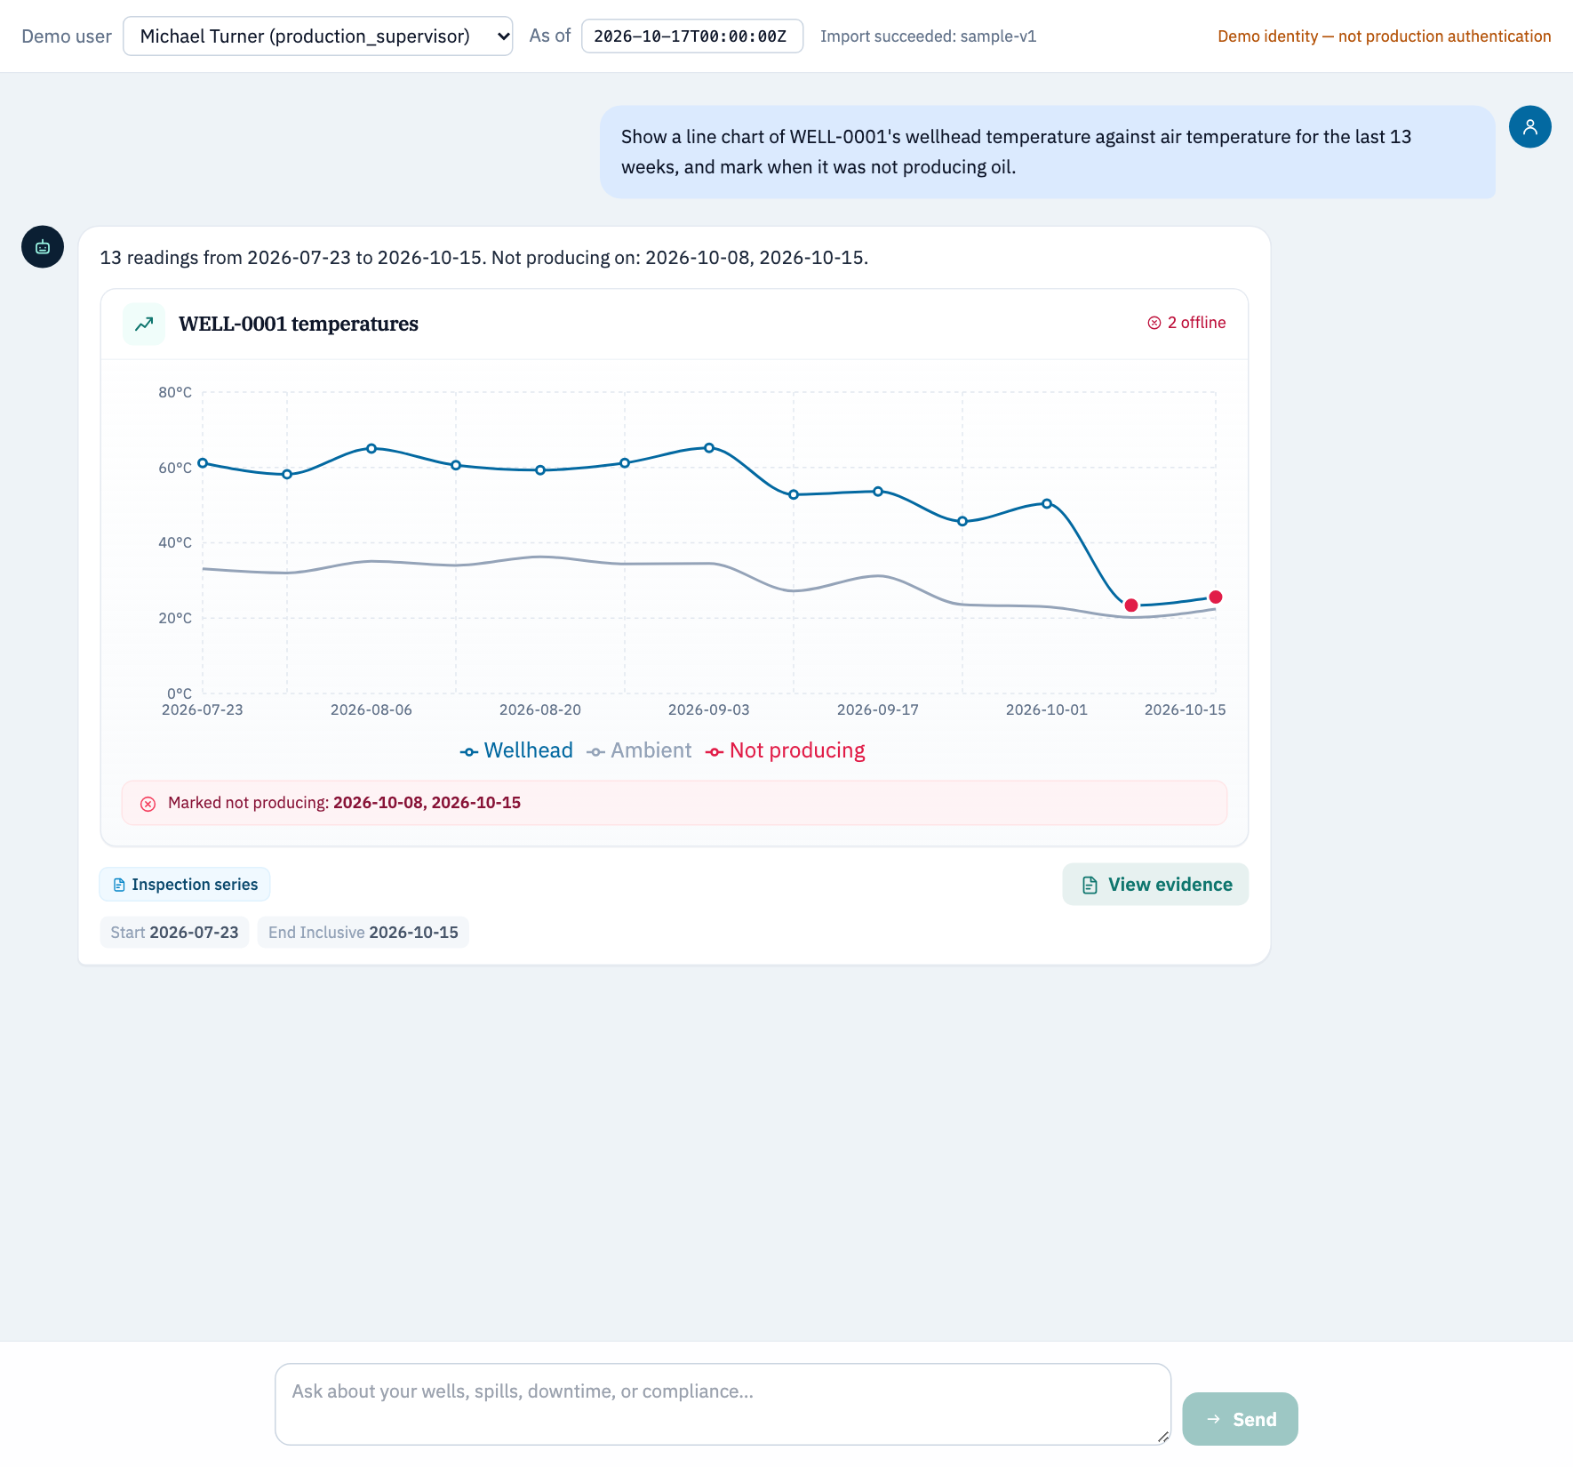
Figure: Q3 — FieldSense UI response

Q4 — Michael Turner

Question asked
How many oil spills has WELL-0001 had in the last 4 years, and how much oil in total? List them in a table.

Expected (challenge brief)
Expected: 6 spills, 15.1 bbl; INS-0001-0070 rainwater excluded.

Actual system answer
6 spills totaling 15.1 bbl in the last 4 years (through 2026-10-17). 7 detections raw; excluded as non-oil/corrected: INS-0001-0070 (2024-03-07).
Visual / kind: table

Result rows (system data)
date | volume_bbl | inspection_id
2023-03-16 | 0.5 | INS-0001-0021
2023-04-27 | 2.6 | INS-0001-0027
2023-09-28 | 3.3 | INS-0001-0048
2023-10-19 | 0.3 | INS-0001-0051
2026-06-11 | 6.8 | INS-0001-0185
2026-10-01 | 1.6 | INS-0001-0201

UI screenshot
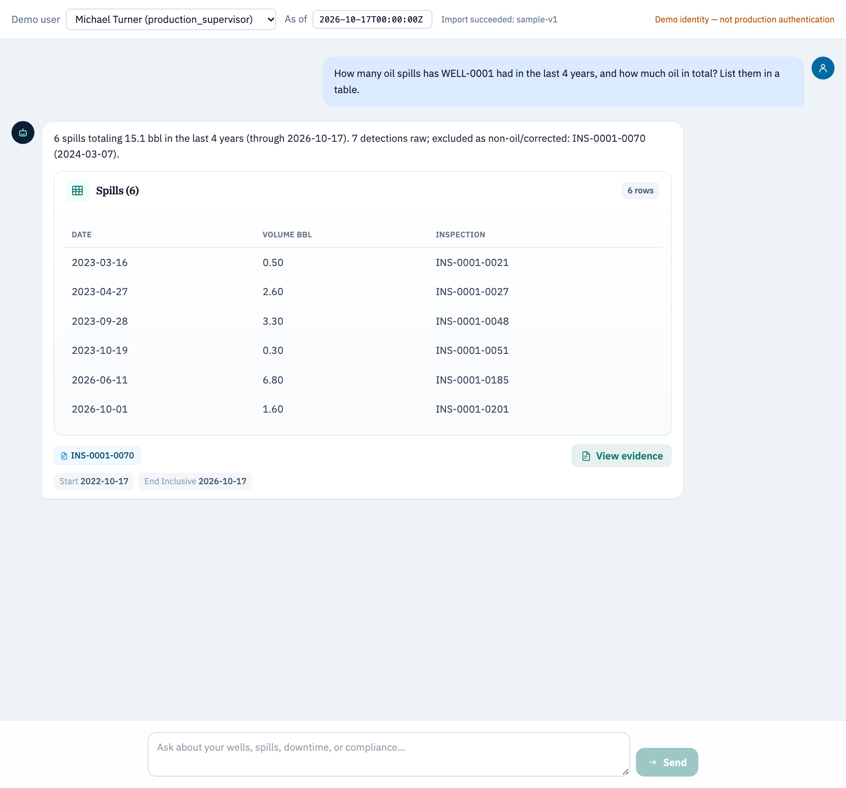
Figure: Q4 — FieldSense UI response

Q5 — Michael Turner

Question asked
How many days was WELL-0001 down in 2025?

Expected (challenge brief)
Expected: 21 days from 3 non-producing inspections; no visual required.

Actual system answer
WELL-0001 was down 21 days in 2025. 3 weekly inspection findings × 7 days = 21 days. 2025-07-24 (ΔT 8.5 °C): Prime mover tripped on high temperature (MNT-0001-021); 2025-10-16 (ΔT 3.4 °C): Stuffing box packing leak (MNT-0001-023); 2025-10-23 (ΔT -0.6 °C): Stuffing box packing leak (MNT-0001-023)
Visual / kind: short_answer / text

Result rows (system data)
cause | delta_c | inspected_at | inspection_id | ambient_temp_c | maintenance_id | wellhead_temp_c
Prime mover tripped on high temperature | 8.5 | 2025-07-24T15:30:00+00:00 | INS-0001-0140 | 43.1 | MNT-0001-021 | 51.6
Stuffing box packing leak | 3.4 | 2025-10-16T13:45:00+00:00 | INS-0001-0152 | 23.2 | MNT-0001-023 | 26.6
Stuffing box packing leak | -0.6 | 2025-10-23T11:45:00+00:00 | INS-0001-0153 | 16.6 | MNT-0001-023 | 16.0

UI screenshot
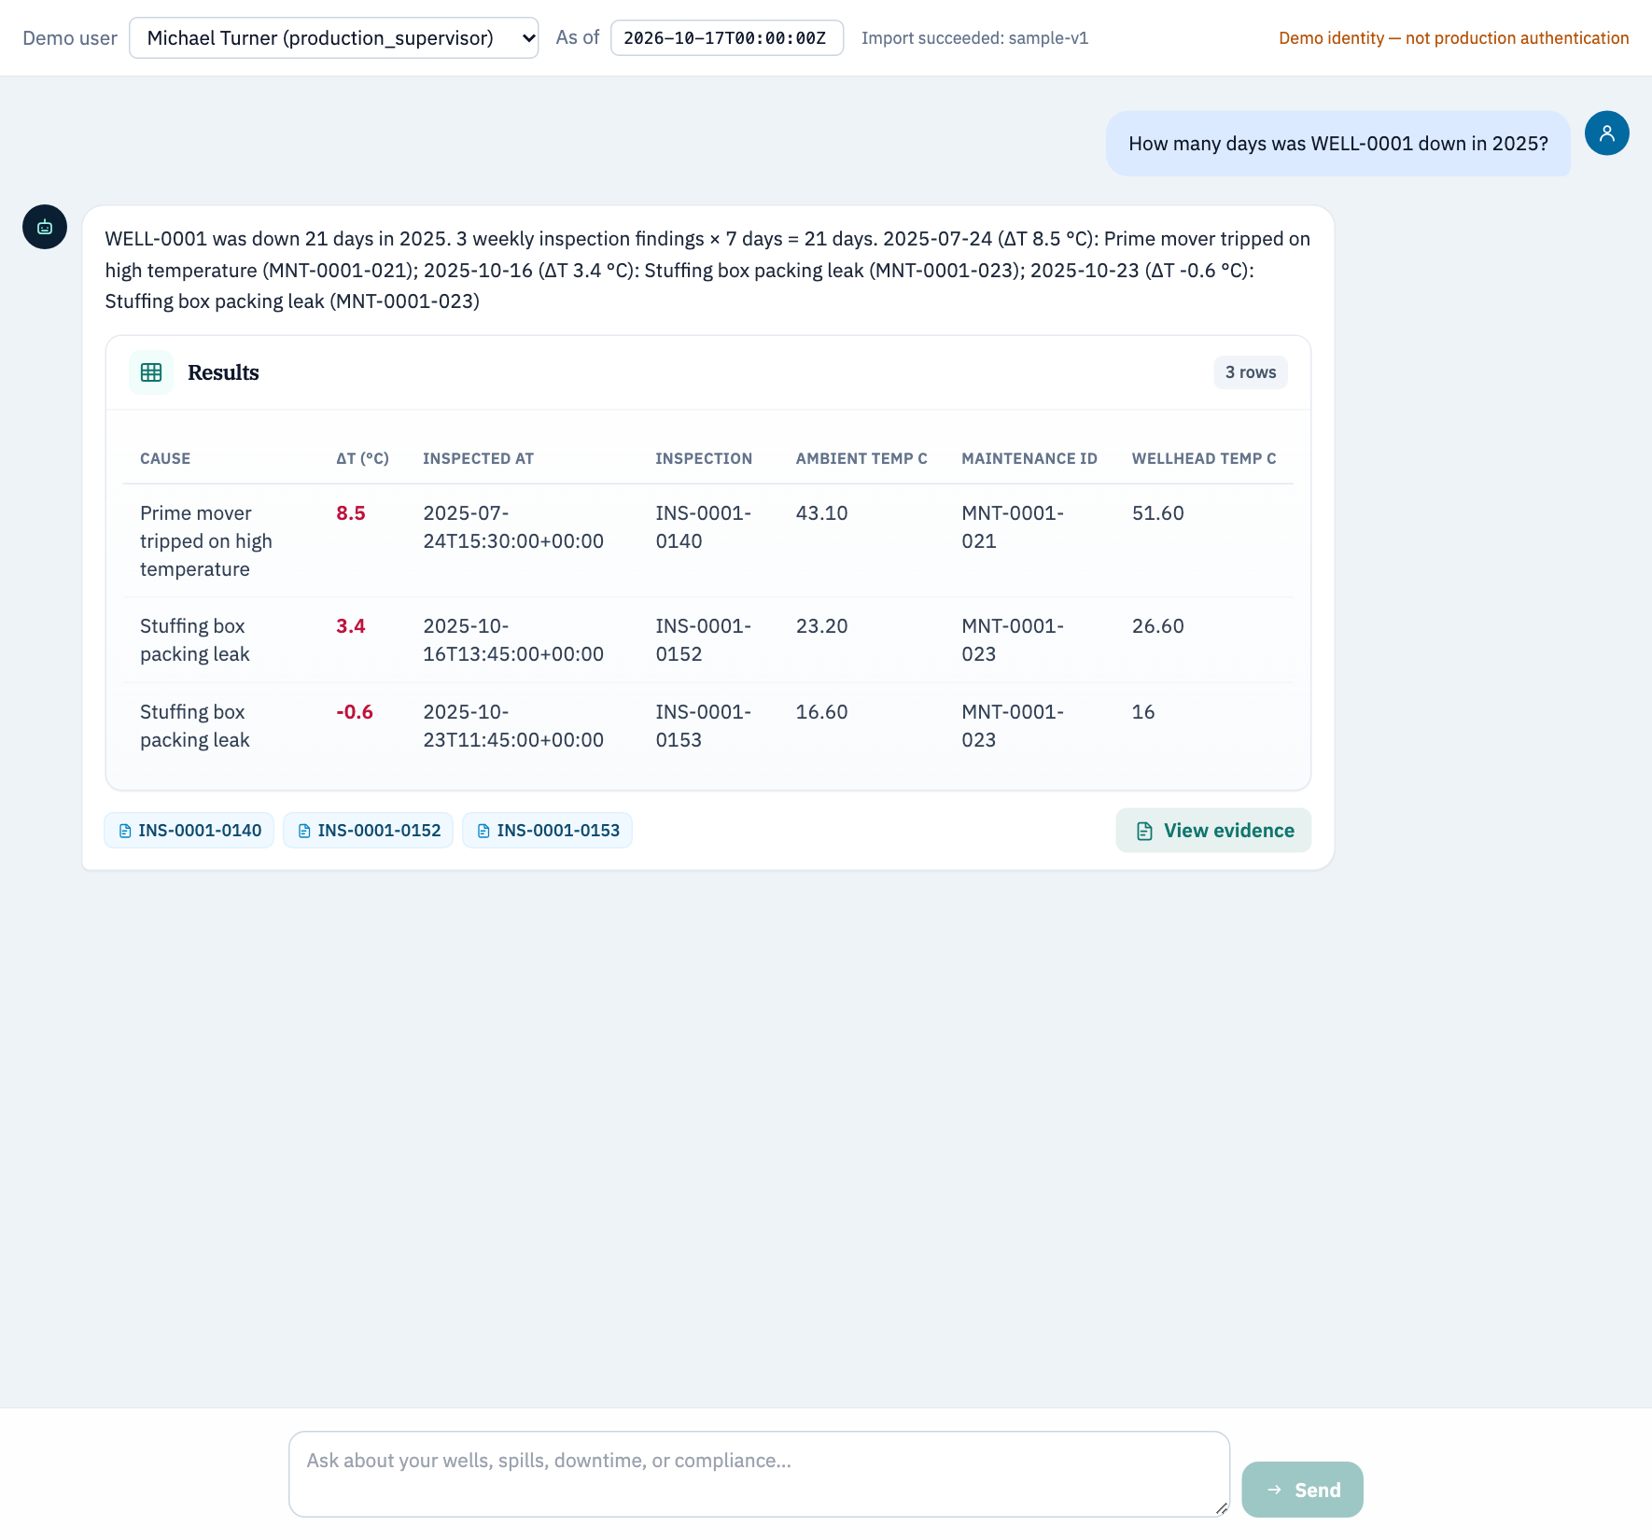
Figure: Q5 — FieldSense UI response

Q6 — Michael Turner

Question asked
Which 3 wells in Northeast Block 7 had the most downtime in the last 4 months? Show a bar chart.

Expected (challenge brief)
Expected: WELL-0121 49d, WELL-0138/0107 42d (16 Jun–16 Oct 2026).

Actual system answer
Top downtime wells in Northeast Block 7 between 16 Jun and 16 Oct 2026: WELL-0121 (49 days), WELL-0107 (42 days), WELL-0138 (42 days). Downtime = 7 days × non-producing weekly inspections (missed inspections add 0).
Visual / kind: bar_chart, table

Result rows (system data)
why | asset_id | well_type | downtime_days | inspection_count | non_producing_count | contributing_inspection_ids
{"summary": "Prime mover failure", "relationship": "explicit_link", "maintenance | WELL-0121 | T200 | 49 | 18 | 7 | ["INS-0121-0189", "INS-0121-0200", "INS-0121-0201", "INS-0121-0202", "INS-0121-0
{"summary": "Stuffing box packing leak", "relationship": "explicit_link", "maint | WELL-0107 | T350 | 42 | 18 | 6 | ["INS-0107-0194", "INS-0107-0195", "INS-0107-0196", "INS-0107-0197", "INS-0107-0
{"summary": "Flowline leak causing spill", "relationship": "explicit_link", "mai | WELL-0138 | T350 | 42 | 18 | 6 | ["INS-0138-0195", "INS-0138-0196", "INS-0138-0200", "INS-0138-0201", "INS-0138-0

UI screenshot
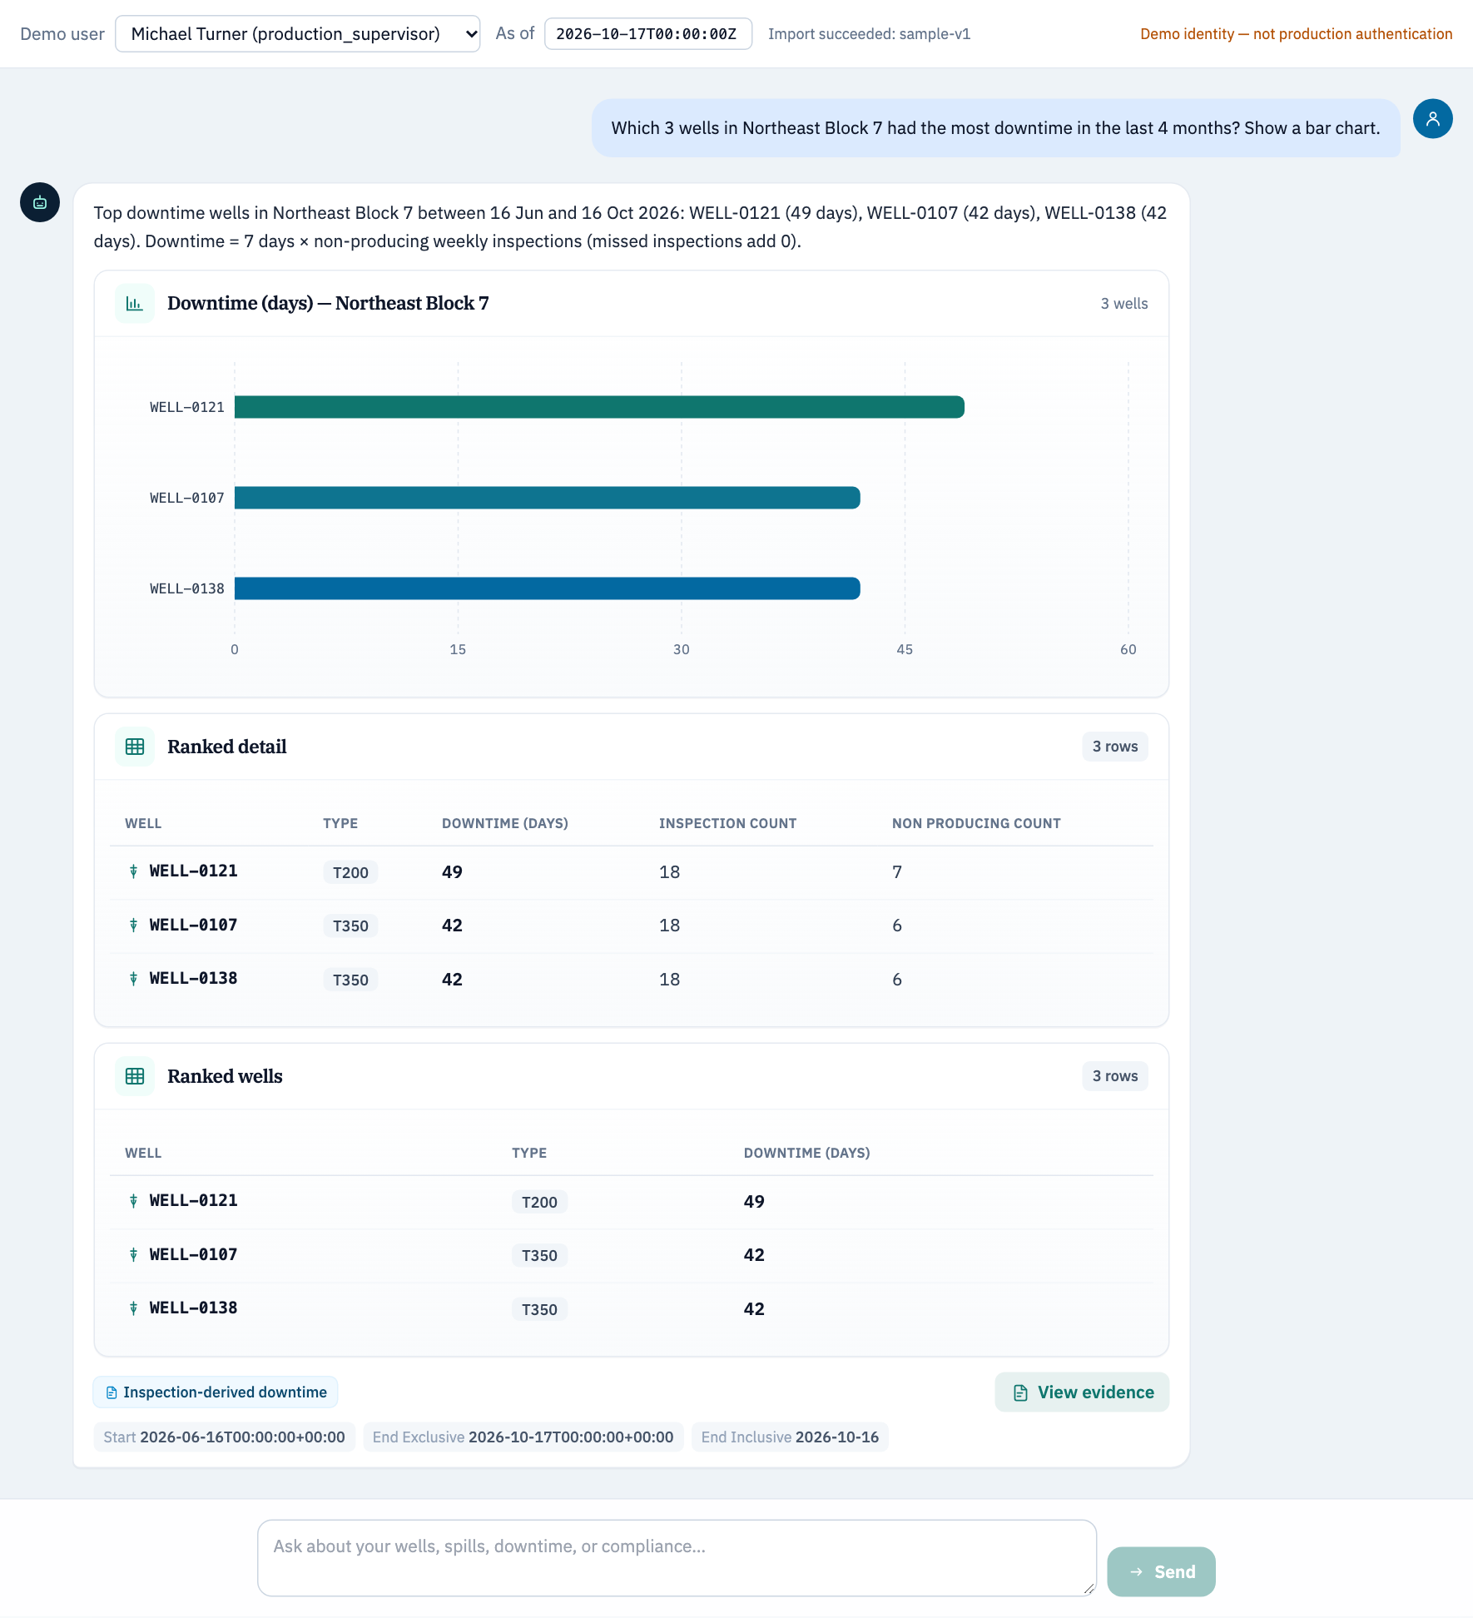
Figure: Q6 — FieldSense UI response

Q7 — Michael Turner

Question asked
Show on a map every well in Northeast Block 8 with a real spill in the last 90 days.

Expected (challenge brief)
Expected map: WELL-0151, 0165, 0175, 0186.

Actual system answer
4 wells with effective spills in Northeast Block 8 over the last 90 days.
Visual / kind: map

Result rows (system data)
lat | lon | events | asset_id
32.12246 | -102.18445 | [{"date": "2026-09-24", "volume_bbl": 4.5, "inspection_id": "INS-0151-0201"}] | WELL-0151
32.15665 | -102.14522 | [{"date": "2026-07-30", "volume_bbl": 1.2, "inspection_id": "INS-0165-0194"}] | WELL-0165
32.1802 | -102.1479 | [{"date": "2026-07-30", "volume_bbl": 3.9, "inspection_id": "INS-0175-0193"}] | WELL-0175
32.17552 | -102.17775 | [{"date": "2026-07-23", "volume_bbl": 0.6, "inspection_id": "INS-0186-0097"}] | WELL-0186

UI screenshot
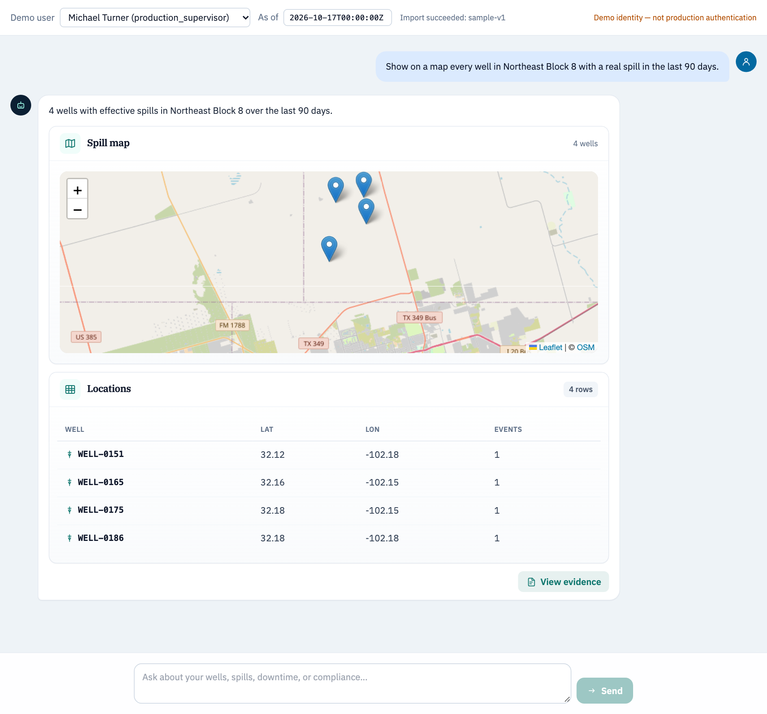
Figure: Q7 — FieldSense UI response

Q8 — Michael Turner

Question asked
Show a heatmap of 2026 spills by geographic area and month.

Expected (challenge brief)
Expected area×month heatmap with corrected detections removed.

Actual system answer
2026 spill counts by area and month (formal corrections excluded).
Visual / kind: heatmap

Result rows (system data)
total | months | values | area_name
37 | ["2026-01", "2026-02", "2026-03", "2026-04", "2026-05", "2026-06", "2026-07", "2 | [5, 3, 2, 4, 6, 6, 2, 4, 4, 1] | Northeast Block 7
26 | ["2026-01", "2026-02", "2026-03", "2026-04", "2026-05", "2026-06", "2026-07", "2 | [4, 4, 4, 3, 2, 4, 4, 0, 1, 0] | Northeast Block 8
35 | ["2026-01", "2026-02", "2026-03", "2026-04", "2026-05", "2026-06", "2026-07", "2 | [4, 3, 3, 6, 3, 4, 4, 3, 3, 2] | Southwest Block 23
43 | ["2026-01", "2026-02", "2026-03", "2026-04", "2026-05", "2026-06", "2026-07", "2 | [7, 4, 5, 6, 5, 5, 3, 1, 5, 2] | Southwest Block 24

UI screenshot
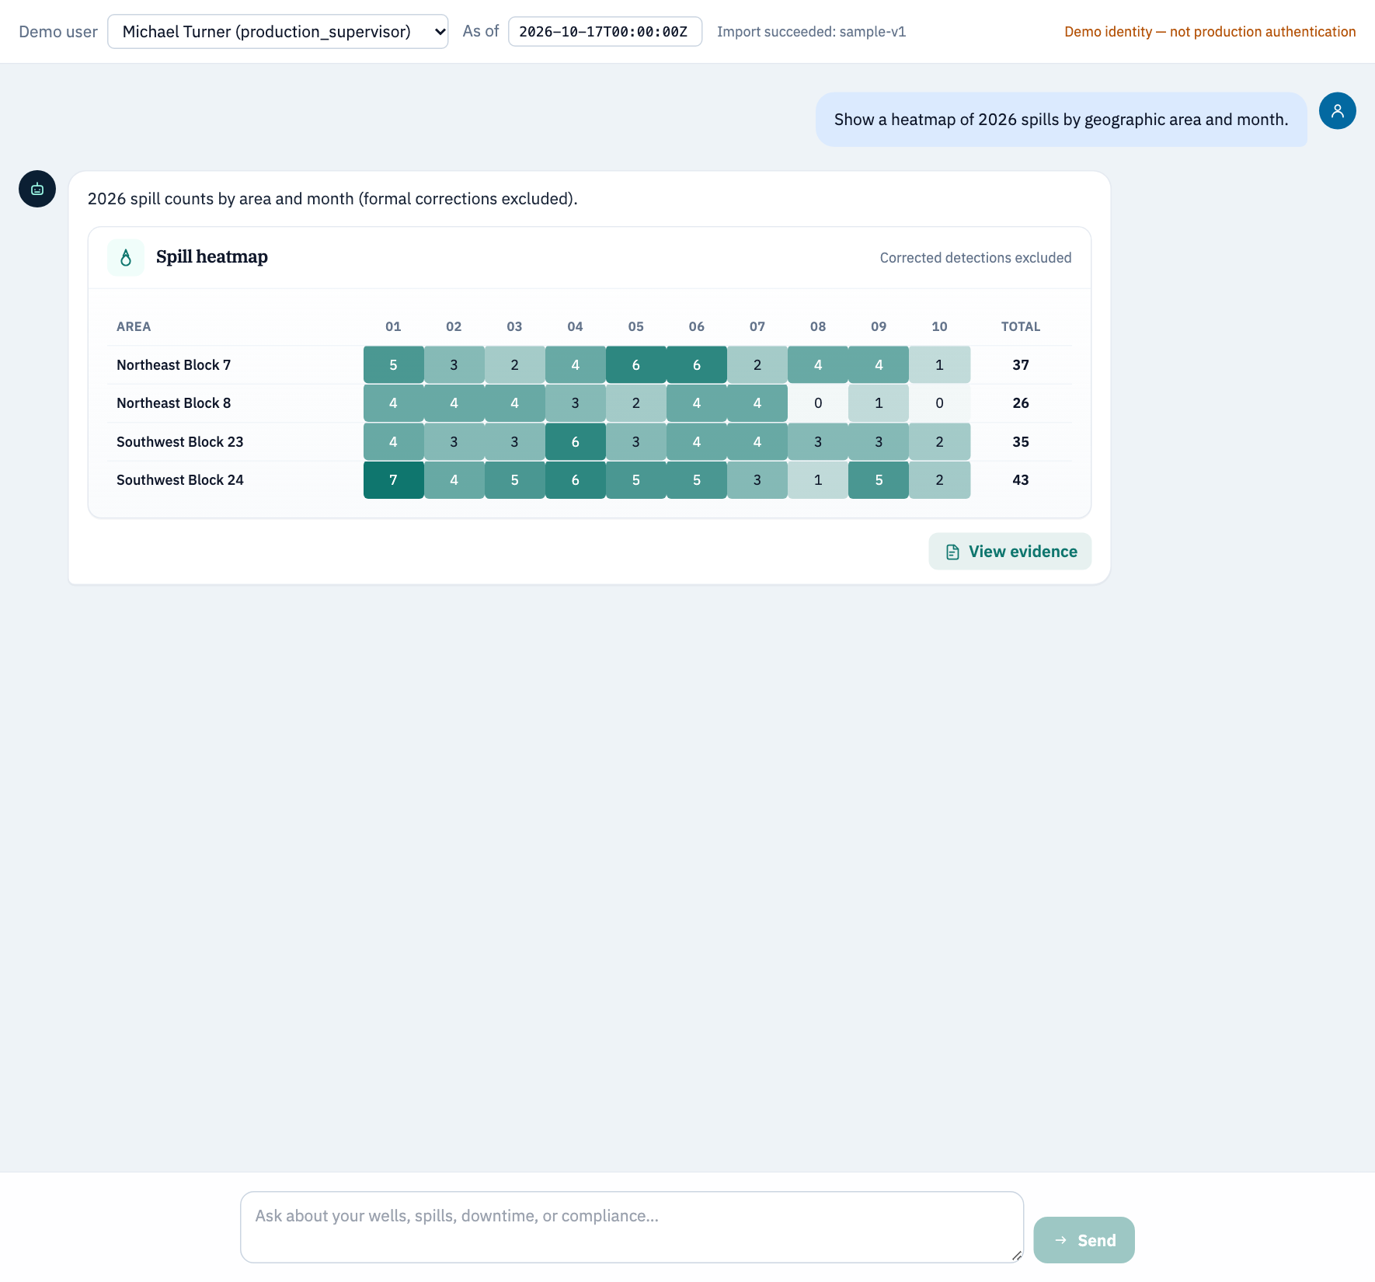
Figure: Q8 — FieldSense UI response

Q9 — Michael Turner

Question asked
Which rules has WELL-0001 broken in the last 12 months, and what is still open?

Expected (challenge brief)
Expected: SR-01/02/03, RC-04 breaches; USD 5,000 fines; pending RCA/records.

Actual system answer
WELL-0001 has 10 rule breach(es) in the last 12 months; recorded fines USD 5,000 (still open where noted). 2 open action(s) still pending (not yet counted as breaches). Met: Flowline test MNT-0001-026 on 2026-03-07.
Visual / kind: table

Result rows (system data)
detail | status | category | event_id | fine_usd | protocol_id | event_status
Reported after 41.00 hours | breached | breach | REG-0001-001 |  | SR-01 | closed
Reported after 41.00 hours | breached | breach | REG-0001-002 | 5000.0 | SR-01 | open
No NOV response recorded | breached | breach | REG-0001-002 |  | RC-04
Contained after about 5.3000 hours | breached | breach |  |  | SR-02
Contained after about 5.3000 hours | breached | breach |  |  | SR-02
Contained after about 6.8000 hours | breached | breach |  |  | SR-02
Contained after about 6.8000 hours | breached | breach |  |  | SR-02
Contained after about 7.0000 hours | breached | breach |  |  | SR-02
Contained after about 7.0000 hours | breached | breach |  |  | SR-02
Cleanup verification still open | breached | breach | REG-0001-003 |  | SR-03
3 corrective flowline repairs in 12 months (threshold 3) | pending | pending |  |  | RCA
Planned shut-in not yet recorded in maintenance system | pending_review | pending |  |  | RECORDS
Flowline test MNT-0001-026 on 2026-03-07 | met | met |  |  | RC-02

UI screenshot
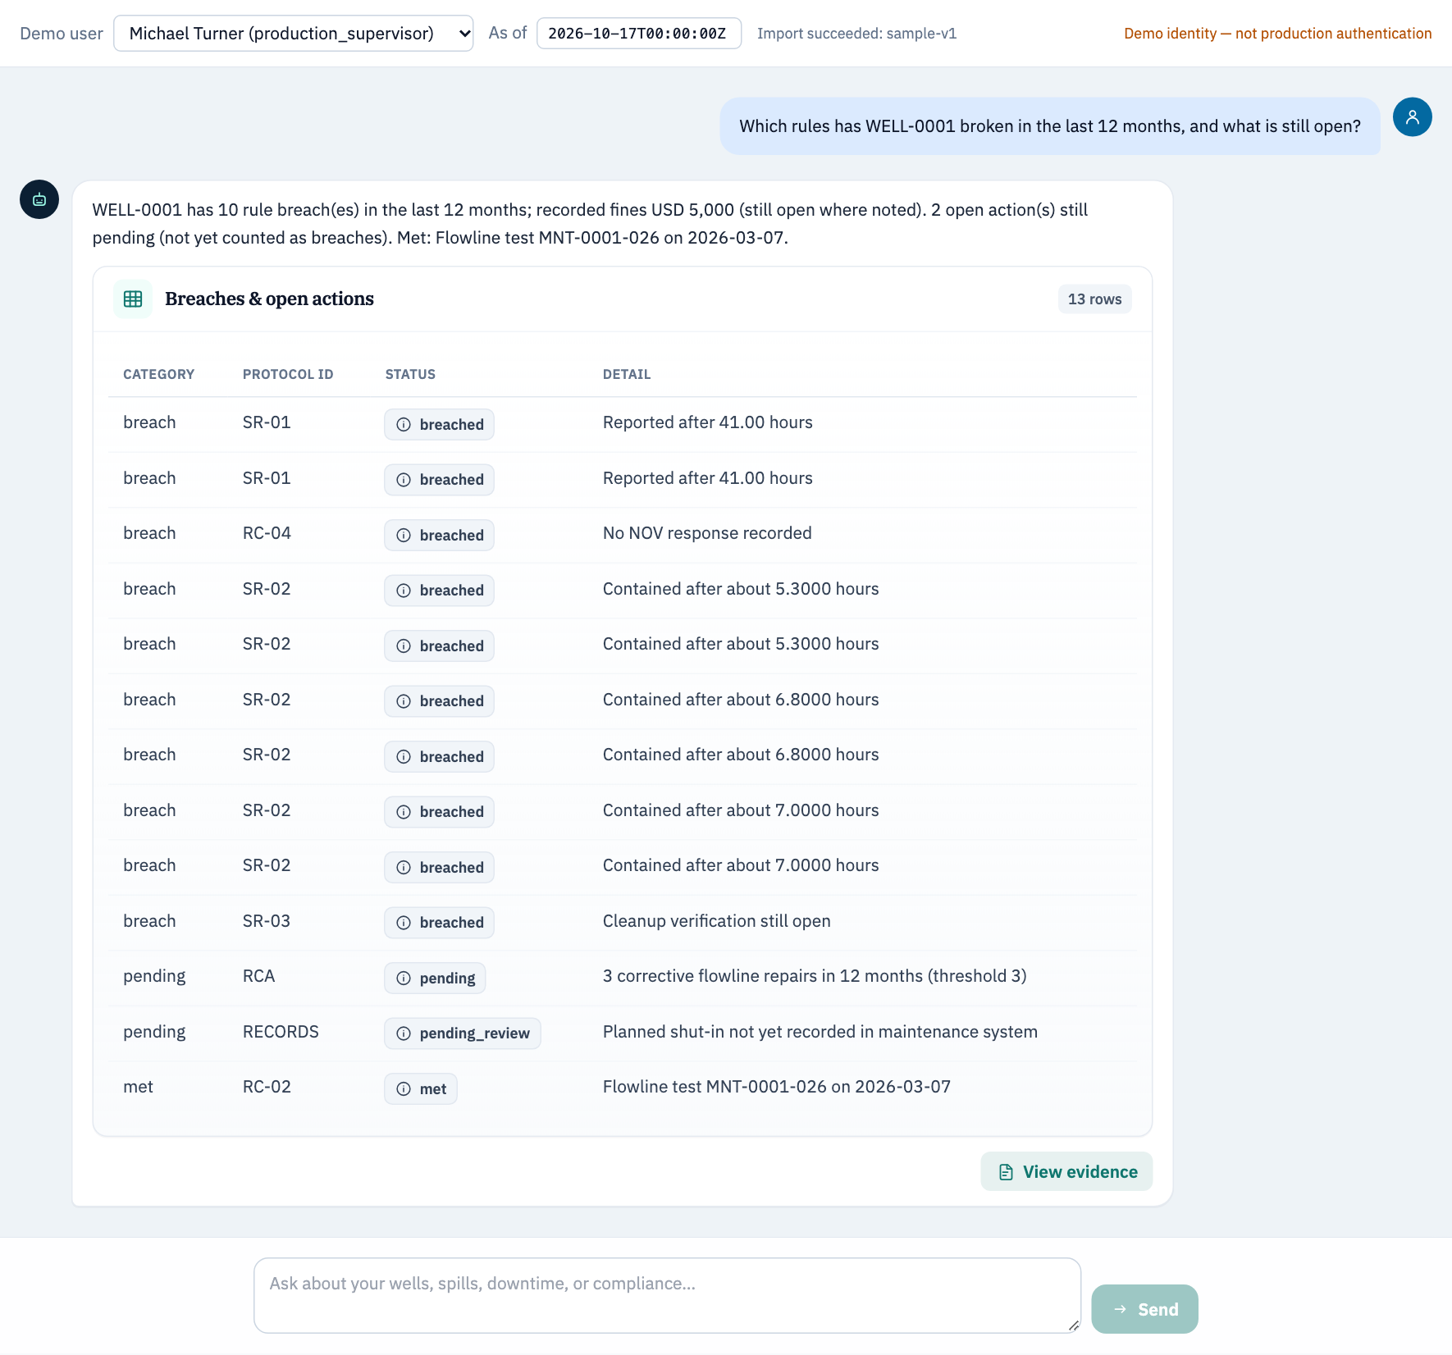
Figure: Q9 — FieldSense UI response

Q10 — Michael Turner

Question asked
In Southwest Block 24, which spills in the last 90 days were not contained within the SOP time limit?

Expected (challenge brief)
Expected: WELL-0082 (~7.1 h), WELL-0100 (~8.1 h).

Actual system answer
2 spills exceeded the 4-hour containment limit (SR-02). Coverage: {'candidate_count': 10, 'assessed_count': 10, 'missing_count': 0}.
Visual / kind: table

Result rows (system data)
status | asset_id | approximate | limit_hours | report_path | inspection_id | maintenance_id | supporting_text
exceeded | WELL-0082 | True | 4.0 | assets/WELL-0082/maintenance-reports/MNT-0082-028.md | INS-0082-0198 | MNT-0082-028 | contained about 7.1 hours
exceeded | WELL-0100 | True | 4.0 | assets/WELL-0100/maintenance-reports/MNT-0100-034.md | INS-0100-0196 | MNT-0100-034 | contained about 8.1 hours

UI screenshot
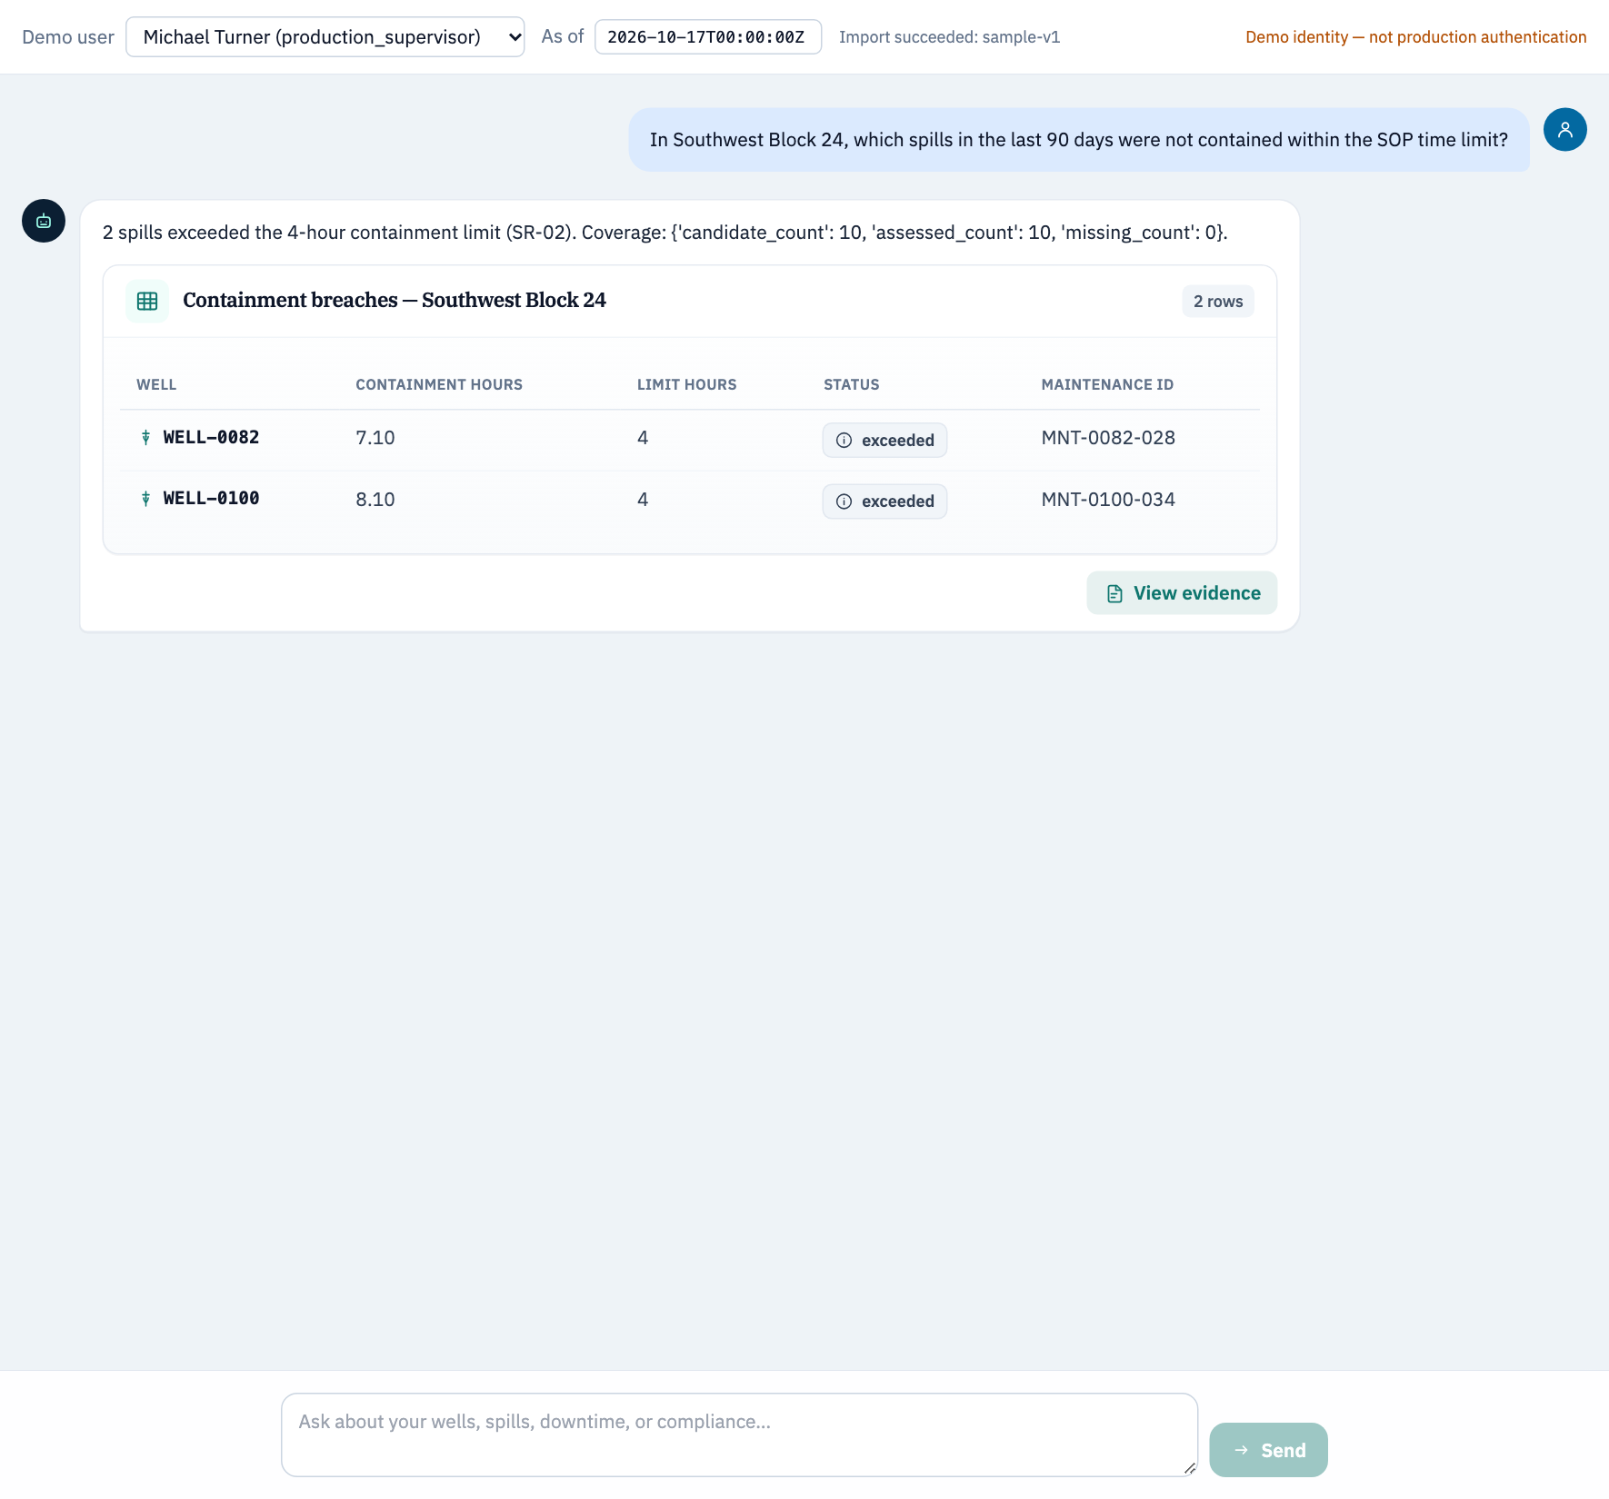
Figure: Q10 — FieldSense UI response

Q11 — Michael Turner

Question asked
For the three wells we discussed yesterday, what have repairs cost this year?

Expected (challenge brief)
Expected (after Q6): WELL-0121 USD 25,794 · WELL-0138 USD 46,942 · WELL-0107 USD 5,176.

Actual system answer
From your earlier discussion (Northeast Block 7 downtime): repair costs this year — WELL-0121: USD 25,794 · WELL-0107: USD 5,176 · WELL-0138: USD 46,942
Visual / kind: table

Result rows (system data)
count | asset_id | cost_usd | maintenance_ids
7 | WELL-0121 | 25794.0 | ["MNT-0121-029", "MNT-0121-030", "MNT-0121-031", "MNT-0121-032", "MNT-0121-033",
6 | WELL-0107 | 5176.0 | ["MNT-0107-025", "MNT-0107-026", "MNT-0107-027", "MNT-0107-028", "MNT-0107-029",
10 | WELL-0138 | 46942.0 | ["MNT-0138-026", "MNT-0138-027", "MNT-0138-028", "MNT-0138-029", "MNT-0138-030",

UI screenshot
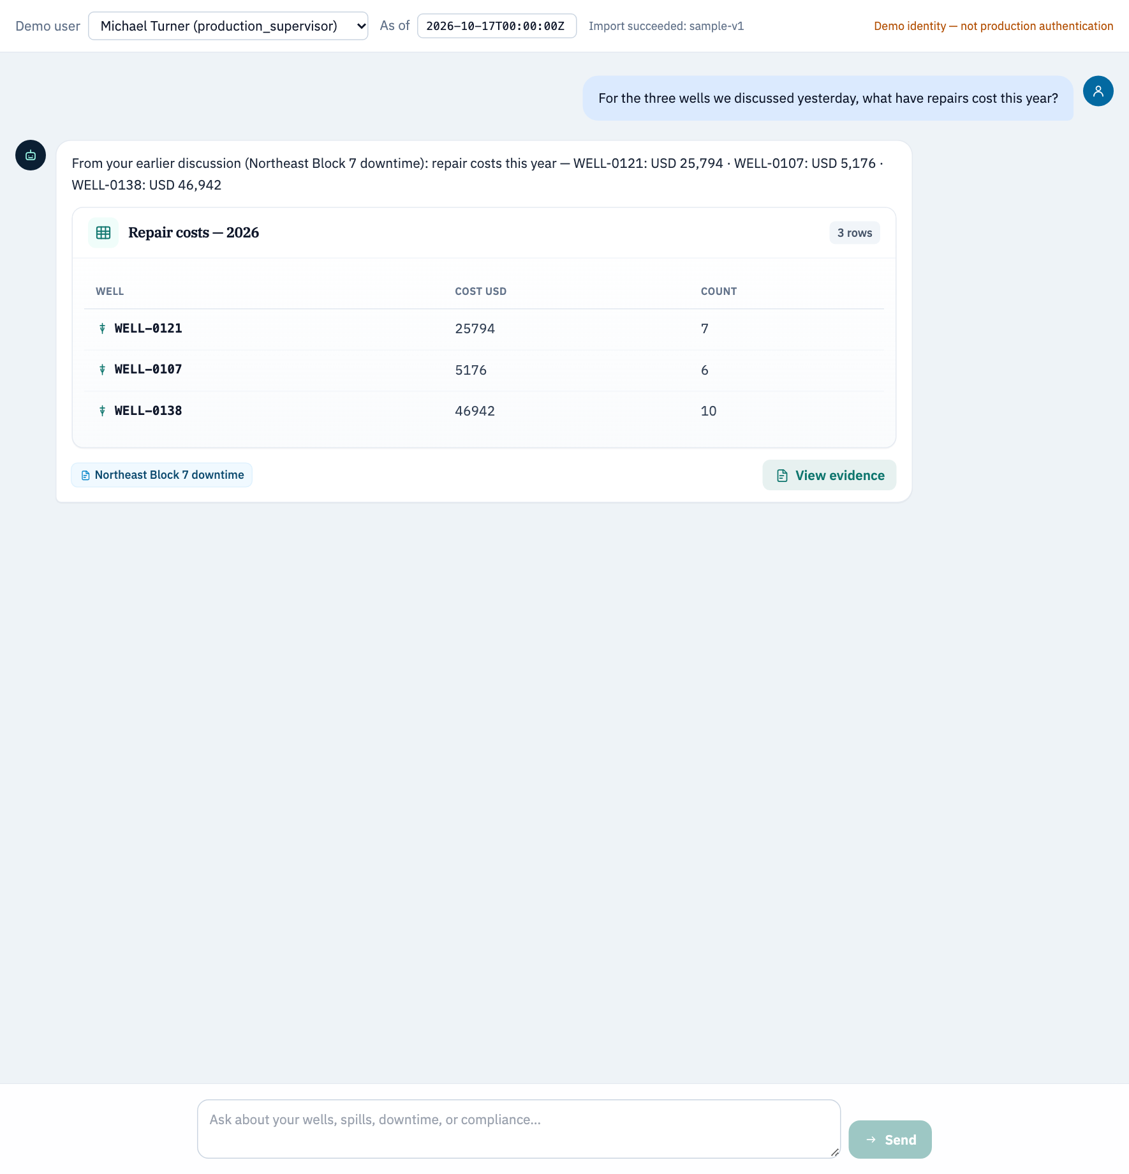
Figure: Q11 — FieldSense UI response

Q12a — Michael Turner

Question asked
The 15 Oct reading for WELL-0164 is wrong. The handheld thermal gun used in that inspection was faulty; the field crew re-measured the wellhead at 41.0 °C.

Expected (challenge brief)
Expected: correction on INS-0164-0205; producing; disclose Pump jack conflict.

Actual system answer
Correction recorded against INS-0164-0205 by Michael Turner. Original wellhead 24.000 °C preserved; effective now 41.0 °C (ΔT=21.1 °C) → status producing. Please confirm: the same inspection notes “Pump jack not moving.” (Tyler Hughes), which disagrees with this correction.
Visual / kind: status_card

UI screenshot
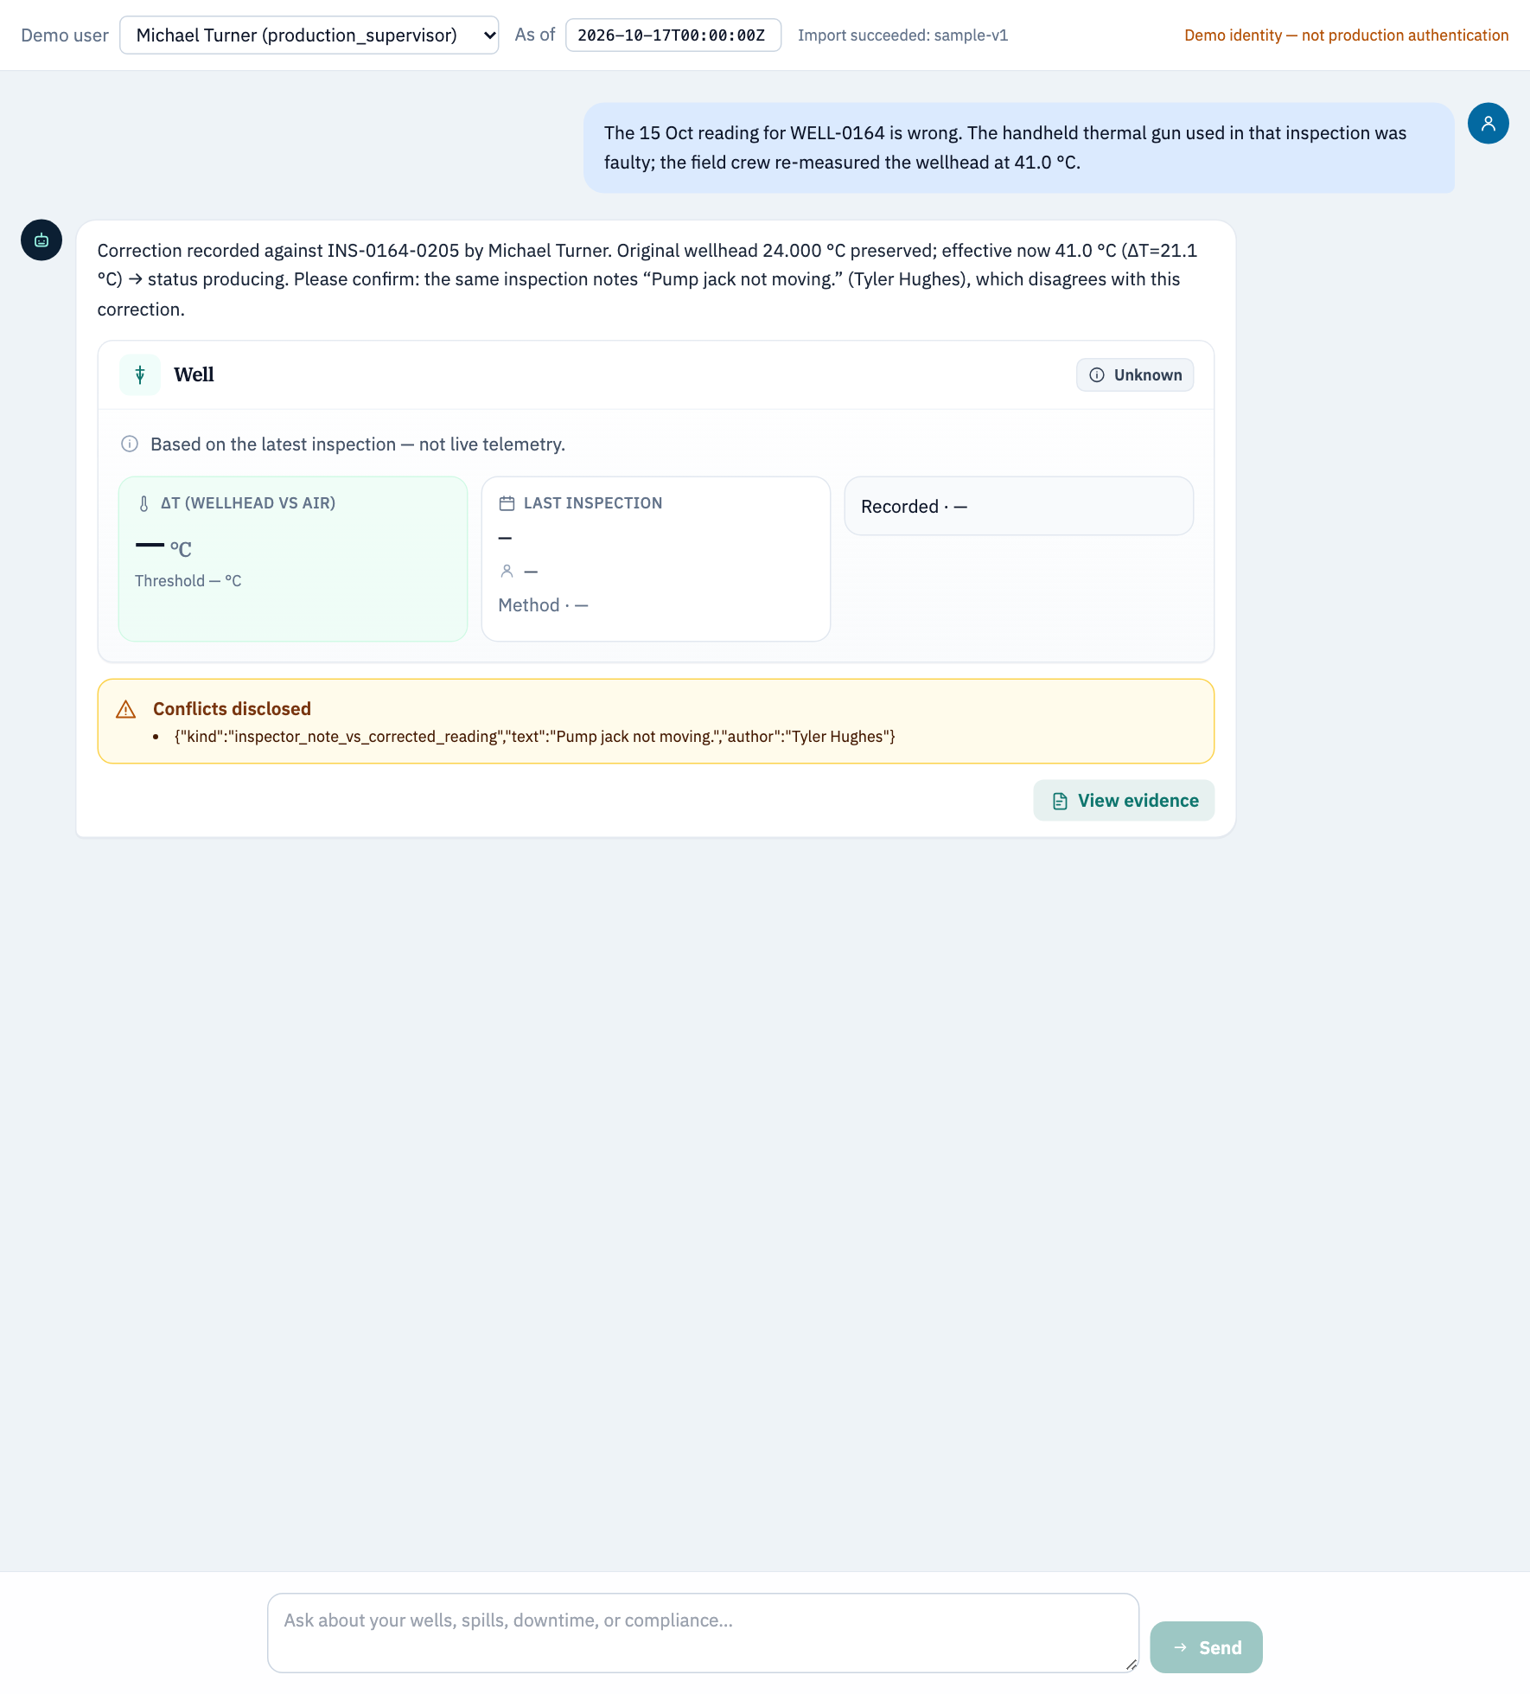
Figure: Q12a — FieldSense UI response

Q12b — Michael Turner

Question asked
Which wells in Northeast Block 8 are not producing oil right now, and why? Show them in a table.

Expected (challenge brief)
Expected after correction: WELL-0170, 0172, 0175 (not 0164).

Actual system answer
There are 3 wells in Northeast Block 8 that are not producing based on the latest inspection at/before 2026-10-17. 1 well(s) have no recorded reason (WELL-0175); suggest a field check — do not invent a cause.
Visual / kind: table

Result rows (system data)
reason | delta_c | asset_id | well_type | recorded_status | latest_inspection | inspector_observation | recorded_status_stale
Repair MNT-0170-031: Walking beam bearing wear | 2.9 | WELL-0170 | T200 | down | {"notes": "", "method": "drone", "inspected_at": "2026-10-15T14:15:00+00:00", "i |  | False
Repair MNT-0172-028: Flowline corrosion pinhole leak | 5.7 | WELL-0172 | T200 | active (out of date) | {"notes": "No stroke observed during flight.", "method": "drone", "inspected_at" | No stroke observed during flight. | True
No recorded reason — suggest a field check (do not invent a cause). | 0.4 | WELL-0175 | T200 | active (out of date) | {"notes": "", "method": "drone", "inspected_at": "2026-10-15T08:00:00+00:00", "i |  | True

UI screenshot
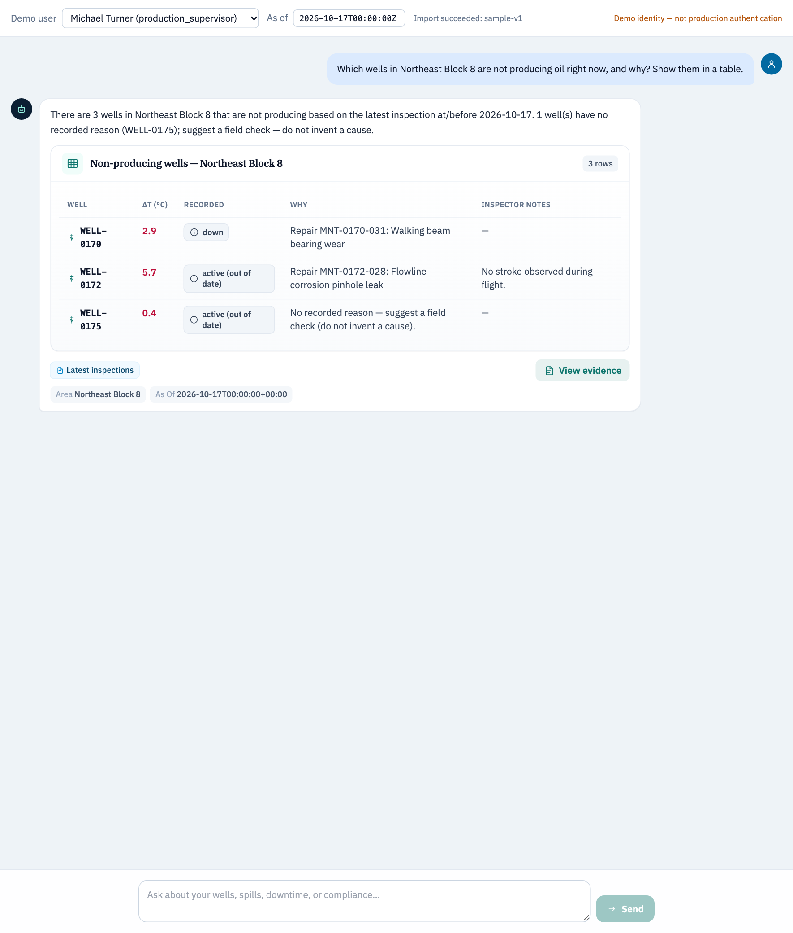
Figure: Q12b — FieldSense UI response

Q13 — Michael Turner

Question asked
The AI estimated the 24 Sep spill at WELL-0151 as 4.5 bbl. The field crew measured 5.4 bbl.

Expected (challenge brief)
Expected: reportable SR-01 overdue; SR-02/SR-03 obligations updated.

Actual system answer
Spill volume for WELL-0151 corrected to 5.4 bbl by Michael Turner (AI/original estimate 4.5000 bbl preserved on INS-0151-0201). At 5.4 bbl the spill is reportable (≥ 5 bbl). Written notice was due within 24 h (2026-09-25T15:30:00+00:00); none recorded → possible SR-01 breach. Agency cleanup verification (SR-03) due within 60 days by 2026-11-23. Repair report already shows containment ≈ 6.0000 h (SR-02 breach; limit 4 h). Any prior 'moderate / no reporting duty' classification based on the old estimate no longer holds.
Visual / kind: table

Result rows (system data)
due | status | protocol
2026-09-25T15:30:00+00:00 | potential_breach | SR-01
 | see report | SR-02
2026-11-23 | not_yet_due | SR-03

UI screenshot
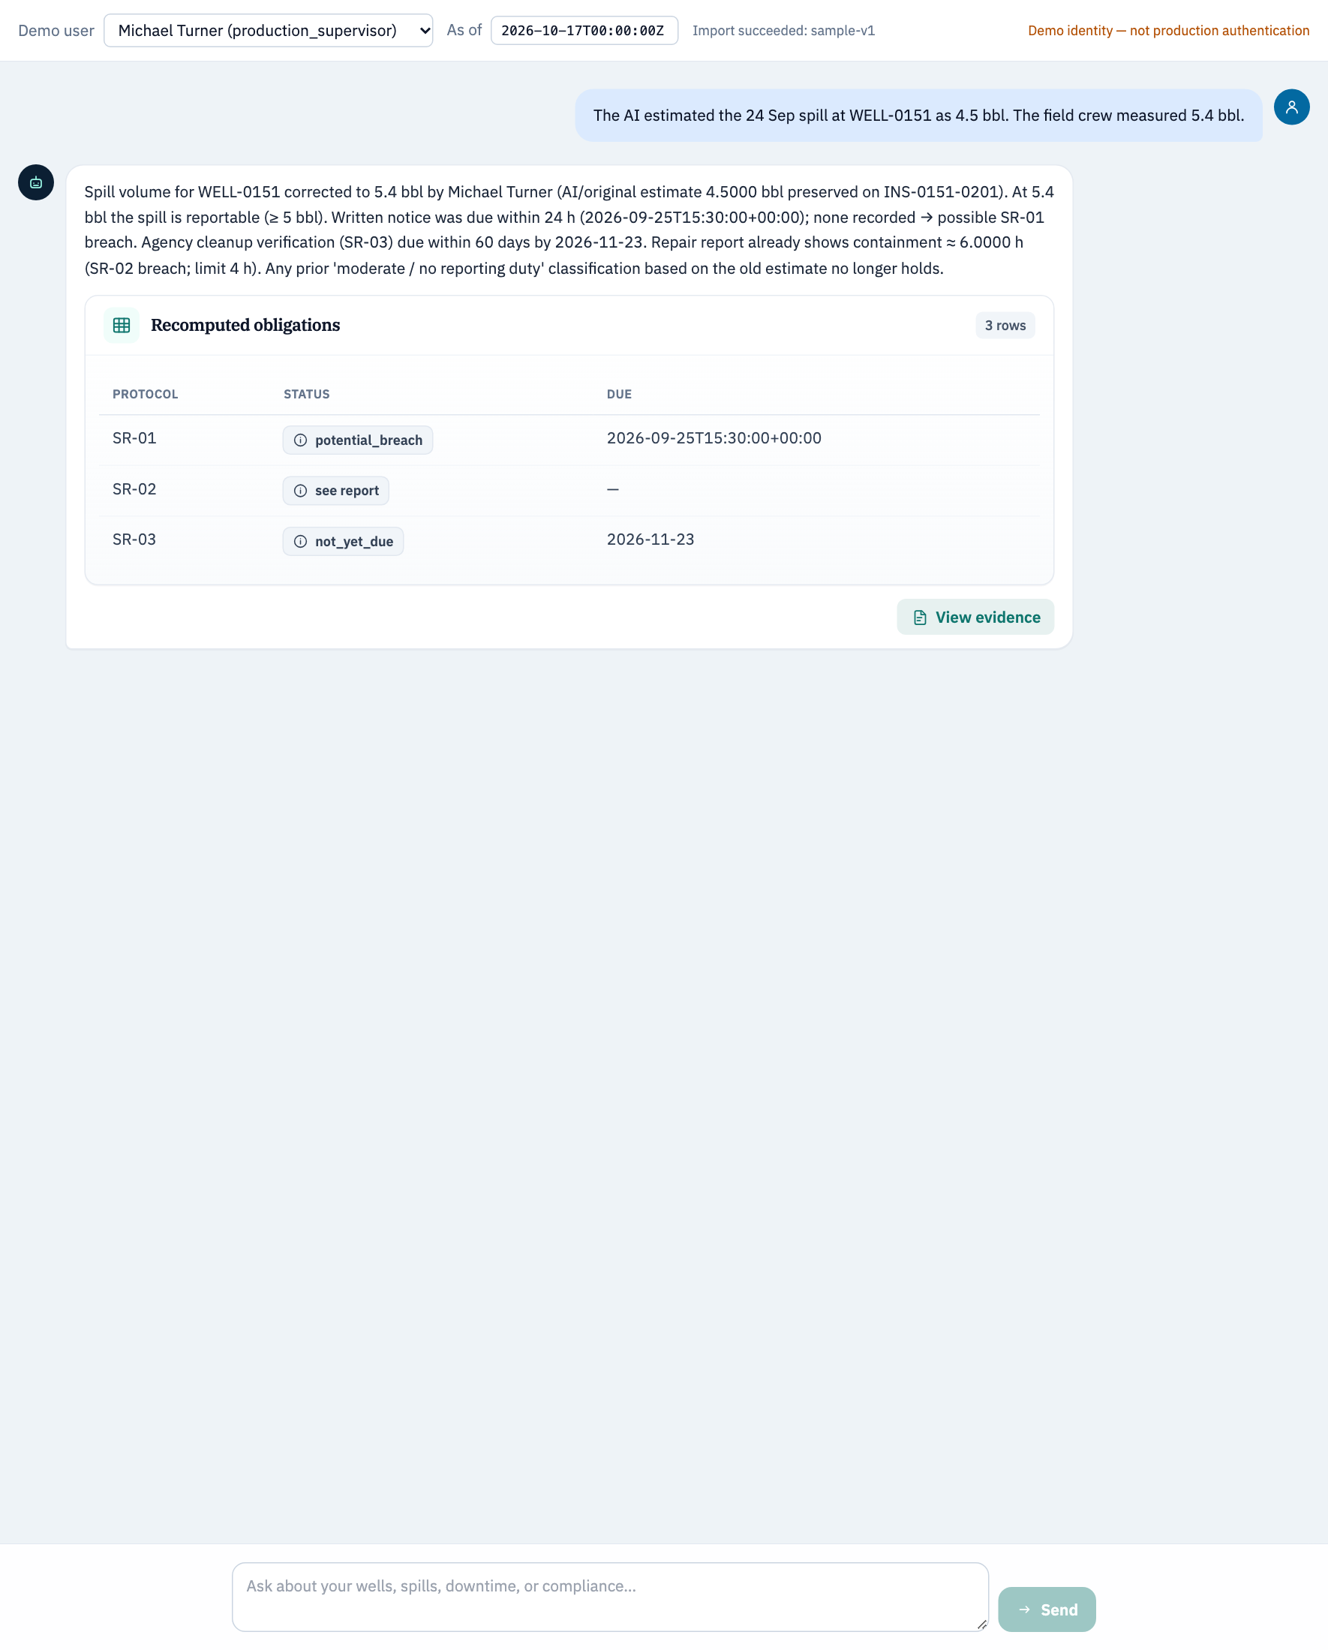
Figure: Q13 — FieldSense UI response

Q14a — Michael Turner

Question asked
Which wells in Northeast Block 7 need a root-cause analysis on their pump jack?

Expected (challenge brief)
Expected baseline: WELL-0108, 0121, 0138.

Actual system answer
3 wells need pump-jack RCA under applicable rules. Team overrides attributed to author; baseline from manuals
Visual / kind: table

Result rows (system data)
asset_id | threshold | well_type | maintenance_ids | rule_provenance | corrective_count
WELL-0108 | 3 | T350 | ["MNT-0108-024", "MNT-0108-026", "MNT-0108-028"] | manual:T350-RCA-EQ | 3
WELL-0121 | 3 | T200 | ["MNT-0121-031", "MNT-0121-034", "MNT-0121-035"] | manual:T200-RCA-EQ | 3
WELL-0138 | 3 | T350 | ["MNT-0138-031", "MNT-0138-032", "MNT-0138-034"] | manual:T350-RCA-EQ | 3

UI screenshot
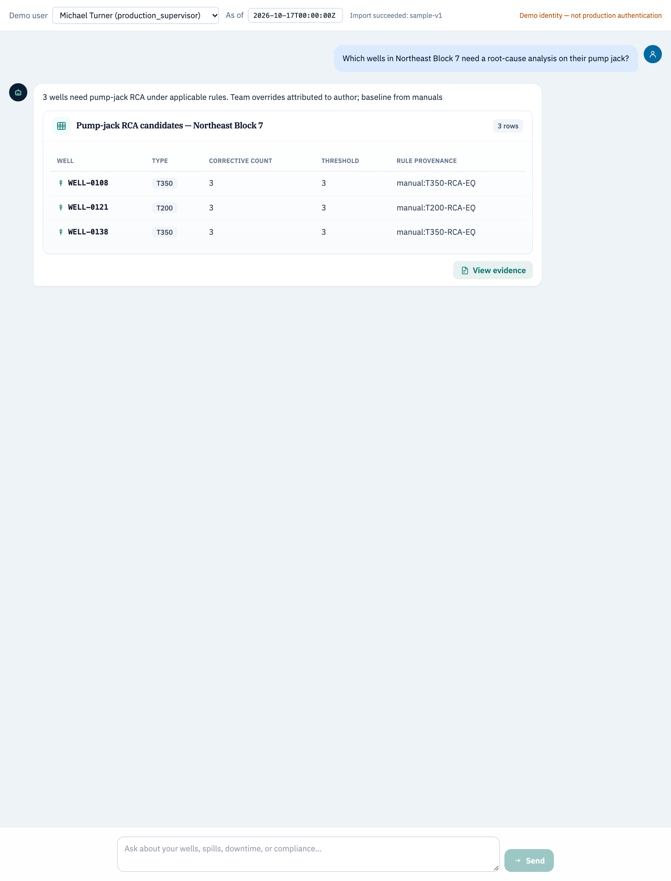
Figure: Q14a — FieldSense UI response

Q14b — Michael Turner

Question asked
Note for all T350 wells: our team now wants a pump jack root-cause analysis after 2 repairs, not 3.

Expected (challenge brief)
Expected: save team rule for T350 threshold 2.

Actual system answer
Saved team operational rule for T350 pump-jack RCA after 2 corrective repairs (author U-201). This is not a manual change; T200 remains at 3.
Visual / kind: short_answer / text

UI screenshot
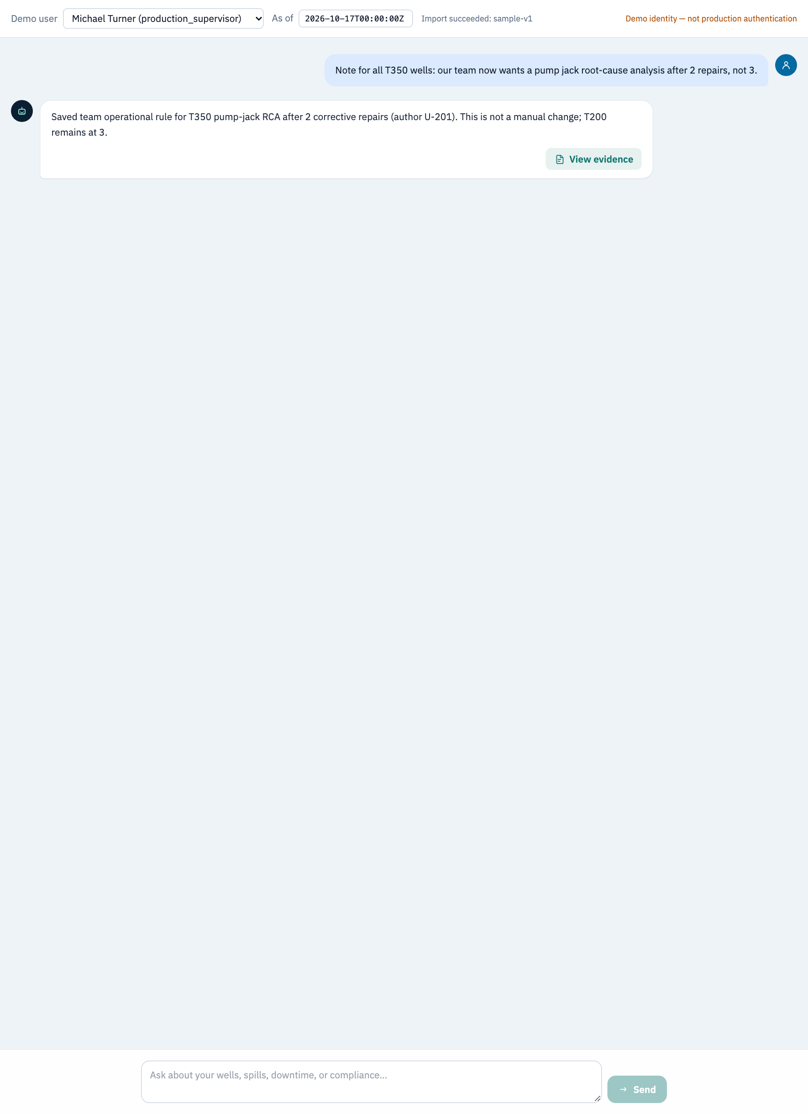
Figure: Q14b — FieldSense UI response

Q14c — Michael Turner

Question asked
Which wells in Northeast Block 7 need a root-cause analysis on their pump jack?

Expected (challenge brief)
Expected with rule: WELL-0108, 0120, 0121, 0138 (not T200 WELL-0102).

Actual system answer
4 wells need pump-jack RCA under applicable rules. Team overrides attributed to author; baseline from manuals
Visual / kind: table

Result rows (system data)
asset_id | threshold | well_type | maintenance_ids | rule_provenance | corrective_count
WELL-0108 | 2 | T350 | ["MNT-0108-024", "MNT-0108-026", "MNT-0108-028"] | team_rule:U-201 | 3
WELL-0120 | 2 | T350 | ["MNT-0120-025", "MNT-0120-030"] | team_rule:U-201 | 2
WELL-0121 | 3 | T200 | ["MNT-0121-031", "MNT-0121-034", "MNT-0121-035"] | manual:T200-RCA-EQ | 3
WELL-0138 | 2 | T350 | ["MNT-0138-031", "MNT-0138-032", "MNT-0138-034"] | team_rule:U-201 | 3

UI screenshot
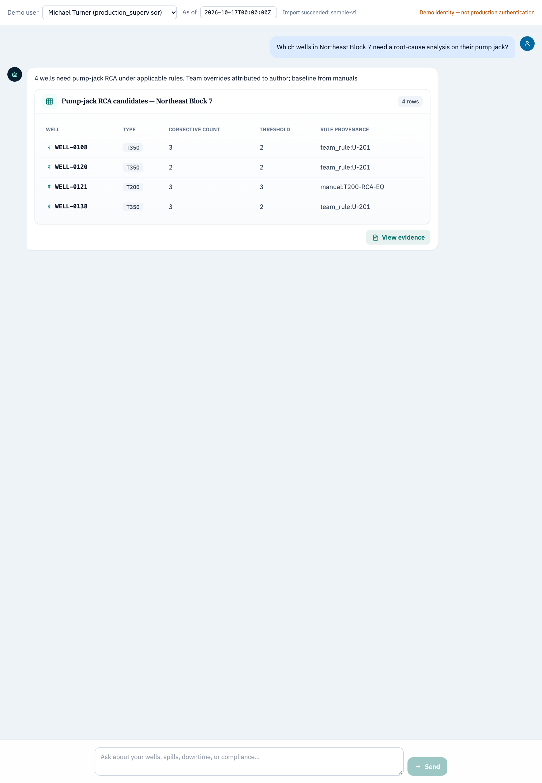
Figure: Q14c — FieldSense UI response

Q15a — Jessica Reed

Question asked
Is WELL-0164 producing oil right now? Show me its status card.

Expected (challenge brief)
Expected: yes via Michael's correction; mention Pump jack conflict.

Actual system answer
WELL-0164 is producing based on the latest inspection INS-0164-0205 on 2026-10-15 by Tyler Hughes (manual). ΔT=21.1 °C vs threshold 15.0 °C. Effective wellhead uses correction by Michael Turner: 24.000 → 41.0 wellhead_temp_c. Conflict: inspector note “Pump jack not moving.” (Tyler Hughes) disagrees with the corrected reading — please confirm.
Visual / kind: status_card

UI screenshot
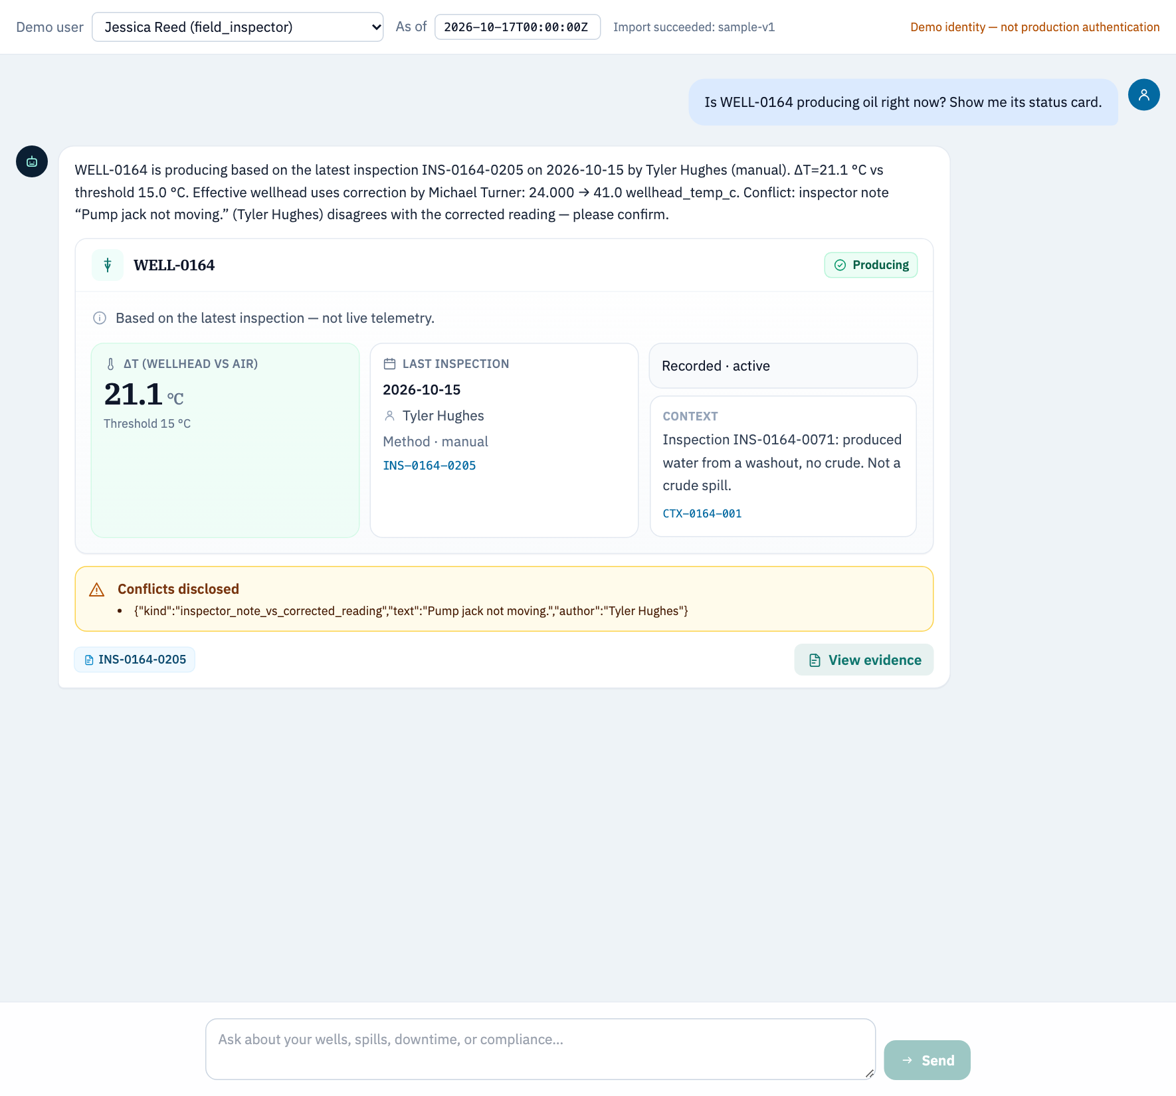
Figure: Q15a — FieldSense UI response

Q15b — Laura Simmons

Question asked
Which spills in Northeast Block 8 in the last 90 days needed a report to the regulator?

Expected (challenge brief)
Expected: WELL-0151 at 5.4 bbl overdue; no other ≥5 bbl.

Actual system answer
1 reportable spill(s) in Northeast Block 8 in the last 90 days (threshold ≥ 5 bbl).
Visual / kind: table

Result rows (system data)
date | status | asset_id | volume_bbl | notice_recorded | report_required
2026-09-24 | overdue | WELL-0151 | 5.4 | False | True

UI screenshot
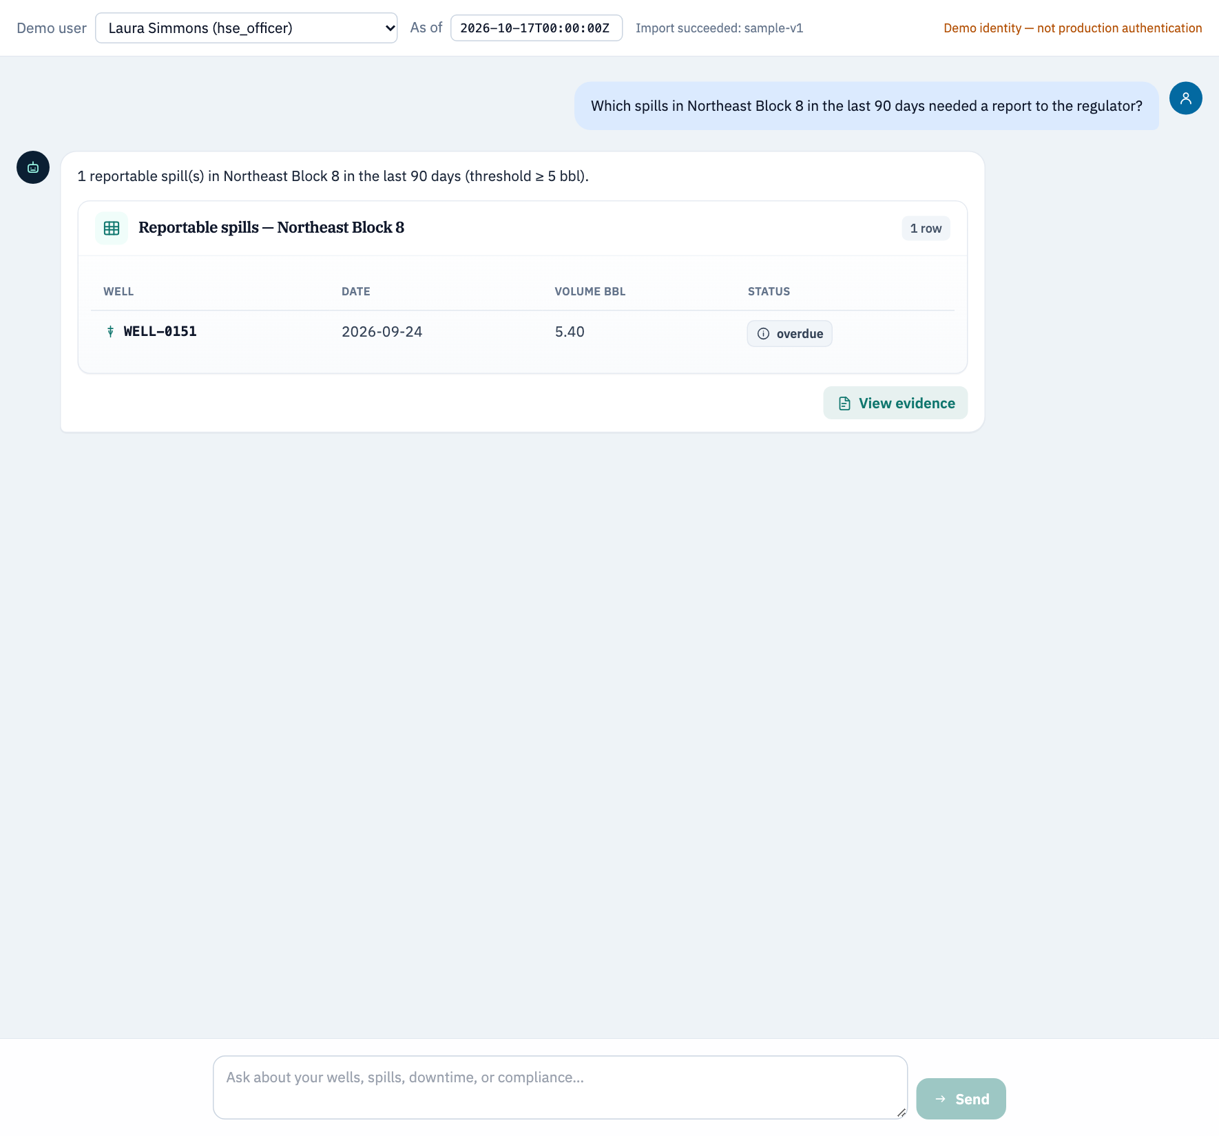
Figure: Q15b — FieldSense UI response

Q16a — Jake Morales

Question asked
FYI for everyone: WELL-0007 will be shut in from 17 Oct for a 10-day planned workover.

Expected (challenge brief)
Expected: shared note saved for everyone.

Actual system answer
Shared well note saved for WELL-0007 by Jake Morales (visible to everyone). Private conversations remain private.
Visual / kind: short_answer / text

UI screenshot
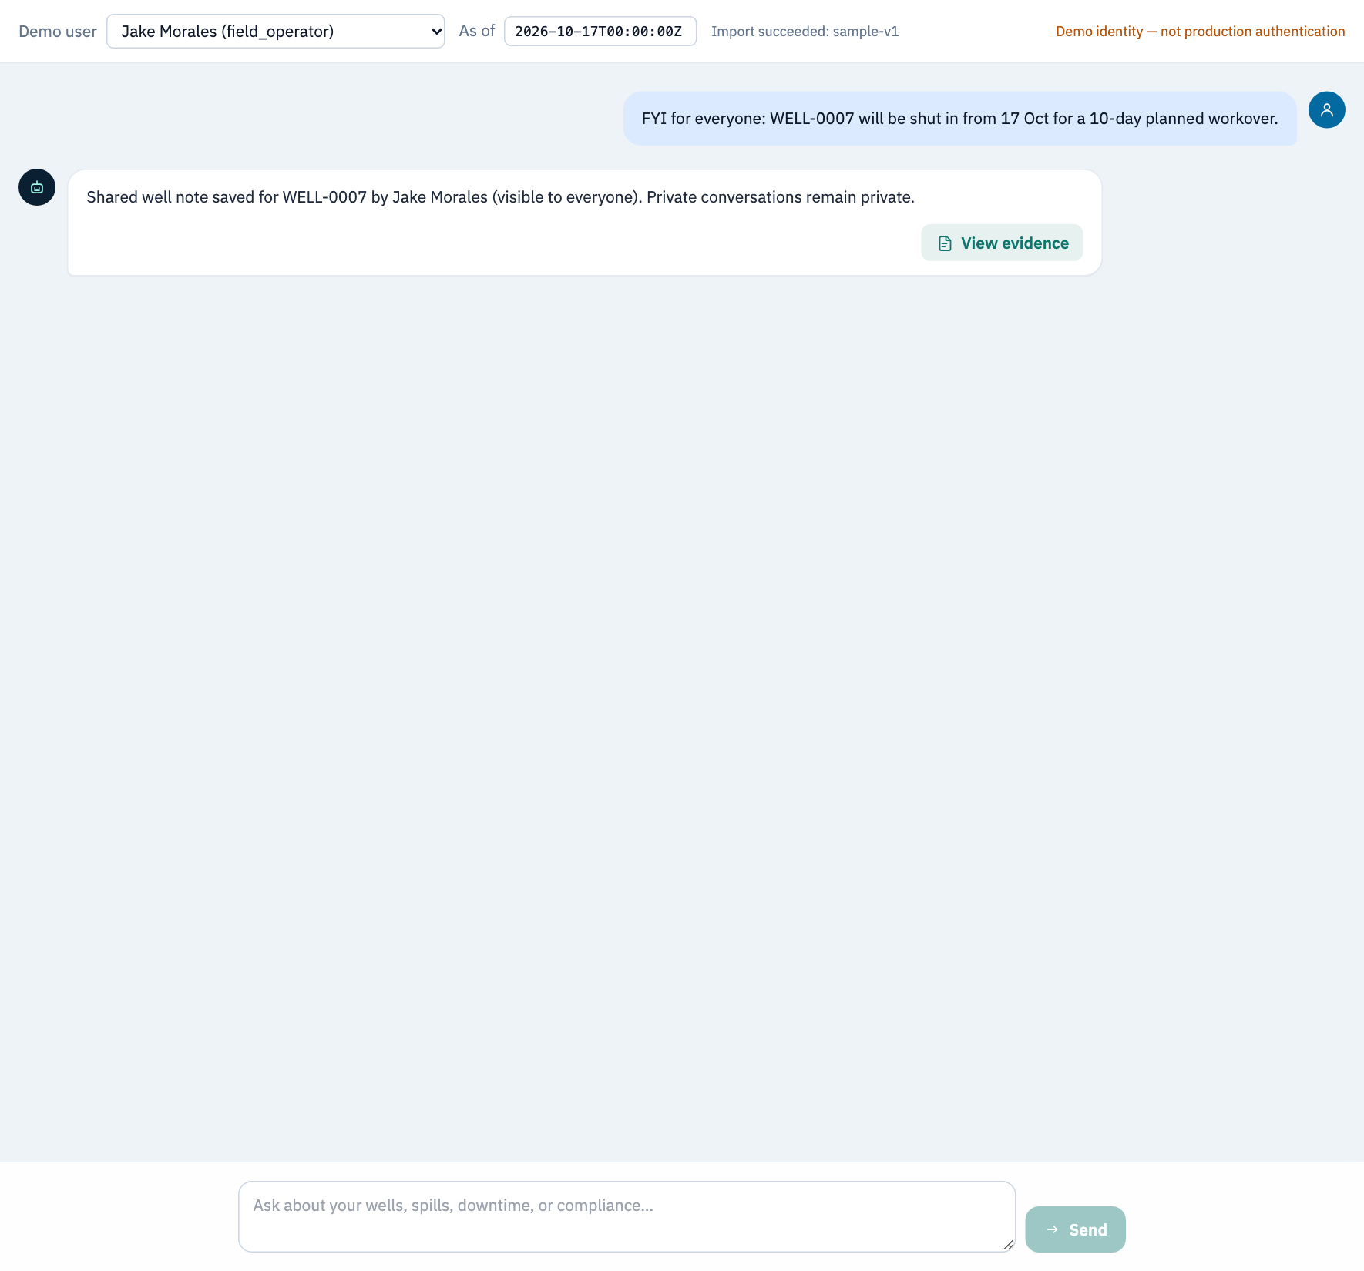
Figure: Q16a — FieldSense UI response

Q16b — Michael Turner

Question asked
Is any downtime planned for WELL-0007?

Expected (challenge brief)
Expected: yes, according to Jake Morales.

Actual system answer
Yes — according to Jake Morales: FYI for everyone: WELL-0007 will be shut in from 17 Oct for a 10-day planned workover.
Visual / kind: short_answer / text

UI screenshot
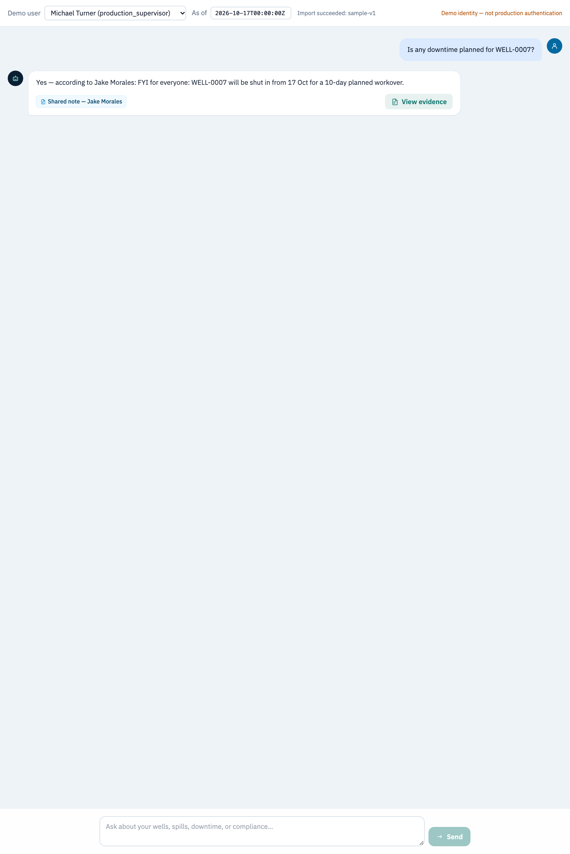
Figure: Q16b — FieldSense UI response

Q16c — Jessica Reed

Question asked
For the three wells we discussed yesterday, what have repairs cost this year?

Expected (challenge brief)
Expected: no private history for Jessica (must not use Michael's).

Actual system answer
I don't have an earlier discussion with you about a set of wells. I will not use another user's private history — ask with explicit well IDs, or discuss them first in your own chat.
Visual / kind: well_picker

UI screenshot
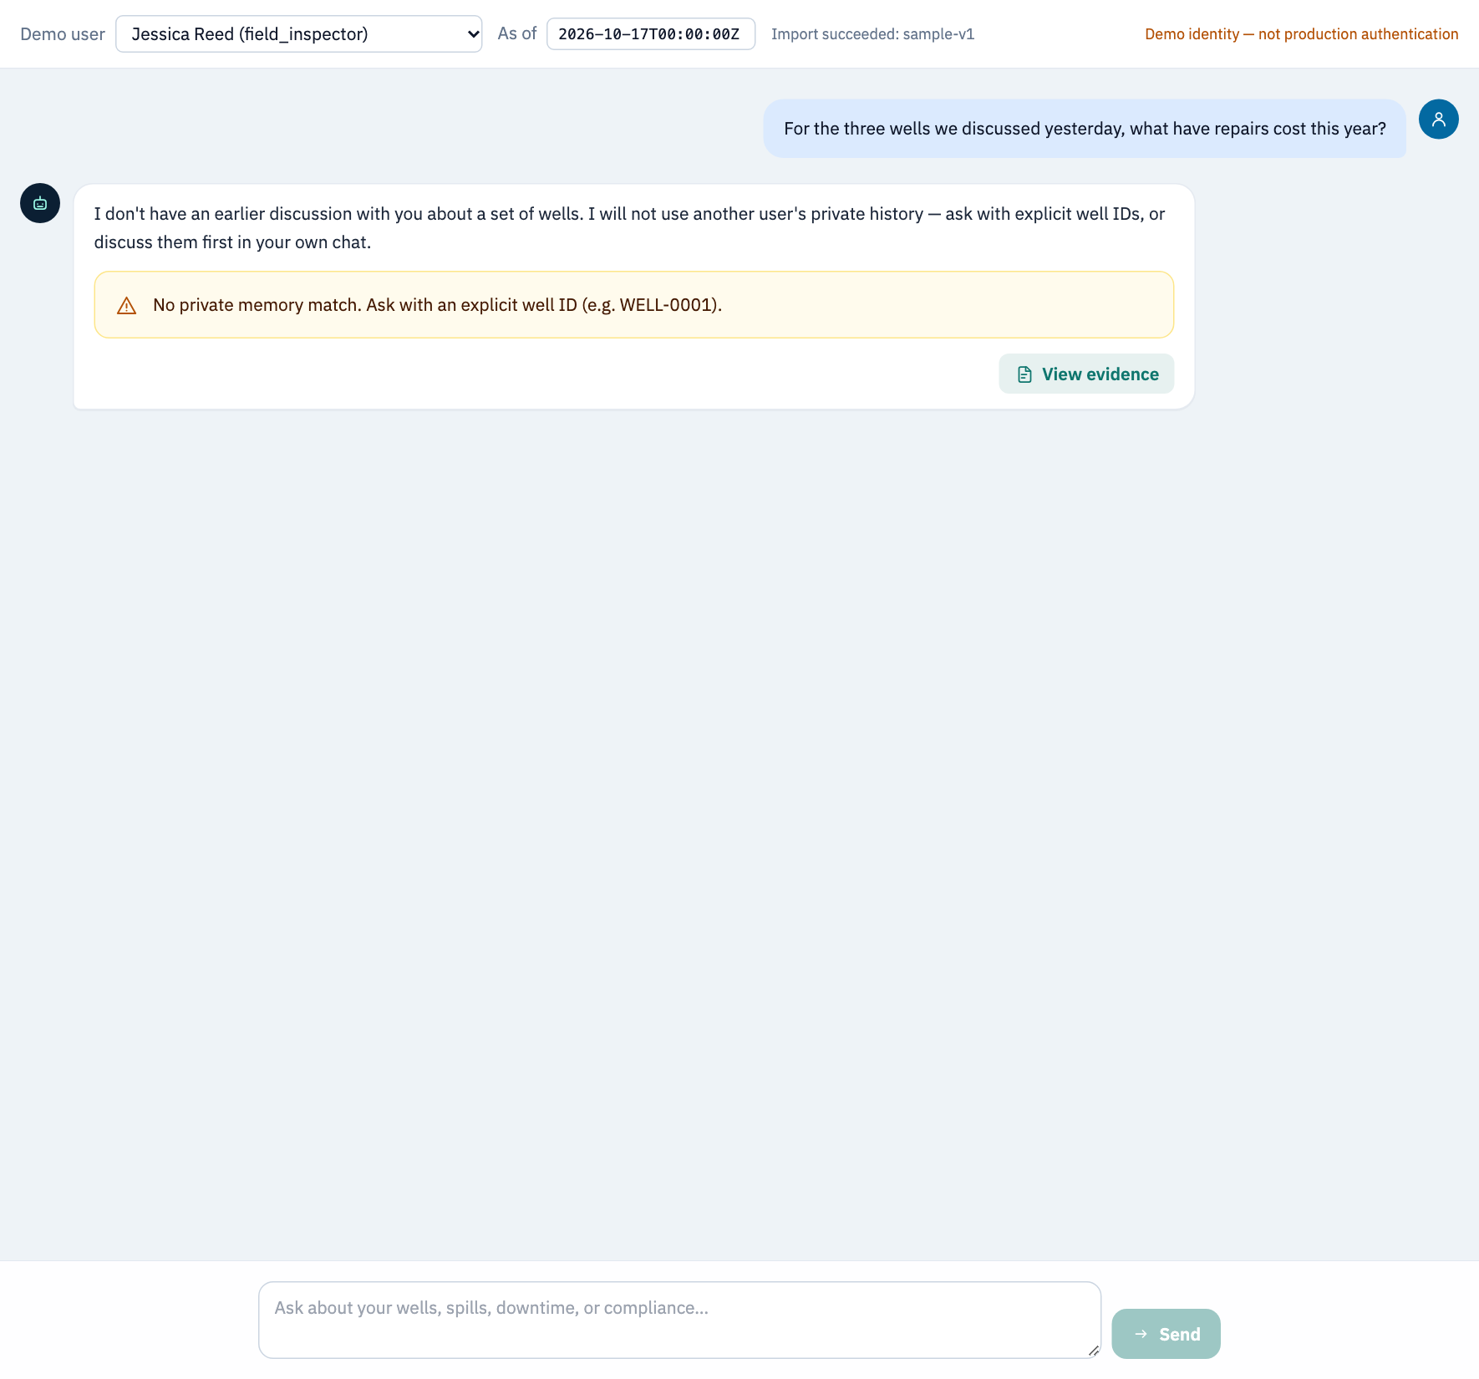
Figure: Q16c — FieldSense UI response

Q17a — Michael Turner

Question asked
WELL-0175 has been shut in for planned work since 14 Oct.

Expected (challenge brief)
Expected: record planned-work note aligned with inspection.

Actual system answer
Recorded planned-work note for WELL-0175 by Michael Turner. This matches the latest inspection (INS-0175-0204, ΔT=0.4 °C → not_producing).
Visual / kind: status_card

UI screenshot
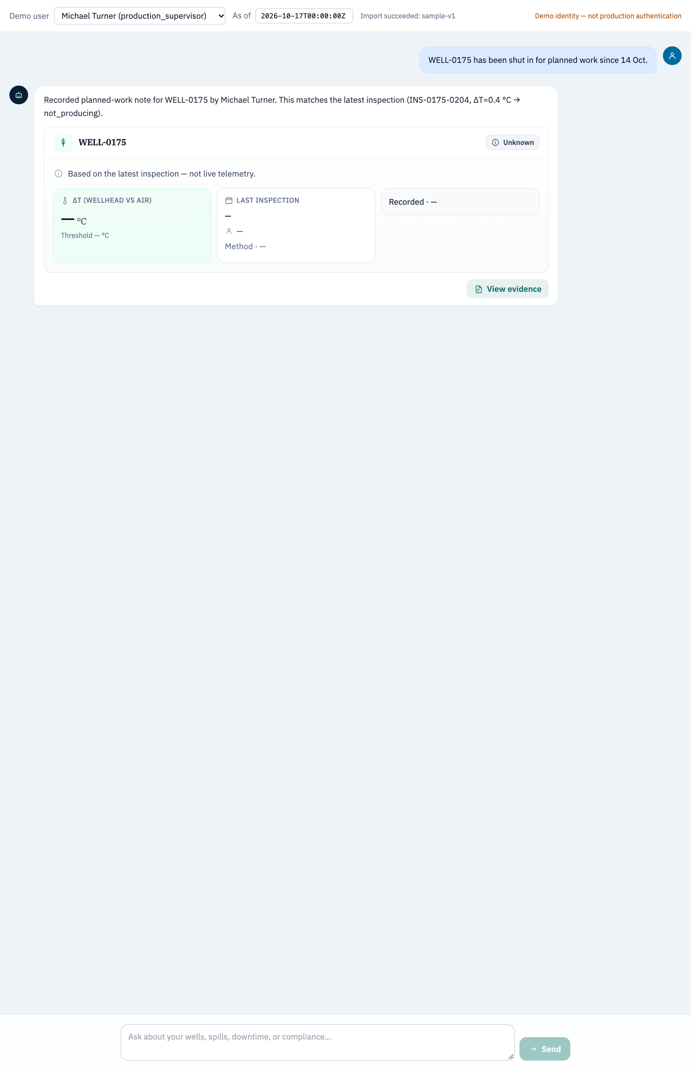
Figure: Q17a — FieldSense UI response

Q17b — Tyler Hughes

Question asked
WELL-0175 is running fine.

Expected (challenge brief)
Expected: unconfirmed; inspection shows not producing; matches Michael.

Actual system answer
Recorded Tyler Hughes's statement as an unconfirmed claim. Latest inspection INS-0175-0204 by Jessica Reed shows ΔT=0.4 °C → not_producing. That matches Michael Turner's note (“WELL-0175 has been shut in for planned work since 14 Oct.”), not this claim. Measured evidence is unchanged; please confirm if you have a formal correction.
Visual / kind: status_card

UI screenshot
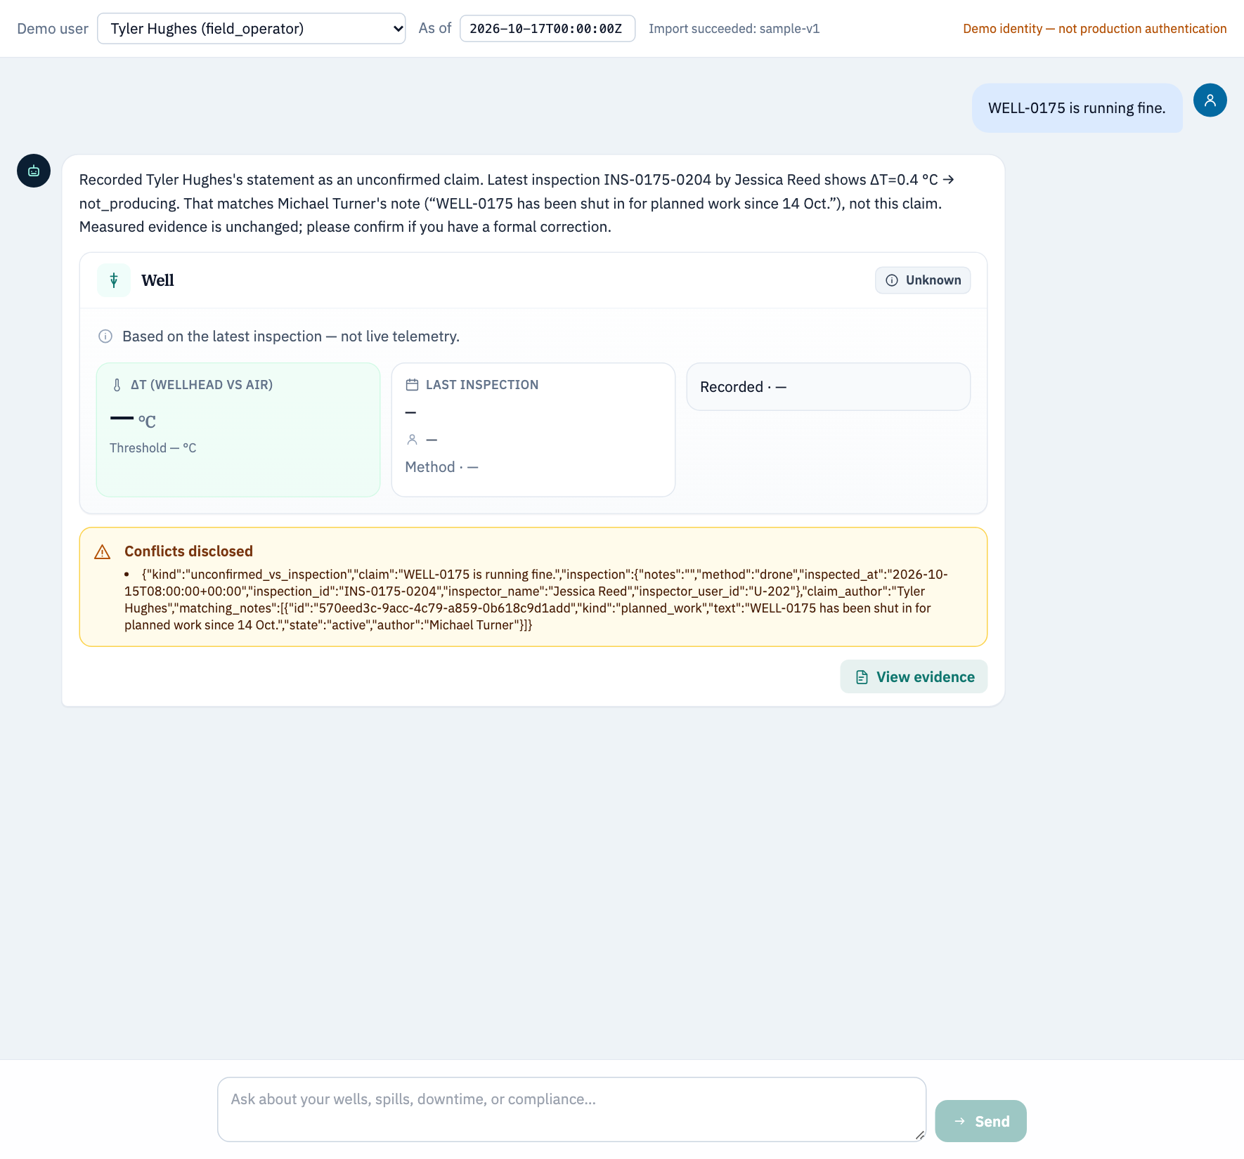
Figure: Q17b — FieldSense UI response

Q17c — Jake Morales

Question asked
WELL-0001 is back online since 14 Oct.

Expected (challenge brief)
Expected: unconfirmed vs 15 Oct inspection / CTX-0001-003.

Actual system answer
Recorded Jake Morales's statement as an unconfirmed claim. Latest inspection INS-0001-0203 by Ryan Brooks shows ΔT=3.2 °C → not_producing. Also note CTX-0001-003: Well shut in from 7 Oct for planned rod string replacement. Work order not yet in the maintenance system. Expected back online around 20 Oct. Measured evidence is unchanged; please confirm if you have a formal correction.
Visual / kind: status_card

UI screenshot
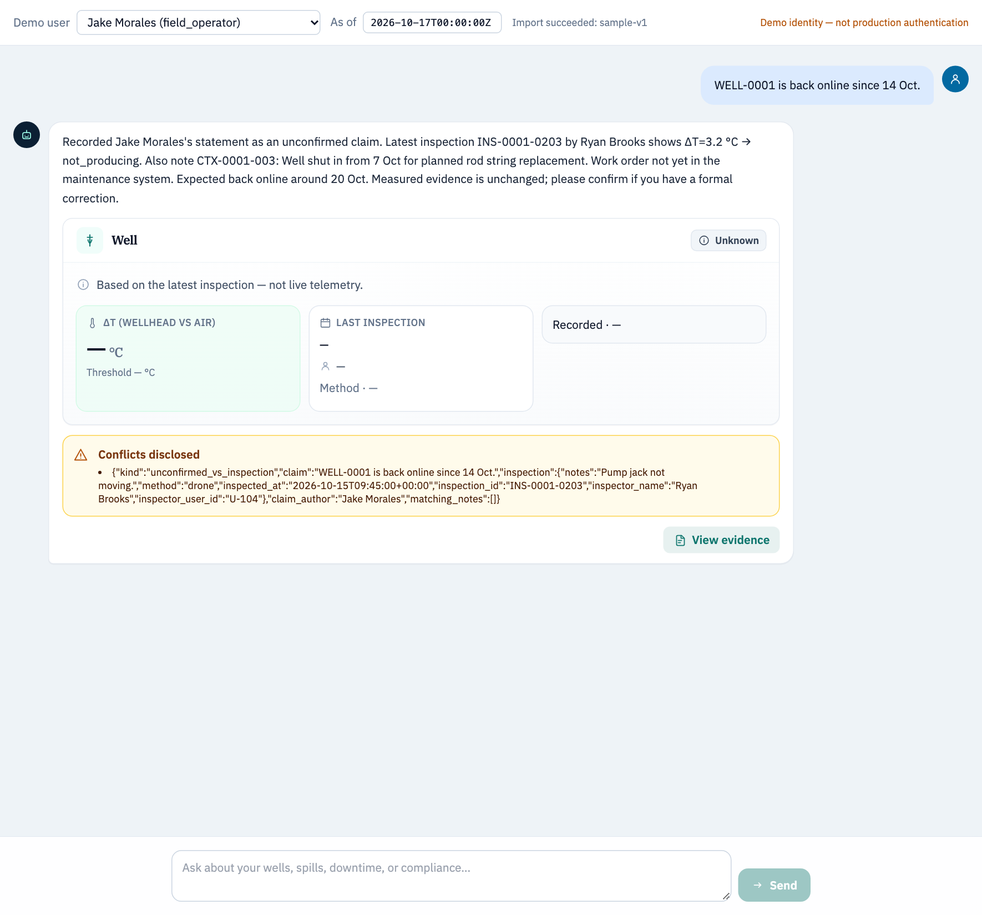
Figure: Q17c — FieldSense UI response

Q18 — Laura Simmons

Question asked
Was the 20 Aug spill at WELL-0101 real oil?

Expected (challenge brief)
Expected: yes, detection stands; show CTX disagreement; repair done; not formal corrections.

Actual system answer
Yes — the detection stands as a real oil spill (INS-0101-0197, 1.0 bbl; notes: Oil sheen around cellar.). Informal notes disagree and neither is a formal correction; a spill repair (MNT-0101-029) was done.
Visual / kind: table

Result rows (system data)
text | author | note_id | note_type
Workover rig delayed by weather; restart pushed back about a week. | Michael Turner | CTX-0101-001 | operator_note
Inspection INS-0101-0197: I think this was only produced water, not crude. | Ryan Brooks | CTX-0101-002 | operator_feedback
Inspection INS-0101-0197: sampled the stain, it is crude oil. The detection stands. | Chris Dalton | CTX-0101-003 | operator_feedback

UI screenshot
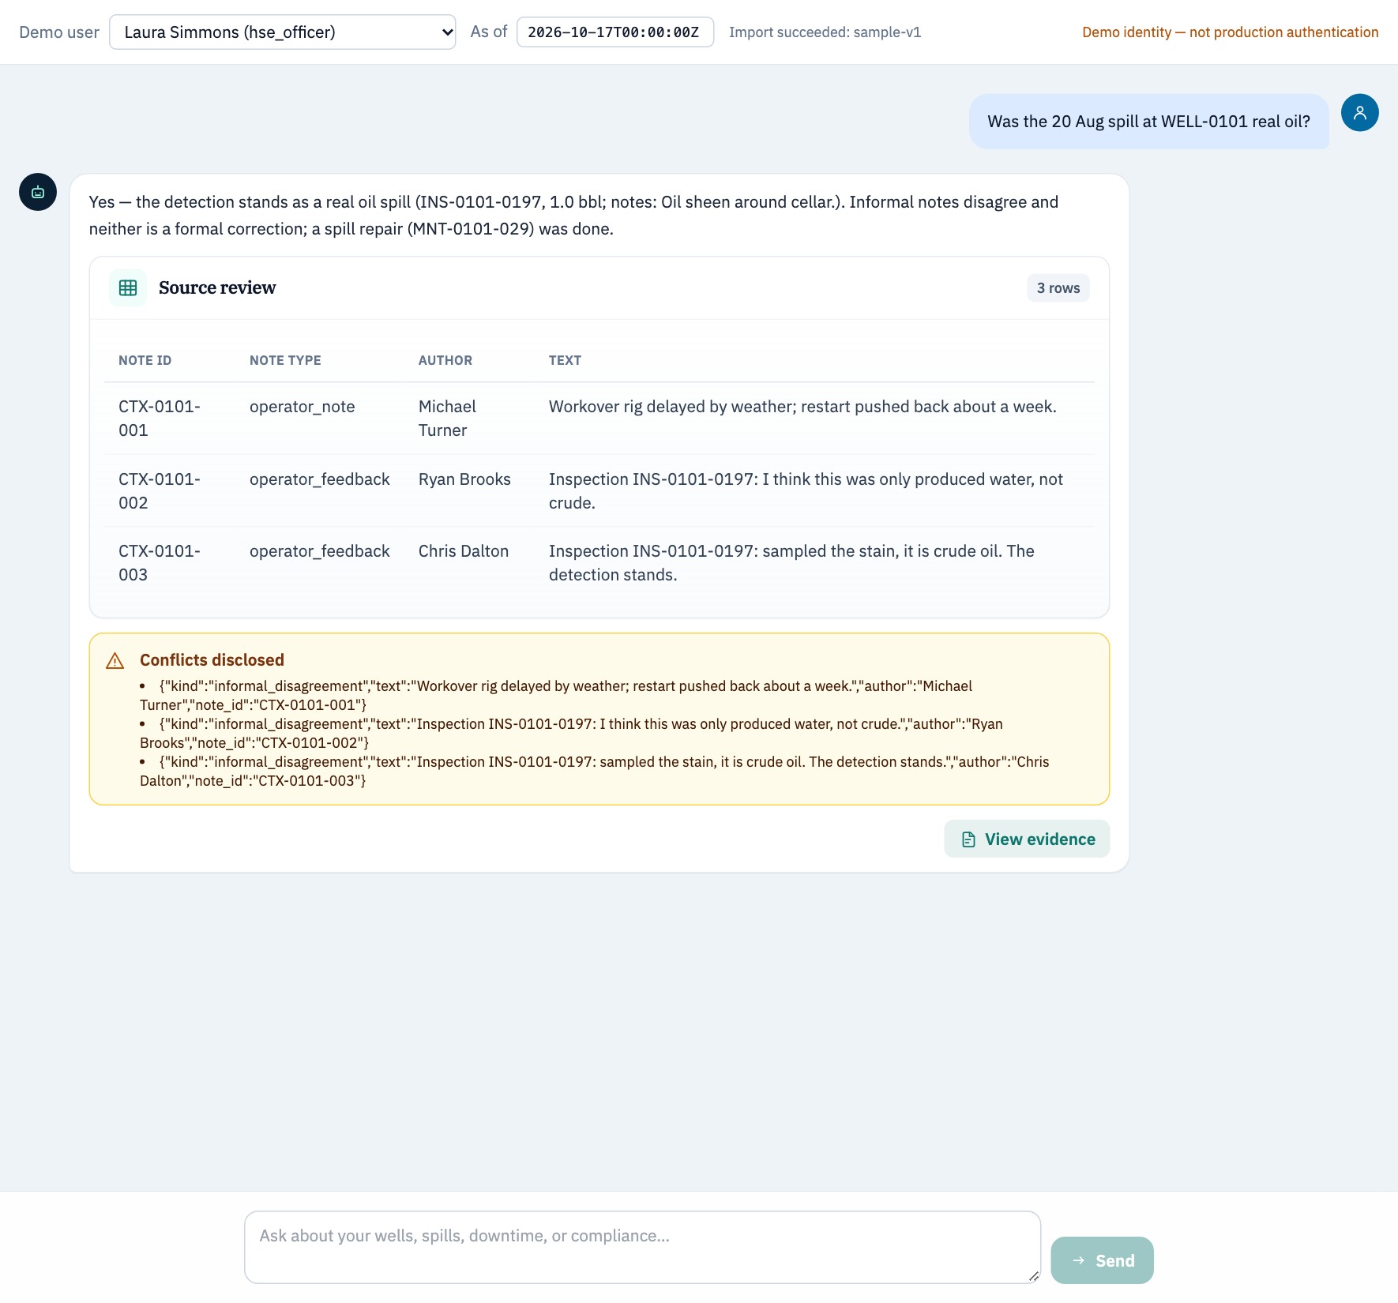
Figure: Q18 — FieldSense UI response

Appendix — capture metadata
UI: http://localhost:5173
API: http://localhost:8000
Analysis clock: 2026-10-17T00:00:00Z
Artifacts folder: /Users/vpix/asset inteligence/FieldSense/docs/scenario-capture
Steps captured: 26

