FieldSense — System Design Write-up
Asset Intelligence Copilot · Page 1 of 2 · Architecture & operating model
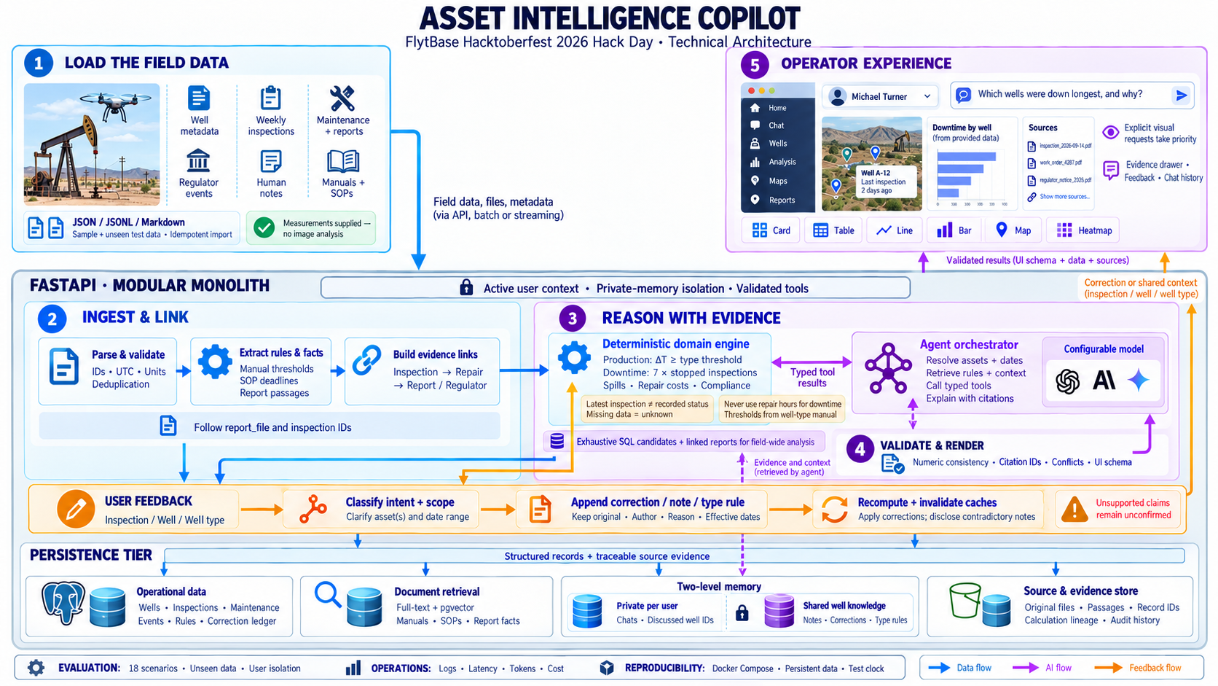
Figure 1. FieldSense modular monolith — store → retrieve → tools → answer envelope.
1. How data is stored, indexed, and retrieved
FieldSense is a modular monolith: React/Vite UI, FastAPI API, background worker, and PostgreSQL 16 with pgvector. Challenge sample files mount read-only; an idempotent ingestion CLI loads wells, areas, weekly inspections, maintenance/repairs, regulatory events, source notes, manuals/SOPs, and extracted report facts into normalized tables. Content hashes keep re-imports safe. Well counts and area names are discovered at import — not hardcoded.
- Store: relational tables for assets/events; corrections, assertions, and rule overrides as append-only knowledge; result sets + evidence items per answer.
- Index / retrieve: primary path is typed SQL and deterministic domain services keyed by asset_id, area, and as-of time. Lexical full-text search is the always-on document fallback; embeddings/pgvector are optional. Evaluation answer sheets are never indexed.
- Clock: analysis uses a controllable as-of (default 2026-10-17T00:00:00Z). “Right now” = latest inspection at/before that clock.
2. Tools the copilot uses
A single orchestrator routes each question (deterministic intent router; optional OpenAI-compatible LLM for planning/explanation when configured). Typed tools include:
- Analytics: well status/ΔT, area non-producing tables, temperature series, downtime rankings, spill history/map/heatmap, repair costs.
- Compliance: SOP breach assessment (SR-01/02/03, RC-04, RC-02), containment-hour facts from repair reports, pump-jack RCA thresholds from manuals + team overrides.
- Feedback: measurement/detection corrections (preview → apply), shared notes, unconfirmed claims, well-type rule overrides.
- UI schema tools: status card, table, bar/line chart, map, heatmap — bound to server result rows so visuals cannot invent numbers.
3. Combining numbers, documents, and notes
Numbers always come from deterministic code over an effective-inspection layer: production status from wellhead−air ΔT vs T200 (15 °C) / T350 (20 °C) manual thresholds; downtime = 7 × non-producing weekly inspections in the window; spill volumes and exclusions from detections ± formal corrections/notes. Manuals and SOPs seed domain rules (reporting windows, containment limits, RCA counts). Free-text repair reports contribute extracted facts (e.g. containment hours) with coverage when missing. Human notes explain context and conflicts but never silently override measurements. Every factual answer carries citations and resolvable evidence IDs (INS-…, MNT-…, CTX-…, REG-…).
4. Two memory levels
- Private memory: conversations and ConversationReference (discussed well sets) are scoped by demo user id in the backend before retrieval. “Wells we discussed yesterday” only sees that user’s multi-well history — never another operator’s chat.
- Shared knowledge: formal corrections, FYI/planned-work assertions, and well-type rule overrides are visible to everyone and immediately affect analytics via the effective layer.
5. Conflicts and new data
Conflicts are disclosed, not resolved quietly: inspector notes vs corrected readings, unconfirmed “running fine / back online” claims vs latest ΔT, and informal disagreeing notes on a spill (Q18) keep the detection if no formal correction exists. Corrections preserve originals, record author/reason, and supersede prior actives on the same field. New dataset versions import idempotently alongside existing chats/corrections; quarantine paths avoid silent row drops.
6. Models used and cost
Hack Day path: no paid LLM required. The deterministic router answers Q1–Q18 analytical and memory scenarios offline (≈ $0 inference). Optional OpenAI-compatible endpoint (OpenRouter / Ollama / Google AI Studio) can be enabled via MODEL_* env vars for richer phrasing; tool-calling models are preferred. Embeddings remain optional. Hosting cost for the demo is a single Docker Compose stack (Postgres + API + worker + nginx).
7. What we would do next
- Replace brittle phrase routing with a small tool-calling planner + JSON schemas.
- Harden report-fact extraction (LLM-assisted, human-confirm) for SOP narratives.
- SSE streaming polish, Playwright e2e for Q1–Q18, and production auth beyond demo X-User-Id.
- Richer conflict UX (side-by-side evidence) and continuous re-eval on the final test set.

FieldSense — Results Write-up
Page 2 of 2 · Example scenarios Q1–Q18 on sample-v1 (as-of 17 Oct 2026) · Screenshots in FieldSense_Q1-Q18_System_Answers.doc
1. Scope of evaluation
We ran the official example scenarios end-to-end in the Docker UI with the sample dataset (200 wells). “Today” / as-of = 17 Oct 2026. Part A used Michael Turner; Part B switched Jessica Reed, Laura Simmons, Jake Morales, and Tyler Hughes. Full answer text, tables, and UI screenshots are in the companion document FieldSense_Q1-Q18_System_Answers.doc. Below: what matched the expected sheets, what was weaker, and why.
2. What worked
- Q1–Q5 (single-well analytics): Correct not-producing status for WELL-0001 (INS-0001-0203, Ryan Brooks, ΔT 3.2 °C, stale “active”); 13-point temperature series with 8 Oct / 15 Oct offline marks; 6 spills / 15.1 bbl with rainwater INS-0001-0070 excluded; 21 downtime days in 2025 with maintenance causes.
- Q2 / Q6–Q8 (area visuals): Four non-producing NE Block 8 wells in a table; top downtime bar chart WELL-0121 (49), WELL-0107/0138 (42); four real-spill map pins; 2026 area×month heatmap with formal false-positive corrections removed.
- Q10 containment: WELL-0082 and WELL-0100 flagged over the 4-hour SOP limit from report-extracted hours.
- Q11 private memory: After Q6, repair costs returned WELL-0121 USD 25,794 · WELL-0138 USD 46,942 · WELL-0107 USD 5,176 from Michael’s discussion only.
- Q12–Q15 corrections (shared): Thermal 41.0 °C on INS-0164-0205 → producing, conflict with “Pump jack not moving” disclosed; Q2 shrinks to three wells; spill 5.4 bbl on INS-0151-0201 → reportable SR-01/SR-03 narrative; Jessica and Laura see the same shared corrections.
- Q14 team rule: Baseline RCA trio; after T350-after-2 override, WELL-0120 appears and T200 WELL-0102 does not; provenance cites the team rule.
- Q16–Q18 multi-user: Jake’s FYI shared to Michael; Jessica’s “three wells yesterday” correctly refuses Michael’s history; unconfirmed claims vs inspections recorded; Q18 keeps the oil detection while showing disagreeing notes.
3. What didn’t (or was weaker) — and why
- Q9 compliance narrative density: We surface SR-01/02/03, RC-04, USD 5,000 fines, pending RCA/records, and met RC-02, but the breach list can over-count related regulatory rows versus the brief’s tidy “four breaches” storyline. Cause: event-level enumeration vs curated spill-centric narrative. Fix: group breaches by initiating spill and separate “still open” fines more clearly in the summary.
- Intent routing brittleness: Early builds mis-routed “not producing oil right now” (substring of single-well status) and “heatmap” (substring “map”). Fixed with ordered intents, but paraphrase coverage still depends on keywords rather than a planner. Why it matters: final Hack Day questions may not match example phrasing.
- Report-fact / SOP depth: Containment hours work when regex/heuristics extract them; richer SR-02 storytelling from full report prose is still thinner than a human reader. Maps need network tiles (table fallback offline).
- No LLM cost, but also less free-form prose: Answers are accurate and evidenced; they are less essay-like than a large model might write. Optional MODEL_* wiring is ready when a provider is available.
- Final sealed test set: Released only in the last window of the hack day — not pre-loaded here. We validated against the published example scenarios and kept eval fixtures out of the retrieval index so the same stack can run the finals cleanly.
4. Evidence that the visuals matched the ask
Status card (Q1/Q15), tables (Q2/Q4/Q9/Q10/Q11/Q14), line chart with offline marks (Q3), bar chart (Q6), map (Q7), heatmap (Q8), correction receipts (Q12/Q13), conflict reviews (Q17/Q18). Where the question named a visual, the UI rendered that kind; where it did not (Q5), we returned a short evidenced answer with no chart.
5. Bottom line
FieldSense meets the challenge’s core bar: deterministic, evidence-backed answers over real sample data; generative UI bound to server rows; shared corrections with private chat isolation; honest conflict handling. Remaining gaps are narrative polish on compliance, planner generality for unseen phrasings, and deeper report understanding — not missing foundations. Companion artifacts: architecture diagram in README/docs, Q1–Q18 screenshot pack, and ADRs under docs/decisions/.

