National Cheng Kung University
Department of Electrical Engineering

Introduction to VLSI CAD (Spring 2023)

Lab Session 2

Design and Simulation of K-map simplifier, Multiplier and Carry Lookahead Adder

Name | Student ID
鄭智宇 | E94096110
Practical Sections: |  | Points | Marks
Prob A |  | 20
Prob B |  | 20
Prob C |  | 25
Report |  | 30
File hierarchy, naming…etc. |  | 5
Notes

Due Date: 14:59, March 1, 2023 @ moodle
Deliverables
- All Verilog codes including testbenches for each problem should be uploaded.
NOTE: Please DO NOT include source code in the paper report!
- All homework requirements should be uploaded in this file hierarchy or you will not get the full credit.
NOTE: Please DO NOT upload waveforms!
- Important! TA will use the command in Appendix A to check your design under SoC Lab environment, if your code can not be recompiled by TA successfully using the commands, you will not get the full credit.
- If you upload a dead body which we can’t even compile you will get NO credit!
- All Verilog file should get at least 90% superLint Coverage.
- File hierarchy should not be changed; it may cause your code can not be recompiled by TA successfully using the autograding commands

Lab2_StudentID.tar
Lab2_StudentID
StudentID.docx
ProbA
kmap.v
kmap_tb.v
ProbB
FA.v
CLA_tb.v
ProbC
multi.v
multi_tb.v
CLA.v

Fig.1 File hierarchy for Homework submission
Objectives:
Help students get familiar with the CAD tools (NC-Verilog & Verdi) for digital logic design. Please go through the hands-on exercise step-by-step.
Prob A: Design Steps
- Understand the K-map method and gate level.
Exercise 1-1: Simplifying the giving truth table using K-map method(Please describe/draw your procedure clearly). Draw a Schematic View of your simplified circuit (gate-level diagram)
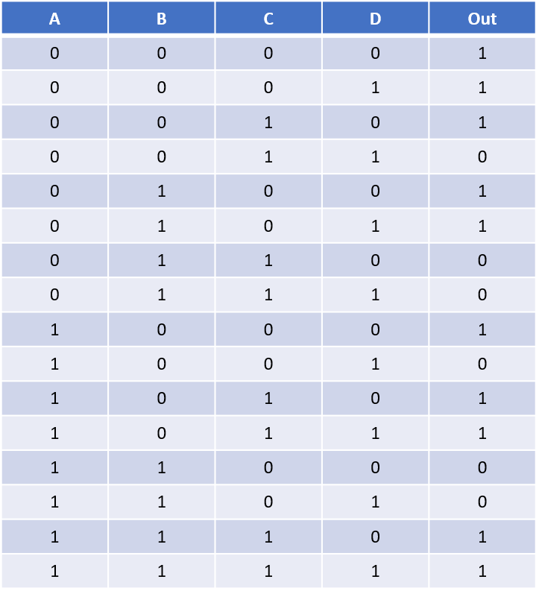

- Design your circuit(simplified by K-map method) with only NAND gate in it.
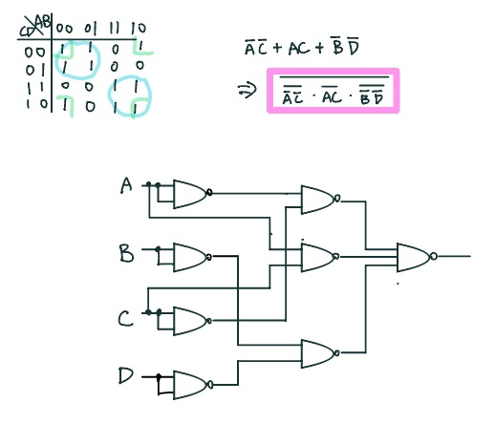

- Implement your simplified circuit based on the gate-level diagram you drawn in 2) by verilog code. (The module name should be kmap)
- You only need to upload your v-code file to moodle, do not paste your code here.

- Read the testbench for a kmap you implemented in 4). (The module is named kmap_tb)
- You only need to upload your v-code to moodle, do not paste your code here.

- Compile the code you implemented in 4) using NC-Verilog. If there are errors, please go back to 3) to debug your code and re-compile again.
(Hint : The command for compiling is %ncverilog kmap.v)

- Simulate your design in 3) with the testbench in 4).
(Hint: The command for simulation is
%ncverilog kmap _tb.v +access+r +define+FSDB)

- Verify your design by comparing the simulation results with the results you predicted. If the results are not the same, please go back to 3) and revise your code. If the simulation results are correct, please snapshot the simulation result on the terminal and the waveform you dumped and explain your waveform. (Hint : The command to open nWave is %nWave &)
In addition, you should check your coding style, there are no error messages and over 90% coverage with Superlint. Snapshot the result and calculate Superlint coverage. (Hint: The command to open Superlint is %jg -superlint superlint.tcl)
Your simulation result on the terminal.
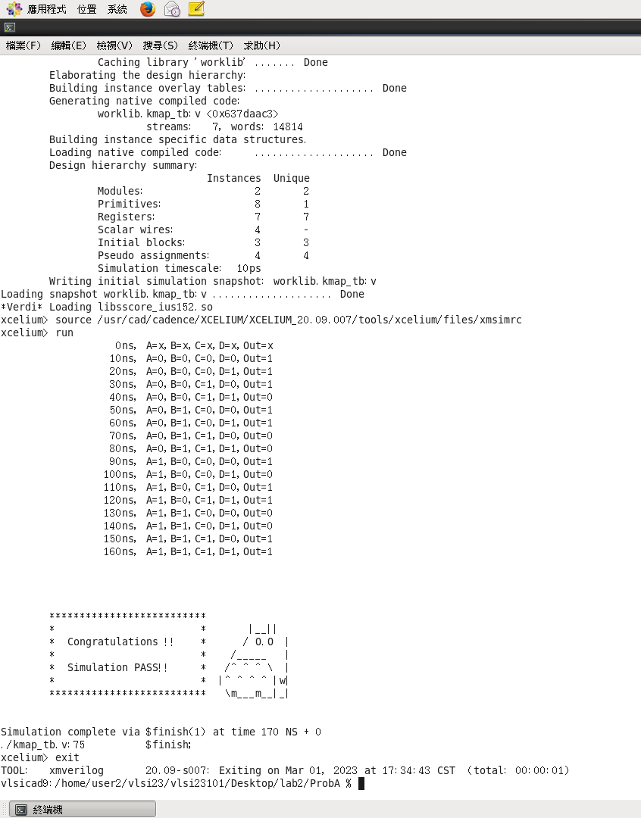
Your waveform :
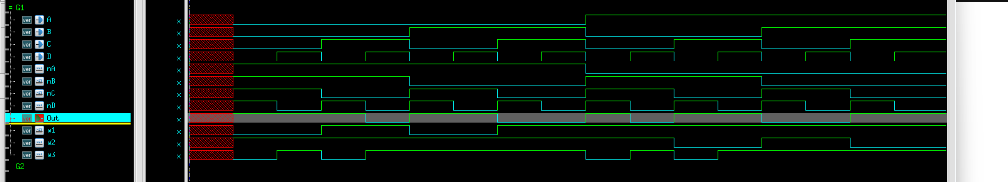
Explanation of your waveform :
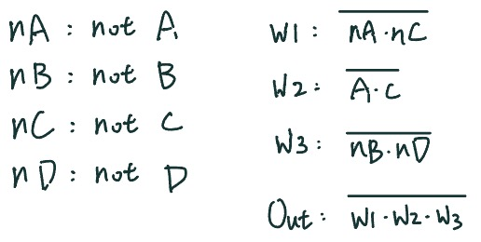

Superlint screenshot and coverage
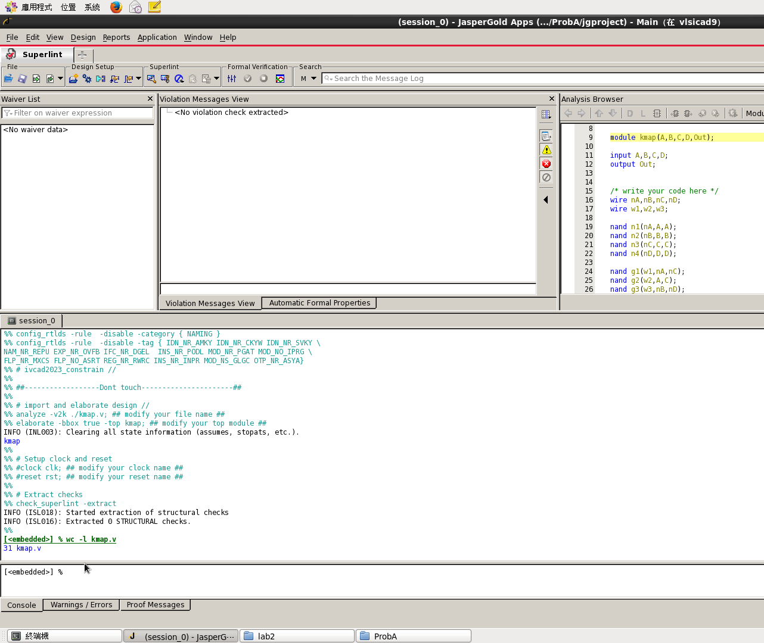

沒error, warning
Coverage:100%

Prob B: hieratical coding
- An adder is a digital circuit that performs addition of number. Please design a full adder in gate level.
- The truth table of full adder
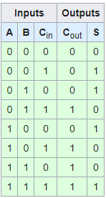
- Draw a full adder in gate level.
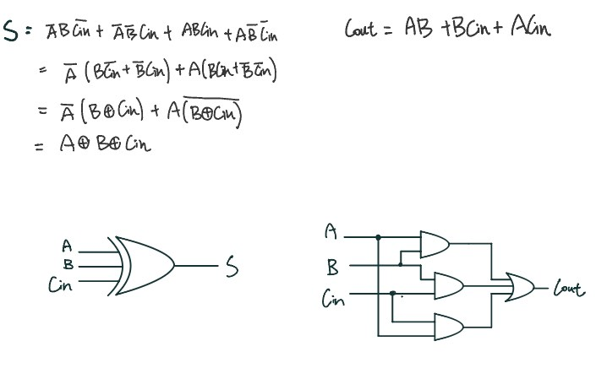

- Design a full adder in Structral coding (The module name should be FA. And the file you include should be FA.v)
- You only need to upload your v-code to moodle, do not paste your code here.
- Design a 4bit carry lookahead adder in hierarchical coding.
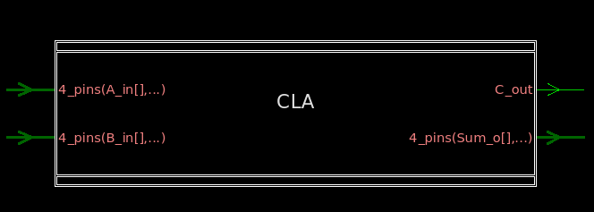
Signal | Type | Bits | Description
A_in | Input | 4 | First operand
B_in | Input | 4 | Second operand
Sum_o | Output | 4 | Result after calculating
C_out | Output | 1 | Carry out bit
- Your design should be named as CLA.v and module names in the file should be the same as file name (CLA).
- Simulate your design in 2) with the following test pattern in sample testbench.
(Hint: The command for compiling is %ncverilog CLA.v)
(Hint: The command for simulation is %ncverilog CLA_tb.v +define+FSDB +access+r)
- Verify your design by comparing the simulation results with the results you predicted. If the results are not the same, please go back to 2) and revise your code. If the simulation results are correct, please snapshot the simulation result on the terminal and the waveform you dumped and explain your waveform. (Hint : The command to open nWave is %nWave &)
In addition, you should check your coding style, there are no error messages and over 90% coverage with Superlint. Snapshot the result and calculate Superlint coverage. (Hint: The command to open Superlint is %jg -superlint superlint.tcl)

Your simulation result on the terminal.
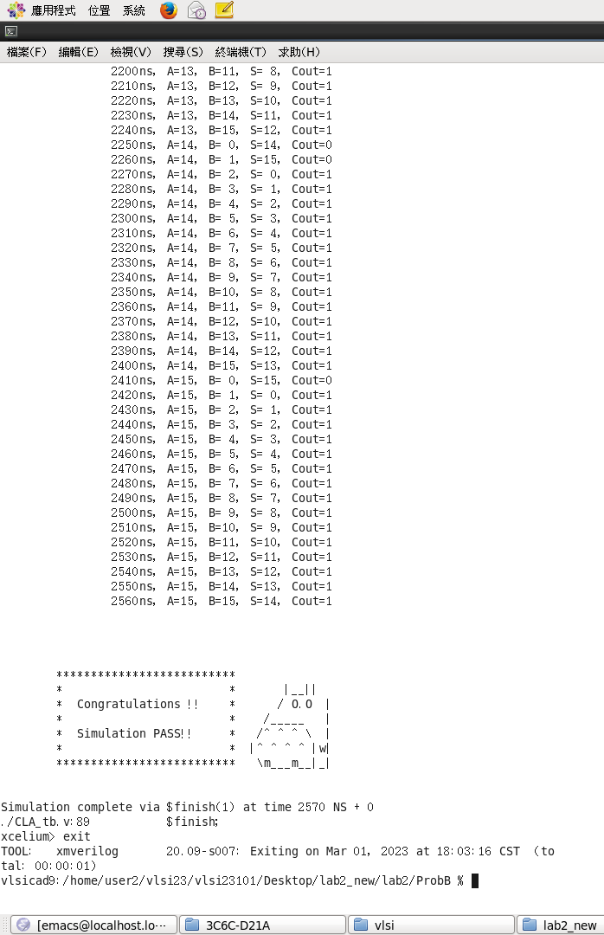
Your waveform :
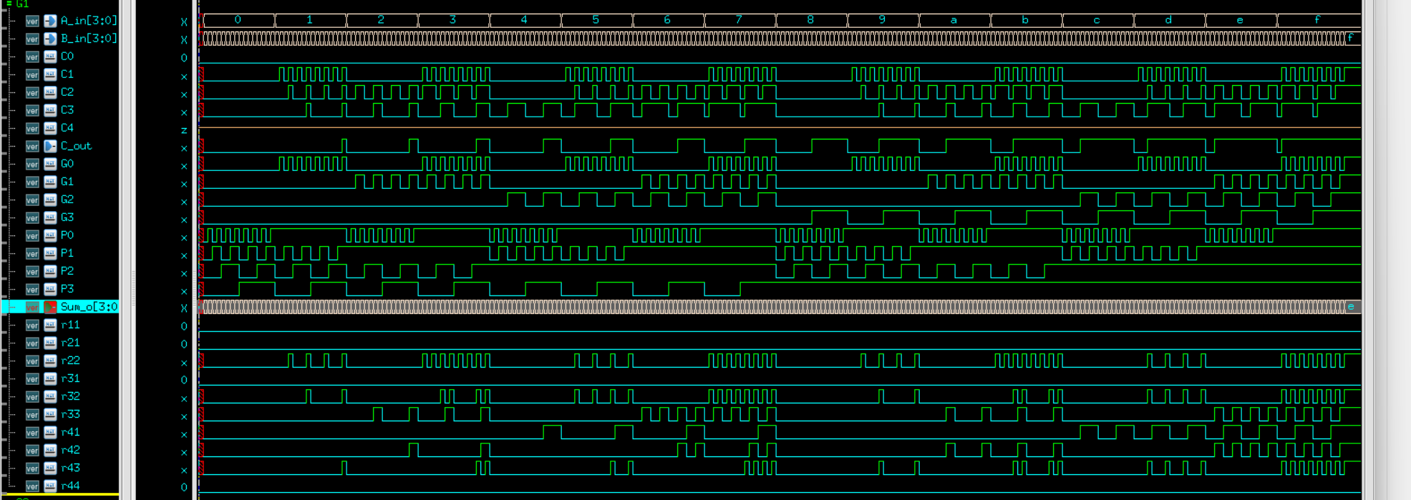

Explanation of your waveform :
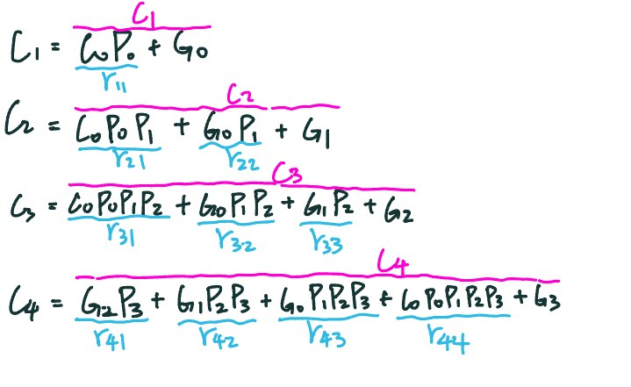

Superlint screenshot and coverage
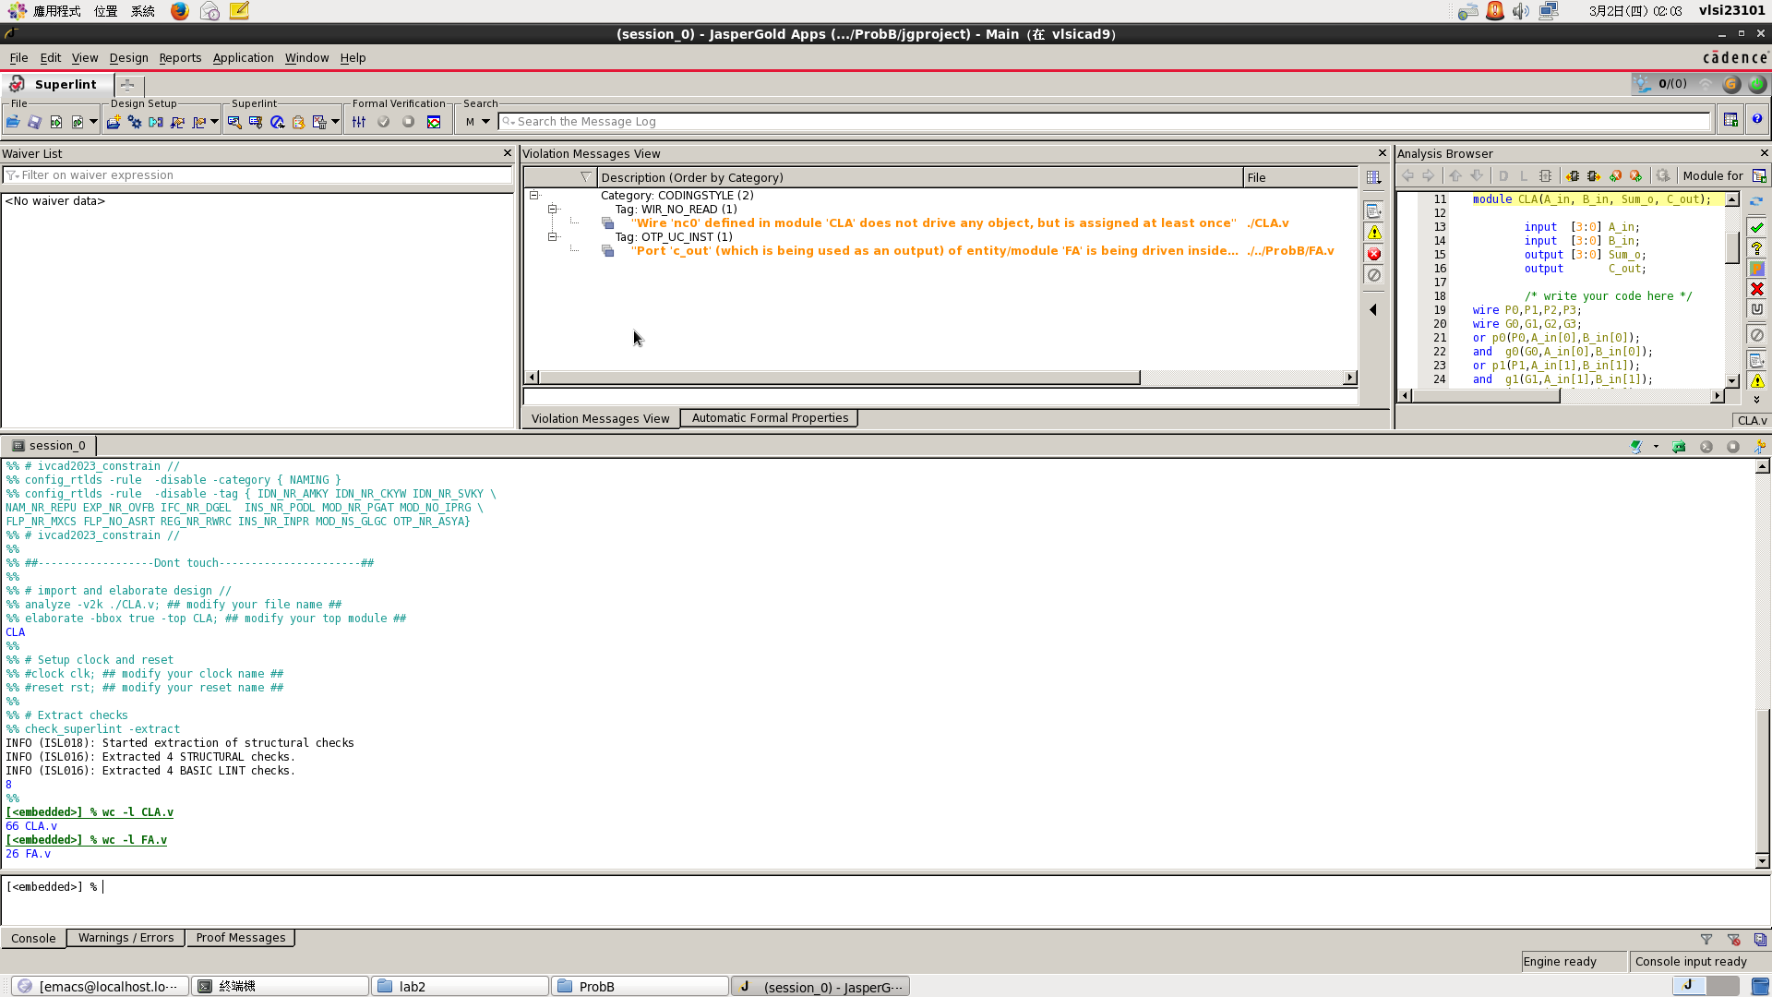
CLA.v : 1 warning ,coverage = 98.48%
FA.v :1 warning ,coverage = 96.15%

Prob C: Application
- Design a 4x4 bits multiplier using CLAs of Prob B, also designed at gate level rather than behavior level. (The module name should be multi. And the file you include should be multi.v)
- Draw your hieratical structure.
- You only need to upload your v-code to moodle, do not paste your code here.
- Simulate your design in 2) with the testbench which includes all case of input.
(Hint: The command for compiling is %ncverilog multi.v)
(Hint: The command for simulation is %ncverilog multi _tb.v +define+FSDB +access+r)
- Verify your design by comparing the simulation results with the results you predicted. If the results are not the same, please go back to 2) and revise your code. If the simulation results are correct, please snapshot the simulation result on the terminal and the waveform you dumped and explain your waveform. (Hint : The command to open nWave is %nWave &)
In addition, you should check your coding style, there are no error messages and over 90% coverage with Superlint. Snapshot the result and calculate Superlint coverage. (Hint: The command to open Superlint is %jg -superlint superlint.tcl)
Draw your hieratical structure.
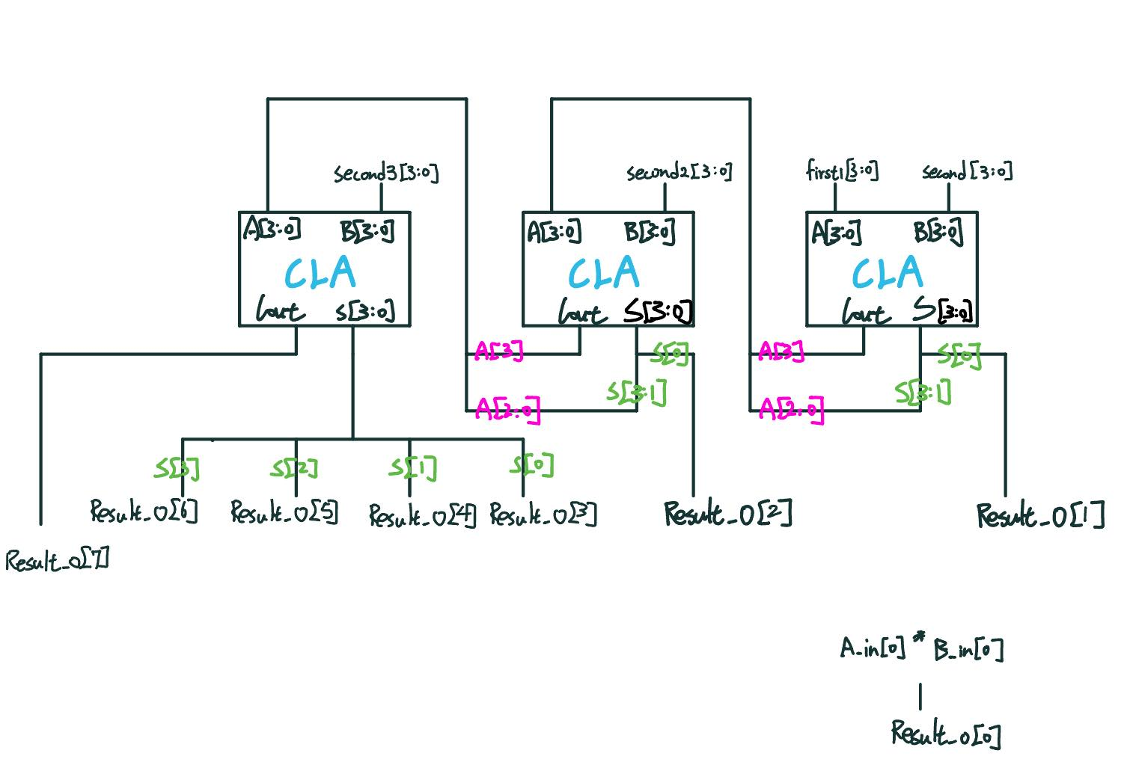
Your simulation result on the terminal.
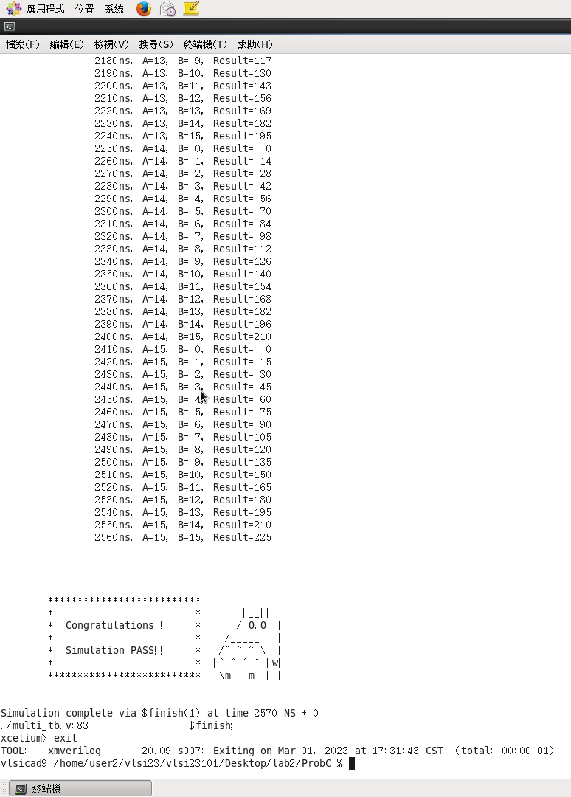

Your waveform :
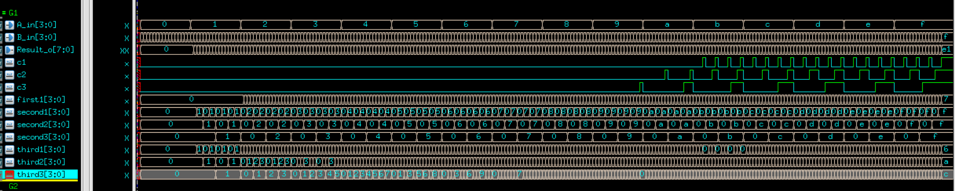

Explanation of your waveform :
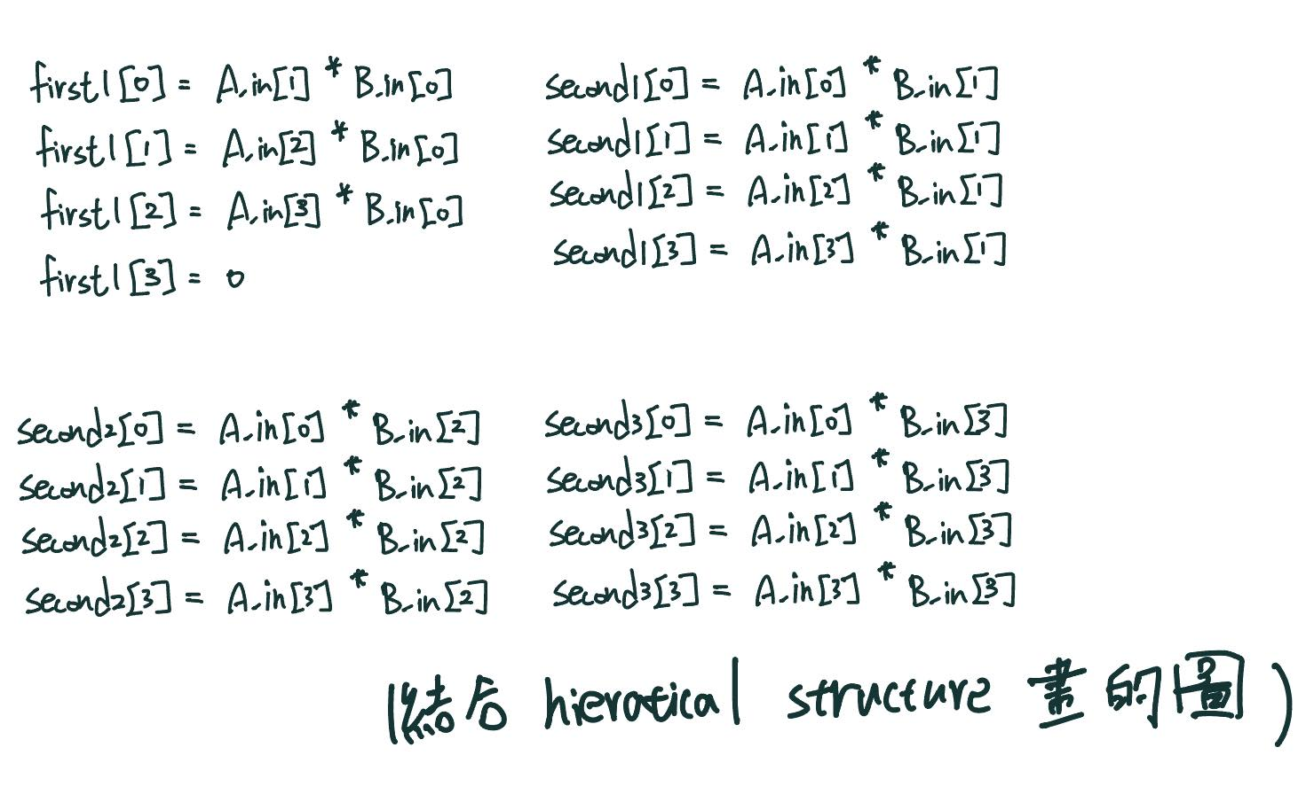
Superlint screenshot and coverage
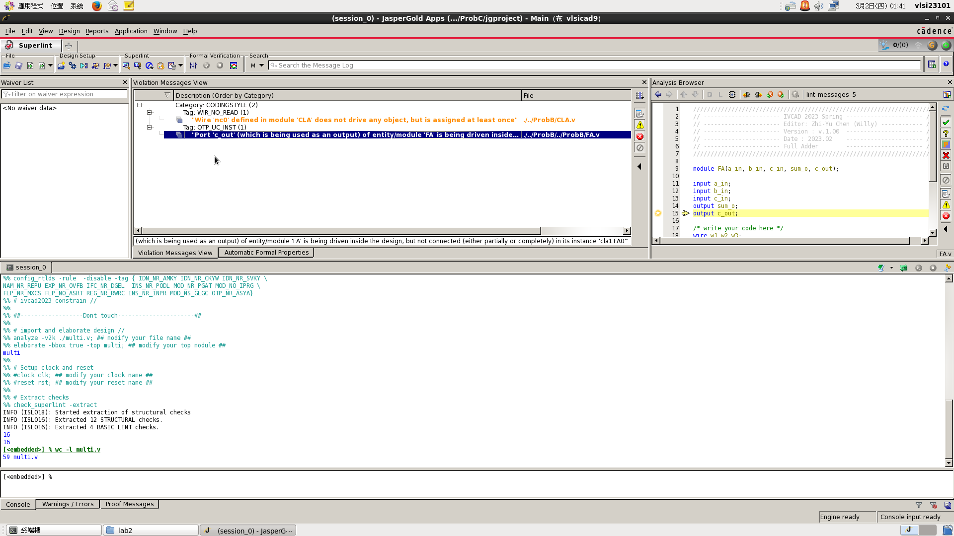

Multi.v : 沒error, warning , coverage : 100%

Appendix A : Commands we will use to check your homework

Problem |  | Command
ProbA | Compile | % ncverilog kmap.v
ProbA | Simulate | % ncverilog kmap_tb.v +access+r +define+FSDB
ProbB | Compile | % ncverilog CLA.v
ProbB | Simulate | % ncverilog CLA_tb.v +access+r +define+FSDB
ProbC | Compile | % ncverilog multi.v
ProbC | Simulate | % ncverilog multi_tb.v +access+r +define+FSDB

