1. **Socio-economic Characteristics of Respondents**

| **Characteristic** | **Indigenous**, N = 651 | **Non-Indigenous**, N = 51 | **p-value**2 |
| --- | --- | --- | --- |
| **Age**  **Residence duration** | 55.98 (15.07)  58.49 (36.02) | 56.00 (9.38)  44.80 (16.28) | >0.9  0.2 |
| **Sex** |  |  | 0.2 |
| Female | 9 (14%) | 2 (40%) |  |
| Male | 56 (86%) | 3 (60%) |  |
| **Main Occupation** |  | 0 (0%) | **0.011** |
| Chief | 4 (6.2%) |  |
| Chief advisor | 6 (9.2%) | 0 (0%) |  |
| Coiffeuse | 1 (1.5%) | 0 (0%) |  |
| Cultural guardian | 4 (6.2%) | 1 (20%) |  |
| Farmer | 2 (3.1%) | 1 (20%) |  |
| Fisher | 9 (14%) | 0 (0%) |  |
| Hunter | 1 (1.5%) | 0 (0%) |  |
| Teacher | 0 (0%) | 1 (20%) |  |
| Salt producer | 0 (0%) | 1 (20%) |  |
| Traditional healer | 8 (12%) | 0 (0%) |  |
| Vodoun priest | 30 (46%) | 1 (20%) |  |
| **Level of Education** |  |  | 0.14 |
| None | 11 (17%) | 3 (60%) |  |
| Primary school | 33 (51%) | 1 (20%) |  |
| Secondary school | 18 (28%) | 1 (20%) |  |
| University | 3 (4.6%) | 0 (0%) |  |
| **Ethnical group** |  |  | 0.2 |
| Fon | 3 (4.6%) | 0 (0%) |  |
| Mina | 21 (32%) | 0 (0%) |  |
| Xwedah | 20 (31%) | 4 (80%) |  |
| Xwlah | 14 (22%) | 0 (0%) |  |
| Yoruba | 7 (11%) | 1 (20%) |  |
| **Country of Origin** |  |  | 0.6 |
| Benin | 49 (75%) | 5 (100%) |  |
| Togo | 16 (25%) | 0 (0%) |  |
| 1Mean (SD); n (%) | | | |
| 2Wilcoxon rank sum test; Fisher's Exact Test for Count Data with simulated p-value (based on 10000 replicates); Fisher's Exact Test for Count Data | | | |

1. **Status of use of ILK across gender and residential status**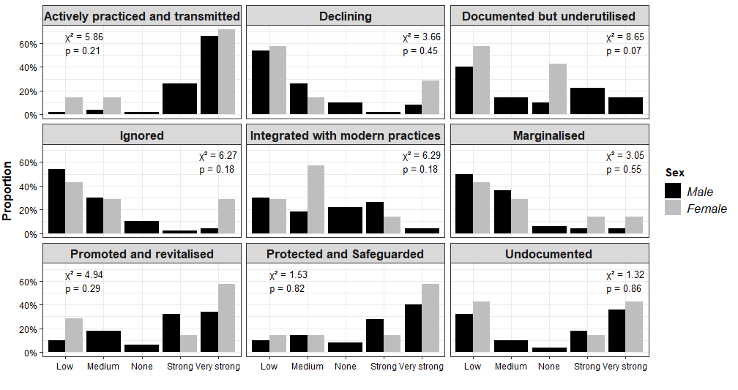

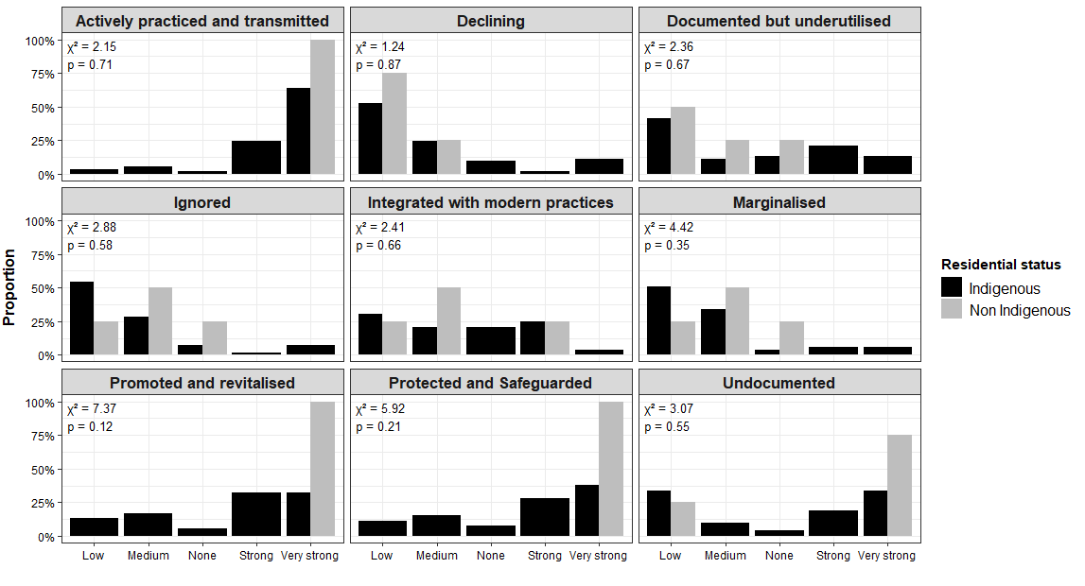

1. **Fields of ILK application   
     
     
   