**Week 2 Workshop Assignment**

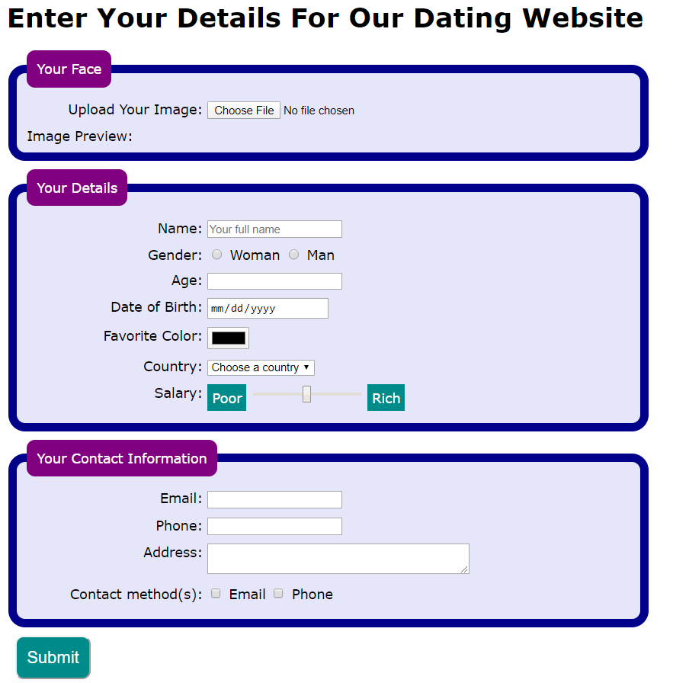**The Premise**

A startup company wishes to build a website for their online dating business. They have employed a designer who has produced the following design using graphics software. The software used by the designer only produces an image and does not produce HTML.

The company has now contracted you to implement the design i.e. build the web page. This includes a working form component. The company thinks the designer has done a great job and wants you to implement the design without altering the style.

**Technical Overview**

From a technical point of view, the webpage is constructed using HTML and CSS. Most of the HTML content are form elements. Some JavaScript will be required, but you will not have to write it, only follow the instructions to include it where needed.

Interactive Features

The company requires you to have two interactive features in the web page.

* When the mouse is moved over any form control or its associated label, the label text will turn blue.
* When the mouse moves off it, it will return to its normal color. This will be accomplished using CSS.

Immediately after the user selects the image of his/her face, the image is to be shown in the web page. A small piece of JavaScript will be provided for you to use for this. However, you are not expected to understand the JavaScript code at this stage in the course and should not create any other JavaScript for this assignment.

**Assignment Tasks**

There are 3 tasks in this assessment.

**For Task 1:** You will use HTML to create the webpage structure and add content, without any CSS.

**For Task 2:**Apply visual styles to the webpage using CSS.

**For Task 3:** Add the interactive features to the webpage.

Each task has been further separated into smaller parts to help organize your approach.

Detailed requirements and instructions are given below.

**TASK 1: Use HTML to create the webpage structure and add content**

|  |  |
| --- | --- |
| **Part 1: Set up the document**   * Create a basic valid HTML5 document as you learned to do in Week 1. Be sure to set the **DOCTYPE** and an appropriate **title**and**meta charset**. | <!DOCTYPE html>  <html lang="en">  <head>      <meta charset="UTF-8">      <meta name="viewport"   content="width=device-width, initial-scale=1.0">      <title>Date Me</title>  </head>  <body>  <h1>Enter Your Details For Our Dating Website</h1>  <!-- <form action="results.html" method="get"> -->  <form action="https://learn.nucamp.co/show_everything.php"  method="post" enctype="multipart/form-data">  <!-- All of the form child elements go here – see Part 3 -->  </form>  </body>  </html> |
| Part 2: Set up the form element  * In the body of your HTML document, create a level 1 heading with the text **Enter Your Details For Our Dating Website**. * Beneath this, create a form element with three attributes:   1. Set the **action** attribute to: (the action attribute is like src or href) "[**https://learn.nucamp.co/show_everything.php**](https://learn.nucamp.co/show_everything.php)**"**.   2. Set the **method** attributeto **"post"**.   3. Set the **enctype**attribute to**"multipart/form-data"**. (no characters are encoded… By default all characters are encoded)   *(***Note:** *there is a “get” method* **form** *tag that goes to a page called resultsl.html - We will experiment with this form later, so it will remain commented out for the time being)* |
| **Part 3: First Fieldset - Your Face**   * Create a **fieldset**inside the form element. All the following elements in this part will go inside this fieldset. (Block Element used to group related elements in a form) * Add a **legend**with the text **Your Face**. (Block Element defines a caption for the fieldset) * Below the legend, add a **div**element. Inside the **div**, add the following elements: (non-Block Element: The label tag defines a label for form elements / 508 compl)   + **label**attribute: **for="avatar"**and text: "**Upload Your Image:**"   + **input**with attributes: **type=**"**file**", **id=**"**avatar**", **name=**"**avatar**", **required** * After the **div** element, add the text "**Image Preview:** " followed by an **img**element with these attributes: **id=**"**preview**", **width**="**500**".   *(***Note:** *You can download a NoFace.jpg image here: http://www.drpage.net/nucamp/images/NoFace.jpg)* | <!-- First Fieldset -->      <fieldset>          <legend>Your Face</legend>          <div>              <label for="avatar">Upload Your Image:</label>              <input type="file" id="avatar" name="avatar" required />          </div>  <input type="checkbox">  <input type="color">  <input type="date">  <input type="datetime-local">  <input type="email">  <input type="file">  <input type="month">  <input type="number">  <input type="password">  <input type="radio">  <input type="range">  <input type="search">  <input type="tel">  <input type="text">  <input type="time">  <input type="url">  <input type="week">          Image Preview:  <img id="preview" src="images/NoFace.jpg" width="200" />      </fieldset> |
| **Part 4: Second Fieldset - Your Details**   * Create a second **fieldset**inside the form element. All the following elements in this part will go inside this fieldset. * Add a **legend**with the text **Your Details**. * Below the legend, add a **div**element. Inside the **div**, add the following elements:   + **label**with attribute: **for="name"**and text: "**Name:**"   + **input**with attributes: **type= "text"**, **id="name"**, **name="name"**,**placeholder="Your full name"**,**required** * Add a second **div** below the previous one. Inside this **div**, add the following elements:   + **input**with attributes:**type="radio"**, **id="woman"**, **name=“gender”**,  **value="woman", required**   + **label**with attribute: **for="woman"**and text: "**Woman**"   + **input**with attributes:**type="radio"**, **id="man"**, **name=“gender”**, **value="man"**   + **label**with attribute: **for="man"**and text: "**Man**" * Add a third **div** below the previous one. Inside this **div**, add the following elements:   + **label** with attribute: **for="age"**and text "**Age:** "   + **input**with attributes:**type="number"**, **id=”age**”, **name=“age”** * Add a fourth **div** below the previous one. Inside this **div**, add the following elements:   + **label**with attribute: **for="dob"**and text: "**Date of Birth:**"   + **input**with attributes:**type="date"**, **id=”dob**”, **name=“dob”** * Add a fifth **div** below the previous one. Inside this **div**, add the following:   + **label**with attribute: **for="color"**and text "**Favorite Color:** "   + **input**with attributes**: type="color"**, **id=”color”**,**name=“color”** * Add a sixth **div** below the previous one. Inside this **div**, add the following elements:   + **label** with attribute: **for="country"** and text: "**Country:** "   + **select**with attributes: **id="country"**, **name="country"** and the following options:     - **option** with text "**Choose a country**"     - **option** with attribute: **value="brazil"**and text: "**Brazil**"     - **option**with attribute: **value="france"**and text: "**France**"     - **option**with attribute: **value="japan"**and text: "**Japan**"     - **option**with attribute: **value="libya"**and text: "**Libya**"     - **option**with attribute: **value="usa"**and text: "**U.S.A.**" * Add a seventh **div** below the previous one. Inside this **div**, add the following elements:   + **label**with attribute: **for="salary"**and text:**"Salary: "**   + **span**with attribute: **class="range-caption"**and text **"Poor"**   + **input**with attributes**: type="range"**, **id=”salary”**,**name=“salary”, min="0", max="100", value="50"**   + **span** with attribute: **class="range-caption"**and text: **"Rich"** | <!-- Second Fieldset -->      <fieldset>          <legend>Your Details</legend>          <div>              <label for="name">Name: </label>              <input type="text" id="name" name="name"  placeholder="Your name" required />          </div>          <div>              <label>Gender:</label>              <input type="radio" id="woman" name="gender"  value="woman" required/>              <label for="woman">Woman</label>              <input type="radio" id="man" name="gender" value="man"  />              <label for="man">Man</label>          </div>          <div>              <label for="age">Age: </label>              <input type="number" id="age" name="age" required />          </div>          <div>              <label for="dob">Date of Birth: </label>              <input type="date" id="dob" name="dob"  />          </div>          <div>              <label for="color">Favorite Color:</label>              <input type="color" id="color" name="color" />          </div>          <div>              <label for="country">Country:</label>              <select id="country" name="country">                  <option>Choose a country</option>                  <option value="brazil">Brazil</option>                  <option value="france">France</option>                  <option value="japan">Japan</option>                  <option value="libya">Libya</option>                  <option value="usa">U.S.A.</option>              </select>          </div>          <div>              <label for="salary">Salary:</label>              <span class="range-caption">Poor</span>              <input type="range" id="salary" name="salary"   min="0" max="100" value="50" >              <span class="range-caption">Rich</span>          </div>      </fieldset> |
| **Part 5: Third Fieldset - Your Contact Information**   * Create a third **fieldset**inside the form element. All the following elements in this part will go inside this fieldset. * Add a **legend**with the text **Your Contact Information**. * Below the legend, add a **div**tag. Inside the **div**, add the following elements:   + **label**with attribute:**for="email"**and text:**"Email: "**   + **input**with attributes: **type="email"**, **id="email"**, **name="email"**,**required** * Add a 2nd **div**below the previous one. Inside this **div**, add these elements:   + **label** with attribute: **for="phone"**and text: "**Phone:**"   + **input**with attributes: **type="tel"**, **id="phone"**, **name="phone"** * Add a 3rd **div**below the previous one. Inside this **div**, add the these elements:   + **label** with attribute: **for="address"**and text: "**Address:**"   + **textarea**with attributes: **cols="40"**, **id="address"**, **name="address"** * Add a fourth **div**below the previous one. Inside this **div**, add the following elements:   + **label** with text: "**Contact method(s):** "   + **input** with attributes: **type="checkbox"**, **name="contact"**,  **id="emailCheckbox"**, **value="email"**   + **label** with attribute: **for="emailCheckbox"**and text: **"Email"**   + **input** with attributes: **type="checkbox"**, **name="contact"**,  **id="phoneCheckbox"**, **value="phone"**   + **label** with attribute: **for="phoneCheckbox"**and text: "**Phone**" | <!-- Third Fieldset -->      <fieldset>          <legend>Your Contact Information</legend>          <div>              <label for="email">Email: </label>              <input type="email" id="email" name="email" required />          </div>          <div>              <label for="phone">Phone: </label>              <input type="tel" id="phone" name="phone" />          </div>          <div>              <label for="address">Address: </label>              <textarea cols="40" id="address" name="address"></textarea>          </div>          <div>              <label>Contact method(s): </label>              <input type="checkbox" name="contact1"  id="emailCheckbox" value="email" />              <label for="emailCheckbox">Email</label>              <input type="checkbox" name="contact2"  id="phoneCheckbox" value="phone" />              <label for="phoneCheckbox">Phone</label>          </div>      </fieldset> |
| **Part 6: Submit Input**   * After the previous fieldset, add a **div**element. This div element should be a sibling element to the previous fieldsets, not inside any fieldset. * Inside this **div**, add an input with attribute: **type="submit"** * After the closing tag for this **div** should be the closing tag of the entire **form** element. | <!-- Submit Input -->      <div>          <input type="submit" />      </div> |

At the end of Task 1, your assignment should look like this in the Chrome browser:

Check for errors using Inspect Element

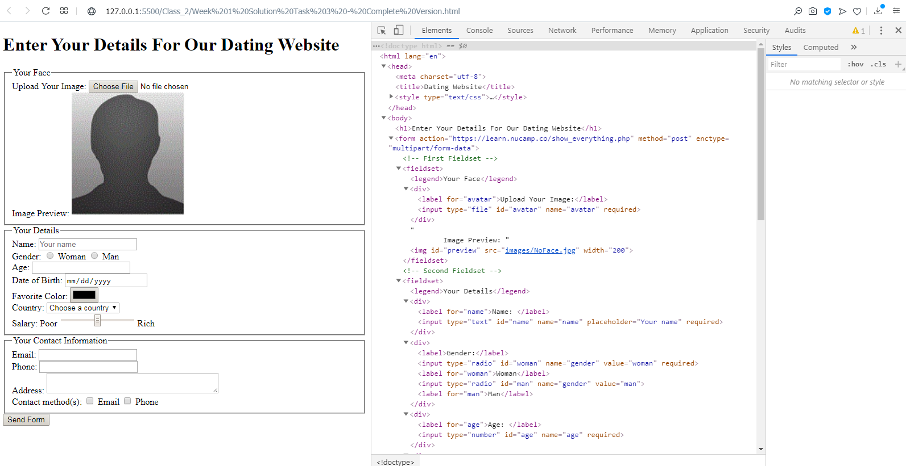

Save the file, and then open the file in your browser. Right click and inspect the code.

#### TASK 2: Apply visual styles using CSS

Now you will need to apply CSS to make the webpage look like the design given to you by the company. Below are important notes from the designer passed to you by the company. You must use this information in your work.

|  |  |
| --- | --- |
| Use an **internal stylesheet** –  Add your CSS rulesets inside a **style** element in the **head** of your document.  **Do not use inline styles.** | <!DOCTYPE html>  <html lang="en">  <head>      <meta charset="UTF-8">      <meta name="viewport"  content="width=device-width, initial-scale=1.0">      <title>Date Me</title>      <style>      /* All Style goes here... see below */ |
| * For the **body** element, set **font-family** to **Verdana, Arial, sans-serif** *Not part of the assignment, but to* **Center a Page** *add the following:*  max-width to 66%, and  margin set to auto. * For all **legend** elements, set **background** to **purple**,  set **border-radius** to **10px**,  set **color** to **white**,  set **padding** to **12px** * For all **fieldset** elements, set **background** to **lavender**,  **border** to **10px solid darkblue**,  **border-radius** to **20px**,  **margin-bottom** to **10px**, and  **width**to **720px** If you set the min-width to 250px, fieldsets will adjust for small devices * For all **div** elements, set **margin** to **10px** * Use the Psudo-Class “hover” for **div**s to change text color to blue *This is discussed in Task 3 below… but you can add it here…* * For all **label**elements, set **display**to **inline-block**,**text-align** to **right**,  **vertical-align** to **top**,  **width**to **200px** If you set the min-width to 200px, labels will adjust for small devices Also, setting white-space to pre will keep them from breaking * Create a ruleset with this selector: input[type="radio"]+label, input[type="checkbox"]+label This selector targets all **labels** that are neighboring children of inputs with a type of radio or checkbox*. While the code has been provided for you, please try to understand it before you continue.* For all elements matching this selector, set **width**to **auto**. * For all elements with a**.range-caption** *class*, set **background**to **darkcyan**,  **color**to **white**, **padding**to **6px**,  **text-align** to **center** * For all **input**elements with a **type** of "**submit**"  (hint: use an*attribute selector*),  set **background**to **darkcyan**,  **border-radius** to **10px**,  **color**to **white**,  **font-siz**e to **20px**, and  **padding**to **12px**. | body {              font-family: Verdana, Arial, sans-serif;              max-width: 66%; /* tweak to center page */              margin: auto; /* tweak to center page */          }          legend {              background: purple;              border-radius: 10px;              color: white;              padding: 12px;          }          fieldset {              background: lavender;              border: 10px solid darkblue;              border-radius: 20px;              margin-bottom: 10px;              /*width: 720px; */              min-width: 250px; /* tweak for small devices*/          }          div {              margin: 10px;          }          div:hover {              color: blue;          }          label {              display: inline-block;              text-align: right;              vertical-align: top;              /* width: 200px; */              max-width: 200px; /* tweak for small devices*/              white-space: pre; /* tweak for small devices*/          }            input[type="radio"]+label, input[type="checkbox"]+label {              width: auto;          }  input[type="range"]{width: 20%;} /* tweak for small devices*/            .range-caption {              background: darkcyan;              color: white;              padding: 6px;              text-align: center;          }          input[type="submit"] {              background: darkcyan;              border-radius: 10px;              color: white;              font-size: 20px;              padding: 12px;          }      </style> |

At the end of Task 2, your assignment should look like this in the Chrome browser:

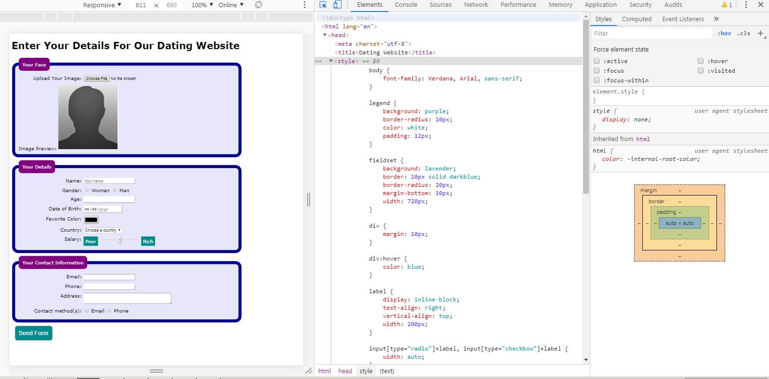

Save the file, and then open the file in your browser. Right click and inspect the code.

**TASK 3: Add interactive features**

For this task, two types of interactive behavior need to be added. These interactive behaviors are demonstrated in the accompanying video.

|  |  |
| --- | --- |
| * In the internal stylesheet, add a ruleset with this selector: use a pseudoclass of **hover** on all **div** elements. Add a declaration of **color: blue**. *Already shown above in task 2* | div:hover {              color: blue;          } |
| * Add the following **script** element before the closing **</body>**tag. It is a link to a file containing JavaScript code. After this is added, the "Your Face" image will be immediately shown in the web page after the user uploads a file. The JavaScript code shows the selected image in the **img**element with**id="preview"** that you added in Task 1 under the file **input**.   <script src="https://url.nucamp.co/datingjs"></script> | <!-- Script for Image Preview -->      <script src="https://url.nucamp.co/datingjs"></script>  </body>  </html>  --------------------------------------------------------------------------------------------------  Here is what the script actually does… See below for a simpler approach.      <script>      window.onload = function() {          var files = document.querySelectorAll("input[type=file]");          files[0].addEventListener("change", function(e) {              if(this.files && this.files[0]) {                  var reader = new FileReader();                  reader.onload = function(e) {                      document.getElementById("preview").setAttribute("src", e.target.result);                  }                  reader.readAsDataURL(this.files[0]);              }          });      }      </script> |
| * **Not Part of the Assignment**… but there is a much simpler script for an Image Preview. It is a function with one line of code. But you need to trigger the function from the form, input type=”file” | <script>        function ImgPreview(){          document.getElementById('preview').src = window.URL.createObjectURL(avatar.files[0])          //NOTE: URL.createObjectURL() can be used to create a reference to a File          //   it doesn’t contain the actual File, but rather, it holds a reference to it.        }  </script>  You need to trigger the function from the form, input type=”file”  <input type="file" id="avatar" name="avatar" required onchange="ImgPreview()" /> |
| * **Not Part of the Assignment**… but one more quick JS Script that will tweak (adjust) the Contact Method(s) checkboxes from braking when you adjust the screen size to a small devices. But you need to trigger the function from the body tag. | <script>          function checkWidth(){              if(window.outerWidth <= 650){                  document.getElementById("x").innerHTML = "<br>";              }              else{document.getElementById("x").innerHTML = ""}          }      </script>  But you need to trigger the function from the body tag.  <body onload="checkWidth()" onresize="checkWidth()"> |

External style: <link rel="stylesheet" type="text/css" href="../css/DateStyle.css">

Test the interactive features.

Submission

Once all three tasks are complete, upload the final version of datingform.html via the uploader below.

Completed Code:

<!DOCTYPE html>

<html lang="en">

<head>

    <meta charset="UTF-8">

    <meta name="viewport"

          content="width=device-width, initial-scale=1.0">

    <title>Date Me</title>

    <style>

    body {

            font-family: Verdana, Arial, sans-serif;

            max-width: 66%; /* tweak to center page */

            margin: auto; /* tweak to center page */

        }

        legend {

            background: purple;

            border-radius: 10px;

            color: white;

            padding: 12px;

        }

        fieldset {

            background: lavender;

            border: 10px solid darkblue;

            border-radius: 20px;

            margin-bottom: 10px;

            /*width: 720px; */

            min-width: 250px; /* tweak for small devices */

        }

        div {

            margin: 10px;

        }

        div:hover {

            color: blue;

        }

        label {

            display: inline-block;

            text-align: right;

            vertical-align: top;

            /* width: 200px; */

            max-width: 200px; /* tweak for small devices */

            white-space: pre; /* tweak for small devices */

        }

        input[type="radio"]+label, input[type="checkbox"]+label {

            width: auto;

        }

        input[type="range"]{width: 20%;} /* tweak for small devices */

        .range-caption {

            background: darkcyan;

            color: white;

            padding: 6px;

            text-align: center;

        }

        input[type="submit"] {

            background: darkcyan;

            border-radius: 10px;

            color: white;

            font-size: 20px;

            padding: 12px;

        }

    </style>

</head>

<body onload="checkWidth()" onresize="checkWidth()"> <!--CheckWidth tweak -->

   <h1>Enter Your Details For Our Dating Website</h1>

   <form action="results.html" method="get">

   <!--  <form action="https://learn.nucamp.co/show_everything.php"

         method="post" enctype="multipart/form-data"> -->

    <!-- First Fieldset -->

    <fieldset>

            <legend>Your Face</legend>

            <div>

                <label for="avatar">Upload Your Image:</label>

                <input type="file" id="avatar" name="avatar" required onchange="ImgPreview()" />

            </div>

            Image Preview:

            <img id="preview" src="images/NoFace.jpg" width="200" />

        </fieldset>

     <!-- Second Fieldset -->

        <fieldset>

            <legend>Your Details</legend>

            <div>

                <label for="name">Name: </label>

                <input type="text" id="name" name="name"

                       placeholder="Your name" required />

            </div>

            <div>

                <label>Gender:</label>

                <input type="radio" id="woman" name="gender"

                      value="woman" required/>

                <label for="woman">Woman</label>

                <input type="radio" id="man" name="gender" value="man"  />

                <label for="man">Man</label>

            </div>

            <div>

                <label for="age">Age: </label>

                <input type="number" id="age" name="age" required />

            </div>

            <div>

                <label for="dob">Date of Birth: </label>

                <input type="date" id="dob" name="dob"  />

            </div>

            <div>

                <label for="color">Favorite Color:</label>

                <input type="color" id="color" name="color" />

            </div>

            <div>

                <label for="country">Country:</label>

                <select id="country" name="country">

                    <option>Choose a country</option>

                    <option value="brazil">Brazil</option>

                    <option value="france">France</option>

                    <option value="japan">Japan</option>

                    <option value="libya">Libya</option>

                    <option value="usa" selected>U.S.A.</option>

                </select>

            </div>

            <div>

                <label for="salary">Salary:</label>

                <span class="range-caption">Poor</span>

                <input type="range" id="salary" name="salary"

                       min="0" max="100" value="50" >

                <span class="range-caption">Rich</span>

            </div>

        </fieldset>

     <!-- Third Fieldset -->

        <fieldset>

            <legend>Your Contact Information</legend>

            <div>

                <label for="email">Email: </label>

                <input type="email" id="email" name="email" required />

            </div>

            <div>

                <label for="phone">Phone: </label>

                <input type="tel" id="phone" name="phone" />

            </div>

            <div>

                <label for="address">Address: </label>

                <!-- Inline Style tweak for textarea -->

                <textarea style="max-width:100%; width:400px"

                        id="address" name="address"></textarea>

            </div>

            <div>

                <label>Contact method(s): </label>

                <span id="x"></span><!-- Span is a tweak fo checkWidth()-->

                <input type="checkbox" name="contact1"

                       id="emailCheckbox" value="email" />

                <label for="emailCheckbox">Email</label>

                <input type="checkbox" name="contact2"

                       id="phoneCheckbox" value="phone" />

                <label for="phoneCheckbox">Phone</label>

            </div>

        </fieldset>

        <!-- Submit Input -->

        <div>

            <input type="submit" value="Click To Submit" />

        </div>

   </form>

<!--<script src="https://url.nucamp.co/datingjs"></script> -->

<!-- Below is an alternative to the nucamp js to preview image, but you have to add a trigger to input type="file"  -->

   <script>

        function ImgPreview(){

          document.getElementById('preview').src = window.URL.createObjectURL(avatar.files[0])

          //NOTE: URL.createObjectURL() can be used to create a reference to a File

          //     it doesn’t contain the actual File, but rather, it holds a reference to it.

        }

    </script>

    <script>  //This is a tweak to make check boxes work when using smart phone

        function checkWidth(){

            if(window.outerWidth <= 650){

                document.getElementById("x").innerHTML = "<br>";

            }

            else{document.getElementById("x").innerHTML = ""}

        }

    </script>

</body>

</html>

Completed ***Results.html*** Code for Get Method (Save this code in your class folder):

<!DOCTYPE>

<html>

<head>

    <title>Parsing URL Query String Using only Javascript</title>

    <script type="text/javascript">

        // Build an empty URL structure in which we will store the individual query values by key.

        var objURL = new Object();

        // Use the “string”.replace method to iterate over each name-value pair in the query string.

        window.location.search.replace(

            new RegExp( "([^?=&]+)(=([^&]*))?", "g" ),

// Regular expressions are patterns used to match character combinations in strings.

            // For each matched query string pair, add that pair to the URL structure

            //  using the equals value as the key.

//**$**'s are not a "variable", they are a placeholders that are used in the **.replace()** call.  **$n** represents the **nth** capture group of the regular expression.

//**$1** is whatever is matched in the first capture. If you have more captures you can use **$2, $3** etc…

            function( $0, $1, $2, $3 ){ objURL[ $1 ] = $3; }

**)**;

    </script>

</head>

<body>

    <p>

        <h1>Results - Parsing URL Query String Using only Javascript (with RegExp)</h1>

        <h2>Push this to your Database</h2>

    </p>

    <p>

        <script type="text/javascript">

            // Loop over the URL values that you collected.

            document.write("<table>")

            for (var strKey in objURL){

                // Output the key to the document.

                document.write(

                    "<tr><td><strong>" + strKey + ":</strong></td>"

                    );

                // replace "%23" to "#"", "%40" to "@", "+"" to " "

                objURL[ strKey ] = objURL[ strKey ].replace(/%23/g, "#");

                objURL[ strKey ] = objURL[ strKey ].replace(/%40/g, "@");

                objURL[ strKey ] = objURL[ strKey ].replace(/\+/g, " ");

                // Output the value stored at that key.

                document.write(

                    "<td>" +objURL[ strKey ] + "</td></tr>"

                    );

            }

            document.write("</table>")

        </script>

    </p>

    <p>Rem: This does not handle the image blob</p>

</body>

</html>