DOCUMENTATION

ASSIGNMENT 2

STUDENT NAME: CORNOC ROLAND NICHOLAS
GROUP: 30423

CONTENTS
DOCUMENTATION 1
ASSIGNMENT 2 1
CONTENTS 2
1. Assignment Objective 3
2. Problem Analysis, Modeling, Scenarios, Use Cases 3
3. Design 6
4. Implementation 8
5. Conclusions 10
6. Bibliography 10

Assignment Objective

Objective:
Develop an application to simulate queuing-based systems, facilitating the analysis of client arrivals, queue management, service provision, and departure processes. The simulation aims to compute essential metrics such as average waiting time, average service time, and peak-hour traffic.

Sub-Objectives:

- Problem Analysis and Requirement Identification:
- Evaluate the queuing system's dynamics, pinpointing the necessary functionalities and constraints to build an effective simulation tool.
- Application Design:
- Develop a comprehensive design for the simulation application, outlining the architecture, user interface, data flow, and algorithms required to replicate real-world queuing scenarios accurately.
- Application Implementation:
- Translate the design into a functional simulation application, incorporating features for client generation, queue management, service allocation, time tracking, and data analysis.
- Application Testing:
- Rigorously test the simulation application to ensure its accuracy, reliability, and scalability. Verify that it produces valid results under various scenarios and handles edge cases effectively.
- By accomplishing these sub-objectives, the simulation application will provide a valuable tool for analyzing queuing systems, aiding in decision-making and optimization efforts for businesses and organizations reliant on efficient service delivery.

Problem Analysis, Modeling, Scenarios, Use Cases

Functional Requirements:

- Simulation Setup: Users should have the capability to configure simulation parameters such as the number of clients, service durations, and queue capacities. This functionality enables customization to mimic real-world scenarios accurately and cater to specific use cases.

- Simulation Initiation: Once the setup is complete, users should be able to commence the simulation seamlessly. This action triggers the simulation engine to execute the predefined scenario, simulating client arrivals, queueing, service provision, and departures based on the configured parameters.
- Real-time Queue Visualization: The application should offer a real-time graphical representation of queue statuses, illustrating the current queue lengths, client positions, and service operations. This visual feedback allows users to monitor the progression of the simulation and identify any potential bottlenecks or inefficiencies.

- Simulation Statistics: Upon completion of the simulation, users should have access to comprehensive statistics and metrics summarizing the simulation's performance. This includes key indicators such as average waiting time, average service time, peak-hour traffic, and other relevant insights essential for analyzing and optimizing queuing systems.

Non-functional Requirements:

- Intuitive User Interface: The user interface should be intuitively designed, with clear navigation and user-friendly controls, ensuring ease of use for users with varying levels of technical expertise. Intuitive design enhances user satisfaction and facilitates efficient interaction with the application.
- Robust Error Handling: The application should incorporate robust error handling mechanisms to detect and gracefully handle errors or exceptional scenarios that may arise during simulation setup or execution. Informative error messages should be provided to guide users in resolving issues and maintaining the application's usability.
- Performance and Scalability: The simulation application should demonstrate high performance and scalability, even when simulating large numbers of clients and servers. It should be capable of handling complex queuing scenarios efficiently, without compromising responsiveness or user experience. Performance optimizations should be implemented to minimize simulation execution times and maximize throughput.

Use Case Diagram

The use case diagram provides a visual representation of the various interactions between users and the queue management application. It illustrates the different actions and functionalities accessible to users, including simulation setup, initiation, monitoring, and result analysis. This diagram serves as a blueprint for understanding the system's behavior and guiding the development process to ensure alignment with user requirements and expectations.
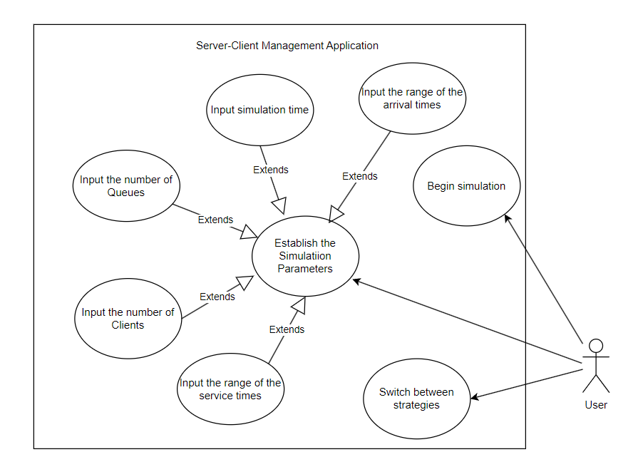
Figure 1. Use Case Diagram

Use Case: Simulation Setup and Start

Primary Actor: User

Main Success Scenario:

- The user navigates to the setup section of the application.
- The user inputs values for the number of clients, number of queues, simulation interval, minimum and maximum arrival time, and minimum and maximum service time.
- The user confirms the setup by clicking on the "Start Simulation" button.
- The application validates the input data for correctness and consistency.
- If the validation is successful, the application initiates the simulation and displays a message prompting the user to start the simulation.
- The user starts the simulation by clicking on the designated button.
- The application begins simulating client arrivals, queue management, service provision, and departure processes based on the configured parameters.

Alternative Sequence:

- If the user inputs invalid values for any of the setup parameters:
- The application detects the invalid input and displays an error message indicating the specific parameter(s) requiring correction.
- The user revises the input values accordingly.
- The scenario returns to step 4 of the main success scenario.

Use Case: Change Strategy

Primary Actor: User

Main Success Scenario:

- The user navigates to the strategy selection section within the application interface.
- The user is presented with options to choose between different queue allocation strategies, such as the shortest time strategy or the shortest queue strategy.
- The user selects the desired strategy by interacting with the corresponding UI component.
- The application acknowledges the user's selection and updates the queue allocation strategy accordingly.

Alternative Sequence:

- If the user encounters difficulty in selecting a strategy:
- The application provides clear instructions or tooltips to assist the user in understanding the available options and their implications.
- The user revises their selection based on the provided guidance.

Design

At the apex of the design hierarchy lies the segmentation of the system into distinct packages, each delineating a crucial facet of functionality. The Graphical User Interface (GUI) package stands as the bastion of user interaction, housing classes imbued with the art of interface orchestration. Nestled within the Business Logic enclave, one finds the cogitative powerhouses, where classes wield their acumen in the intricate management of simulation configurations as envisioned by the user. Meanwhile, the Data Models sanctum harbors the very essence of the application, encapsulating classes that breathe life into abstract concepts, manifesting them as tangible entities within the digital realm. Thus, through this stratification, the design coalesces into a harmonious symphony of prowess and precision, each package playing its unique role in the grand tapestry of software engineering excellence.

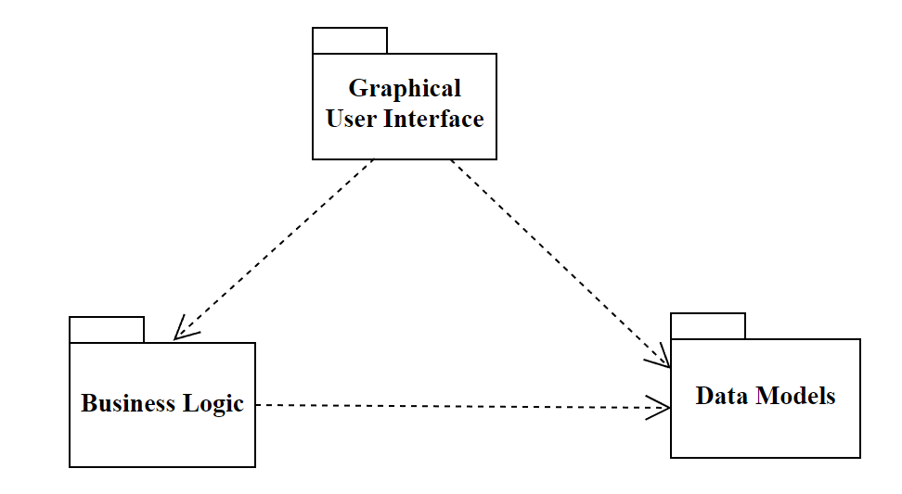
Figure 2. UML package diagram

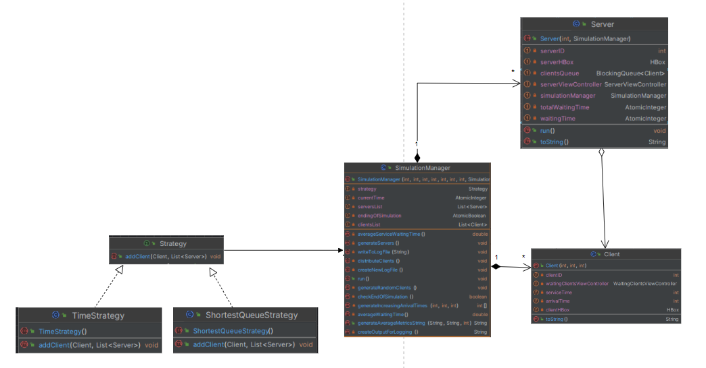
Figure 3. UML Class Diagram

Implementation

Client Class:

Fields:

- clientID: An integer representing the unique identifier of the client.
- arrivalTime: An integer representing the arrival time of the client.
- serviceTime: An integer representing the service time required for the client.
- clientHBox: An HBox element representing the graphical representation of the client in the user interface.
- waitingClientsViewController: An instance of WaitingClientsViewController responsible for managing the client's view in the waiting area.

Important Methods:

- Client(int clientID, int arrivalTime, int serviceTime): Constructor for creating a new client instance. It initializes the client's attributes and loads the graphical representation of the client.
- getWaitingClientsViewController(): Getter method for obtaining the waiting clients view controller associated with the client.
- toString(): Overrides the toString() method to provide a string representation of the client object.

Server Class:

Fields:

- serverID: An integer representing the unique identifier of the server.
- totalWaitingTime: An AtomicInteger representing the total waiting time experienced by clients at the server.
- waitingTime: An AtomicInteger representing the current waiting time at the server.
- clientsQueue: A BlockingQueue of Client objects representing the queue of clients waiting to be served.
- simulationManager: An instance of SimulationManager responsible for managing the server's interactions within the simulation.
- serverHBox: An HBox element representing the graphical representation of the server in the user interface.
- serverViewController: An instance of ServerViewController responsible for managing the server's view in the user interface.

Important Methods:

- Server(int serverID, SimulationManager simulationManager): Constructor for creating a new server instance. It initializes the server's attributes and loads the graphical representation of the server.
- run(): Overrides the run() method of the Runnable interface to define the server's behavior during execution.
- toString(): Overrides the toString() method to provide a string representation of the server object.

SimulationManager Class:

Fields:

- clientsNumber: An integer representing the total number of clients in the simulation.
- serversNumber: An integer representing the total number of servers in the simulation.
- simulationTime: An integer representing the duration of the simulation.
- serviceTimeMin: An integer representing the minimum service time for clients.
- serviceTimeMax: An integer representing the maximum service time for clients.
- arrivalTimeMin: An integer representing the minimum arrival time for clients.
- arrivalTimeMax: An integer representing the maximum arrival time for clients.
- clientsList: A list of Client objects representing the clients participating in the simulation.
- serversList: A list of Server objects representing the servers participating in the simulation.
- executor: An ExecutorService responsible for managing the execution of server tasks.
- endingOfSimulation: An AtomicBoolean flag indicating the end of the simulation.
- currentTime: An AtomicInteger representing the current time in the simulation.
- simulationViewController: An instance of SimulationViewController responsible for managing the simulation's view in the user interface.
- strategy: An instance of a strategy pattern representing the strategy for distributing clients to servers.

Important Methods:

- SimulationManager(int clientsNumber, int serversNumber, int simulationTime, int serviceTimeMin, int serviceTimeMax, int arrivalTimeMin, int arrivalTimeMax, SimulationViewController simulationViewController): Constructor for creating a new simulation manager instance. It initializes the simulation parameters and the user interface components.
- run(): Overrides the run() method of the Runnable interface to define the simulation manager's behavior during execution.
- generateRandomClients(): Generates random clients with specified attributes and adds them to the simulation.
- generateServers(): Generates server instances and adds them to the simulation.
- distributeClients(): Distributes clients to servers based on the chosen strategy.
- checkEndOfSimulation(): Checks if the simulation has ended based on specific criteria.
- writeToLogFile(String output): Writes simulation data to a log file.
- generateAverageMetricsString(String averageWaitingTime, String averageServiceTime, int peakTime): Generates a string containing average metrics for the simulation results.

Conclusions

In conclusion, the queue management application exemplifies the adept application of object-oriented principles and design patterns, forging a resilient and adaptable system tailored for orchestrating queues within a simulation setting. Through the integration of dynamic queue allocation strategies and real-time queue visualization, the application emerges as a potent tool for unraveling insights into queue orchestration and optimization.

This assignment has served as a crucible for expanding my repertoire of software development concepts and methodologies. Key takeaways include:

Design Patterns: Delving into design patterns, particularly the Strategy Pattern, has illuminated pathways for resolving common design challenges while fostering code modularity and longevity.
Multi-threading: The exploration of Java's multi-threading capabilities through Executors and Futures has empowered me to simulate concurrent processing, enabling proficient management of asynchronous tasks.
File I/O Operations: Mastery over file writing operations has enabled the persistence of simulation data, laying the foundation for generating comprehensive log files essential for in-depth analysis and auditing.

Looking forward, one avenue for the queue management application's advancement lies in augmenting its visualization prowess. Enhancing graphical representations to depict queues and client movements within the simulation milieu would elevate user comprehension and engagement, fostering deeper insights into queue dynamics and system behavior.

In essence, this project has not only fortified my technical acumen but also instilled a mindset of continual refinement and innovation, poised to propel future endeavors towards ever greater heights of excellence.

Bibliography
http://docs.oracle.com/javase/tutorial/essential/concurrency/index.html - http://www.tutorialspoint.com/java/util/timer_schedule_period.htm - http://www.javacodegeeks.com/2013/01/java-thread-pool-example-using-executors-and-threadpoolexecutor.htm

