U S E R M A N U A L
NewtonEDMS
User Manual
Every file, found and governed
Version 1.0 — August 2026
Covers the current release end to end
For users and administrators

NewtonEDMS Documentation

Table of Contents

1. Introduction 1
2. Signing In 1
3. The Workspace 1
4. Browsing Folders and Documents 1
5. Uploading Documents 1
6. The Document Inspector 1
7. Versioning and Check-Out 1
8. Sharing Documents 1
8.1 Share links 1
8.2 Internal access 1
8.3 Ownership transfer 1
9. Signing a Document 1
10. People: Address Book, Users, and Groups 1
10.1 Users and roles 1
10.2 Groups 1
10.3 Address book 1
11. Search and the Query Language 1
12. Tasks, Calendar, and Messages 1
13. Personal Settings 1
14. Administration 1
15. Keyboard Shortcuts 1

Note: This Table of Contents is generated via field codes. To ensure page number accuracy after editing, please right-click the TOC and select "Update Field."

1. Introduction
NewtonEDMS is an enterprise document management system. It lets you capture documents from uploads, scanning, and e-mail; organize them in hierarchical folders with full access control; search everything, including text recognized inside scans; share documents safely with people inside and outside your organization; run review workflows; sign PDFs; and keep a complete audit trail of who did what.
This manual walks through everyday tasks with screenshots of the running application. It covers the current release, including People management, share permission levels, digital signing, and ownership transfer. Chapter 13 is aimed at administrators; everything else is written for regular users.

2. Signing In
Open the NewtonEDMS address in your browser, enter the username and password given to you by your administrator, and click Sign in.
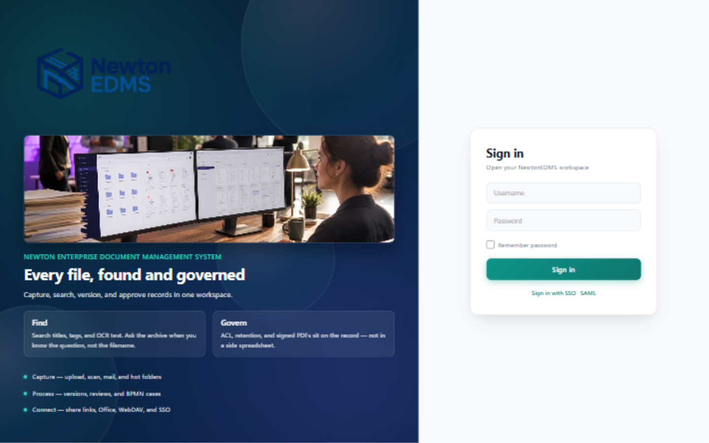
Figure 1 — The sign-in page
- If your account has two-factor authentication (TOTP) enabled, a code field appears after you enter your credentials; type the six-digit code from your authenticator app.
- Your organization may also offer single sign-on links (SSO or SAML) below the sign-in button.
- If you forget your password, contact your administrator. Passwords are stored only as secure hashes and cannot be read out by anyone, including administrators.
After signing in you land on the dashboard overview, described in the next chapter.

3. The Workspace
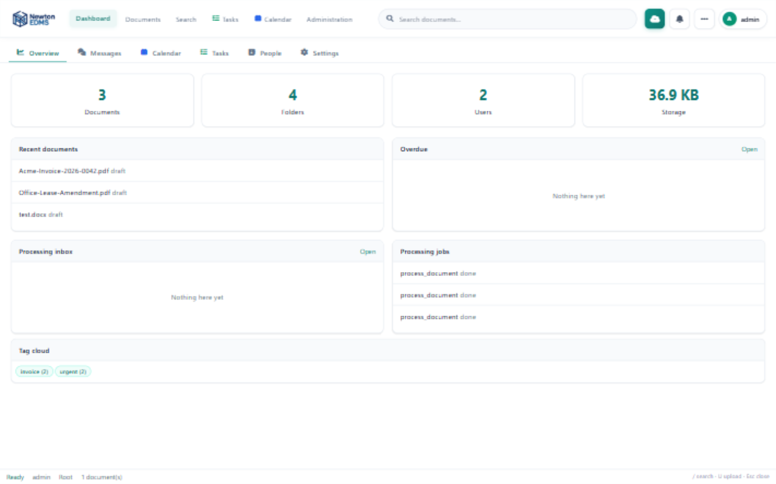
Figure 2 — The dashboard overview
The dashboard is your landing page: it summarizes recent activity, your open tasks, due dates, and quick access to saved dashboards. The same header bar is present on every page:
Table 1 — Header areas
Area | What it does
Dashboard / Documents / Search | Switch between the overview, the folder browser, and search.
Search box | Full-text and query-language search; the / key jumps here.
Upload button | Upload documents from anywhere; U is the keyboard shortcut.
Tools menu | Scanner capture, folder creation, exports, saved searches.
Account menu | Settings, theme toggle, and sign out.

4. Browsing Folders and Documents
Click Documents in the header to open the repository browser.
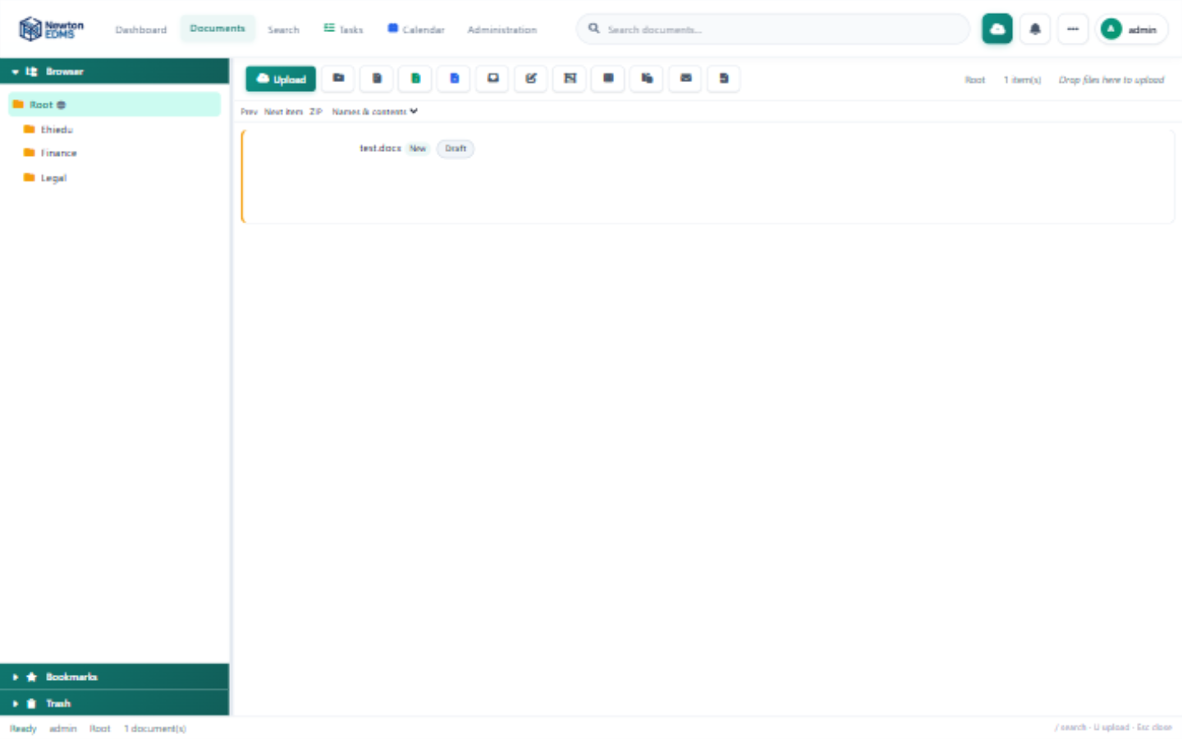
Figure 3 — The documents view with the folder tree and document list
The left panel is the folder tree. Click a folder to open it; the tree also lets you expand and collapse levels. When a folder is selected, folder tools appear beneath the tree for creating subfolders and for renaming, security, and delete operations.
The toolbar above the document list handles uploads, folder export as ZIP or as styled Excel and Word reports, the processing inbox, bulk editing, merging, and switching between list and tile views. You can also drag files from your desktop straight onto the list to upload them into the current folder.
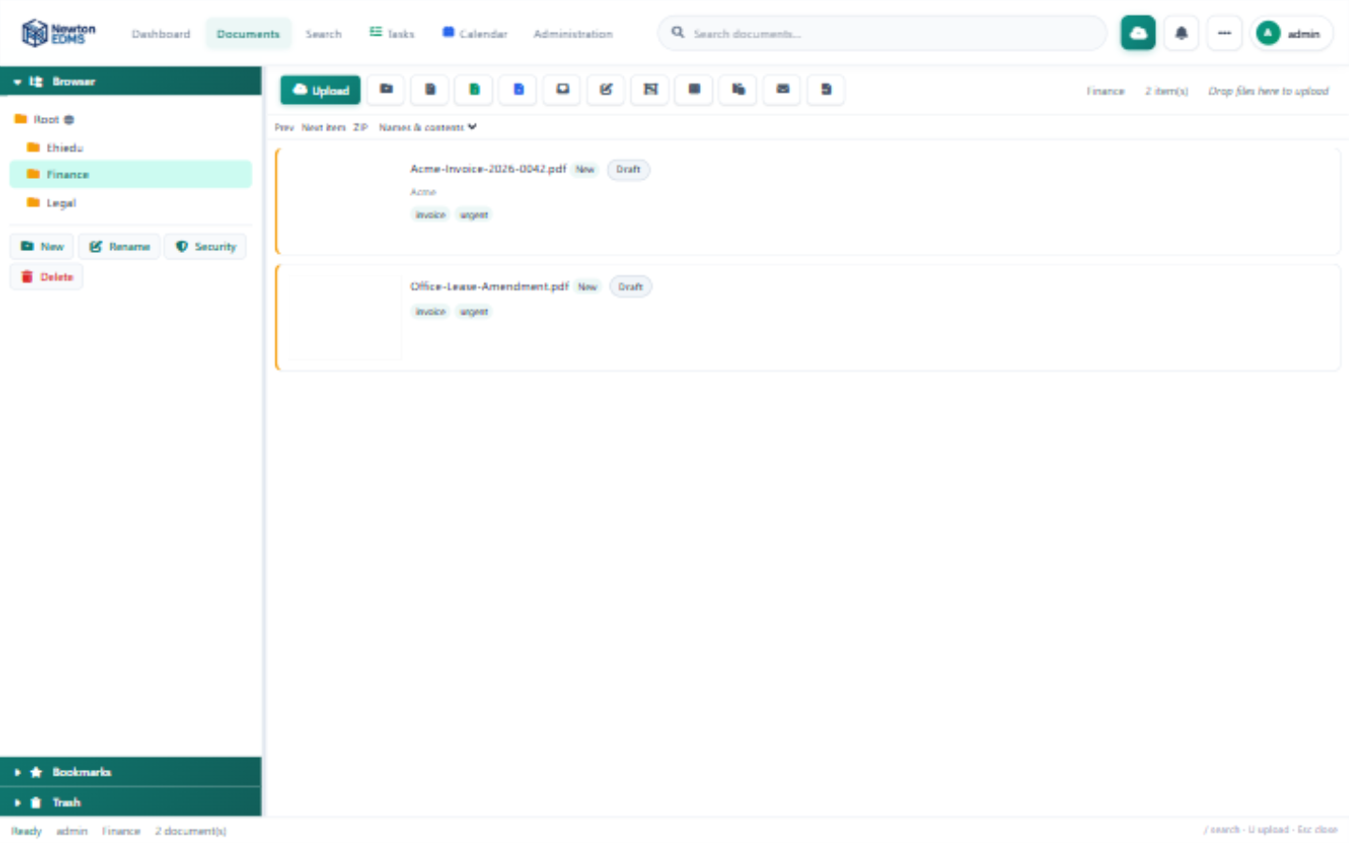
Figure 4 — An open folder with documents
Each document card shows the title, workflow status, and tags. In the illustration the capture pipeline has automatically suggested the correspondent Acme and the tags invoice and urgent from the document contents; you can accept or change these suggestions at any time.

5. Uploading Documents
Click Upload in the header or in the toolbar of the folder you want to file into.
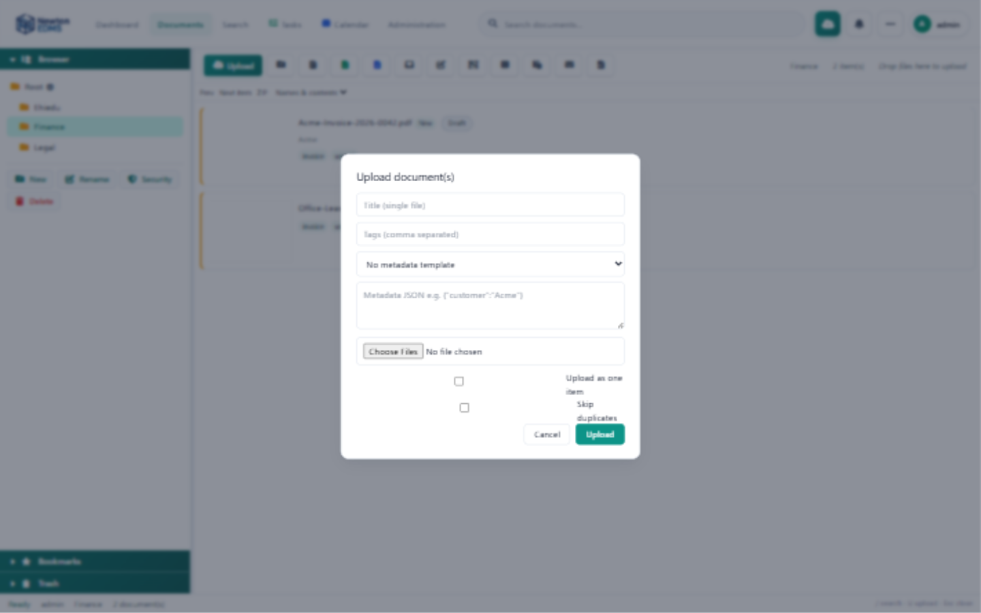
Figure 5 — The upload dialog
Table 2 — Upload dialog fields
Field | Purpose
Title | Used when uploading a single file.
Tags | Comma-separated tags applied on upload.
Template | Optionally applies a metadata template with custom fields.
Metadata JSON | Extra custom fields, for example {"customer": "Acme"}.
Upload as one item | Combines multiple selected files into a single multi-file item.
Skip duplicates | Files whose content hash is already known are ignored.
After upload, the background processor keeps the untouched original, computes the content hash, extracts text (with OCR for scans), suggests tags, contacts, and dates, and adds the document to the search index. This usually completes within seconds; the Processing inbox in the toolbar shows anything still being worked on.

6. The Document Inspector
Click any document to open the inspector, the panel on the right that accompanies every document task.
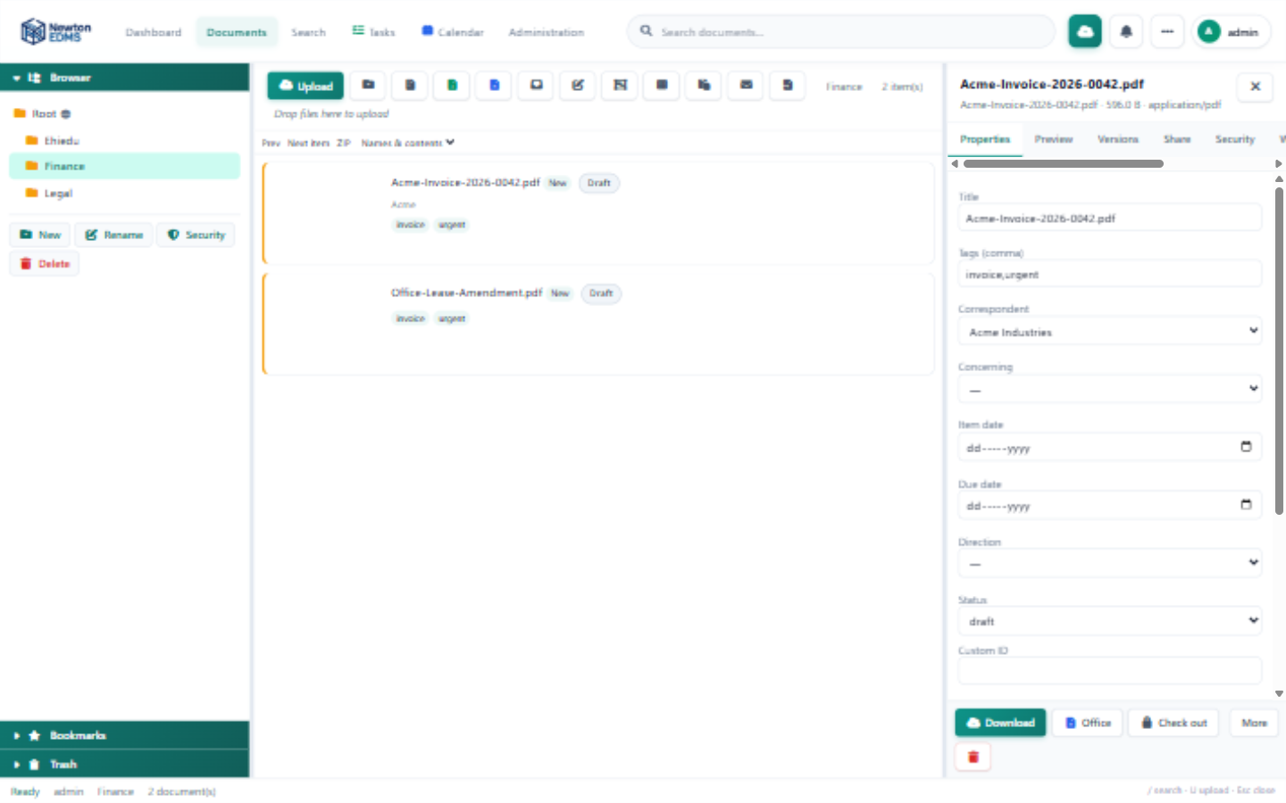
Figure 6 — The inspector showing document properties
Table 3 — Inspector tabs
Tab | What you can do
Properties | Rename, set status, tags, and rating, edit custom fields.
Preview | View the document in the browser (PDF, images, text).
Versions | Browse the version history, add a version, restore (Chapter 7).
Share | Share links with permission levels, internal grants, ownership transfer (Chapter 8).
Security | Fine-grained access bits: read, write, delete, download, and more.
Workflow | Start a review workflow on the document.
PDF / Sign | Watermark, stamp, and digital signatures (Chapter 9).
More | Notes and comments, links, history, aliases, subscriptions, attachments.
The footer of the inspector holds quick actions: Download, Office (for desktop and online editing), the check-out and check-in lock, and Delete.

7. Versioning and Check-Out
Every change that replaces a file creates a new version. Nothing is ever overwritten: earlier versions remain listed and downloadable, so you can always prove what a document looked like at any point in time.
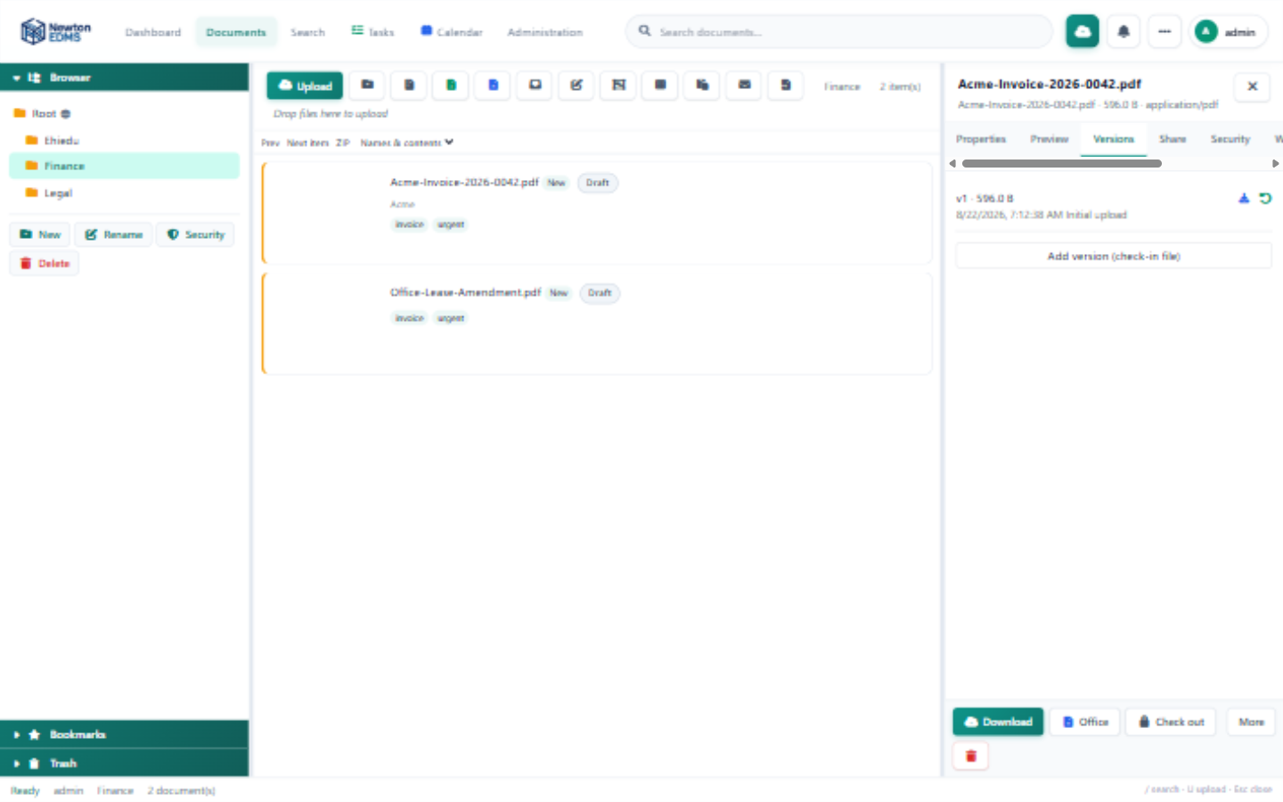
Figure 7 — The version history of a document
- Add version uploads a new file as the next version and prompts you for a version comment, such as Revised payment terms.
- Restore rolls back to an earlier version. The current file is itself preserved as a new version, so restores are never destructive.
- Check-out and check-in (the padlock in the inspector footer) lock a document while you work on it. Other users with edit rights cannot replace the file until you check it back in.

8. Sharing Documents
Open the Share tab in the inspector to share a document with colleagues or with external people.
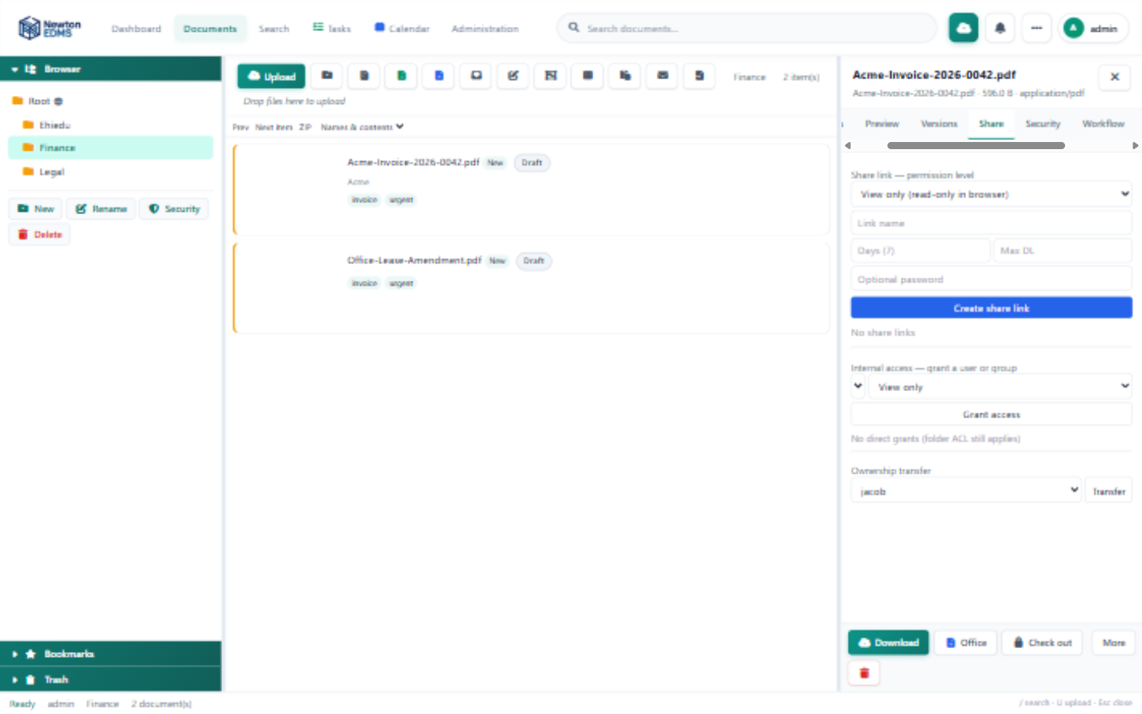
Figure 8 — The Share tab with permission levels, grants, and ownership transfer

8.1 Share links
Share links work for people without a NewtonEDMS account. When you create a link you choose a permission level:
Table 4 — Share link permission levels
Level | What recipients can do
View only | Open a web page that shows the document in the browser. Downloading is disabled.
View & comment | The same page plus a comment box; reviewers type their name and comment, and the comments appear in the document's Notes tab marked via share.
Download | A classic download link with an optional download counter.
Every link can carry an optional password, an expiry date (seven days by default), and a download cap for download links, and any link can be revoked at any moment. View and comment pages render PDFs and images directly in the browser.

8.2 Internal access
Below the link section, Internal access grants a specific user or group View only or Edit rights on the document — the natural way to give the finance team access to an invoice. Grants are listed as chips and can be revoked with one click.

8.3 Ownership transfer
The Ownership transfer section, visible to the document owner and to administrators, hands the document to another user. The new owner also takes over any open check-out. This is the right tool when people change roles or leave the organization.

9. Signing a Document
Open the inspector's PDF / Sign tab.
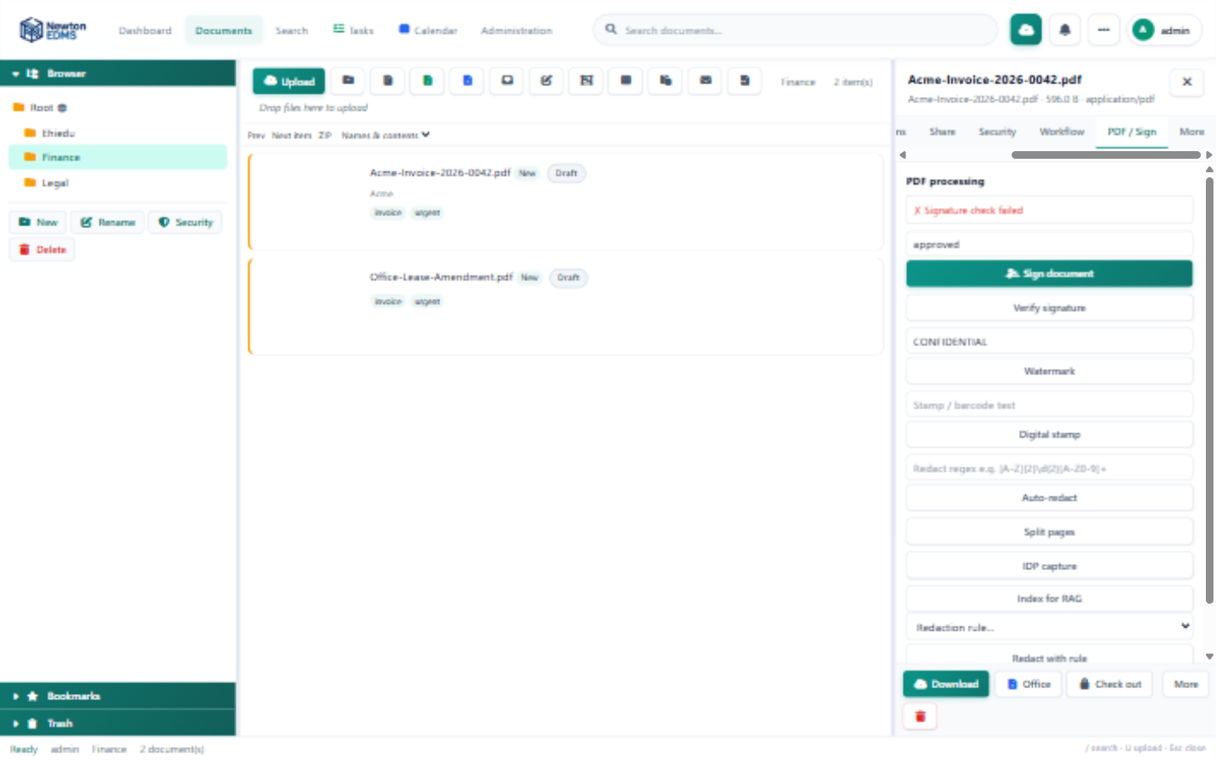
Figure 9 — The PDF / Sign tab with signature status and actions
The status box at the top shows whether the document is already signed, by whom, and when. To sign, enter a reason (for example, Approved for payment) and click Sign document. NewtonEDMS applies a visible signature stamp and embeds a cryptographic PAdES signature inside the PDF, which readers such as Adobe Acrobat can verify independently. The Verify signature button re-checks the embedded signature at any time.
The same tab offers Watermark, Digital stamp, Auto-redact (pattern-based removal of sensitive text), Split pages, and IDP capture for extracting data from fixed zones of a form.

10. People: Address Book, Users, and Groups
Open Dashboard, then People. The page has up to three sub-tabs; users and groups are visible to administrators only.
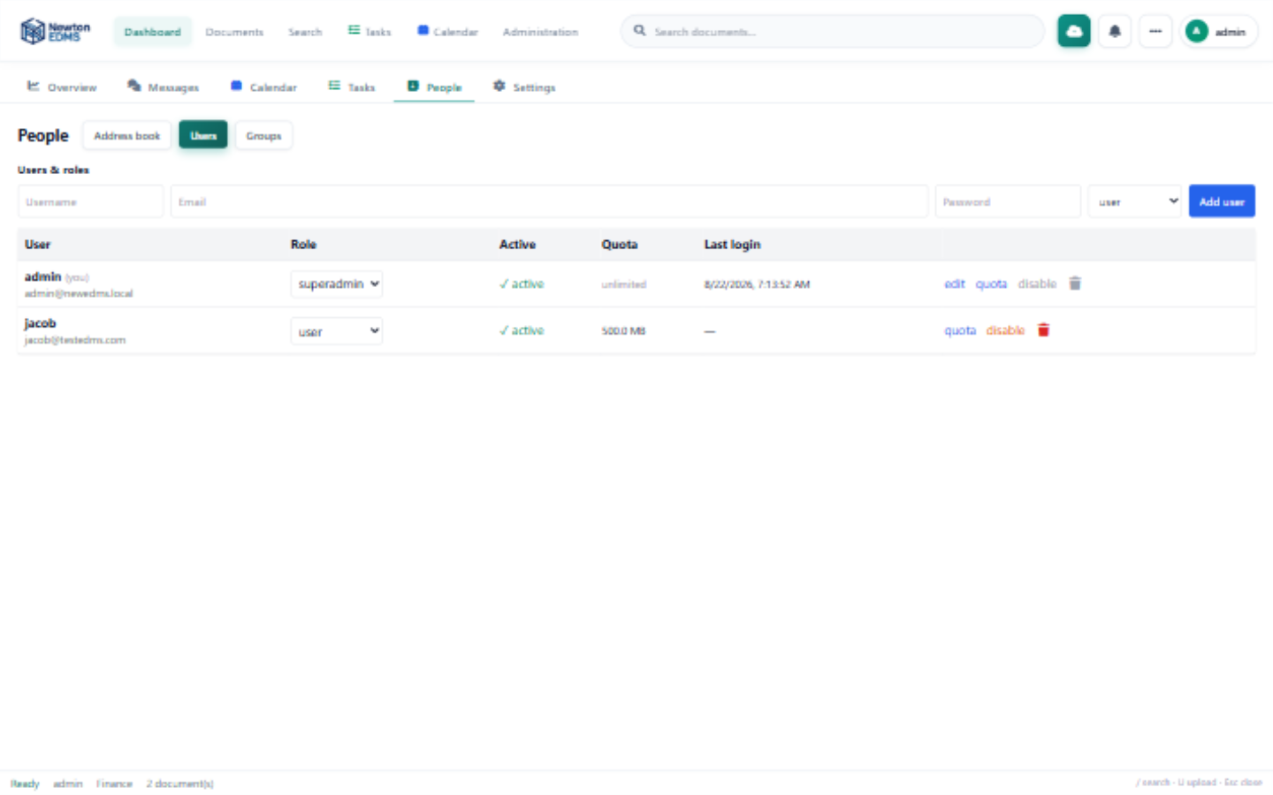
Figure 10 — People — user management

10.1 Users and roles
Administrators create users with a username, e-mail, initial password, and role (user, manager, admin, or superadmin). Each row shows the role, which can be changed with the drop-down, the active or disabled state, the storage quota, and the last login. The row actions set a storage quota in megabytes (zero means unlimited), disable or enable an account (blocking login without deleting anything), and delete — which is refused for accounts that own content, because their documents must keep a valid provenance chain; deactivate instead.
For your own account the disable and delete buttons are intentionally locked: deactivating yourself would lock you out of the system.
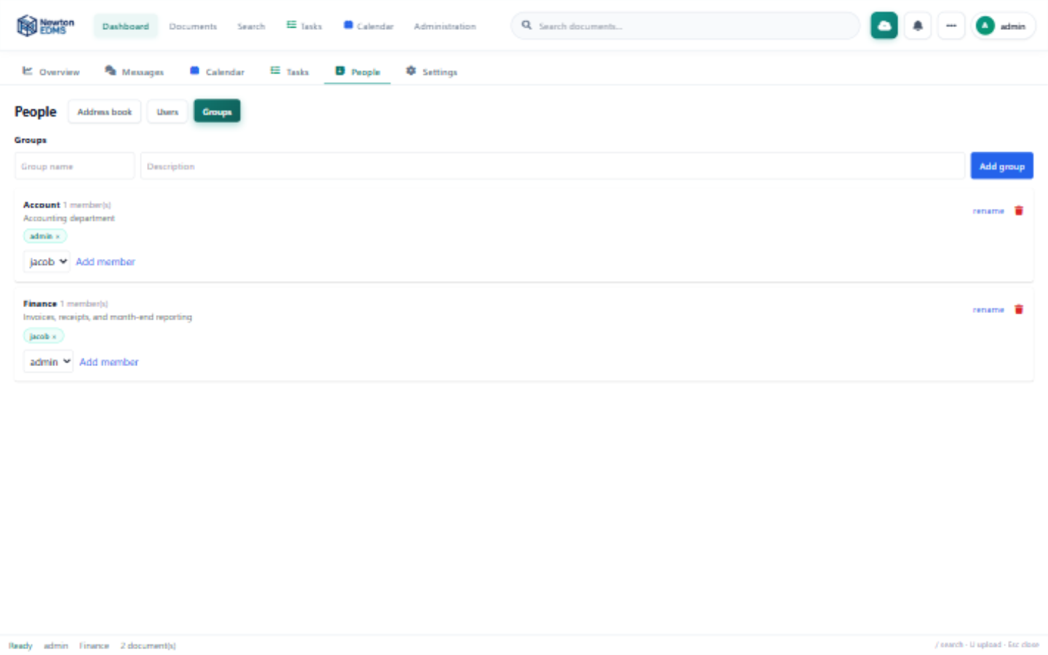
Figure 11 — People — group management

10.2 Groups
Groups bundle users for permission grants. Create a group with a name and description, add members from the drop-down, and remove them with the chips. Groups can be granted folder and document permissions in the Security tab and internal access in the Share tab — one grant then covers everyone in the group.

10.3 Address book
The address book manages correspondents and concerning parties. The capture pipeline uses it to suggest contacts when new documents arrive.

11. Search and the Query Language
Type in the header search box and press Enter, or open the Search tab for full-text and parameter forms. The search box accepts structured filters that can be combined freely; remaining words are matched against the full text, including OCR results from scans.
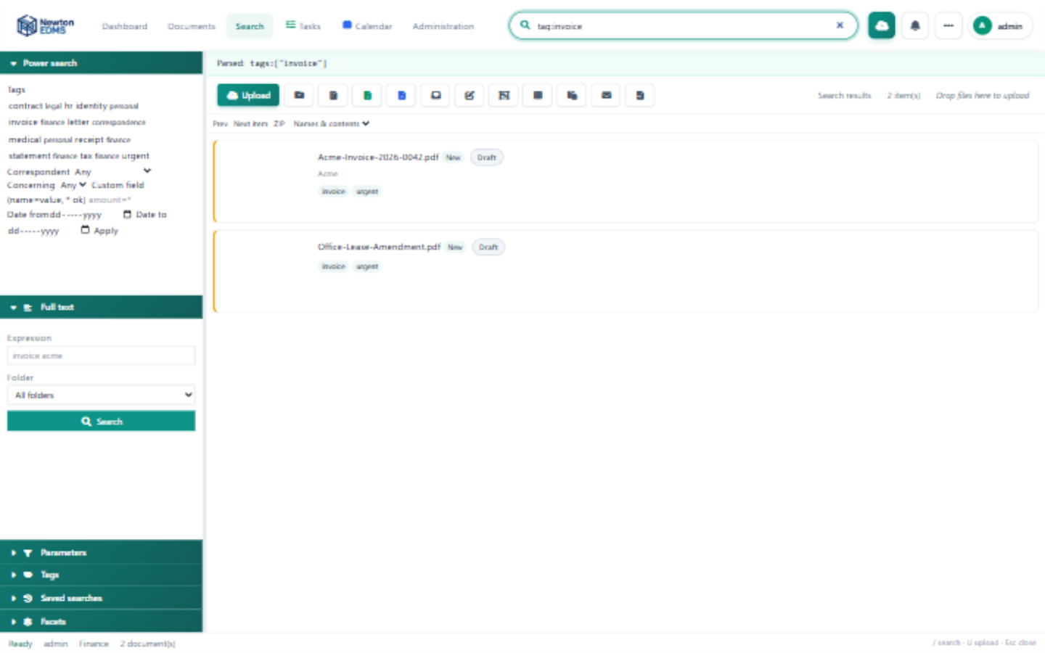
Figure 12 — Search results for the query tag:invoice
Table 5 — Query fields
Field | Meaning
tag: | Has this tag.
correspondent: / concerning: | Linked contact.
status: | draft, review, approved, published, or archived.
folder: | Folder identifier.
due: | overdue, none, or a year and month such as 2026-09.
source: | Where the document came from: upload, email, scan, and so on.
name: / notes: / custom: | Search a specific field.
inbox | Only unprocessed items.
Save frequent searches with Tools, then Save search; they appear under Bookmarks in the folder browser.

12. Tasks, Calendar, and Messages
The bell icon and Dashboard, then Tasks, list your review and approval tasks; you can approve or reject each with an optional comment. The calendar shows due dates, retention events, and your own entries, and Messages is the internal mail between users. The badge on the Tasks tab counts your unread notifications.

13. Personal Settings
Open the account menu at the top right, then Settings.
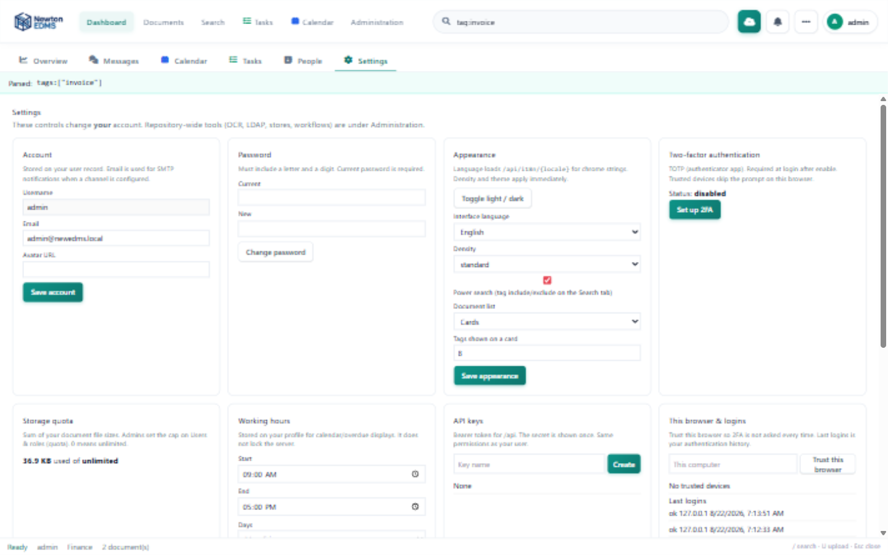
Figure 13 — Personal settings
- Appearance: theme, language, density, and avatar.
- Two-factor authentication: enable TOTP with any authenticator app by scanning the secret and confirming one code.
- Quota: how much of your storage allowance you have used.
- API keys: create and revoke tokens for scripted access.
- Trusted devices and recent logins for account security.

14. Administration
Administrators see an extra Administration tab. The left rail groups every setting area, and the filter box at the top jumps straight to any of them.
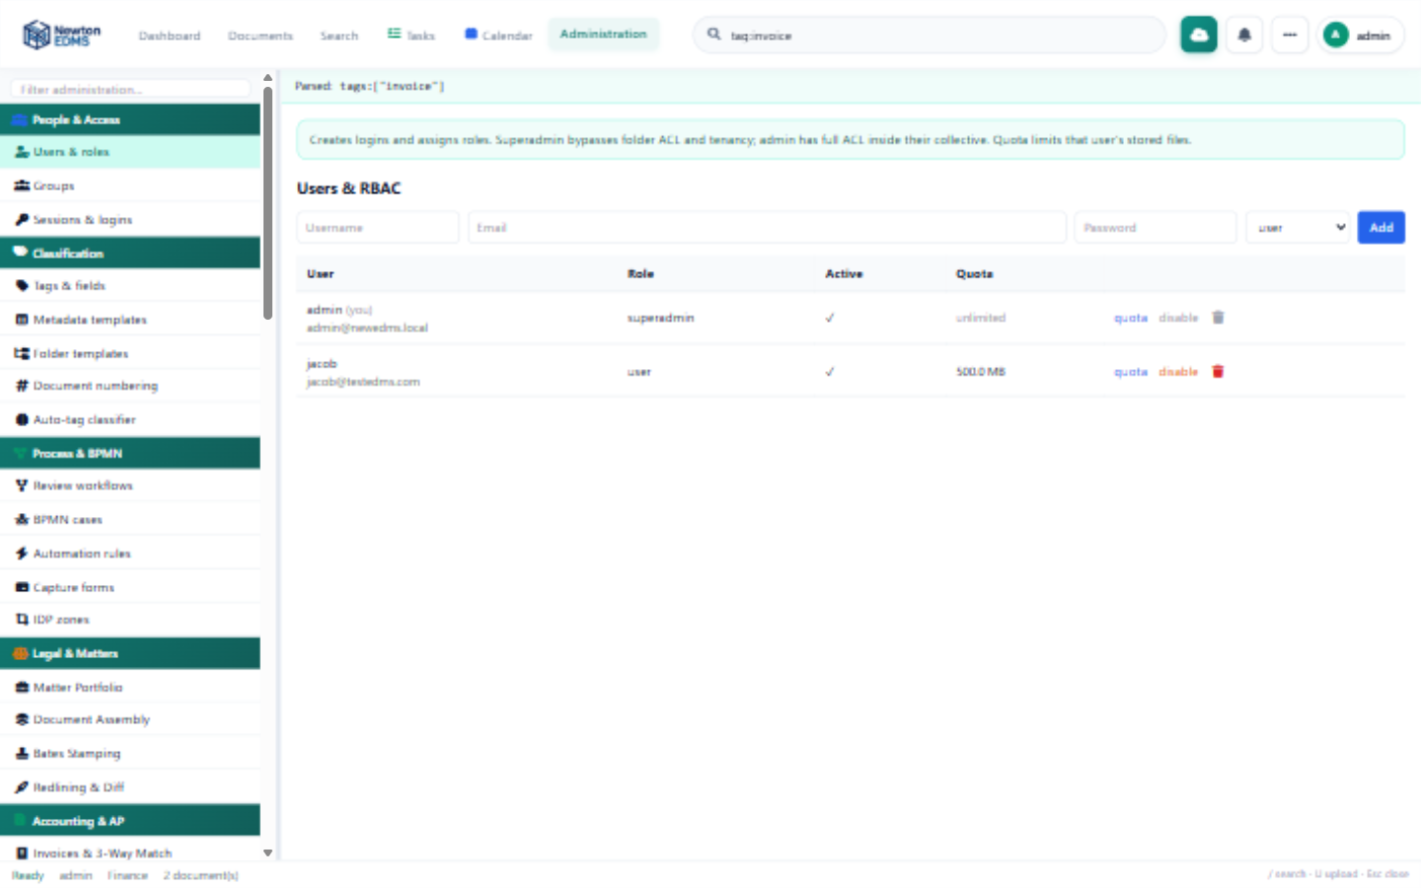
Figure 14 — The administration console
Table 6 — Administration areas
Group | Contains
People | Users and roles, groups, sessions and logins.
Classification | Tags and fields, metadata templates, folder templates, numbering, auto-tag classifier.
Process | Review workflows, BPMN cases, automation rules, capture forms, IDP zones.
Ingest | Hot folders, mailbox import, anonymous upload URLs, CSV import, scanner, backup.
Integrations | SMTP and IMAP accounts, Microsoft Office, LDAP and SAML, connectors, protocols, addons.
Storage & jobs | File stores, OCR and converters, search index, processing jobs, schedules, cluster.
Security & retention | Login and IP policy, legal hold, GDPR export, redaction rules, retention, audit, compliance.
Sharing & insights | Share links, query shares, notifications, reports, report builder, RAG, server log.

15. Keyboard Shortcuts
Table 7 — Keyboard shortcuts
Key | Action
/ | Focus the search box.
U | Open the upload dialog.
Esc | Close the inspector and dialogs.
NewtonEDMS — every file, found and governed.

