Analysis of Algorithms Lab 04

Felix Rolando Gonzalez
Knapsack: Analysis_Algorithms/Codes/lab_4_KDF.cpp at main · rolandogonzlz/Analysis_Algorithms

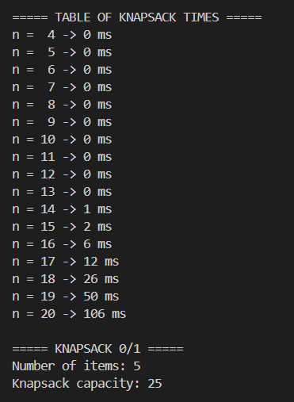
1. Solve the 0/1 Knapsack problem using exhaustive search. Generate the problem, capacity, weights, and values randomly for a problem size n. You could also use a benchmark dataset if you wish. Find which is the biggest problem size n that you can solve in 10min. You will have to record in a table the execution time for each n = 4,5,6,…

The results of the Knapsack 0/1 algorithm show that the program worked correctly for all the tested values of n. For small inputs, from n = 4 to n = 13, the execution time was 0 ms, which means the program solved those cases almost instantly. Starting at n = 14, the running time began to increase little by little, reaching 106 ms at n = 20. This behavior makes sense because the exhaustive search method checks all possible combinations of items, so the number of possibilities grows very fast as n becomes larger.

In the example with 5 items, the knapsack capacity was 25, and the best solution found had a total value of 25 and a total weight of 23. The selected items were 0, 1, 3, and 4. This means the algorithm was able to find the combination with the highest value without exceeding the allowed capacity. Even though this case was small and the execution time was only 0 ms.

2. Implement a Depth First Search algorithm to print the values of each node in a graph. Decide which data structure to use: adjacency matrix or adjacency list.

For the DFS part, the traversal starting from node 0 produced the order 0 1 3 4 5 2. This result shows that the algorithm explored the graph in depth, following one branch as far as possible before going back and continuing with other nodes. That is exactly how Depth First Search is supposed to work. The implementation successfully visited all nodes in the graph without repeating already visited ones, which means the visited control was working correctly.
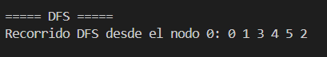

3. Implement a Breadth First algorithm to print the values of each node in a graph. Decide which data structure to use: adjacency matrix or adjacency list.
For the BFS part, the traversal starting from node 0 produced the order 0 1 2 3 4 5. This result shows that the algorithm visited the graph level by level. It first visited node 0, then its immediate neighbors 1 and 2, and after that it continued with the next level, visiting nodes 3, 4, and 5. This is the expected behavior of Breadth First Search, so the implementation can be considered correct.
