#1 Feladat:

db.collection.find({},

{

user_id: 1,

firstName: 1,

lastname: 1,

_id: 0

})

#2 Feladat:

db.collection.find({

firstName: "Grace"

},

{

email: 1,

password: 1,

_id: 0

})

#7 Feladat:

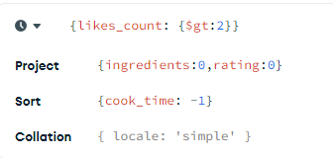

#8 Feladat:

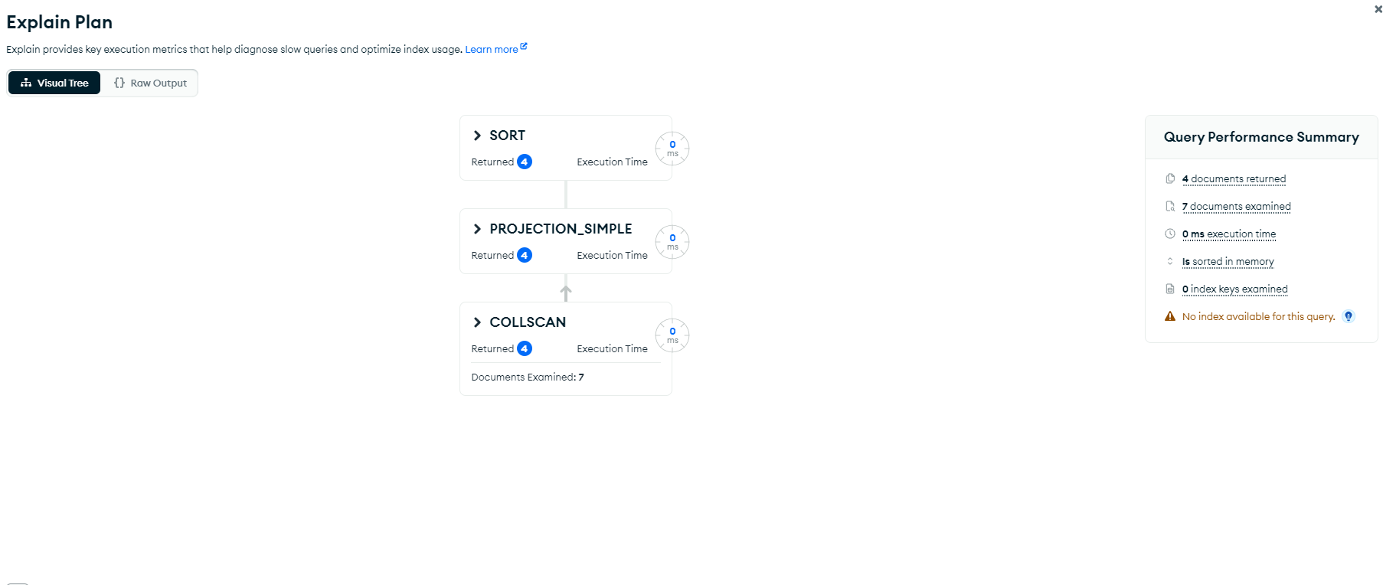

#9 Feladat: 

#11 feladat:

db.receptek.find({"title": {$regex: /Taco/}}).sort({"title": -1}).limit(2).pretty()

#12 feladat:  
db.receptek.aggregate([ { $group: { _id: "$type", osszeg: { $sum: "$cook_time" } } }] )

#13 feladat:

db.receptek.find({$and: [{servings: 4},{tags: {$in: ["quick","easy"]}}]},{}).count()