Amos Roland
Southern New Hampshire University
CS-499 Computer Science Capston
Professor Akhil Gudivada
02 November 2025

CS 499 Module One Assignment

- Self-Introduction: Address all of the following questions to introduce yourself.

  - How long have you been in the Computer Science program?

I am Amos Roland, an active duty Hospital Corpsman Second Class (HM2) in the United States Navy currently pursuing a Bachelor of Science in Computer Science at Southern New Hampshire University. I began this program in early 2023 and have dedicated approximately three years to developing my academic and technical expertise while serving full-time. My coursework has strengthened my understanding of software development, cybersecurity, artificial intelligence, and data management.

  - What have you learned while in the program? List three of the most important concepts or skills you have learned.

Throughout my time in the Computer Science program, I have learned several essential concepts that define how technology solves real-world problems.
The first important skill I have gained is software development and engineering, where I learned how to design and build applications using structured programming principles, testing strategies, and the software development life cycle. I became more comfortable coding in languages such as Java, Python, and JavaScript.
The second major skill is data management and database design. I learned how to use both SQL and NoSQL systems, including MySQL and MongoDB, to store and manage data efficiently. This knowledge helped me understand the importance of data integrity, relationships, and security.
The third skill is information security. I learned how to protect data and systems from unauthorized access, which directly supports my professional interest in cybersecurity. These lessons taught me the importance of encryption, secure authentication, and identifying vulnerabilities in code and architecture.

  - Discuss the specific skills you aim to demonstrate through your enhancements to reach each of the course outcomes.

My goal is to demonstrate strong problem-solving, analytical, and collaborative skills through the enhancements I will perform on my selected artifacts. These enhancements will allow me to meet all five CS 499 course outcomes by applying algorithmic principles, secure software design, and full-stack development best practices. By doing so, I aim to showcase my growth as a computer science professional capable of developing and deploying real-world applications.

  - How do the specific skills you will demonstrate align with your career plans related to your degree?

The skills I plan to demonstrate align with my goal of becoming an information security professional within the field of computer science. By improving my software engineering and data management skills, I will be prepared to develop secure and scalable systems. The ability to identify and fix vulnerabilities in design and code will help me transition into a career that focuses on secure software development, data protection, and threat mitigation. These enhancements will strengthen my technical portfolio and demonstrate my readiness to work in both software and security environments.

  - How does this contribute to the specialization you are targeting for your career?

My specialization in information security focuses on preventing and managing digital threats. Enhancing my artifacts will help me demonstrate how to apply secure coding practices, encryption, and safe database management. It will also show my ability to integrate data protection measures in application design and manage sensitive data responsibly. The projects will strengthen my ability to analyze risks, build secure systems, and contribute to the field of cybersecurity through software solutions.

- ePortfolio Set Up:

  - Submit a screen capture of your ePortfolio GitHub Pages home page that clearly shows your URL.
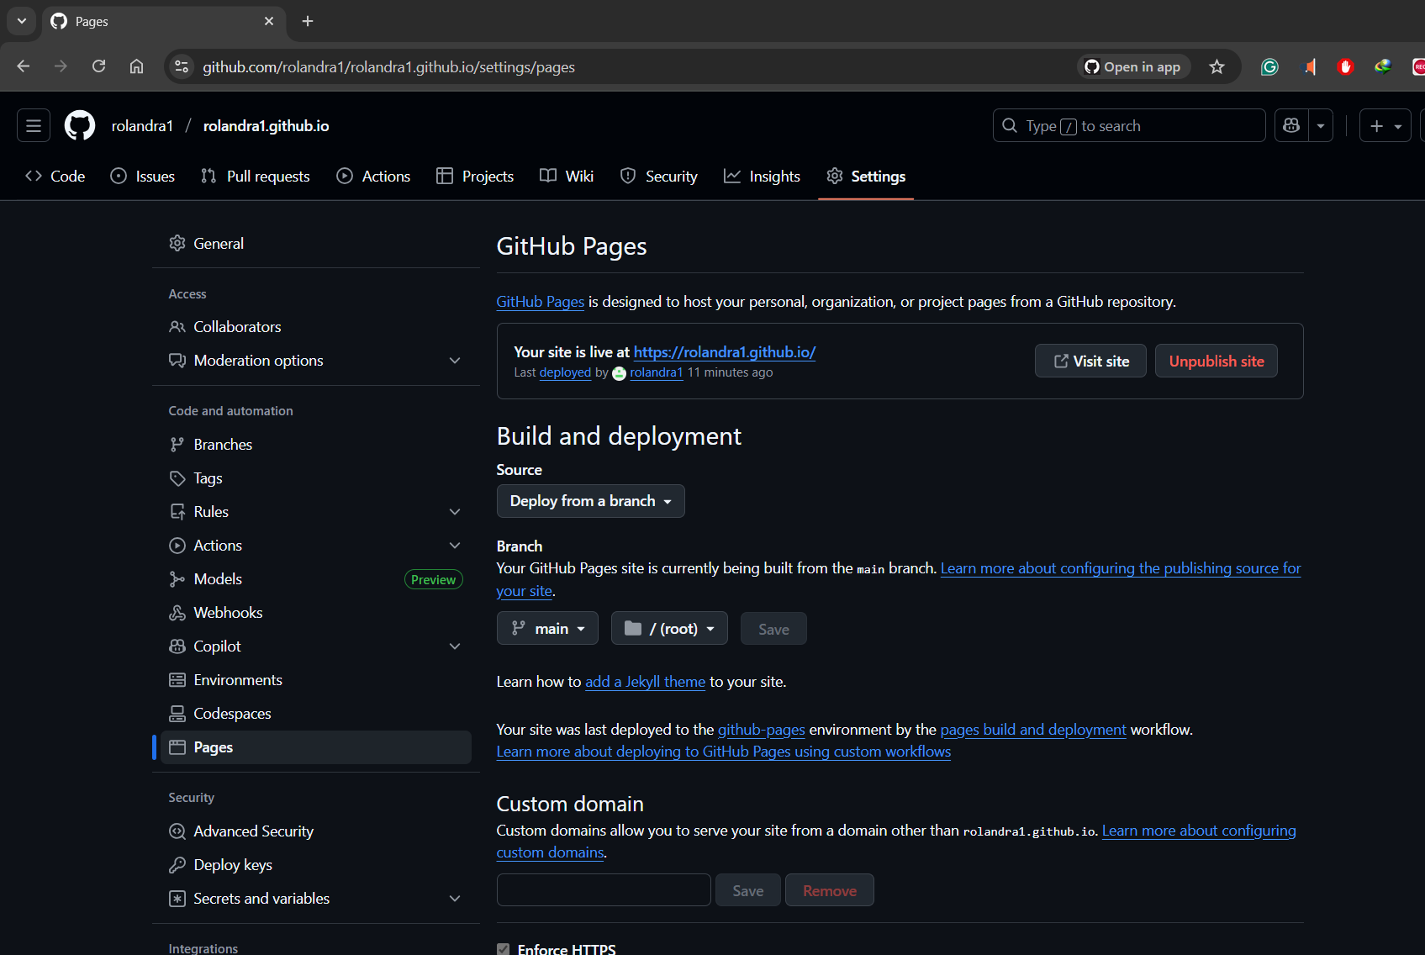

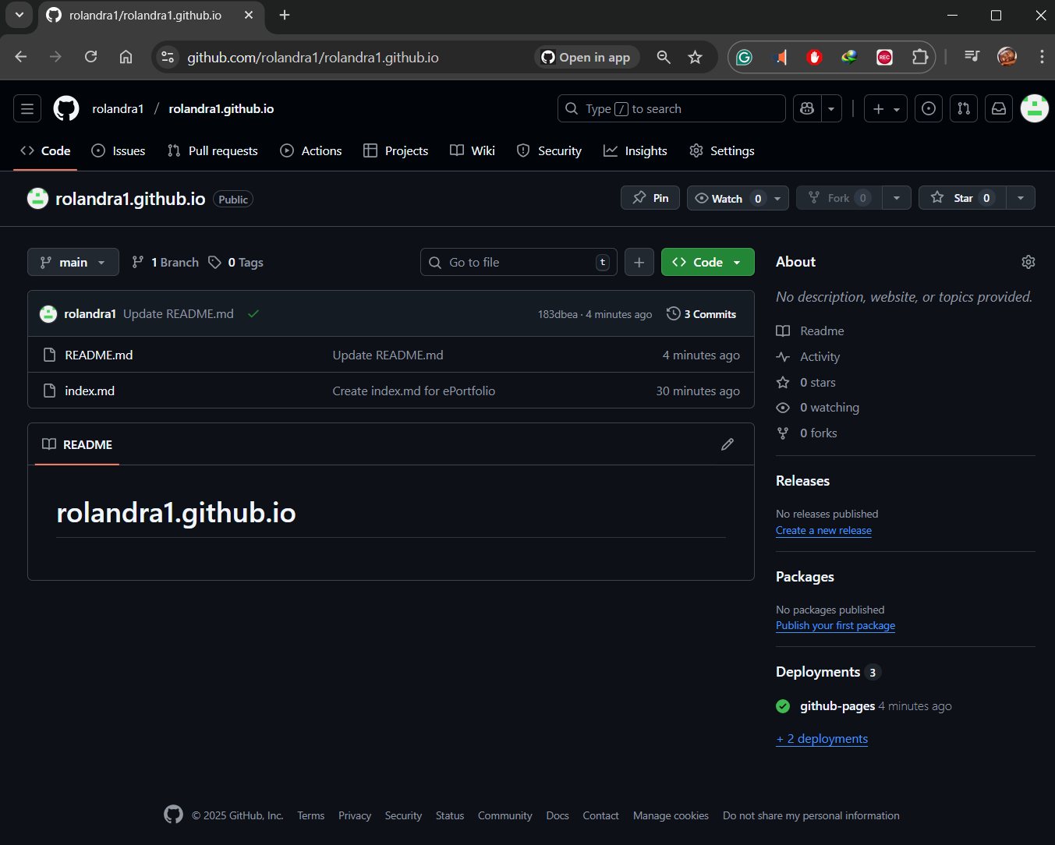

- Enhancement Plan:

  - Category One: Software Engineering and Design
    - Select an artifact that is aligned with the software engineering and design category and explain its origin. Submit a file containing the code for the artifact you choose with your enhancement plan.

Artifact: Travlr Getaways Full Stack Website
Course of Origin: CS 465 Full Stack Development I

This artifact was originally created as a travel website that allows users to browse and explore destinations. It was built using Node.js, Express, and Handlebars with a simple MVC structure. In its initial version, the site used static JSON files for data and did not include any persistent storage or authentication system. Because of these limitations, the project is well suited for enhancement into a full RESTful web service with database integration. The enhancement will focus on improving functionality, scalability, and security by connecting the application to MongoDB and converting it into a modern, API-driven architecture. I selected this artifact because it allows me to demonstrate my understanding of full stack software engineering, security integration, and scalable architecture design.

    - Describe a practical, well-illustrated plan for enhancement in alignment with the category, including a pseudocode or flowchart that illustrates the planned enhancement.

The goal of this enhancement is to transform the existing static site into a dynamic full stack application with a secure and modular backend. I plan to integrate MongoDB using Mongoose for data persistence and create separate controller and service layers to follow a clean architectural structure. A secure authentication system will also be implemented using JSON Web Tokens (JWT), along with middleware for validation, error handling, and security headers.
- Enhancement Steps:
- Database Integration: Add MongoDB with Mongoose models for users, trips, and bookings.
- API Refactoring: Replace Handlebars routes with RESTful API endpoints for creating, reading, updating, and deleting data.
- Authentication: Add registration and login routes that use JWTs for session management.
- Validation and Security: Implement middleware for validating input data, handling errors, and applying security headers using Helmet.
- Testing and Documentation: Test endpoints with Postman and create API documentation for developers.
- Pseudocode for Trip API:

IF user requests GET /api/trips
READ query parameters (search, page, limit)
CALL TripService.findTrips()
RETURN JSON response with trip data
ELSE IF user sends POST /api/trips
VALIDATE input data
IF validation passes
CREATE new trip in database
RETURN success response
ELSE
RETURN error message

    - Explain how the planned enhancement will demonstrate specific skills and align with course outcomes.

      - Identify and describe the specific skills you will demonstrate that align with the course outcome.

- Software architecture and modular design: I will separate concerns into routes, controllers, and services.
- Database design and persistence: I will model users, trips, bookings, and reviews in MongoDB with Mongoose, including validation and relationships.
- API design and standards compliance: I will create REST endpoints with clear resources, pagination, filtering, and consistent error formats.
- Security practices: I will implement JWT authentication, role-based authorization, secure password storage, input validation, security headers, secret management, and rate limiting.
- Testing and reliability: I will write unit and integration tests, seed data for test scenarios, and use an error middleware with trace IDs for observability.
- DevOps awareness: I will add environment configuration and containerization to support repeatable local and deployment setups.

Implementing JWT authentication and structured validation not only enhances system security but also demonstrates my ability to design professional computing solutions that align with industry and ethical standards. This improvement connects directly to the course outcomes by showing my ability to apply secure, scalable, and standards-based practices.

      - Select one or more of the course outcomes below that your enhancement will align with.

- Outcome 3: Design and evaluate computing solutions using algorithmic principles and practices while managing trade-offs.
I will design search and pagination logic for trips, calculate booking totals, and evaluate trade-offs between simplicity and performance in queries and indexing.

- Outcome 4: Use well-founded and innovative techniques, skills, and tools to implement computing solutions that deliver value.
I will employ Express, Mongoose, JWT, structured validation, and automated testing to deliver a professional-quality API that supports future clients.

- Outcome 5: Develop a security mindset to anticipate exploits, mitigate design flaws, and protect data and resources.
I will apply defense in depth with authentication, authorization, validation, sanitization, security headers, secret storage, and logging with traceability.

  - Category Two: Algorithms and Data Structures

- Select an artifact that is aligned with the algorithms and data structures category and explain its origin. Submit a file containing the code for the artifact you choose with your enhancement plan. You may choose work from the courses listed under Category One.

Artifact: Deep Q-Learning Cartpole
Origin of Artifact: CS 370 Artificial Intelligence

My artifact is the Deep Q Learning Cartpole project from CS 370 Artificial Intelligence. The original notebook trains a neural network to balance a pole using experience replay and an epsilon greedy policy. It logs episode rewards and ends with a saved model. I selected this artifact because it demonstrates my ability to apply reinforcement learning and algorithmic optimization techniques in a simulated environment.

- Describe a practical, well-illustrated plan for enhancement in alignment with the category, including a pseudocode or flowchart that illustrates the planned enhancement.

I will improve algorithmic stability, data efficiency, and clarity of analysis. The plan includes Double DQN to reduce value overestimation, a target network with soft updates, prioritized experience replay to sample informative transitions, a carefully tuned epsilon schedule, gradient clipping, and a clean evaluation harness with confidence intervals. I will also add a light comparison to a basic policy gradient agent to justify design choices.
Key steps:

- Replace single network updates with Double DQN updates that select an action from the online network and evaluate it with the target network.
- Use a target network with soft update tau for stable learning.
- Implement Prioritized Experience Replay with proportional priority and importance sampling weights.
- Tune epsilon decay, learning rate, and discount factor through short sweeps.
- Add gradient clipping and reward normalization.
- Create an evaluation harness that runs fixed seeds and reports mean and standard deviation of episode returns.
- Produce plots that show learning curves and moving averages and compare DQN and DDQN.

Pseudocode for the planned enhancement

BEGIN Enhance_DQN_Cartpole
INITIALIZE OnlineNet, TargetNet ← same weights
INITIALIZE PER_Buffer(alpha, beta0), epsilon ← 1.0

FOR episode IN 1..N:
state ← env.reset()
WHILE not done:
WITH prob epsilon:
action ← random_action()
ELSE:
action ← argmax_a OnlineNet.Q(state, a)

next_state, reward, done ← env.step(action)
td_error ← |reward + gamma * max_a' TargetNet.Q(next_state, a') - OnlineNet.Q(state, action)|
PER_Buffer.add(state, action, reward, next_state, done, priority=td_error)

state ← next_state

IF time_to_learn():
batch, idxs, ISw ← PER_Buffer.sample(batch_size)
// Double DQN target
a_star ← argmax_a' OnlineNet.Q(batch.next_state, a')
y ← batch.reward + gamma * (1 - batch.done) * TargetNet.Q(batch.next_state, a_star)
loss ← MSE(OnlineNet.Q(batch.state, batch.action), y) weighted by ISw
BACKPROP with gradient_clipping
UPDATE priorities(idxs, new_td_errors)

SOFT_UPDATE(TargetNet, OnlineNet, tau)
END WHILE

epsilon ← max(eps_min, eps_decay * epsilon)
LOG episode_return
END FOR

EVALUATE model over K seeds and REPORT mean ± std
END

- Explain how the planned enhancement will demonstrate specific skills and align with course outcomes.

  - Identify and describe the specific skills you will demonstrate to align with the course outcome.
- Algorithmic design and analysis through Double DQN and prioritized replay
- Data structure implementation for an indexed replay buffer with priorities
- Statistical evaluation of models with fixed seeds and summary statistics
- Clear visual communication of results and trade-offs

  - Select one or more of the course outcomes listed under Category One that your enhancement will align with.
- Outcome 3: I will design and evaluate a computing solution using algorithmic principles and explain trade offs in stability and sample efficiency
- Outcome 4: I will apply innovative tools including deep learning libraries, vectorized operations, and evaluation harnesses
- Outcome 2: I will create clear narrative and visuals that are technically sound and adapted to the audience

  - Category Three: Databases

    - Select an artifact that is aligned with the databases category and explain its origin. Submit a file containing the code for the artifact you choose with your enhancement plan. You may choose work from the courses listed under Category One.

Artifact: Android Mobile App – Weight Tracking App
Origin of Artifact: CS 360 Mobile Architecture and Programming

This app was designed to let users track their daily weight progress and goals. It uses Android Studio and a local SQLite database. I selected this artifact because it provides the opportunity to showcase secure data management, encryption, and cloud integration within a real mobile application.

    - Describe a practical, well-illustrated plan for enhancement in alignment with the category, including a pseudocode or flowchart that illustrates the planned enhancement.

I will enhance the app by integrating a cloud database using Firebase, adding user authentication, and improving the user interface for better accessibility. I will also implement encryption for sensitive user data such as weight and goal information.
Pseudocode for Data Enhancement
IF user registers:
STORE credentials in Firebase Auth
CREATE secure database node for user
IF user adds weight:
VALIDATE input data
ENCRYPT before storage
UPDATE user progress in Firebase
DISPLAY progress chart dynamically

Security updates will include hashed credentials, encrypted storage, and controlled access. I will also update the UI with Material Design components for clarity and user satisfaction.

    - Explain how the planned enhancement will demonstrate specific skills and align with course outcomes.

      - Identify and describe the specific skills you will demonstrate that align with the course outcome.

- Cloud database design and real-time synchronization.
- Secure authentication and data encryption.
- CRUD operations and data validation for mobile applications.
- Cross-platform integration between local and cloud storage.

      - Select one or more of the course outcomes listed under Category One that your enhancement will align with.

- Outcome 4: Use innovative techniques and tools (Firebase, SQLCipher) for industry solutions.
- Outcome 5: Develop a security mindset by anticipating vulnerabilities and protecting data at rest and in transit.

- ePortfolio Overall Skill Set
  - Accurately describe the skill set to be illustrated by the ePortfolio overall.
    - Skills and outcomes planned to be illustrated in the code review

In my code reviews, I will demonstrate skills in secure coding, debugging, version control, and problem-solving. I will focus on software reliability, maintainability, and cybersecurity principles such as encryption and data validation.

    - Skills and outcomes planned to be illustrated in the narratives

My narratives will demonstrate critical thinking, project analysis, and communication skills. They will show how I applied algorithms, data structures, and security concepts to practical software projects.

    - Skills and outcomes planned to be illustrated in the professional self-assessment

My professional self-assessment will reflect my growth throughout the Computer Science program, including how I developed proficiency in programming, software design, data security, and ethical computing. It will highlight how these skills prepare me for a professional role in information security and software development.

