JARVIS 1.0
Automation Tool Manual

Created by: Kass Miranda

Date Created: 21May2013
I. Setting up Selenium Webdriver via Eclipse
- Open Eclipse located at .\ ALL ABOUT SELENIUM\ECLIPSE

- Browse the location of the workspace then click okay.

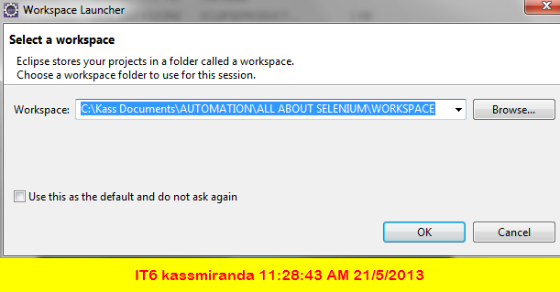

- Importing jar files: right click project - properties - java build path - go to libraries - add external jars - import (#2) - import all Jar files from the following folders:

  - . ALL ABOUT SELENIUM\LIB\
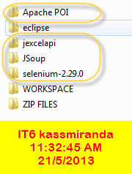

  - C:\Program Files (x86)\Java\jre7\lib
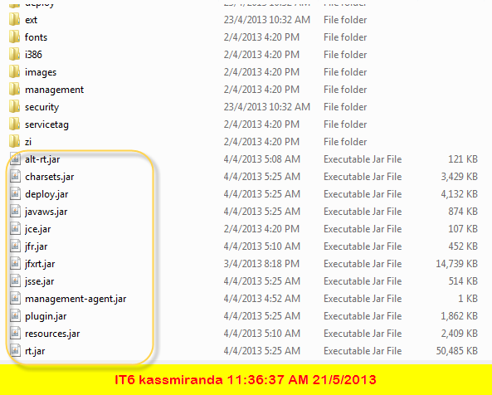

II. Installing TestNG
- First we need to install TestNG plugin for Eclipse.
- Go to Help – Install New Software – Click Add
- In Add Repository box, type TestNG and type the URL http://beust.com/eclipse
- TestNG plugin will added into Available Software List.
- Click on Next and follow the installation screen to complete the setup
- Restart Eclipse and go to Run menu and open Run Configurations

III. Compatible Browser:
- Firefox 18.0
- If you’re using a different version, uninstall current version
- Go to this site: https://ftp.mozilla.org/pub/mozilla.org/firefox/releases/18.0b7/win32/en-GB/
- Download the exe then install firefox

IV. Installing Firebug
- Open Firefox
- Go to Google and search Firefox Add-on
- Search for Firebug then install add-on
- Check if all add-ons are updated.
- Restart Firefox

V. Installing FirePath
- Open Firefox
- Go to Google and search Firefox Add-on
- Search for Firepath then install add-on
- Check if all add-ons are updated
- Restart Firefox

VI. Installing Apache POI (Java API for Microsoft Documents)
- Go to http://poi.apache.org/
- Download poi.jar
- importing jar file: right click project - properties - java build path - go to libraries - add external jars – select Apache Poi JAR file
- Restart Application

VII. Downloading Eclipse
Go to eclipse (http://www.eclipse.org/downloads/)
- Eclipse IDE for Java EE Developers, 221 MB

VIII. Downloading Selenium
http://docs.seleniumhq.org/download/
- download JAVA - Selenium Client & WebDriver Language Bindings

IX. Issues and Troubleshooting:

Error Details:
Error: Could not find or load main class CopyOfHybridFramework

Solution:
- Properties
- Java Build Path
- Remove all jar files
- Reload all jar files

