**WEB-BASED MEMBERSHIP**

**APPLICATION SYSTEM**

A Capstone Project

Submitted to the Faculty of

Department of Information Technology

Cavite State University

Imus City, Cavite

In partial fulfillment

of the requirements for the degree of

Bachelor of Science in Information Technology

**LUCION, MAXINE S.**

**PITOGO, SHARLYN CLAIRE S.**

**SORIANO, ERIC YEOJ H.**

January 2024

**INTRODUCTION**

CAPEDA Organization was first established and organized by Pablo Guerrero in the year of 1986. It is an organization that consists of pedicab drivers that provides the daily transportation of the residents residing in different parts of Camella Bacoor. As the years go by, Pedicabs transformed from manual *“padyak”* to electric powered bikes also called E-bikes. In the present year, there are 500 members of CAPEDA and still growing, only few drivers who use manual *padyak* remains and majority of them use Ebikes to as the main engine to run their pedicabs.

Pedicab is a mode of transportation that is both financial and environmentally friendly whilst also being slightly on par with other smoke-emitting vehicles when it comes to mobility. It is commonly found in the cities and local areas in the Philippines. In due course, it is inevitable that many Filipinos who have basic knowledge about driving a vehicle would want to attempt to make a living out of driving a pedicab since it’s getting popular among commuters.

As the population of pedicab drivers grows, collecting and preserving data has become even more challenging to CAPEDA Org., as their only method of gathering information is through transcribing it to Microsoft Word. With that in mind, the researchers aim to provide a solution by creating a Web-based Membership System to improve the organization’s method of gathering data and provide an even more convenient experience for both the organization’s staff and its members.

**Project Context**

CAPEDA is an organization of drivers from different barangays residing ranging from Salinas I to Salinas IV. It was founded by Pablo Guerrero on 1986. The organization was made to organize the pedicab drivers that provides daily transport of the residents from the barangays mentioned above. As of 2023, there are over 500 active members of CAPEDA. And due to the growing population of the drivers the auditor of CAPEDA org is having a hard time managing the information relevant to the organization. And his manual ways of organizing are by using his personal desktop and Microsoft Word. This adds up to his workload and makes the confidential data of CAPEDA vulnerable for problems.

**Purpose and Description**

The study was conducted to know the needs of the organization to improve the membership application process for the CAPEDA. The researcher developed a web-based system that will aid the organization’s needs to provide a convenient and accessible platform for the members and organize the application processes. This project has helped the CAPEDA to increase efficiency and accuracy in handling data, and have an easier and faster way of managing the organization; this system has benefitted both the client and the users.

**Objective of the study**

        Generally, this study aimed to help CAPEDA to have an efficient and effective way of handling membership application as well as the handling of data and information of the organization and its constituents.

  Specifically, this study aims to:

1.    Design and develop a web-based membership system that will replace the manual process of managing membership applications

2.   Manage and maintain the data and information of the members for future retrieval and reference

3.   Record data in a secured database to avoid problems that the existing method can cause.

4.   Improve the existing process of membership application

**Scope and Limitation**

The proponents developed a web-based Membership system for CAPEDA, that allows its affiliates to manage their membership process digitally instead of manually managing, requesting and storing their confidential documents for the membership process. The system has 4 main modules**: Login Module, Applicant Module, Member Module, and Admin Module.** These main modules have sub features that complete the requirements of the system. Listed below are the details of the features for each module:

**Applicant Profiles Module:** this module is responsible for accepting account profile applications that need validation from admins in order to access the main website.

**Login Module:** This module is responsible for validating the credentials of the account that attempts to log in to the system. The system has 3 user types. The admin is the highest rank of user type which consists of the CAPEDA Officers, If the account is validated as an admin the admin module will be accessible to the account, if the account is validated as a member the member module will be accessible to the account and when the user is validated as an applicant the applicant module will be accessible to the user. The login module requires username and password, if one of the credentials is incorrect, the login will not push through.

**Admin Module:** This module is only accessible for the admin profiles registered in the system. Only the admin has the authority to manipulate information inside the web bases system. In this module the admin can view the total number of the member profiles registered in the system, the active and inactive members, and pending account profile applications. The admin can also accept account profile applications, view the member’s personal information as well as manage it. In this module the admin is authorized to create a list of documents that is needed to be uploaded by the members. The admin can also view the uploaded documents and download it to save a soft copy of it.

**Applicant Module:** This module will be accessible to applicants that wants to apply for membership in CAPEDA org. This module is similar to member module but with less accessibility since this module will be centralized on accepting the applicant’s required documents in order for the admins/officer to monitor their eligibility of joining the organization.

**Member Module:** This module is only accessible to the registered members of CAPEDA. It has 3 sub features, it allows the employees to manage their account, manage their personal information, and upload documents that are requested by the admin. They can also download their own documents and save a soft copy of it.

The limitations of the system developed by the proponents are the following:

* The system is intended only for CAPEDA Org.
* The main focus of the system is the membership process of CAPEDA Org.
* The billing process only focuses on the payment for the membership fee.
* Only members of CAPEDA can access the system

**REVIEW OF RELATED LITERATURE**

**Related Literature**

**BookNow Software. (2023). Key Benefits of Member Management Software. URL:** [**https://booknowsoftware.com/key-benefits-of-member-management-software/**](https://booknowsoftware.com/key-benefits-of-member-management-software/)

According to an article for BookNow Software, having a member management system produce positive impacts for the business and its components. By having a software that will help with the management of data and information, businesses are more likely to perform better. It also attracts potential customers/members because it enables transparency by making sure members are able to see every detail they need to see. Also, this type of softwares provides peace of mind in exploring new ways of improving businesses. BookNow Software (2023).

**Davies Genealogy. (2019) Advantages of Online Applications. URL:** [**http://www.daviesgenealogy.com/advantages-of-online-job-applications/**](http://www.daviesgenealogy.com/advantages-of-online-job-applications/)

As indicated by an article published by Davies Genealogy, it is vital to understand that online applications are helping various organizations to accumulate qualified applicants and enhancing the overall candidate experience. Physically applying for a job can be time consuming and expensive, however, you have an opportunity to reduce all that by using online application platforms.

**Clear Company. (2022) Online Payment Importance and Benefits. URL:** [**https://www.clear.in/s/online-payment-importance-benefits**](https://www.clear.in/s/online-payment-importance-benefits)

Electronic payments have constantly undergone advancements making them hassle-free and fast ways of making payments. According to the article of Clear Company, payments through online can help businesses provide their customers with a convenient payment experience. Online payments have higher security such as tokenization, and encryption so the users wouldn’t have to worry about their data being stolen.

**Related Study**

**usanto, U., Nurlaela, L., Sopian, A., & Alfiah, F. (2022). Umrah Registration System Using Extreme Programming Method Towards Worship Tourism. *International Journal of Cyber and IT Service Management*, *3*(1), 22–31.** [**https://doi.org/10.34306/ijcitsm.v3i1.104(FOREIGN)**](https://doi.org/10.34306/ijcitsm.v3i1.104(FOREIGN))

                     A study conducted in 2022 paved the way for enhanced method of handling registration applications by developing a Registration System that helped with the daily transactions and handling of big amounts of data. It was also shown that having such a system helped the business to store big amounts of data, it also helped with the time consumption regarding the transaction processes of the business. usanto, U., Nurlaela, L., Sopian, A., & Alfiah, F. (2022).

**Fearnley, M., & Amora, J. (2020) Learning Management System Adoption in Higher Education Using the Extended Technology Acceptance Model. *De La Salle-College of Saint Benilde Manila Philippines,***

[**https://files.eric.ed.gov/fulltext/EJ1265695.pdf**](https://files.eric.ed.gov/fulltext/EJ1265695.pdf)**(LOCAL)**

According to Marissa Fearnley and Johnny Amora (2020). This study investigated factors that influenced adoption of a learning management system by higher education teachers using the technology acceptance model which incorporates three external constructs: system quality, perceived self-efficacy and facilitating conditions. Additionally, system quality directly affected perceived ease of use and attitudes toward technology use. Implications for practice, policy and potential research directions are likewise presented.

**Kwangho Jung & Sabinne Lee (2015) A Systematic Review of RFID Applications and Diffusion: Key Areas and Public Policy Issues,**

[**https://jopeninnovation.springeropen.com/articles/10.1186/s40852-015-0010-z**](https://jopeninnovation.springeropen.com/articles/10.1186/s40852-015-0010-z) **(FOREIGN)**

A systematic analysis of 111 previous studies conducted in the public sector has identified six primary areas where RFID is commonly employed: defense and security, identification, environmental applications, transportation, healthcare and welfare, and agriculture-livestock. However, the integration and utilization of RFID technology can present unforeseen drawbacks, such as deficiencies in technology, uncertain advantages, concerns regarding transparency, privacy issues, and disparities in digital power and literacy.

**METHODOLOGY**

         This chapter presents the methods and materials the researchers used to conduct this study. The materials include the hardware and software, while the methods consist of the figure of the process model and the explanation of each phase.

**3.1 Requirement Specifications**

**3.1.1 Functional Requirements**

·         Login Access for CAPEDA Officers, drivers, and IT Admins

·         IT Admins can monitor the on-going processes in the admin’s access in order to keep track and maintain the system

·         Potential Members of CAPEDA can create account profile that will be validated by CAPEDA officers if the potential member is eligible for membership

·         Officers can monitor the member list including the active, and inactive

·         A system that accepts online payment using Gcash for membership fee only.

·         A system that handles membership applications online.

·         A system that provides notification through email or SMS if the application is approved or denied.

·         A system that generates reports for all of users with different level of transparency

**3.1.2 Hardware Requirements**

**Table 3.1**

|  |  |  |  |
| --- | --- | --- | --- |
|  | MINIMUM | RECOMMENDED | DEVELOPMENT |
| Processor | Intel core i3 | Intel core i5 or equivalent | Intel i5/ryzen 5 or higher |
| Memory | 8gb ram | 16gb ram | 16gb 64 BIT |
| Cache Memory | 217gb | 217gb or higher | 217gb |
| Hard Disk | At least 500gb | 1tb | 1tb or higher |
| Resolution | 1280 x 800 | 1920 x 1080 | 1920 x 1080 |
| Internet Connection | At least 5mbps | 25mbps or higher | 25mbps |

**3.1.3 Software Requirements**

**Table 3.2**

|  |  |  |  |
| --- | --- | --- | --- |
|  | MINIMUM | RECOMMENDED | DEVELOPMENT |
| Operating System | Windows 7 | Windows 10 | Windows 10 |
| Browser | Microsoft Edge | Brave/Google | Brave |
| Front-End tool | n/a | n/a | PHP  Visual Studio Code 2023 |
| Back-End tool | n/a | n/a | XAMPP MySQL |

**3.2**  **Research Methods**

The method of research used in this study is Exploratory. This method was chosen by the proponents due to its effectiveness on exploring new insights and opportunities that helped the researches to understand the problems residing in the existing process that is currently being used by the organization.

This method allowed the proponents to gather data and information by conducting literature reviews, brainstorming and discussions with the actual member of the targeted organization. By doing so, the proponents were able to identify key challenges and generate hypotheses that acted as a crucial role in shaping the direction of the development of the system.

**3.3 Data Gathering Instruments and Procedures**

**3.3.1**  **Data Gathering Instruments Used**

**Interview Sheets**

Interviewers provided a set of questions for the target interviewees engaged in the proposed system, the Web-based Membership System. Interviewees were the CAPEDA Officers, and drivers.

**3.3.2**  **Procedures Used in the Study Interview**

The proponents conducted a formal interview with the auditor of CAPEDA. In a formal interview, it is easier to gather more accurate information to facilitate the development and design of the system.

The auditor gave the authority and signed the proposal letter that allowed the researchers to gather the data needed from the subject coordinators for the system’s benefit. As the target users of the system, the auditor of CAPEDA were able to express the struggle in handling membership application manually. And by that, the researchers and developers came up with the proposal for a system that will benefit both officers and drivers. It is important that the proponents of the said system use the needs and desires of the clients as their basis.

**Evaluation**

The proponents will conduct the testing period for the system they developed with the CAPEDA Org. This will be the basis for enhancing features for the system’s benefit which would help for its future assessment. The system will be evaluated in terms of its performance: 5 - excellent, 4 - very good, 3 - good, 2 – fair, 1 – need of improvement.

**Online Research**

**The researchers used online articles as a guide and basis for their studies, and searched for other data gathering methods.**

**Library Research**

This research process is used in searching reference books in gathering information for Related Literature and Studies matters. The researchers read books and thesis in the library correlated to the studies they are undergoing.

**3.4 Software Design**

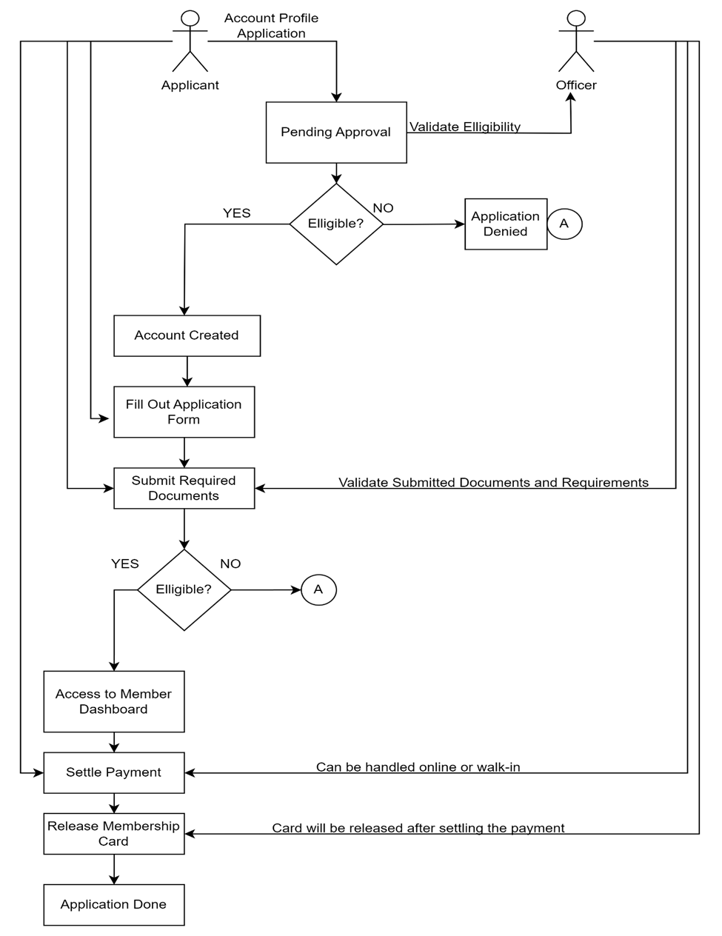**3.4.1 Conceptual Diagram**

**3.4.2 Software Development Life Cycle**

The proponents utilized an Agile methodology for its execution. This method focuses on flexibility and teamwork, and continuously reassessing and for managing a project that involves constant collaboration and working in iterations. Agile project management works off the basis that a project can be continuously improved upon throughout its life cycle, with changes being made quickly and responsively.

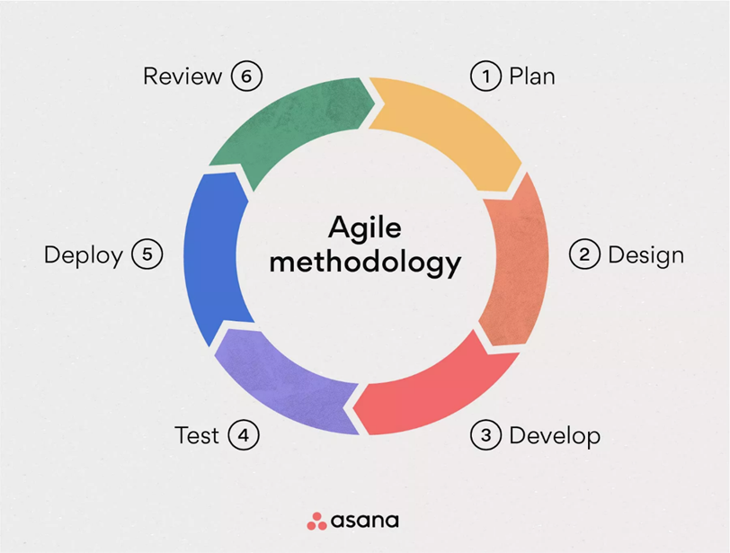

**Requirements Phase**

This is the earliest stage of the system development life cycle. The researchers set a one-on-one appointment with the auditor of CAPEDA in order to determine just what exactly the organization needs to improve in their existing Membership Registration System. In this stage, the proponents gathered crucial informations such as:

1. The general background of the client.
2. The problems that they face while using their current manual system.
3. How their usual transaction works.
4. What changes they want the proposed system to possess.

**Design Phase**

This is the second phase wherein the proponents will utilize the data that they have acquired to create flow charts for each module, database, and designing the user interface. The developers ought to use HTML, CSS, and JavaScript to design the modules of the system.

**Development Phase**

         In the third phase of the System Development, the proponents used PHP and SQL to implement the coding to create the functionality of each designed module. This is when the developers make the elements of the system interact with each other to serve its purpose.

**Testing Phase**

In the testing phase of System Development, the proponents have set up an online meeting with the client using google meet to present the current progress of the system. This is where the client checks if the system is functional.Together, they will examine the whole system for possible bugs, critic its performance, and contemplate how to implement changes if necessary.

**Deployment Phase**

      In this phase, the developers will upload the web-based system in the hosting site to test its functionality when it runs online. This means that the system will finally be accessible to both the client and its potential users.

**Review**

      In the last phase, the system is reviewed by the developers and the client to confirm if the system is ready to be used, if the system has bugs or errors the cycle

**3.5** **Technical Design**

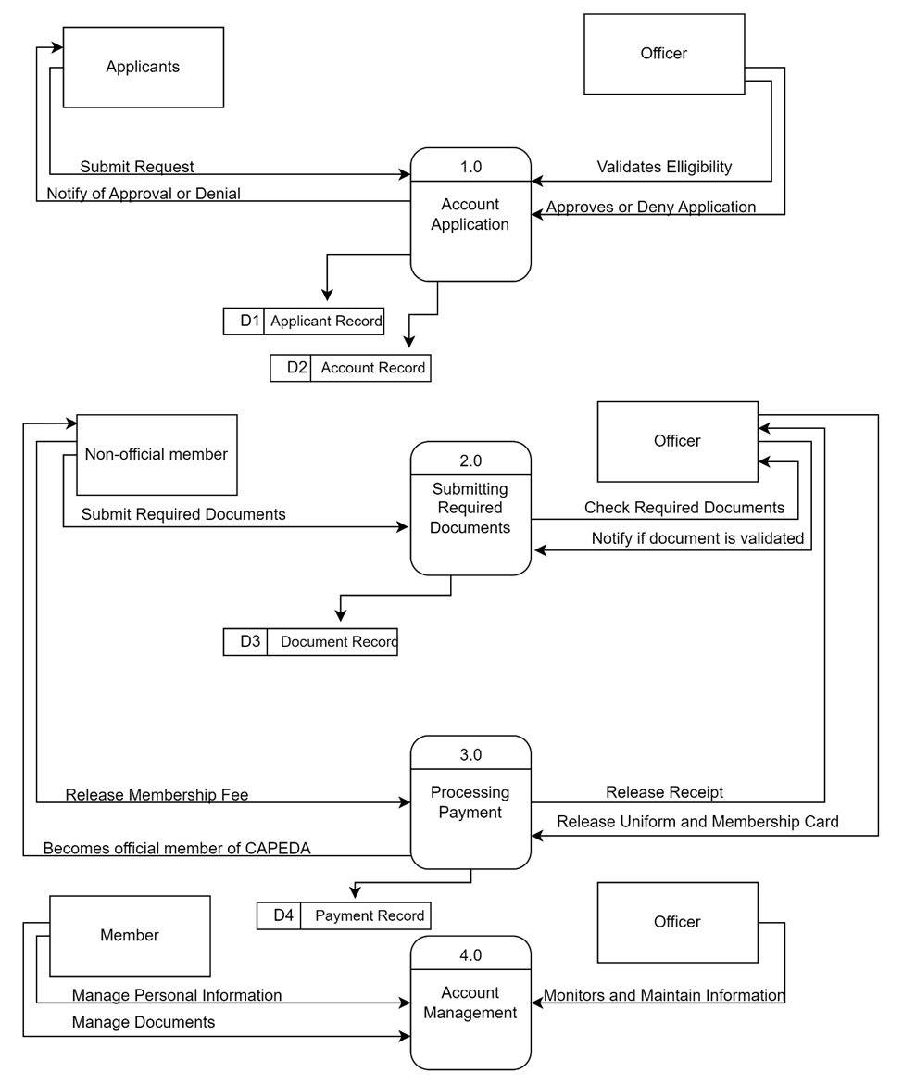**3.5.1**    **Data Flow Diagram**