**WEB-BASED MEMBERSHIP SYSTEM CAPEDA DRIVERS**

**OF CAMELLA HOMES**

A Capstone Project

Submitted to the Faculty of

Department of Information Technology

Cavite State University

Imus City, Cavite

In partial fulfillment

of the requirements for the degree of

Bachelor of Science in Information Technology

**LUCION, MAXINE S.**

**PITOGO, SHARLYN CLAIRE S.**

**SORIANO, ERIC YEOJ H.**

June 2023

**INTRODUCTION**

CAPEDA Organization was first established and organized by Pablo Guerrero in the year of 1986. It is an organization that consists of pedicab drivers that provides the daily transportation of the residents residing in different parts of Camella Bacoor. As the years go by, Pedicabs transformed from manual *“padyak”* to electric powered bikes also called E-bikes. In the present year, there are 500 members of CAPEDA and still growing, only few drivers who use manual *padyak* remains and majority of them use Ebikes as the main engine to run their pedicabs.

Pedicab—a mode of transportation that is both financial and environmentally friendly whilst also being on par with other smoke-emitting vehicles when it comes to mobility. It is commonly found in the cities and local areas in the Philippines. In due course, it is inevitable that many Filipinos who have basic knowledge about driving a vehicle would want to attempt to make a living out of driving a pedicab since it’s getting popular among commuters.

As the population of pedicab drivers grows, collecting and preserving data has become even more challenging to CAPEDA Org., as their only method of gathering information is through physically transcribing it to Microsoft Word. With that in mind, the researchers aim to provide a solution by creating a Web-based Membership System with Billing and Membership Card to improve the organization’s method of gathering data and provide an even more convenient experience for both the organization’s staff and its members.

**Project Context**

Due to the growing population of the drivers, the auditor of CAPEDA Org. is having a hard time managing the information relevant to the organization. In view of the fact that the auditor usually does their job without any assistance from someone more tech savvy, their way of organizing information is by using their personal desktop and the Microsoft Word. With this approach, manually typing in personal information from members and new applicants will slow them down, and it’s only a matter of time before their workload will pile up. Searching and modifying information in a timely manner will become burdensome since packs of data are stored in their computer, causing for it to load slower. Unforeseen mistakes and incidents are likely to occur, which could result to data being lost, putting their organization’s records at high risk.

**Purpose and Description**

The study was conducted to know the needs of the organization to improve the membership application process for the CAPEDA. The researcher developed a web-based system that will aid the organization’s needs to provide a convenient and accessible platform for the members and organize the application processes. This project has helped the CAPEDA to increase efficiency and accuracy in handling data, and have an easier and faster way of managing the organization; this system has benefitted both the client and the users.

**Objective of the study**

Generally, this study aimed to help CAPEDA to have an efficient and effective way of handling membership application as well as the handling of data and information of the organization and its constituents.

Specifically, this study aims to:

1.    To plan the desired system by discussing how the current information management works, outline the requirements, brainstorm a feasible alternative, consider the modules and components needed, as well as their usage.

2.   To design a web-based system that will replace the manual process of managing membership applications. In this phase, the proponents will present a flowchart with the objective of gathering feedbacks from the client.

3.   To develop the system using the propositions approved by the client.

4.   To test the developed system by evaluating and assessing it for possible bugs and logic errors. This phase requires a lot of time as it is the stage wherein both the proponents and the client would have to communicate and analyze the system thoroughly.

5. To deploy the system to the end users. In this phase, the system will be accessible to both applicants and existing members of CAPEDA.

6. To maintain the deployed system continuously when adjustments or updates are necessary.

**Scope and Limitation**

The proponents developed a web-based Membership system for CAPEDA, that allows its affiliates to manage their membership process digitally instead of manually managing, requesting and storing their confidential documents for the membership process.

The following are the modules of the system along with its feature:

**Login Module:** This module is responsible for verifying the credentials of user accounts attempting to log in to the system. The system supports three user types: applicants, members, and administrators. When an account is validated as an administrator, it gains access to the admin module; for members, the member module is accessible, and applicants are granted access to the applicant module. Successful login requires the entry of both a valid username and password. If either credential is incorrect, the login attempt will be denied.

The modules listed below are the modules that will be accessible to the members of CAPEDA org:

**Applicant Module:** This module only has 1 feature. Applicants can only upload documents that are required in order for the admin to monitor the eligibility of their application.

**MEMBER MODULE:** This module is only accessible to the registered members of CAPEDA. It has 3 sub features each feature is listed below:

**Personal Information Management:** Within this module, members have the ability to modify certain personal details, including their name, contact number, and address. It's important to note that only non-critical personal information can be edited. Sensitive data, such as the member ID, remains non-editable by the user to ensure security and data integrity.

**Account Management:** This module is responsible for handling two primary functions: enabling members to change their passwords and facilitating the updating of their email addresses.

**Document Management:** This module is responsible for the organization and storage of member documents. Members are permitted to upload specific documents as requested by administrators. Additionally, it's important to note that members are not granted the ability to delete uploaded files; instead, they can only update them.

**ADMIN MODULE:** This module is only accessible for the admin profiles registered in the system. Only the admin has the authority to manipulate information inside the web-based system. In this module the admin can view the total number of the member profiles registered in the system, the active and inactive members, and pending account profile applications.

**Admin Manage Applicants:** this module is responsible for managing applicant profiles. The admin has the ability to monitor, add, edit and delete applicant profiles in this module. The admin has the ability to create admin generated account profiles for those applicants that is not technically literate.

**Admin Member Management Module:** This module lets administrators oversee CAPEDA's registered members. Admins can add existing members but cannot create new member profiles. This policy is in place to ensure the system's security and confirm that only real members are added.

**Admin Requirement Management Module:** In this module, administrators have the ability to add, update, and delete the list of requirements. These requirements are necessary for users to submit when applying for membership processing.

**Admin Announcement Management:** In this module, admins can create, update and delete announcement. This announcements will be displayed on the user modules in order for them to be notified.

The limitations of the system developed by the proponents are the following:

* The system is intended only for CAPEDA Org.
* The main focus of the system is the membership process of the drivers of CAPEDA Org.
* Only members of CAPEDA can access the system

**REVIEW OF RELATED LITERATURE**

**Related Literature**

**BookNow Software. (2023) *Key Benefits of Member Management Software*.**

According to an article for BookNow Software, having a member management system produce positive impacts for the business and its components. By having a software that will help with the management of data and information, businesses are more likely to perform better. It also attracts potential customers/members because it enables transparency by making sure members are able to see every detail they need to see. Also, this type of softwares provides peace of mind in exploring new ways of improving businesses. BookNow Software (2023).

**Davies Genealogy. (2019) *Advantages of Online Applications*.**

As indicated by an article published by Davies Genealogy, it is vital to understand that online applications are helping various organizations to accumulate qualified applicants and enhancing the overall candidate experience. Physically applying for a job can be time consuming and expensive, however, you have an opportunity to reduce all that by using online application platforms.

**Clear Company. (2022) *Online Payment Importance and Benefits*.**

Electronic payments have constantly undergone advancements making them hassle-free and fast ways of making payments. According to the article of Clear Company, payments through online can help businesses provide their customers with a convenient payment experience. Online payments have higher security such as tokenization, and encryption so the users wouldn’t have to worry about their data being stolen.

**Related Study**

**Usanto, U., Nurlaela, L., Sopian, A., & Alfiah, F. (2022). Umrah Registration System Using Extreme Programming Method Towards Worship Tourism. *International Journal of Cyber and IT Service Management*, *3*(1), 22–31.**

                     A study conducted in 2022 paved the way for enhanced method of handling registration applications by developing a Registration System that helped with the daily transactions and handling of big amounts of data. It was also shown that having such a system helped the business to store big amounts of data, it also helped with the time consumption regarding the transaction processes of the business. usanto, U., Nurlaela, L., Sopian, A., & Alfiah, F. (2022).

**Fearnley, M., & Amora, J. (2020) Learning Management System Adoption in Higher Education Using the Extended Technology Acceptance Model. *De La Salle-College of Saint Benilde Manila Philippines.***

According to Marissa Fearnley and Johnny Amora (2020). This study investigated factors that influenced adoption of a learning management system by higher education teachers using the technology acceptance model which incorporates three external constructs: system quality, perceived self-efficacy and facilitating conditions. Additionally, system quality directly affected perceived ease of use and attitudes toward technology use. Implications for practice, policy and potential research directions are likewise presented.

**Kwangho Jung & Sabinne Lee (2015) *A Systematic Review of RFID Applications and Diffusion: Key Areas and Public Policy Issues*.**

A systematic analysis of 111 previous studies conducted in the public sector has identified six primary areas where RFID is commonly employed: defense and security, identification, environmental applications, transportation, healthcare and welfare, and agriculture-livestock. However, the integration and utilization of RFID technology can present unforeseen drawbacks, such as deficiencies in technology, uncertain advantages, concerns regarding transparency, privacy issues, and disparities in digital power and literacy.

**METHODOLOGY**

         This chapter presents the methods and materials the researchers used to conduct this study. The materials include the hardware and software, while the methods consist of the figure of the process model and the explanation of each phase.

**3.1 Requirement Specifications**

**3.1.1 Functional Requirements**

·         Login Access for CAPEDA Officers, drivers, and IT Admins

·         IT Admins can monitor the on-going processes in the admin’s access in order to keep track and maintain the system

·         Potential Members of CAPEDA can create account profile that will be validated by CAPEDA officers if the potential member is eligible for membership

·         Officers can monitor the member list including the active, and inactive

·         A system that accepts online payment using Gcash for membership fee only.

·         A system that handles membership applications online.

·         A system that provides notification through email or SMS if the application is approved or denied.

·         A system that generates reports for all of users with different level of transparency

**3.1.2 Hardware Requirements**

**Table 3.1**

|  |  |  |  |
| --- | --- | --- | --- |
|  | MINIMUM | RECOMMENDED | DEVELOPMENT |
| Processor | Intel core i3 | Intel core i5 or equivalent | Intel i5/ryzen 5 or higher |
| Memory | 8gb ram | 16gb ram | 16gb 64 BIT |
| Cache Memory | 217gb | 217gb or higher | 217gb |
| Hard Disk | At least 500gb | 1tb | 1tb or higher |
| Resolution | 1280 x 800 | 1920 x 1080 | 1920 x 1080 |
| Internet Connection | At least 5mbps | 25mbps or higher | 25mbps |
| RFID Scanner | At least 125khz | 13.56mhz | 125khz |
| RFID Card | At least 125khz | 13.56mhz | 125khz |

**3.1.3 Software Requirements**

**Table 3.2**

|  |  |  |  |
| --- | --- | --- | --- |
|  | MINIMUM | RECOMMENDED | DEVELOPMENT |
| Operating System | Windows 7 | Windows 10 | Windows 10 |
| Browser | Microsoft Edge | Brave/Google | Brave |
| Front-End tool | n/a | n/a | PHP  Visual Studio Code 2023 |
| Back-End tool | n/a | n/a | XAMPP MySQL |

**3.2**  **Research Methods**

The method of research used in this study is Descriptive. With the help of this method, the researchers/developers are able to specify the needs of CAPEDA and to give solution to their problem.

Descriptive Method allows the collection, analysis, classification and tabulation of information from the client where developers based their development of the said system.

**3.3 Data Gathering Instruments and Procedures**

**3.3.1**  **Data Gathering Instruments Used**

**Interview Sheets**

Interviewers provided a set of questions for the target interviewees engaged in the proposed system, the Web-based Membership System. Interviewees were the CAPEDA Officers, and drivers.

**3.3.2**  **Procedures Used in the Study Interview**

The proponents conducted a formal interview with the auditor of CAPEDA. In a formal interview, it is easier to gather more accurate information to facilitate the development and design of the system.

The auditor gave the authority and signed the proposal letter that allowed the researchers to gather the data needed from the subject coordinators for the system’s benefit. As the target users of the system, the auditor of CAPEDA were able to express the struggle in handling membership application manually. And by that, the researchers and developers came up with the proposal for a system that will benefit both officers and drivers. It is important that the proponents of the said system use the needs and desires of the clients as their basis.

**Evaluation**

The proponents will conduct the testing period for the system they developed with the CAPEDA Org. This will be the basis for enhancing features for the system’s benefit which would help for its future assessment. The system will be evaluated in terms of its performance: 5 - excellent, 4 - very good, 3 - good, 2 – fair, 1 – need of improvement.

**Online Research**

**The researchers used online articles as a guide and basis for their studies, and searched for other data gathering methods.**

**Library Research**

This research process is used in searching reference books in gathering information for Related Literature and Studies matters. The researchers read books and thesis in the library correlated to the studies they are undergoing.

**3.4 Software Design**

**3.4.1 Conceptual Diagram**

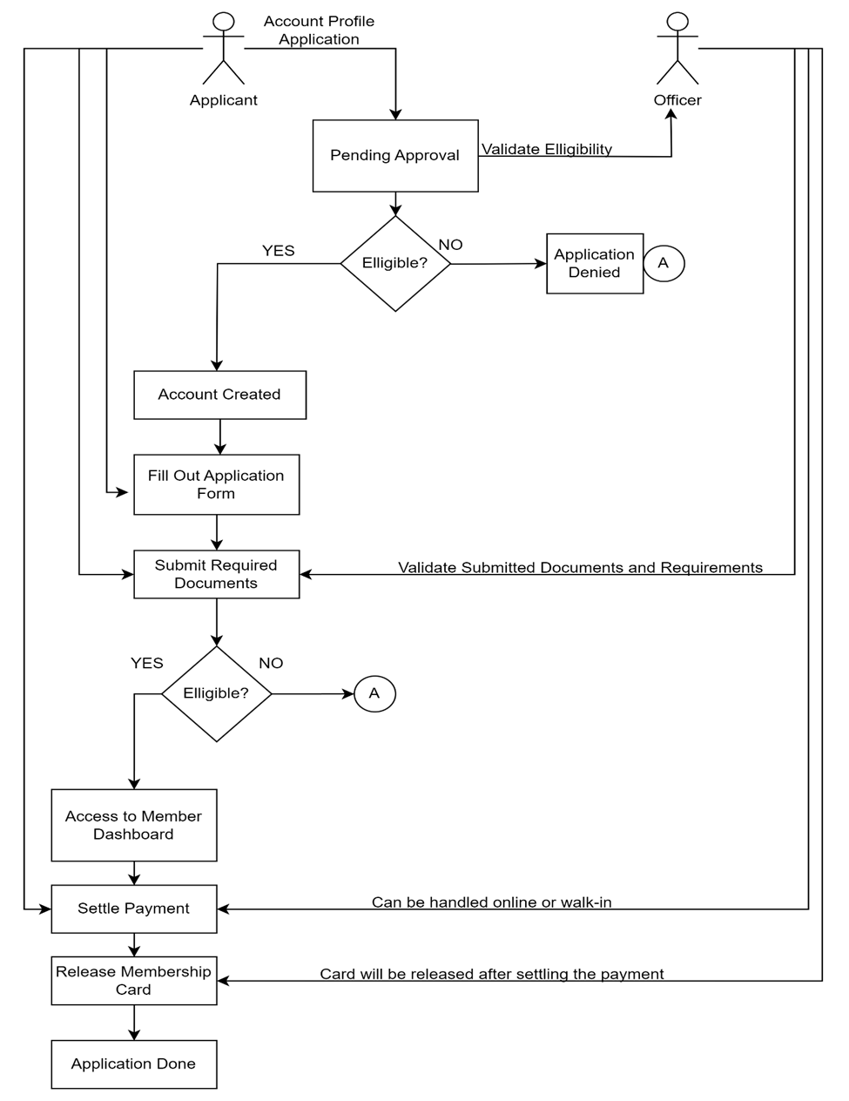

**3.4.2 Software Development Life Cycle**

The proponents utilized an Agile methodology for its execution. This method focuses on flexibility and teamwork, and continuously reassessing and for managing a project that involves constant collaboration and working in iterations. Agile project management works off the basis that a project can be continuously improved upon throughout its life cycle, with changes being made quickly and responsively.

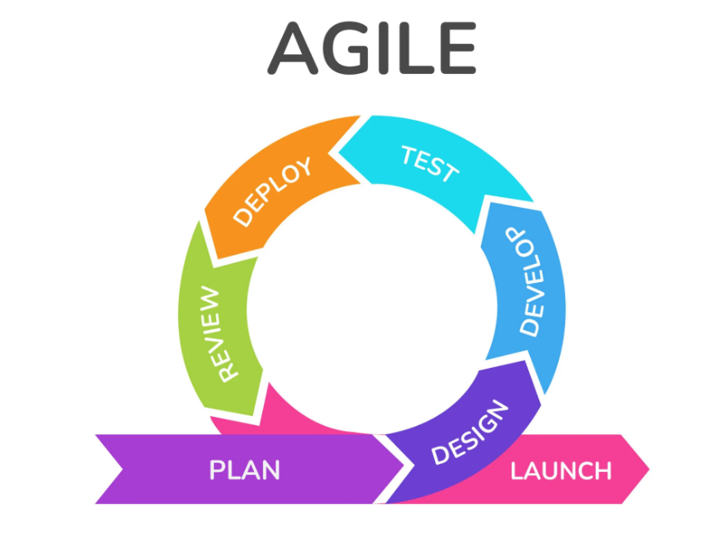

**Requirements Phase**

This is the earliest stage of the system development life cycle. The researchers set a one on one appointment with the auditor of CAPEDA in order to determine just what exactly the organization needs to improve in their existing Membership Registration System. In this stage, the proponents gathered crucial informations such as:

1. The general background of the client.
2. The problems that they face while using their current manual system.
3. How their usual transaction works.
4. What changes they want the proposed system to possess.

**Design Phase**

This is the second phase wherein the proponents will utilize the data that they have acquired to create flow charts for each module, database, and designing the user interface. The developers ought to use HTML, CSS, and JavaScript to design the modules of the system.

**Development Phase**

         In the third phase of the System Development, the proponents used PHP and SQL to implement the coding to create the functionality of each designed module. This is when the developers make the elements of the system interact with each other to serve its purpose.

**Testing Phase**

In the testing phase of System Development, the proponents have set up an online meeting with the client using google meet to present the current progress of the system. This is where the client checks if the system is functional.Together, they will examine the whole system for possible bugs, critic its performance, and contemplate how to implement changes if necessary.

**Deployment Phase**

      In this phase, the developers will upload the web-based system in the hosting site to test its functionality when it runs online. This means that the system will finally be accessible to both the client and its potential users.

**Review**

      In the last phase, the system is reviewed by the developers and the client to confirm if the system is ready to be used, if the system has bugs or errors the cycle

**3.5** **Technical Design**

**3.5.1**    **Data Flow Diagram**