

**JONYO JUNIOR SECONDARY SCHOOL.**

END-TERM 1 ASSESSMENT TEST-2025

GRADE 7

SOCIAL STUDIES.

TIME 2HOUR

NAM_______________________________________ADM NO____________­­­­­­­­­­­DATE________

**Instructions to Learners. Answer all the Questions.**

1. Define the following terms (6 mrk)
2. Map ________________________________________________________________________________________________________________________________________________________________________________________________________________________
3. Picture ________________________________________________________________________________________________________________________________________________________________________________________________________________________
4. Plan ________________________________________________________________________________________________________________________________________________________________________________________________________________________
5. State any three significance of weather forecasting (3 mrk) ________________________________________________________________________________________________________________________________________________________________________________________________________________________________________________________________________________________________________________________________________________________________________________________________________________________________________________________________________________________________________________________
6. Give any two factors to be considered when siting a weather station (2 mrk) __________________________________________________________________________________________________________________________________________________________________________________________________________________________________________________________________________________________________________________________________________________________________________________________________________________________________________________________________________________________________________________
7. The time in the republic of Cabo varde 18oW of the Greenwich Meridian is 11.40 am. What is the time in Ras Hafun 50oE (3 mrk) ________________________________________________________________________________________________________________________________________________________________________________________________________________________________________________________________________________________________________________________________________________________________________________________________________________________________________________________________________________________________________________________
8. Give any two types of maps (2 mrk) ________________________________________________________________________________________________________________________________________________________________________________________________________________________
9. Explain the passing star theory (3 mrks) ________________________________________________________________________________________________________________________________________________________________________________________________________________________________________________________________________________________________________________________________________________________________________________________________________________________________________________________________________________________________________________________
10. Give three importance of maps in our lives (3 mrks) ________________________________________________________________________________________________________________________________________________________________________________________________________________________________________________________________________________________________________________________________________________________________________________________________________________________________________________________________________________________________________________________________________________________________________________________________
11. The time in Yaounde 10o E of the Greenwich Meridian IS 1.20 PM. What is will be the time in the republic of cabo verde 18oE (3 mrks) _______________________________________________________________________________________________________________________________________________________________________________________________________________________________________________________________________________________________________________________________________________________________________________________________________________________________________________
12. The shape of the earth is called? (2 mrks) ________________________________________________________________________________________________________________________________________________
13. Define the term weather. (2 mrks) ________________________________________________________________________________________________________________________________________________________________________________________________________________________________________________________________________________________________
14. Give the weather instruments used to measure the following weather elements. (3 mrks)

|  |  |
| --- | --- |
| Weather element | Weather instrument |
| Temperature |  |
| Rain |  |
| Wind direction |  |

1. State the three components of the solar system. (3mrk) _____________________________________________________________________________________________________________________________________________________________________________________________________________________

13. Name the following types of maps. (3 mrk)

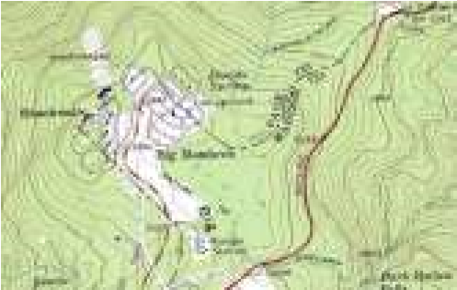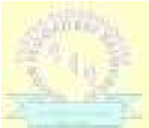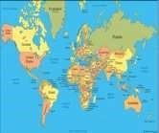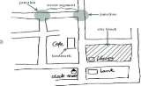

14. Name the discontinuity between the crust and the mantle. (1 mrk) ____________________________________________________________________________________________________________________________________________________

15. Name the following weather instruments. (3 mrk)

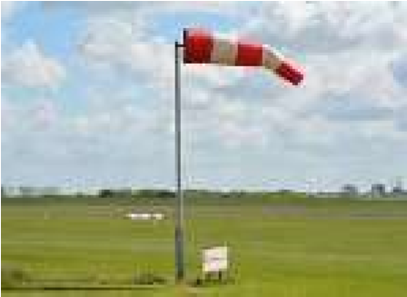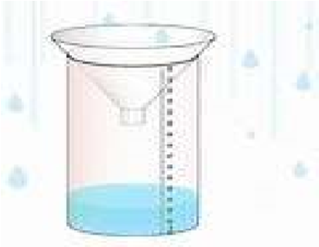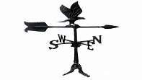

16. Differentiate between mean daily temperature and mean monthly temperature (2 mrks) ________________________________________________________________________________________________________________________________________________________________________________________________________________________________________________________________________________________________________________________

17. Differentiate between rotation and revolution. (2 mrks) ______________________________________________________________________________________________________________________________________________________________________________________________________________________________________________________________________________________________________________________________________________________________________________________________________

18. Give any two effects of rotation and revolution of the earth. (4 mrks)

|  |  |
| --- | --- |
| **Rotation** | **Revolution** |
|  |  |
|  |  |