

**JONYO JUNIOR SCHOOL MID TERM 1 ASSESMENT 2025**

**GRADE 8 SOCIAL STUDIES TIME 1 HOUR 30 MINS**

**NAME__________________________________ADM NO_______ DATE_______________**

**Instruction**s.

This paper consists of 3 printed pages out of 30 marks.

Attempt all the questions in the spaces provided

1. Grade 8 learners were asked to name the career opportunities in studying social studies. Mention two careers that the learner mentioned. (2 marks)

________________________________________________________________________________________________________________________________________________

1. Grade 8 teacher presented the map of Africa below during a lesson. Study the map and answer the questions that follow.

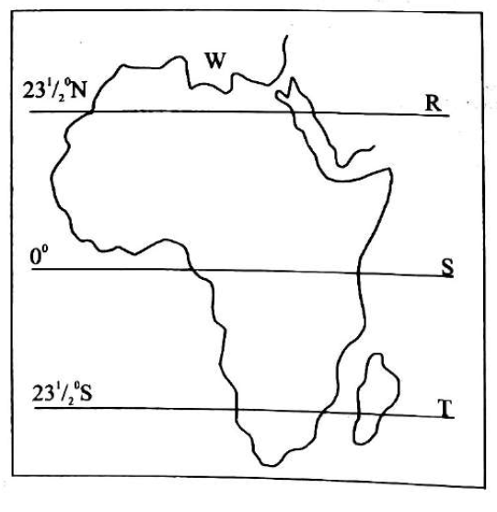

During a social studies lesson, three learners were asked to identify the names the lines marked R, S and T. What was their correct response? (3 marks)

1. a) Define the term solar system (2 marks)

________________________________________________________________________________________________________________________________________________

b) List three components of the internal structure of the earth. (3 marks)

________________________________________________________________________________________________________________________________________________________________________________________________________________________

1. a) The scientific theory about the human origin is called_________________________________________ ( 1 mark)

b) All living organisms underwent processes of change over millions of years by evolving from simple forms to complex forms. This happened through three processes. List down the stages. (3 marks)

________________________________________________________________________________________________________________________________________________________________________________________________________________________

1. The Swahili community along the coast came into being as a result of intermarriage between Africans and Arabs. This combination gave birth to the Swahili civilization. State any three characteristics of the Swahili civilization. (3 marks).

________________________________________________________________________________________________________________________________________________________________________________________________________________________

1. State three effects of population growth in Africa. (3 marks).

________________________________________________________________________________________________________________________________________________________________________________________________________________________

1. a) Define the tem self-esteem. (1 marks).

________________________________________________________________________________________________________________________________________________

b) Self-esteem is influenced by both personal and environmental factors. State any these factors. (3 marks).

________________________________________________________________________________________________________________________________________________________________________________________________________________________

1. List two qualities that one may have so as to be described to be having emotional intelligence. (2 marks)

________________________________________________________________________________________________________________________________________________

1. Highlight two ways of celebrating socio-cultural diversity in the community. (2 marks).

________________________________________________________________________________________________________________________________________________

1. State two common causes of conflicts in families. (2 marks).

________________________________________________________________________________________________________________________________________________

**THIS IS THE LAST PRINTED PAGE.**