gestSQUADRE

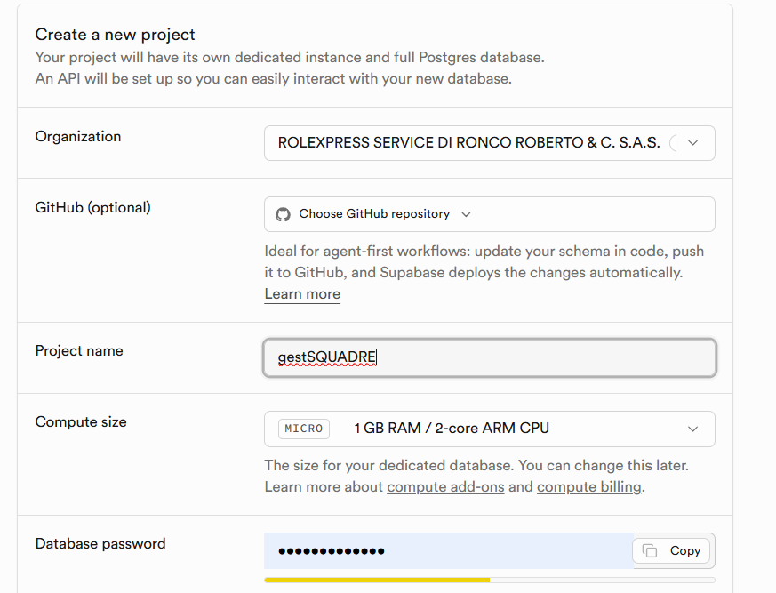
FADyhetENNnx90gD

ProjectID tdylzdrpmxvftfblvmnu
Publishable key sb_publishable_SB78CfrkgdcABmP0T8mJsA_gSE6Vrdp
Secret keys sb_secret_okzEx4At516hzj1tVI7Z3Q_Z3kfr9cm

