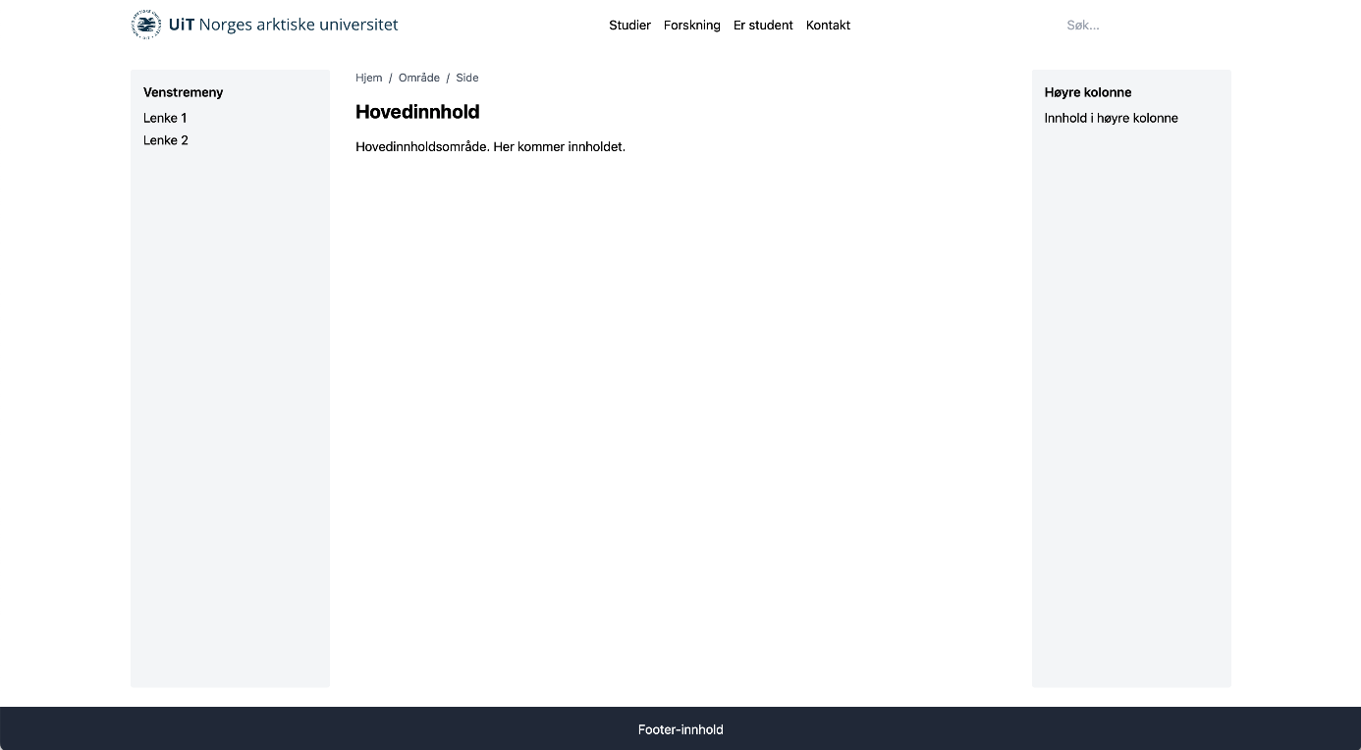

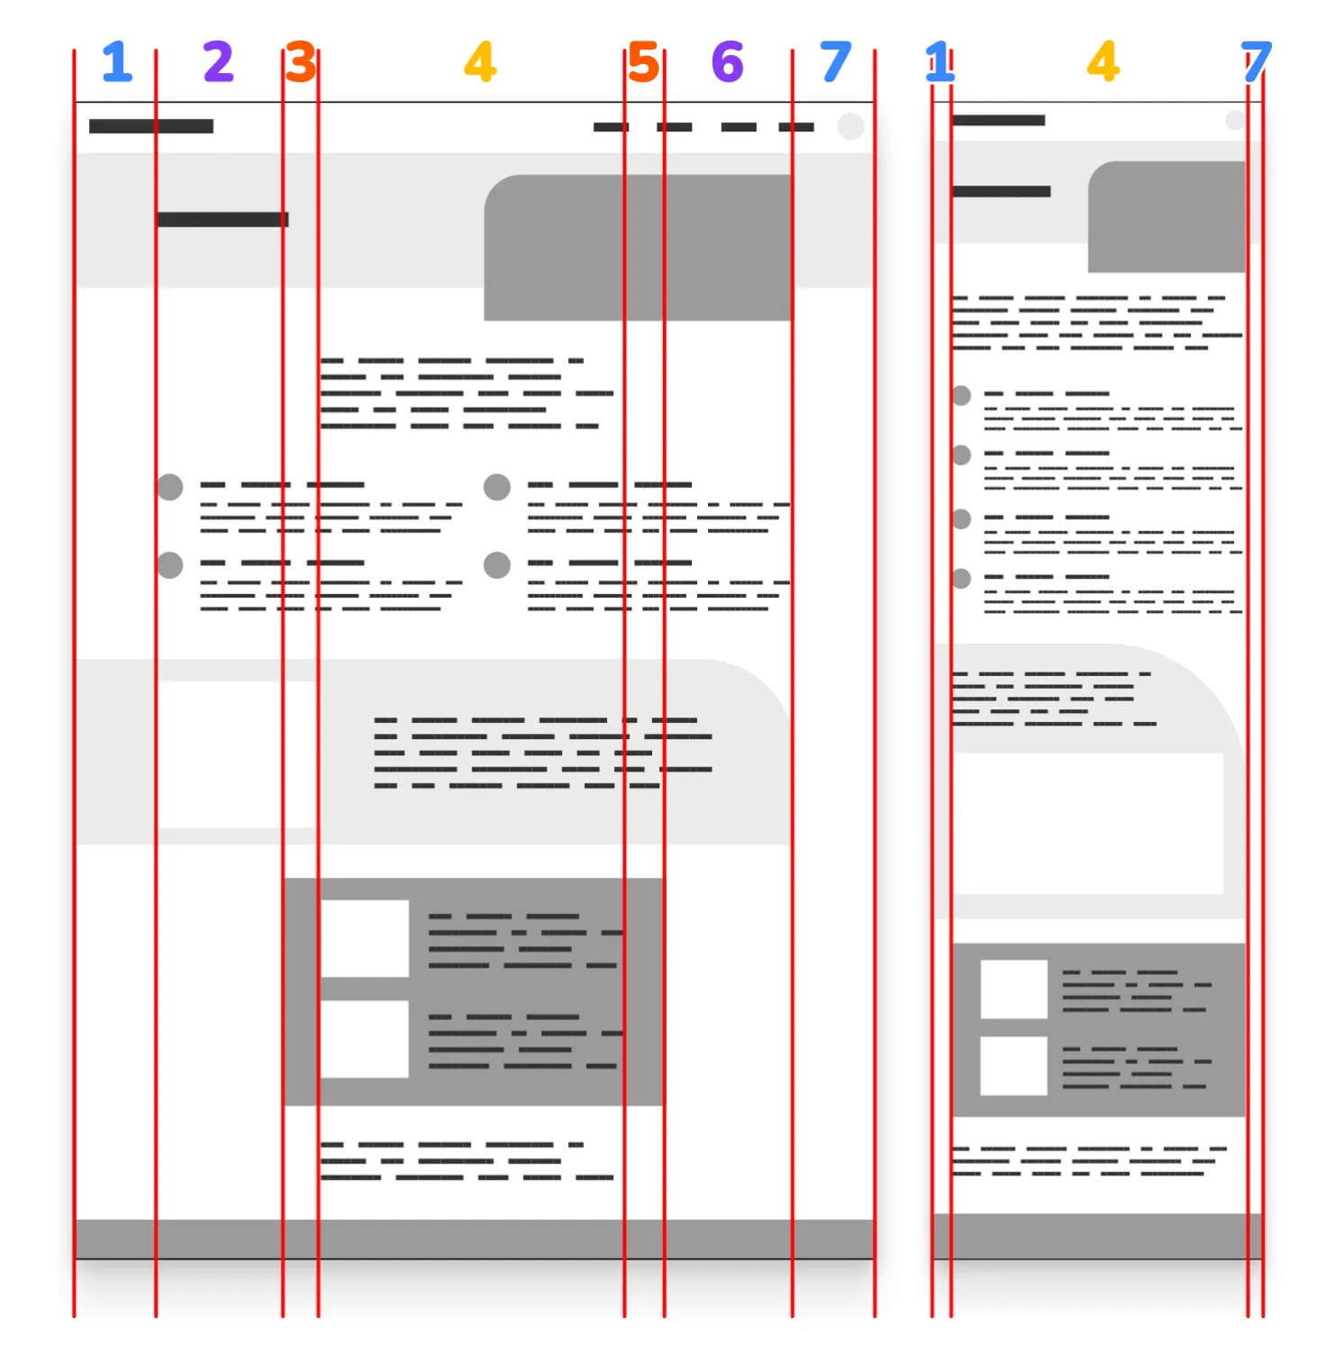

- Left margin / Full-Width
- Left Feature
- Left Popout
- Center Content
- Right Popout
- Right Feature
- Right margin / Full-Width

Yet on mobile, we only need 3 columns, just left margin (1), center content (4), and right margin (7). We want some of these intermediate columns to disappear!
