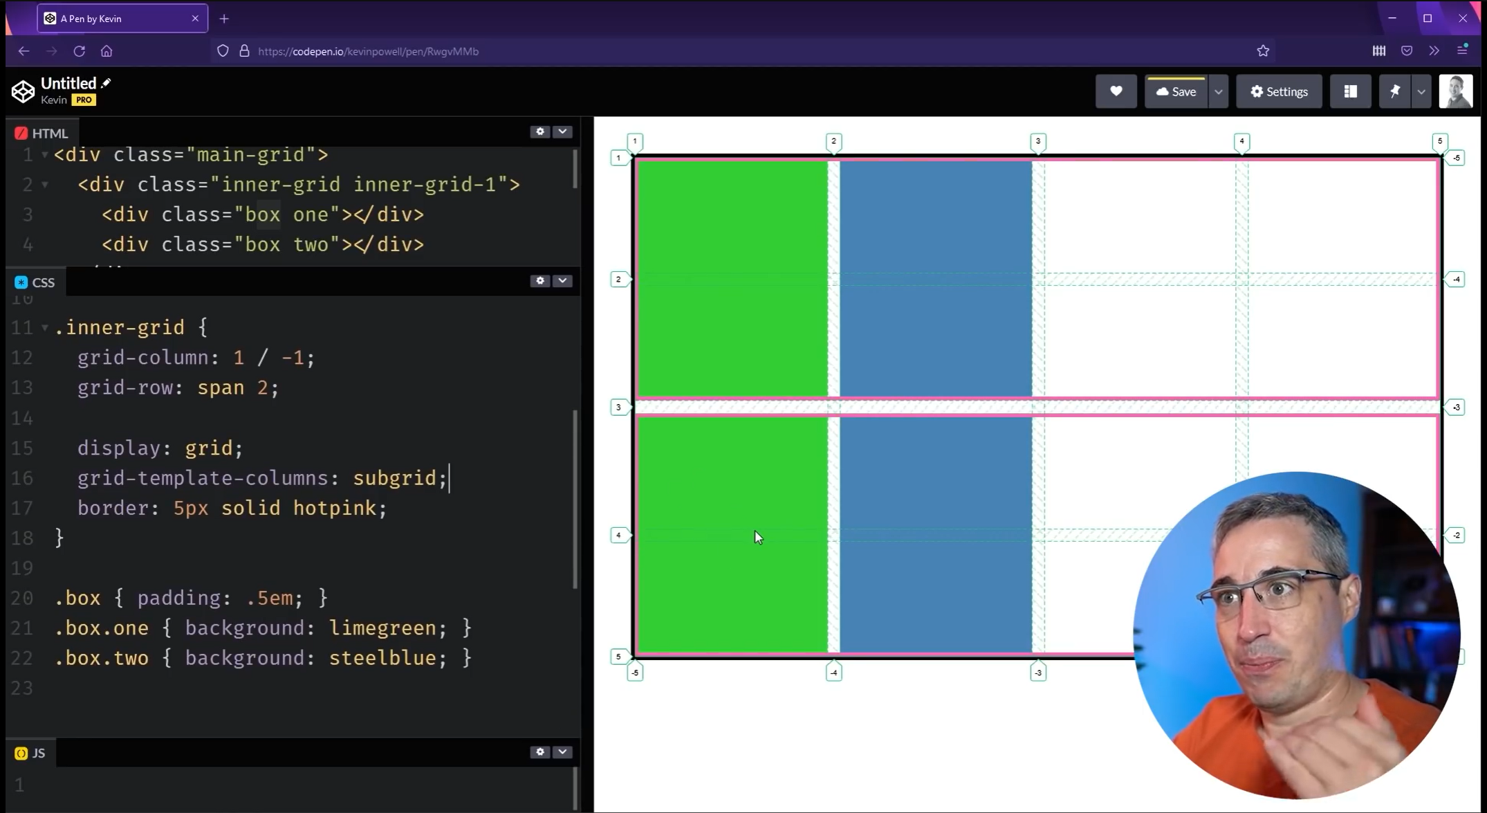

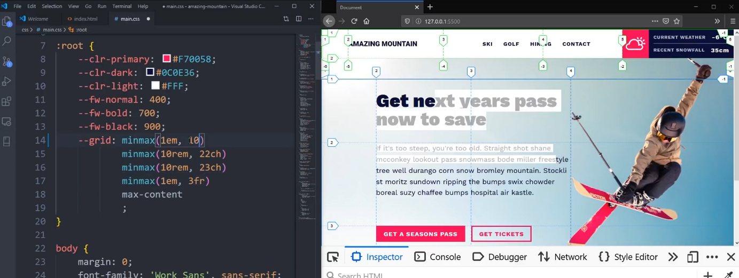

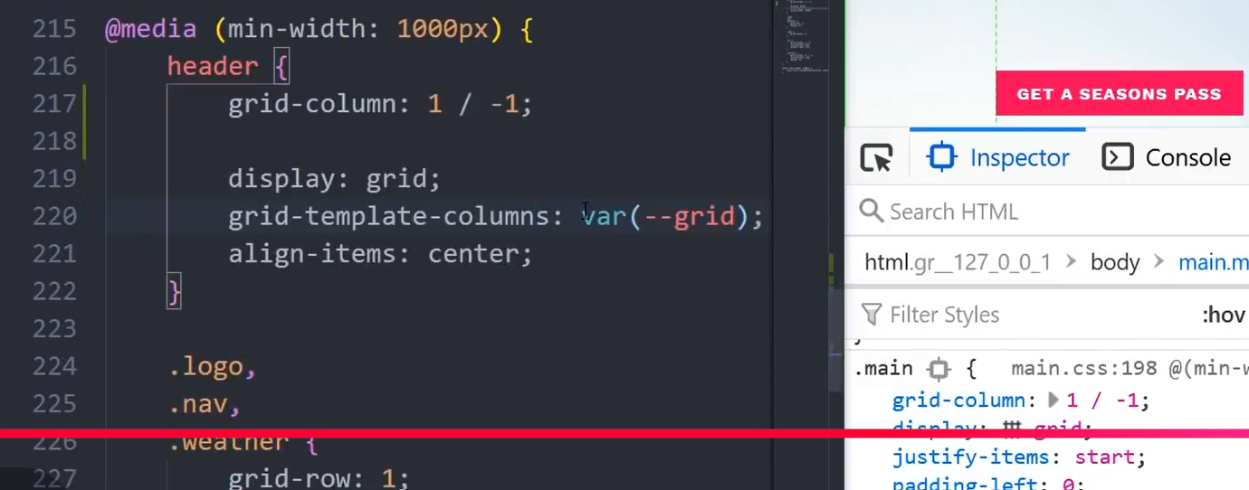

- highlighted-region: problemer
  - <div id="block-uit-theme-primary-local-tasks" class="contextual-region block block-core block-local-tasks-block" style="grid-column: container;">

- Layout Container (Grid)
  - .header-left-region
  - .header-center-region
  - .header-right-region
  - .highlighted-region (Subgrid > full-width
    - <div id="block-uit-theme-primary-local-tasks" class="contextual-region block block-core block-local-tasks-block">
      - <div .contextual … (* grid-column: content; )
      - <nav class="tabs" role="navigation" aria-label="Tabs"> (* grid-column: content; )
  - <aside class="sidebar-first-container"
  - <div class="content-region">
    - <div id="block-uit-theme-breadcrumbs" class="contextual-region block block-system block-system-breadcrumb-block">
    - <div id="block-uit-theme-page-title" class="contextual-region block block-core block-page-title-block">
    - <div id="block-uit-theme-content" class="block block-system block-system-main-block"> CONTENT BLOCK
      - <article data-history-node-id="8" class="contextual-region node node--type-article node--promoted node--view-mode-full">
        - <div data-contextual-id="node:node=8:changed=1766776434&amp;langcode=en" data-contextual-token="YiCn66lU0xJ_TQ39ot_dWkdtGLRs6phtDq9aqviogys" data-drupal-ajax-container="" data-once="contextual-render" class="contextual">
        - <footer class="node__meta">
        - <div class="node__content"> NODE CONTENT (*subgrid)
          - <div class="field field--name-field-image field--type-image field--label-hidden content-grid field__item"> FIELD (image)
          - <div class="clearfix text-formatted field field--name-body field--type-text-with-summary field--label-hidden content-grid field__item"> FIELD (text)
            - <p>
            - <p> …

