Title (Type Your Title Here – Arial 10 pt Bold)

Jósephine A. Catalytic1* (underline presenting author) and Juan R. Platinum2

1(Italics, 8pt) INCAPE, César Milstein 2800, Santa Fe 3000 (Argentina)

2 Chemical Engineering Department, Université de Poitiers, Rue des Sciences 4, 86022 Poitiers, (France),

*jcatal@gmail.com (corresponding author designated with a star)

Introduction

Abstracts must be submitted in English. A variety of information may be provided to introduce the topic presenting the state of the art on the subject and the bibliographic background that leads to the hypothesis of the work. Clearly establish the objectives of the work. The abstract must be informative, carefully prepared to allow the Scientific Committee to judge the scientific merit of the work. References in the text should be given by numbers in square brackets [1], whether they are citations to the chemical problem, or the techniques employed in the study [2]. Note the formatting of in-text citations and formatting for references in the Reference Section. Commonly accepted abbreviations can be employed. (e.g. ppm, wt%, TOF). 20% conv., LHSV = 0.2 h-1 (i.e., 0.2 cc/(cccat h)) [3]. All acronyms should be defined upon first mention.

The first line of the paragraphs must be indented (0.5 cm). One empty line must be left between sections. The document has margins: Top and Bottom: 1.25” (3.18 cm), Left and Right: 1” (2.54 cm). All text should be in Arial font, 8 pt size, single line spacing, and full justification.

Materials and Methods

Briefly describe the techniques, materials, equipment, experimental conditions, methodologies, procedures, etc., as appropriate to the nature of the work presented. Relevant software packages and data analysis tools should be supplied for studies theoretical or computational.

Results and Discussion

Brief descriptions of key results should be supplied along with discussion of relevant conclusion, mechanistic insights, and other deductions.

Figures, tables, schemes and equation can be incorporated as appropriate for the best quality of communication. They should remain within the boundaries of one column of text. All these elements should be numbered in the order they are mentioned in the text with captions given below figures and titles above tables. Text within the figure should not be sized less than 8 pt font. It is best to use conventional formats for artwork (*.tif, *.jpeg, *.gif etc and Microsoft Office-compatible software) but authors are advised that determining the compatibility of artwork with Adobe Acrobat to create a *.pdf file is their responsibility. The preparation of *.pdf files ensures retention of document formatting across most computer platforms.

Presented data should be described, briefly interpreted, and related to the problem under study.

**Table 1. Catalytic Results**

|  |  |  |  |  |  |  |  |
| --- | --- | --- | --- | --- | --- | --- | --- |
| **Catalyst** | **Initial Conversion,%** | **Initial Selectivities, %** | | | | | |
| **AD** | **CO** | **AA** | **AP** | **LAL** | **PD** |
| Cat A | 100 | 64 | 32 | 0 | 0 | 0 | 0 |
| Cat B | 100 | 27 | 13 | 2 | 0 | 2 | 0 |
| Cat C | 100 | 26 | 13 | 4 | 0 | 10 | 0 |

*Reaction Conditions*: 583 K, 101.3 kPa (3kPa AL, 27kPa H2O, 70.3 kPa de N2) W/FAL= 22.3g/mol h

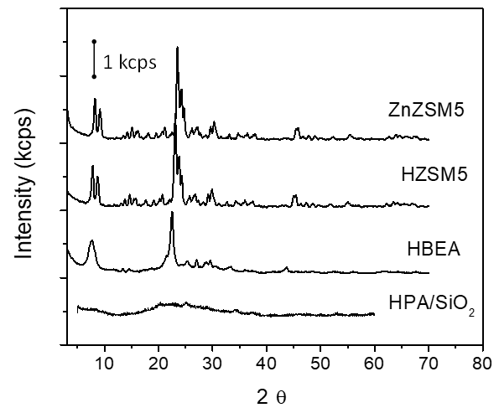

Cat A

Cat B

Cat C

Cat D

.

**Figure 1.** XRD Patterns. Text wrapping may be used around figures. All figure content should be legible if abstract is printed on A4-size paper.

Significance or Main Conclusions

Briefly, in no mor than 4 lines, the most relevant aspects of the work will be presented here, highlighting its originality and importance

**References**

For journal articles follow the example [1]; for books, example [2]; and for papers on conference proceedings, example [3]. The abbreviation “et al.” may be used after the third author.

[1] V. Márquez, R. Torres, F. Solís; Appl. Catal. B: Environmental 138 (2000) 345-355.

[2] G. Maire, L. Hilaire, O. Zahraa en Metal-Support Effects in Catalysis, B. Imelik (Ed.). Elsevier Scientific, Amsterdam (1982) Vol. 11: 285-293.

[3] L. González, J. Cruz, C. Bianchi en Anales del 13º Congreso Brasilero de Catálisis. Foz de Iguazú-PR (1999) Vol. 3: 1751-1757.