Numpy
>>>from numpy import *
>>>a = array([1,2,3,4])
>>>c=array([[1,2,3,4],[4,5,6,7],[7,8,9,10]])
>>>c
array([[1,2,3,4],
[4,5,6,7],
[7,8,9,10]])
>>>c.shape #return a tuple
(3,4)
>>>c.shape=4,3 #change the shape,but RAM’s address don’t be changed
>>>c
array([[1,2,3],
[4,4,5],
[6,7,7],
[8,9,10]])
>>>c.shape=2,-1 #when someone number is -1,that’s to say the number just a placeholder , python while compute the true value
>>>c
array([[1,2,3,4,4,5],
[6,7,7,8,9,10]])
>>> arange(0,1,0.1)
array([ 0. , 0.1, 0.2, 0.3, 0.4, 0.5, 0.6, 0.7, 0.8, 0.9])
>>> linspace(0,1,11)
array([ 0. , 0.1, 0.2, 0.3, 0.4, 0.5, 0.6, 0.7, 0.8, 0.9, 1. ])
#arange is similar to range,pay a attention on the third parameter in linspace:this function divide [a,b] into c-1 parts
>>> logspace(0,8,9,base=2)
array([ 1., 2., 4., 8., 16., 32., 64., 128., 256.])
#this function divide 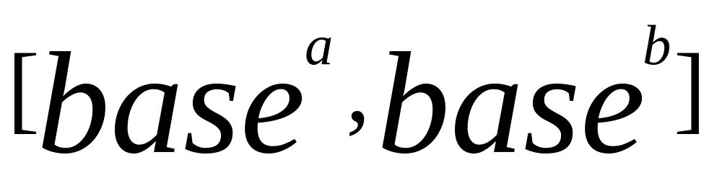 into c-1 parts,this is the geometric progression.
>>> X=array([[1,2],[3,4],[5,6]])
>>> zeros_like(X)
array([[0, 0],
[0, 0],
[0, 0]])
#zeros can be instead by ones,empty.
>>> x=arange(1,4,1)
>>> x
array([1, 2, 3])
>>> x[[2,1,0]]
array([3, 2, 1])
#this character only exist in numpy’s array.the character is so cool!!!
the inside array or list can be instead by any dimensional .
>>> x=random.rand(10)
>>> x
array([ 0.34816436, 0.2339284 , 0.75925431, 0.19877282, 0.29614562,
0.0265267 , 0.92632672, 0.34894374, 0.14326909, 0.95111668])
>>> t=x>0.5
>>> x[t]
array([ 0.75925431, 0.92632672, 0.95111668])
#cool example
>>> a=arange(0,60,10).reshape(-1,1)+arange(0,6)
>>> a
array([[ 0, 1, 2, 3, 4, 5],
[10, 11, 12, 13, 14, 15],
[20, 21, 22, 23, 24, 25],
[30, 31, 32, 33, 34, 35],
[40, 41, 42, 43, 44, 45],
[50, 51, 52, 53, 54, 55]])
>>> a[0,3:5]
array([3, 4])
>>> a[4:,4:]
array([[44, 45],
[54, 55]])
>>> a[:,2]
array([ 2, 12, 22, 32, 42, 52])
>>> a[2::2,::2]
array([[20, 22, 24],
[40, 42, 44]])
# mul_dimensional read’example
>>> x
array([ 0., 1., 2., 3., 4., 5., 6., 7., 8., 9., 10.])
>>> def chose(x):
if x>10:
return 2
elif x>5:
return 1
else:
return 0
>>> f=frompyfunc(chose,1,1)
>>> f(x)
array([0, 0, 0, 0, 0, 0, 1, 1, 1, 1, 1], dtype=object)
#function is single_value_function,we can use frompyfunc(a,b,c) make it to a mul_value_function,just like this example.b is input parameter number of chose(),c is output parameter number. of chose().
>>> a=arange(0,60,10).reshape(-1,1)
>>> a.shape
(6, 1)
>>> b=arange(0,5)
>>> b.shape
(5,)
>>> c=a+b
>>> c
array([[ 0, 1, 2, 3, 4],
[10, 11, 12, 13, 14],
[20, 21, 22, 23, 24],
[30, 31, 32, 33, 34],
[40, 41, 42, 43, 44],
[50, 51, 52, 53, 54]])
# this is amazing~~sometime maybe useful~~
>>> a=random.randint(0,10,size=(4,5))
>>> a
array([[3, 9, 9, 5, 2],
[8, 2, 2, 9, 4],
[3, 1, 6, 1, 7],
[5, 2, 3, 9, 5]])
>>> sum(a)
95
>>> sum(a,axis=0)
array([19, 14, 20, 24, 18])
>>> sum(a,axis=1)
array([28, 25, 18, 24])
>>> mean(a)
4.75
>>> mean(a,axis=0)
array([ 4.75, 3.5 , 5. , 6. , 4.5 ])
>>> mean(a,axis=1)
array([ 5.6, 5. , 3.6, 4.8])
>>> a.max()
9
>>> a.max(axis=0)
array([8, 9, 9, 9, 7])
>>> a.max(axis=1)
array([9, 9, 7, 9])
#min also ok
>>> argmax(a)
1
#return the max value’index ,but this index belong to the vector after changed to one_dimensional,
>>> sort(a)
array([[2, 3, 5, 9, 9],
[2, 2, 4, 8, 9],
[1, 1, 3, 6, 7],
[2, 3, 5, 5, 9]])
>>> argsort(a)
array([[4, 0, 3, 1, 2],
[1, 2, 4, 0, 3],
[1, 3, 0, 2, 4],
[1, 2, 0, 4, 3]])
# argsort() return a array of indexes~
>>> median(a)
4.5
>>> median(a,axis=1)
array([ 5., 4., 3., 5.])
# return the median number.while total number is even return the mean of two middle numbers.
>>> a=array([1,-2,1])
>>> p=poly1d(a)
>>> p(1)
0
# p equal 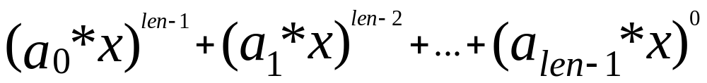
>>>import matplotlib.pyplot as plt
>>> x=linspace(0,10,1000)
>>> y=sin(x)
>>> z=cos(x**2)
>>> plt.figure(figsize=(8,4)) #create a object,and set up its length and width
>>> plt.plot(x,y,label="$sin(x)$",color="red",linewidth=2)
# first and second parameter
are x and y’ type.
>>> plt.plot(x,z,"b--",label="$cos(x^2)$")
>>> plt.xlabel("Time(s)")
>>> plt.ylabel("Volt")
>>> plt.ylim(-1.2,1.2) #the range of show y
>>> plt.legend()
>>> plt.show()
##
>>> for idx,color in enumerate("rgbyck"):
plt.subplot(321+idx,axisbg=color)
>>> plt.show()

