Change: Replaced switch statement for user input with Menu class. This way, while longer, is harder to mess up, and helps reduce conceptual load.

Rule: Replace Type Field With Strategy

Comment:

Before:

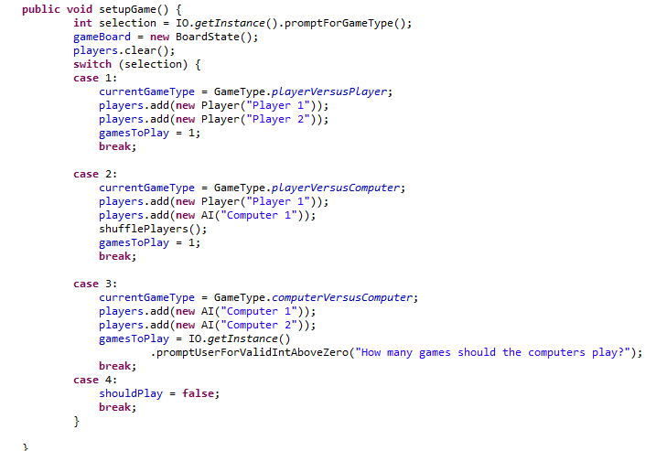

After:

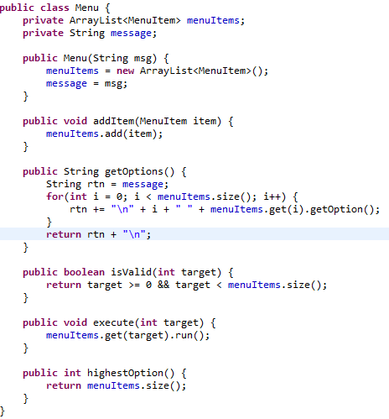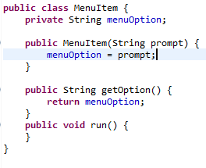

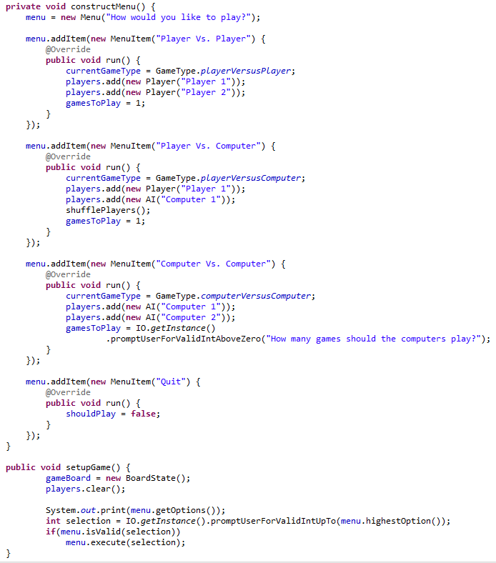

Change:

Rule:

Comment:

Before: