

Lab RSMortgage Config Repository

**Spring Cloud RSMortgage Config Repository**

Udemy Exploring Spring Cloud Course

Presented By

Binit Datta

**Rolling Stone Technology**

**Formatted: December, 2016**

**Table of Content**

1.0 - Introduction 3

1.1 – Create a new Spring Starter Project 4

1.2 – Enter Name 5

1.3 – Do not select any project references 6

1.4—Project shown in Explorer 7

1.5 – Create New Folder 8

1.8 – Enter Folder Name 9

1.7 – Create dev profile yml file – 10

1.8 – Enter file name 11

1.9 – Enter following text in the dev profile file 12

1.10 – Create Property File for Prod Profile 13

1.11 – Enter the following values in the prod property file 14

1.12 – Create Property File for Default Profile 15

1.13 – Enter the following values in the default property file 16

1.14 – Conclusion 17

Chapter 1

*Spring Cloud RSMortgage Config Repository Project Creation*

1.0 - Introduction

The following sections will lead us through creating the Spring Cloud Config Repository creation, one step at a time.

1.1 – Create a new Spring Starter Project

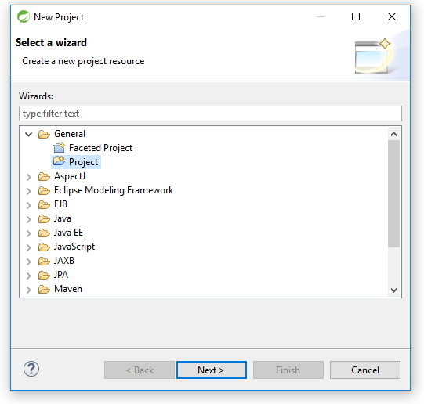

1.2 – Enter Name

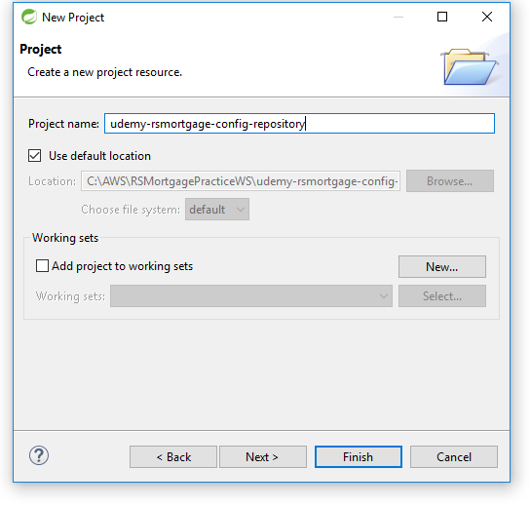

1.3 – Do not select any project references

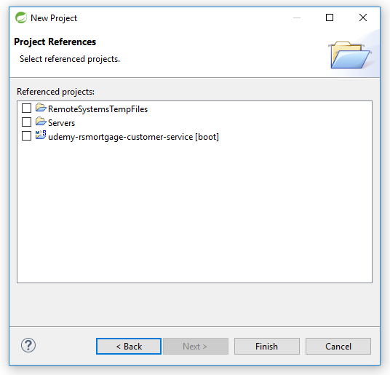

1.4—Project shown in Explorer

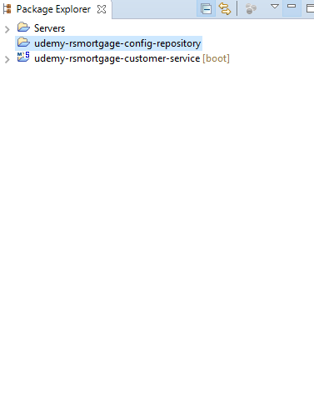

1.5 – Create New Folder

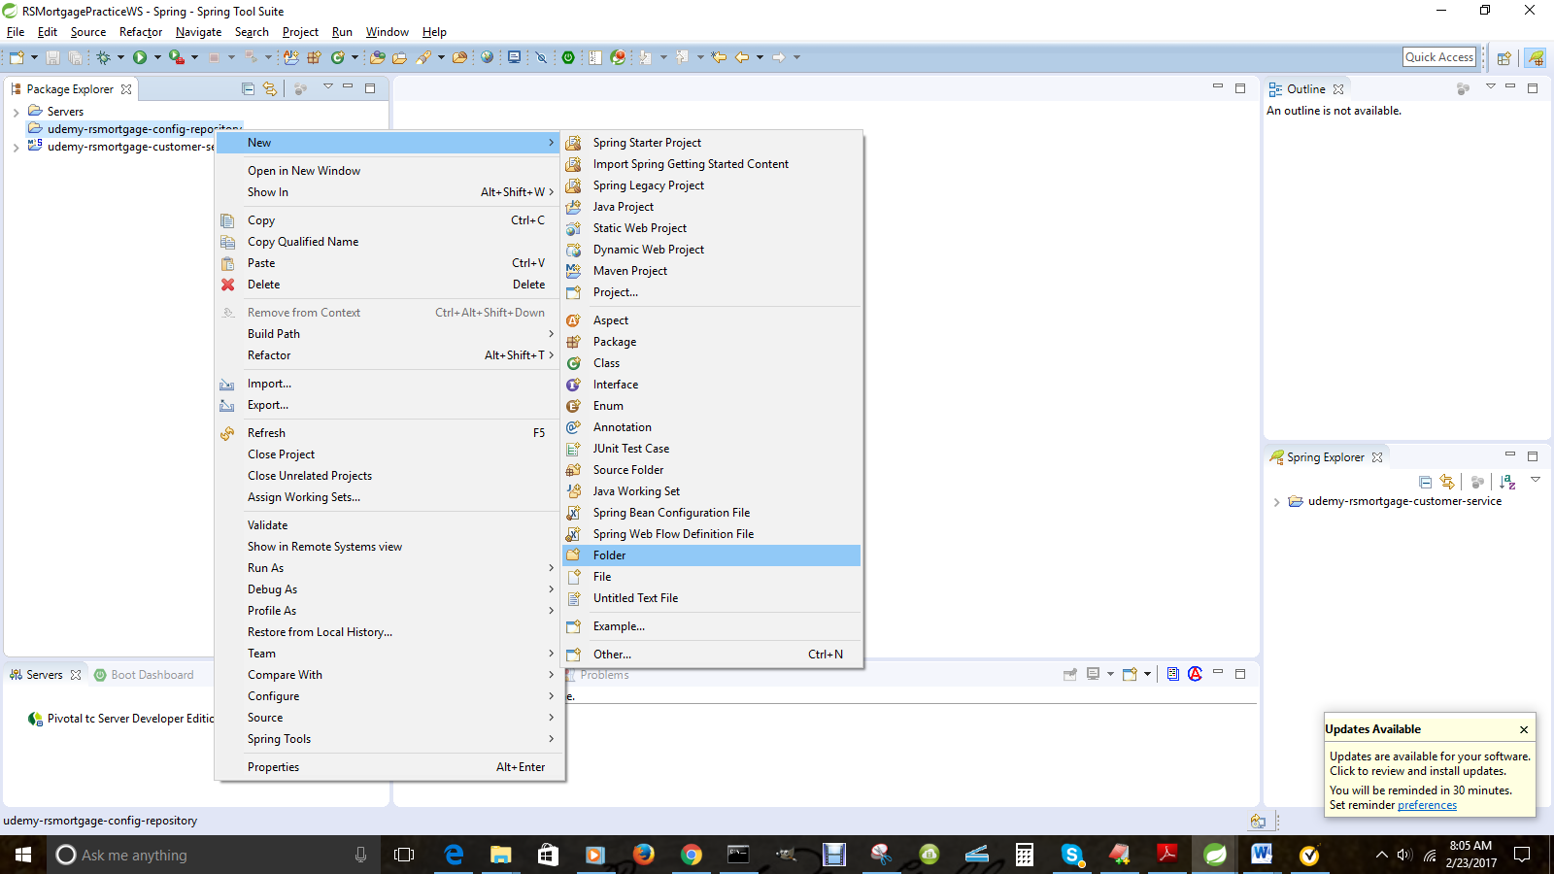

1.8 – Enter Folder Name

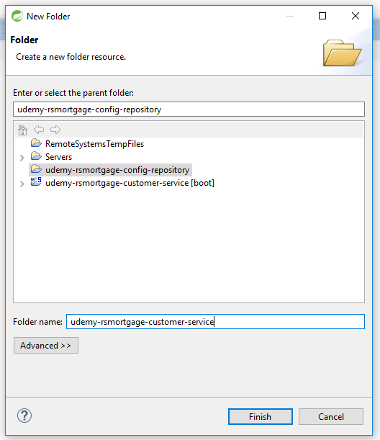

1.7 – Create dev profile yml file –

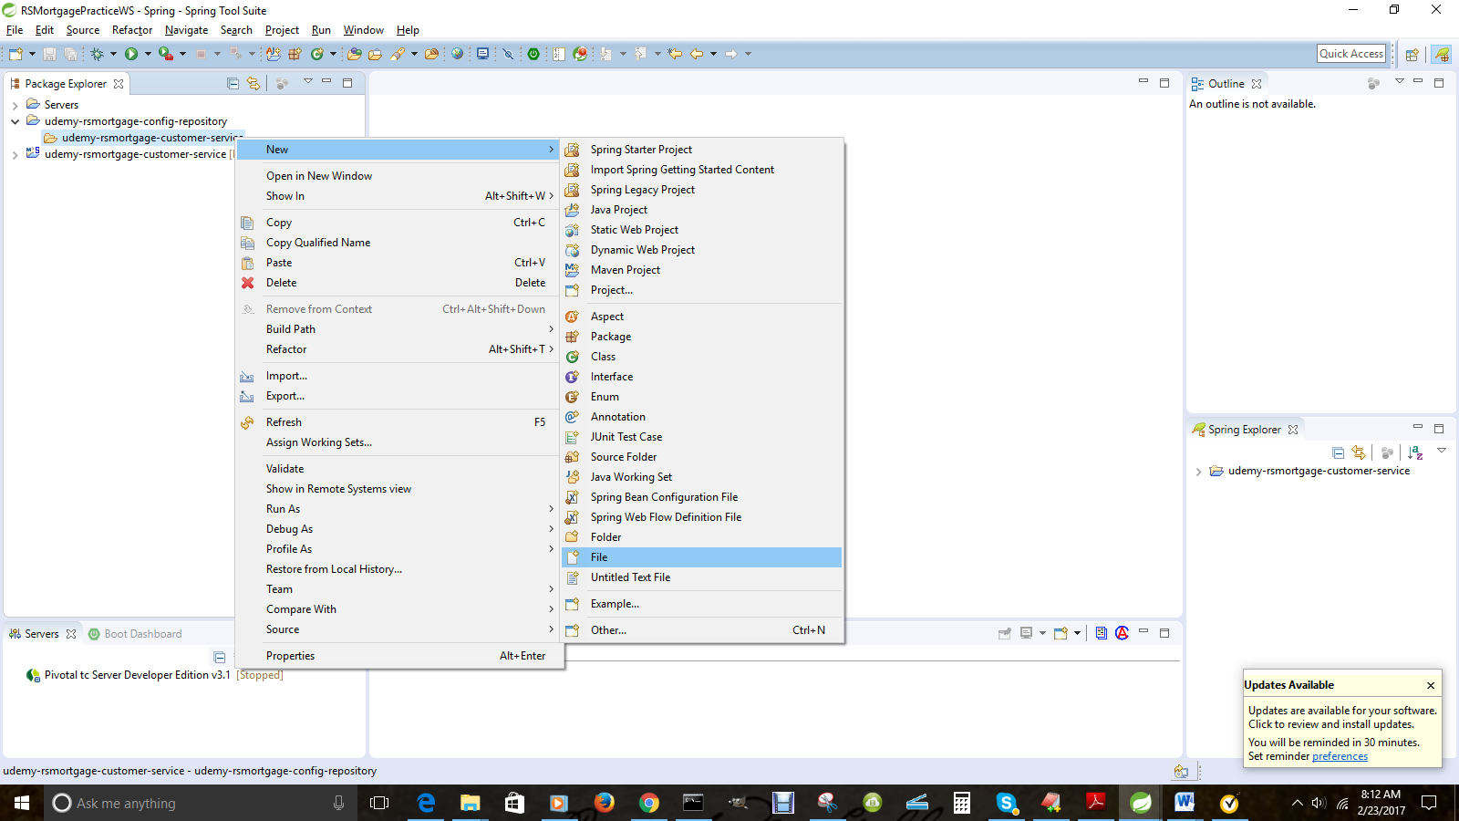

1.8 – Enter file name

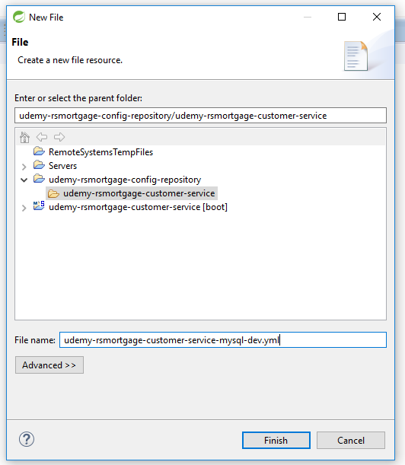

1.9 – Enter following text in the dev profile file

spring.jpa.database: "MYSQL"

spring.datasource.platform: "mysql"

spring.jpa.show-sql: "true"

spring.database.driverClassName: "com.mysql.jdbc.Driver"

spring.datasource.url: "jdbc:mysql://localhost/rsmortgage"

spring.datasource.username: "root"

spring.datasource.password: "root"

spring.datasource.testWhileIdle: "true"

spring.datasource.validationQuery: "SELECT 1"

spring.jpa.properties.hibernate.dialect: "org.hibernate.dialect.MySQLInnoDBDialect"

1.10 – Create Property File for Prod Profile

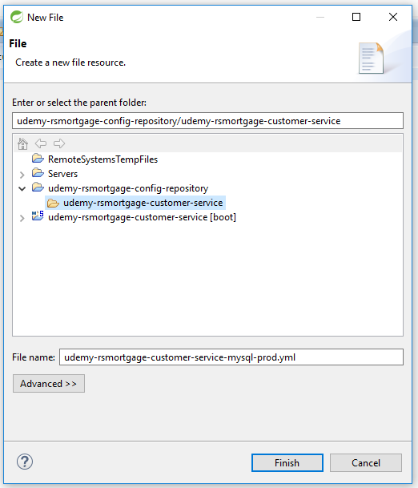

1.11 – Enter the following values in the prod property file

|  |
| --- |
|  |
| spring.jpa.database: "MYSQL"  spring.datasource.platform: "mysql"  spring.jpa.show-sql: "true"  spring.database.driverClassName: "com.mysql.jdbc.Driver"  spring.datasource.url: "jdbc:mysql://localhost/rsmortgage"  spring.datasource.username: "root"  spring.datasource.password: "root"  spring.datasource.testWhileIdle: "true"  spring.datasource.validationQuery: "SELECT 1"  spring.jpa.properties.hibernate.dialect: "org.hibernate.dialect.MySQLInnoDBDialect" |  |
|  |  |
|  |  |
|  |  |
|  |  |
|  |  |
|  |  |
|  |  |
|  |  |

1.12 – Create Property File for Default Profile

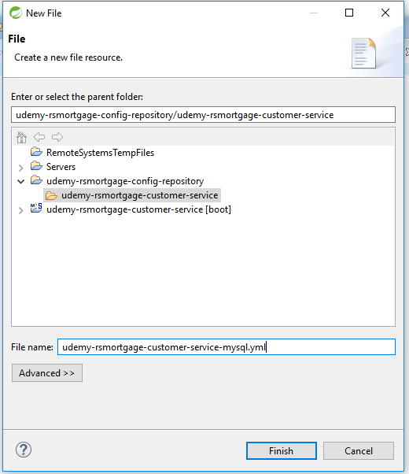

1.13 – Enter the following values in the default property file

spring.database.driverClassName: "com.mysql.jdbc.Driver"

spring.datasource.url: "jdbc:mysql://localhost/rsmortgage"

spring.datasource.username: "root"

spring.datasource.password: "root"

spring.datasource.validationQuery: "SELECT 1"

spring.jpa.properties.hibernate.dialect: "org.hibernate.dialect.MySQL5InnoDBDialect"

spring.jpa.hibernate.ddl-auto: "update"

1.14 – Conclusion

This document listed the steps as well as provided the explanation of creating a Spring Boot application based on Spring Cloud Service Discovery as well as JPA.