

Lab 02 RSMortgage Service Discovery Service 🡪 REST Microservice

**RSMortgage Spring Cloud Service Discovery**

Udemy Spring Cloud Course

Presented By

Binit Datta

**Rolling Stone Technology**

**Formatted: February, 2017**

**Table of Content**

1.0 - Introduction 3

1.1 – Update the hosts file in windows to look like this 4

1.2 – Update the /etc/hosts file MacOS 5

1.3 – Update the /etc/hosts file Linux 5

1.4 – Create a new Spring Starter Project 5

1.5 – Fill initial values 6

1.6 – Choose Eureka and Web as starter projects 7

1.7 – Click Finish Now 8

1.8 – Let Spring Tool Suite Prepare the Project 9

1.9 – Verify the project identification in the pom.xml 10

1.10 – Add Parent project 10

1.11 – Add Properties 10

1.12 – Add Dependencies 11

1.13 – Add DependencyManagement 11

1.14 – Add Build Section 12

1.15 –Create application.yml under resource directory 13

1.16 –Add annotation to the Main Class 14

1.17 –Add bootstrap.yml under resources folder 15

1.18 –Open Git Bash in project folder 16

1.19 –Run the first instance 16

1.20 –Run the second instance 17

1.21 – Navigate to http://localhost:8761 18

1.22 – Navigate to http://localhost:8762 19

1.23 – Navigate to http://eureka-host1:8761/ 20

1.24 – Navigate to http://eureka-host2:8762/ 21

1.24 – Navigate to http://eureka-host1:8762/health 22

1.25 – Navigate to http://eureka-host1:8762/beans 23

1.26 – Navigate to http://eureka-host1:8762/metrics 24

1.27 – Navigate to http://eureka-host1:8762/env 25

1.18 – Conclusion 26

Chapter 1

*Spring Cloud Eureka Service Discovery Project Creation*

1.0 - Introduction

The purpose of this guide is to help walk through the process of creating a Spring Boot / Cloud based Service Discovery application.

1.1 – Update the hosts file in windows to look like this

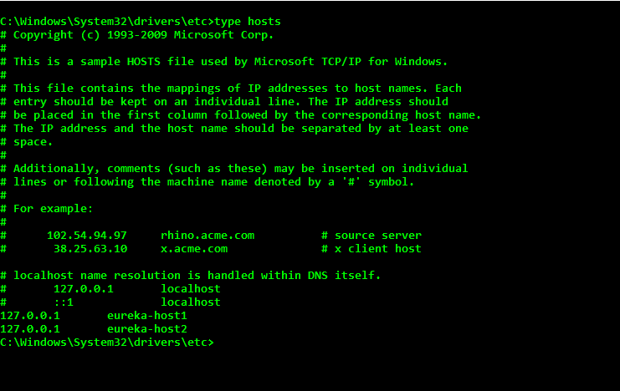

1.2 – Update the /etc/hosts file MacOS

1.3 – Update the /etc/hosts file Linux

1.4 – Create a new Spring Starter Project

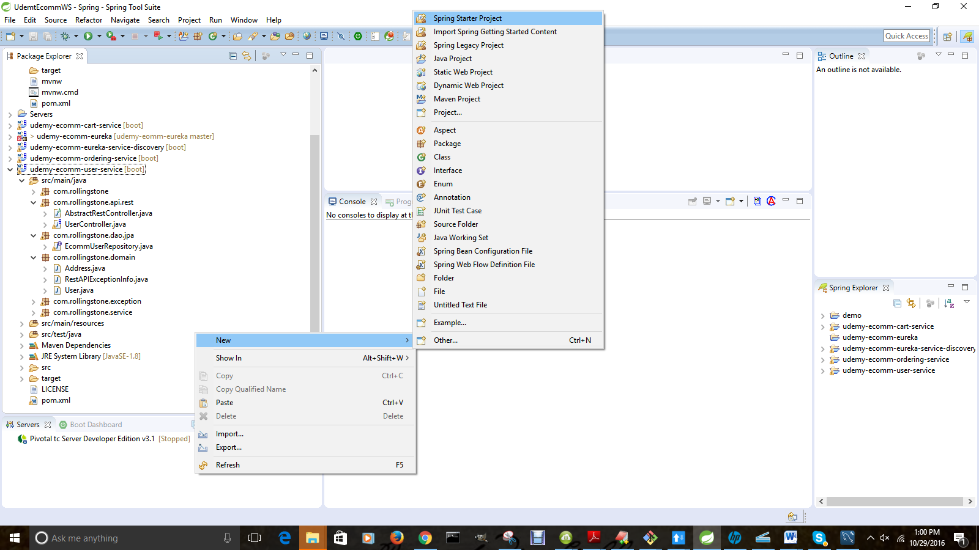

1.5 – Fill initial values

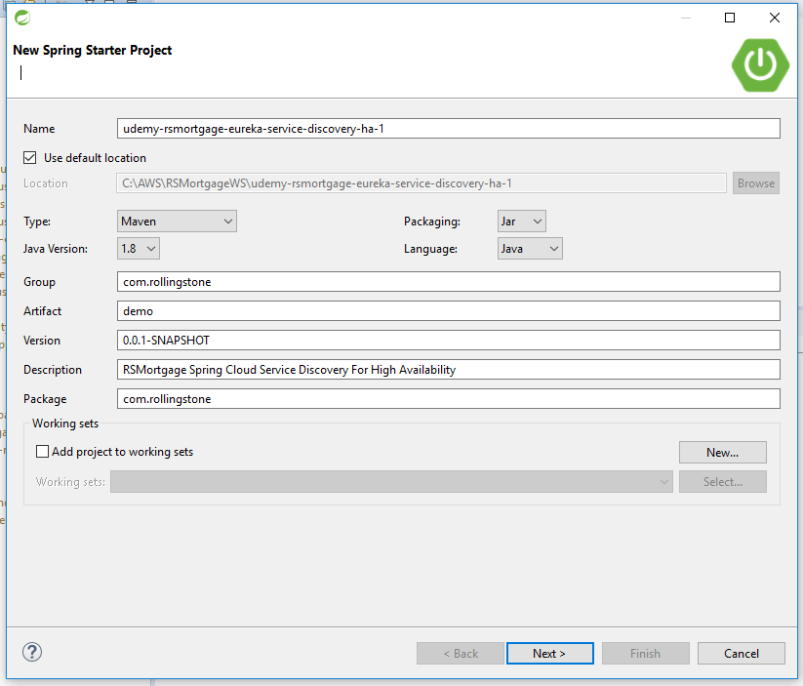

1.6 – Choose Eureka and Web as starter projects

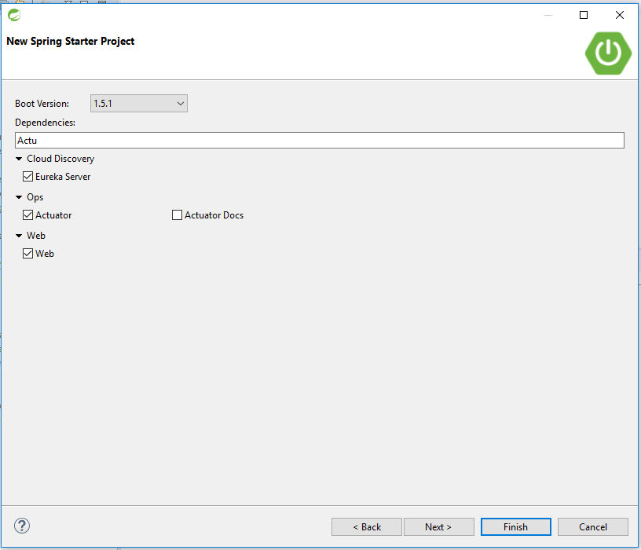

.

1.7 – Click Finish Now

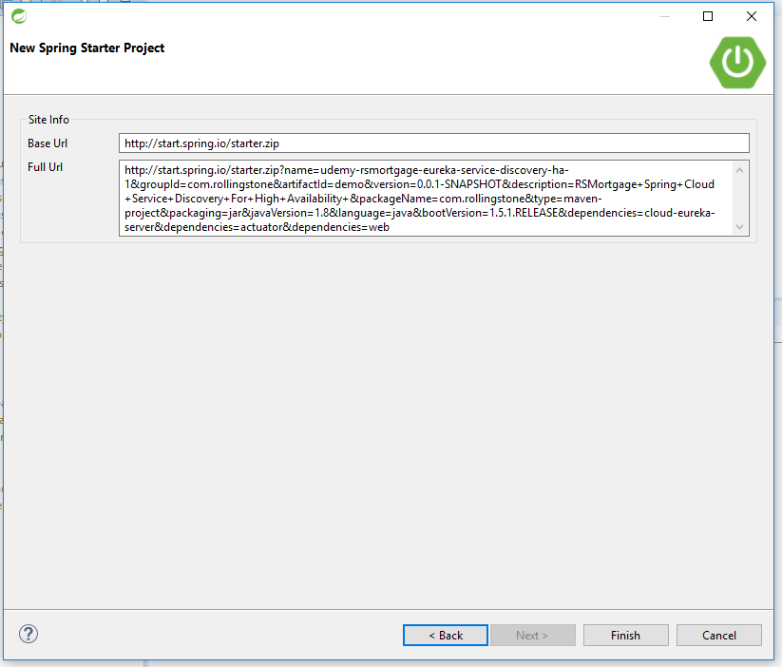

1.8 – Let Spring Tool Suite Prepare the Project

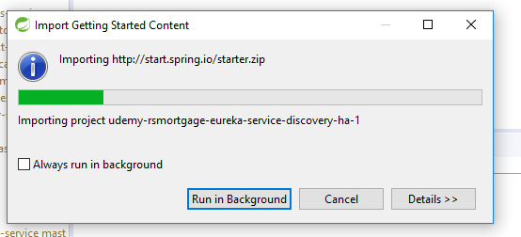

1.9 – Verify the project identification in the pom.xml

<groupId>com.rollingstone</groupId>

<artifactId>udemy-rsmortgage-eureka-service-discovery-ha</artifactId>

<version>0.0.1-SNAPSHOT</version>

<packaging>jar</packaging>

<name>udemy-rsmortgage-eureka-service-discovery-ha</name>

<description>Spring Starter Project for Service Discovery</description>

1.10 – Add Parent project

<parent>

<groupId>org.springframework.boot</groupId>

<artifactId>spring-boot-starter-parent</artifactId>

<version>1.4.1.RELEASE</version>

<relativePath/> <!-- lookup parent from repository -->

</parent>

1.11 – Add Properties

<properties>

<project.build.sourceEncoding>UTF-8</project.build.sourceEncoding>

<project.reporting.outputEncoding>UTF-8</project.reporting.outputEncoding>

<java.version>1.8</java.version>

</properties>

1.12 – Add Dependencies

<dependencies>

<dependency>

<groupId>org.springframework.cloud</groupId>

<artifactId>spring-cloud-starter-eureka-server</artifactId>

</dependency>

<dependency>

<groupId>org.springframework.boot</groupId>

<artifactId>spring-boot-starter-web</artifactId>

</dependency>

<dependency>

<groupId>org.springframework.boot</groupId>

<artifactId>spring-boot-starter-test</artifactId>

<scope>test</scope>

</dependency>

</dependencies>

1.13 – Add DependencyManagement

<dependencyManagement>

<dependencies>

<dependency>

<groupId>org.springframework.cloud</groupId>

<artifactId>spring-cloud-dependencies</artifactId>

<version>Camden.SR1</version>

<type>pom</type>

<scope>import</scope>

</dependency>

</dependencies>

</dependencyManagement>

1.14 – Add Build Section

<build>

<plugins>

<plugin>

<groupId>org.springframework.boot</groupId>

<artifactId>spring-boot-maven-plugin</artifactId>

</plugin>

</plugins>

</build>

1.15 –Create application.yml under resource directory

eureka:

instance:

hostname: localhost

client:

registerWithEureka: **true**

fetchRegistry: **true**

serviceUrl:

defaultZone: http://${eureka.instance.hostname}:${server.port}/eureka/

---

spring:

profiles: eureka-host1

server:

port: 8761

eureka:

instance:

hostname: eureka-host1

client:

serviceUrl:

defaultZone: http://eureka-host2:8762/eureka/

---

spring:

profiles: eureka-host2

server:

port: 8762

eureka:

instance:

hostname: eureka-host2

client:

serviceUrl:

defaultZone: http://eureka-host1:8761/eureka/

1.16 –Add annotation to the Main Class

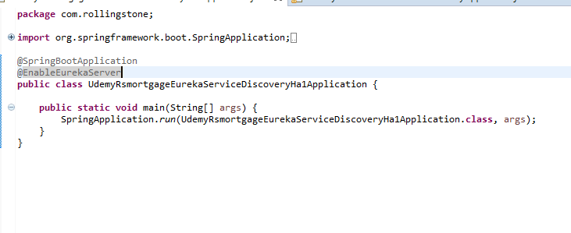

**package** com.rollingstone;

**import** org.springframework.boot.SpringApplication;

**import** org.springframework.boot.autoconfigure.SpringBootApplication;

**import** org.springframework.cloud.netflix.eureka.server.EnableEurekaServer;

@SpringBootApplication

@EnableEurekaServer

**public** **class** UdemyRsmortgageEurekaServiceDiscoveryHaApplication {

**public** **static** **void** main(String[] args) {

SpringApplication.*run*(UdemyRsmortgageEurekaServiceDiscoveryHaApplication.**class**, args);

}

}

1.17 –Add bootstrap.yml under resources folder

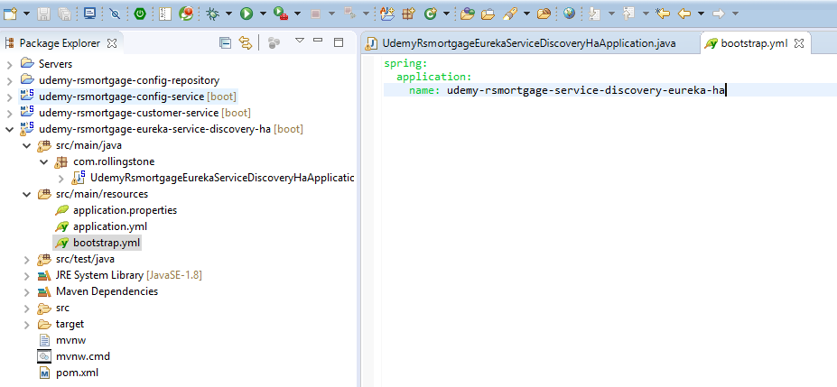

spring:

application:

name: udemy-rsmortgage-service-discovery-eureka-ha

1.18 –Open Git Bash in project folder

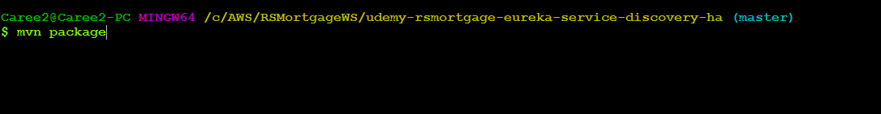

1.19 –Run the first instance

java -jar -Dspring.profiles.active=eureka-host1 target/udemy-rsmortgage-eureka-service-discovery-ha-0.0.1-SNAPSHOT.jar



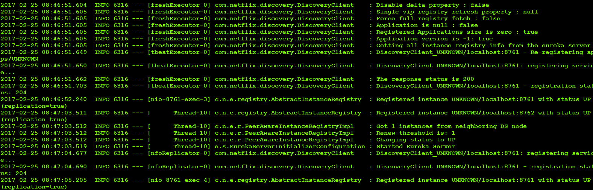

1.20 –Run the second instance

java -jar -Dspring.profiles.active=eureka-host2 target/udemy-rsmortgage-eureka-service-discovery-ha-0.0.1-SNAPSHOT.jar

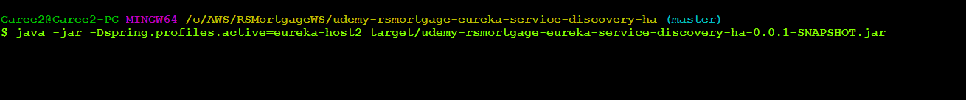

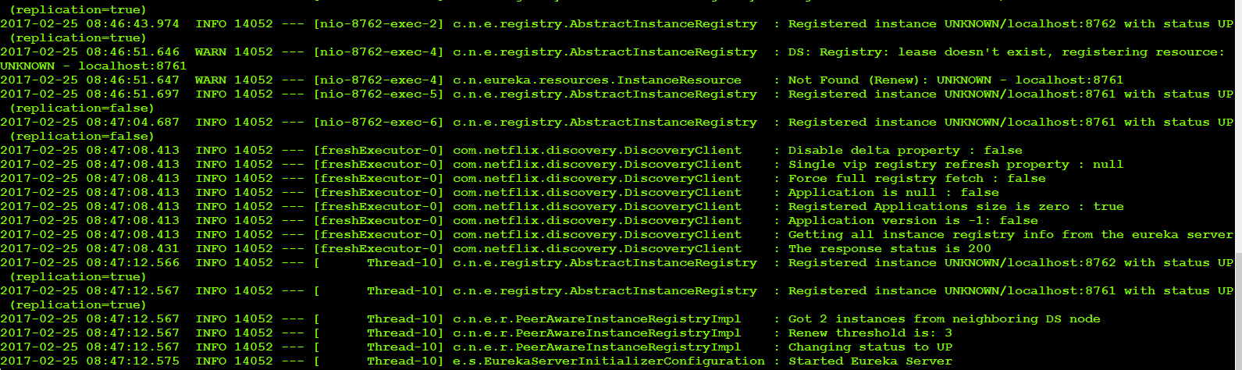

1.21 – Navigate to <http://localhost:8761>

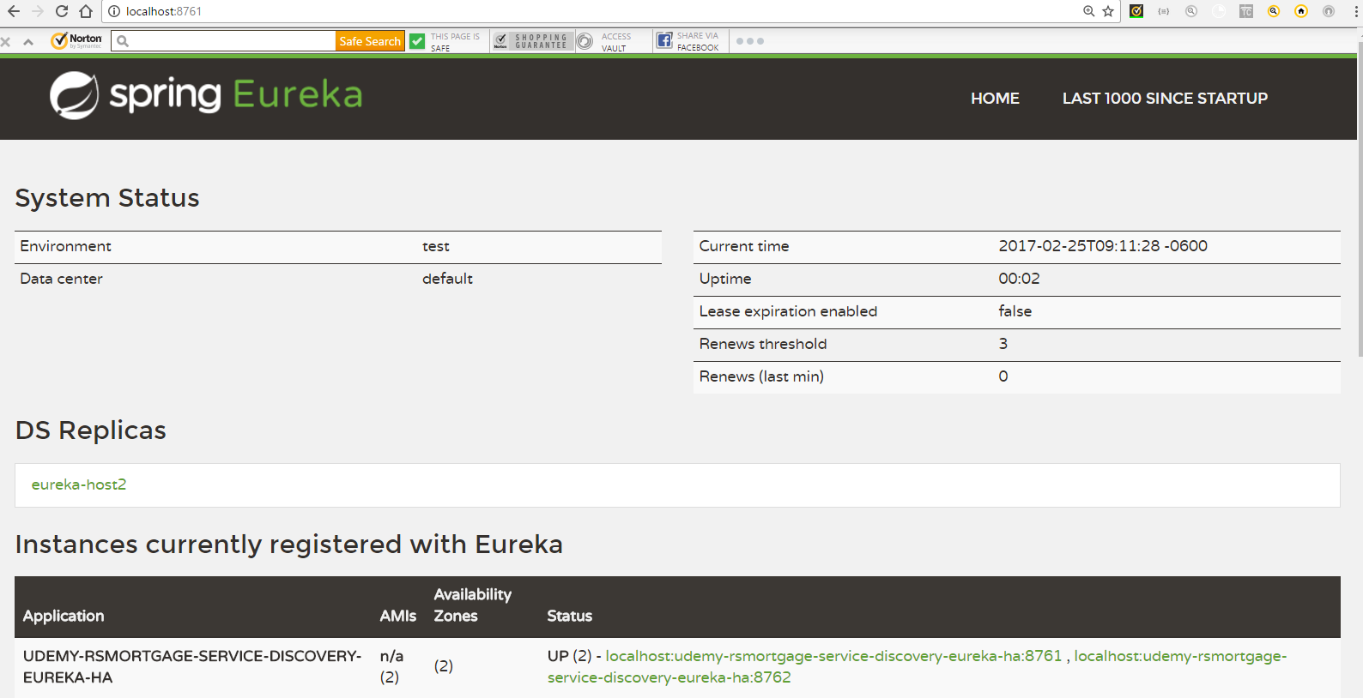

1.22 – Navigate to <http://localhost:8762>

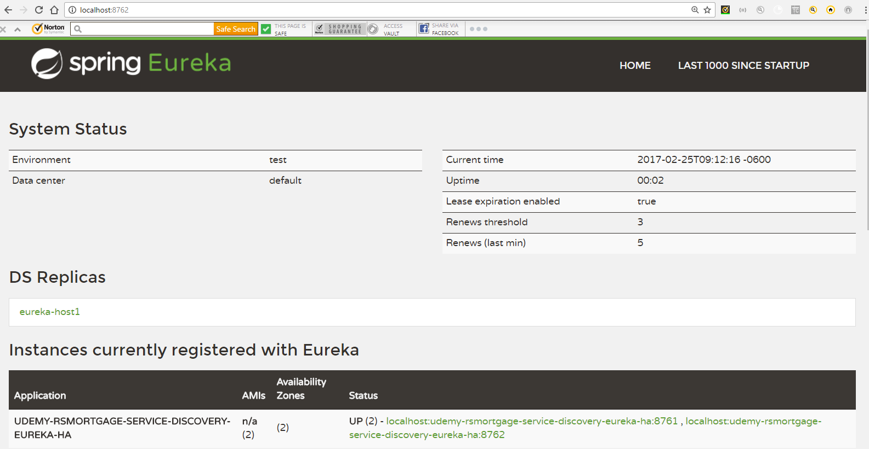

1.23 – Navigate to <http://eureka-host1:8761/>

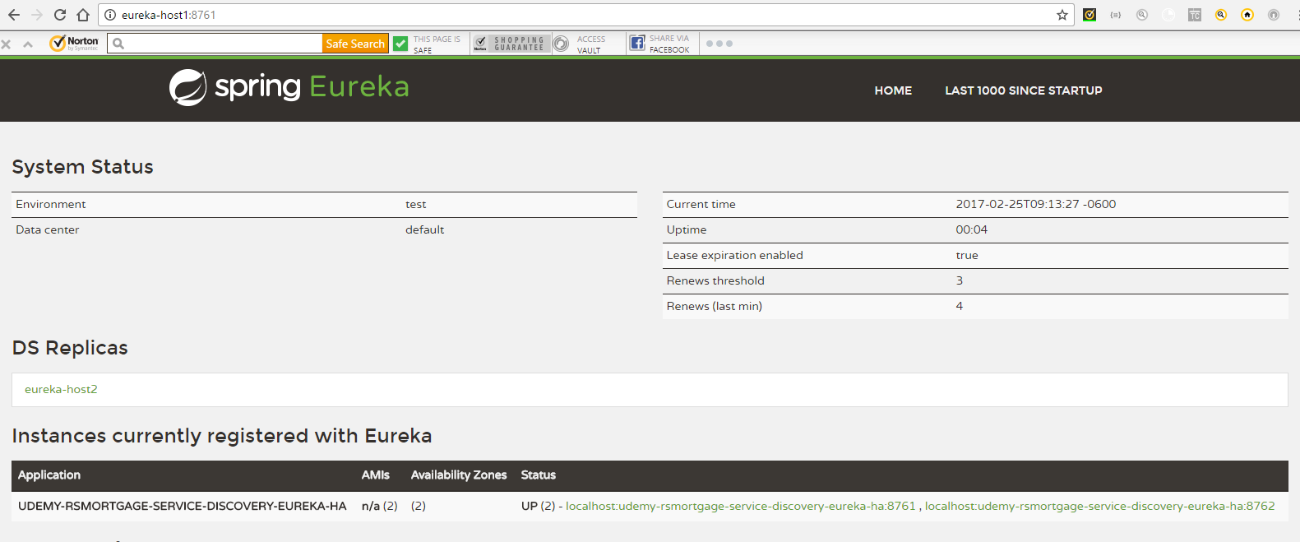

1.24 – Navigate to <http://eureka-host2:8762/>

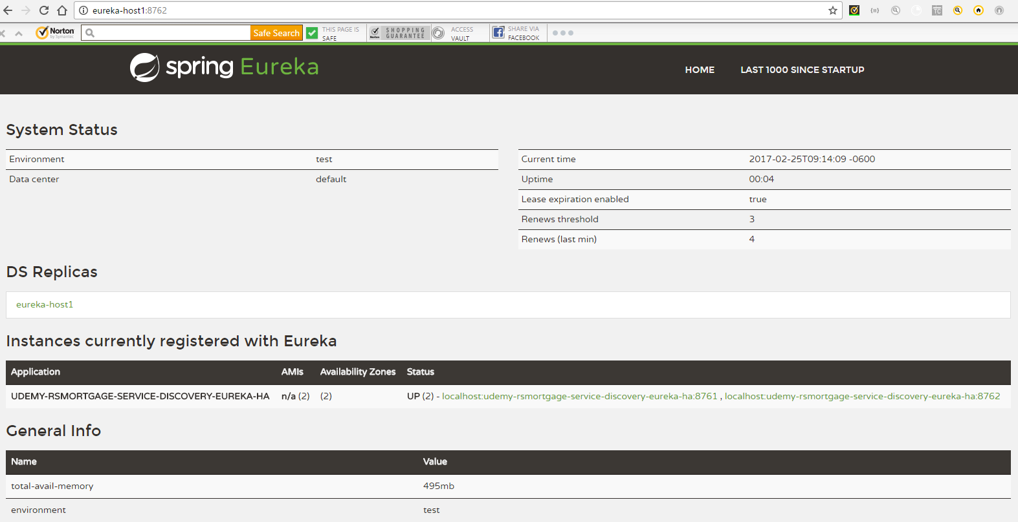

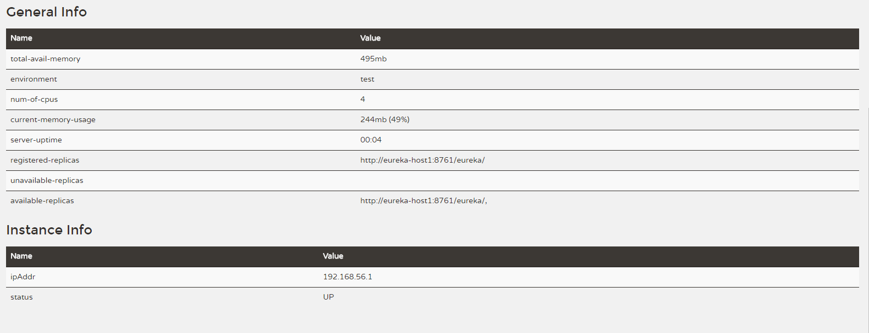

1.24 – Navigate to <http://eureka-host1:8762/health>

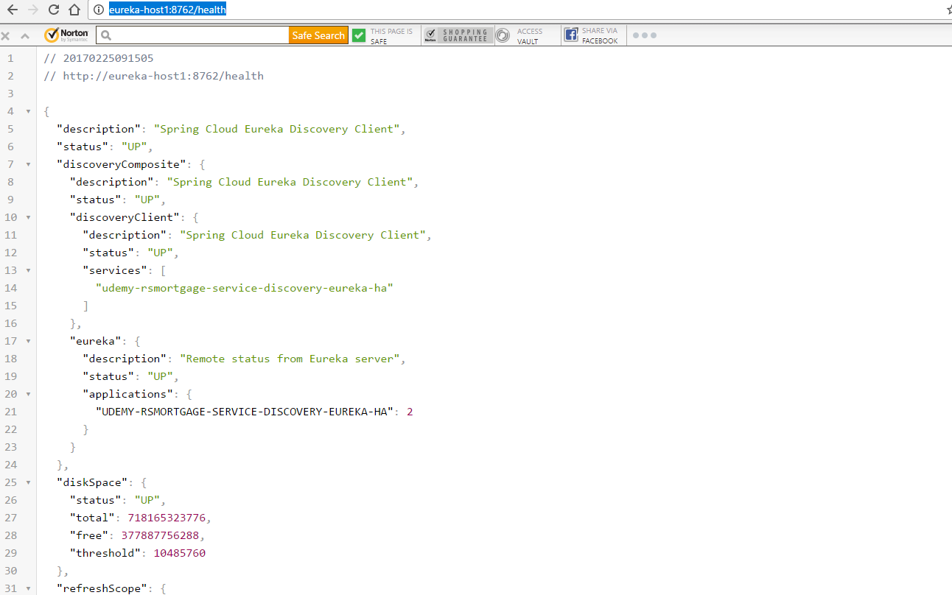

1.25 – Navigate to <http://eureka-host1:8762/beans>

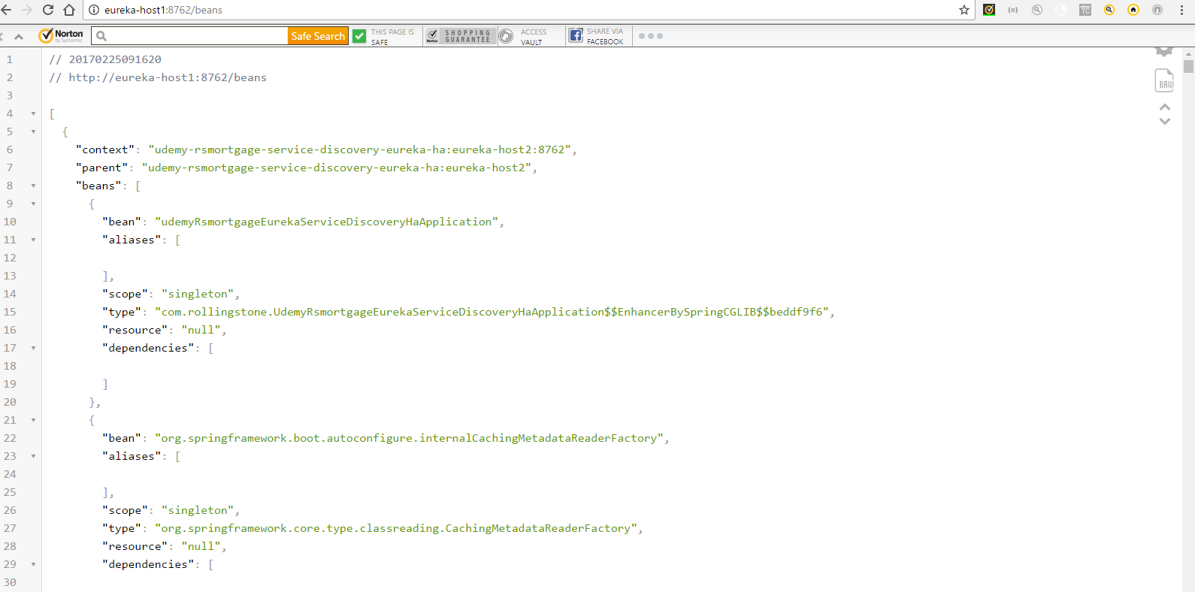

1.26 – Navigate to <http://eureka-host1:8762/metrics>

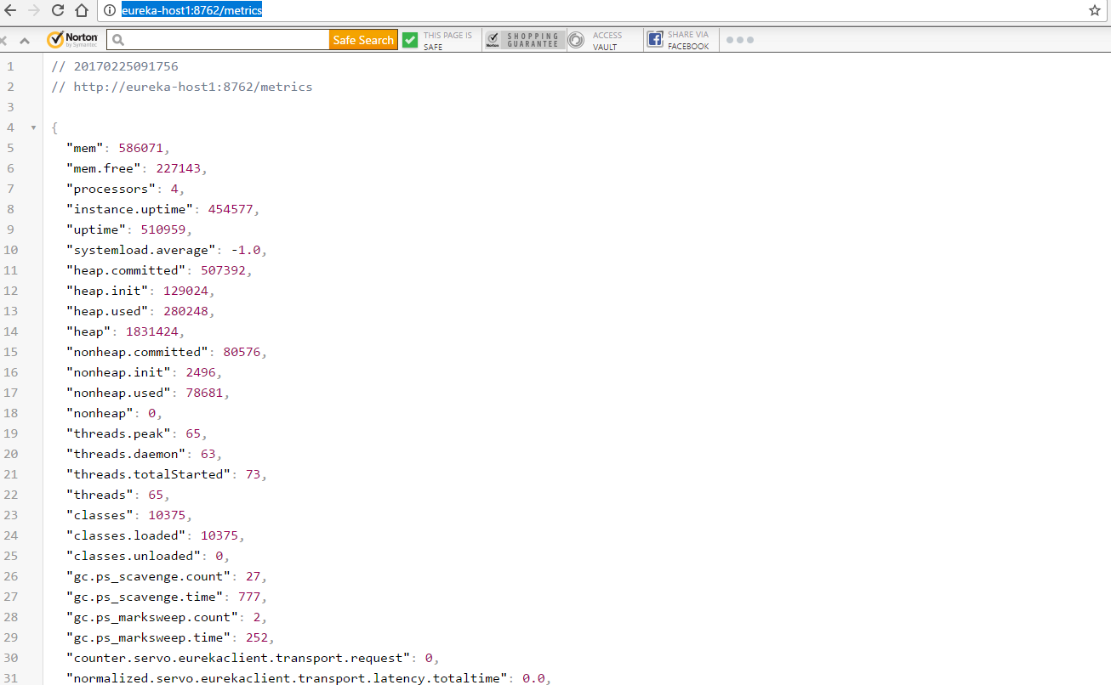

1.27 – Navigate to <http://eureka-host1:8762/env>

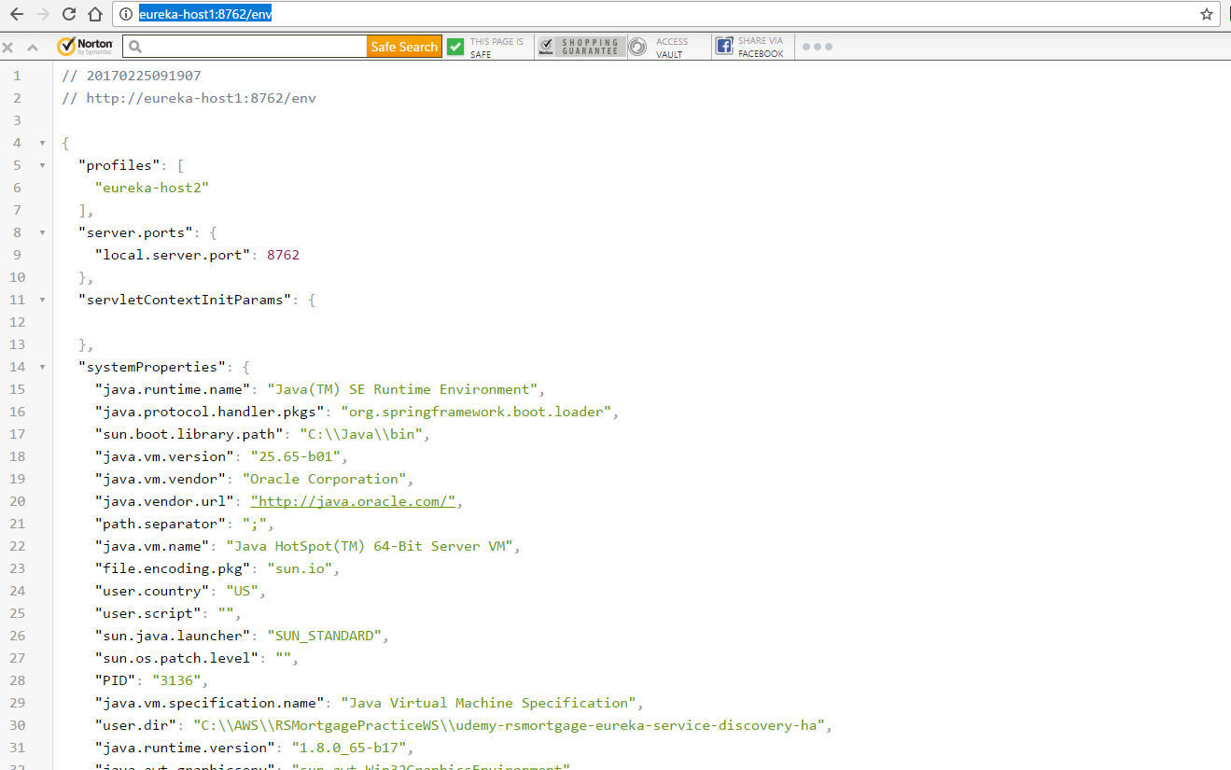

1.18 – Conclusion

This document listed the steps as well as provided the explanation of creating a Spring Boot application based on Spring Cloud Service Discovery.