Project Synopsis — Submission Template
HCLTech Career Shaper Programme | III Year Industry Project | 2025-26
Field | Details (Learner to complete)
Project Title | Cross-Site Scripting (XSS) Attack Detection System (XSS Shield)
Domain | Cybersecurity
Format | Individual Project
Learner Name | KRISHNA GUPTA
Roll Number | 2400320100616
College / Campus | ABES ENGINEERING COLLEGE
Mentor Name | PRIYAN S
Submission Date | 01-NOV-2026
Github Repo | https://github.com/rollnum21/xss-attack-detection
1. Problem Statement
Web developers, students, and security learners (Who) routinely handle user-controlled strings that a web application later places into an HTML body, an HTML attribute, a URL, or a JavaScript block (What, Where). The same characters are interpreted differently by the browser in each of these contexts, and existing pattern checks expect the user to already know the output context, so improperly handled input can silently become executable code and cause Cross-Site Scripting (XSS) (When/Why). We solve this by designing a safe, educational web analyzer that accepts a single untrusted string, automatically checks it against a documented set of deterministic rules in all four supported browser contexts, and returns a predictable, explainable JSON result with CWE-79 association and practical recommendations, while treating the submitted content strictly as inert data (How).
2. Proposed Solution & Approach
We engineered a full-stack web application powered by Java 17, Spring Boot (embedded Tomcat), and a vanilla HTML, CSS, and JavaScript frontend that streamlines XSS pattern analysis without asking the user to identify a browser context. The REST API (POST /api/analyze) validates the request, normalizes the input by trimming outer whitespace and folding case, and in automatic mode evaluates deterministic Java regular-expression rules assigned to HTML_BODY, HTML_ATTRIBUTE, URL, and JAVASCRIPT. The rules cover selected script elements, event handler attributes, embedded HTML elements, attribute breakout sequences, executable URL schemes, HTML data URLs, script element breakouts, and direct JavaScript dialog calls. Each result carries a classification (KNOWN_XSS_PATTERN, NO_KNOWN_XSS_PATTERN, or INVALID_INPUT), the contexts checked, and, for every match, the rule context, explanation, recommendation, CWE-79 mapping, and an OWASP/MITRE security reference. The frontend renders all submitted and returned text with safe DOM APIs (textContent), and adds browser-local history of the latest 10 analyses, JSON report export, and a persistent light/dark theme. The tool is an educational pattern analyzer: a match is not proof of exploitability, and no match is not proof of safety.
3. System Architecture
The system follows a modular, layered architecture comprising a Data Flow Diagram (DFD Level 0 Context Model) and a 4-Tier Functional Block Architecture illustrated below:
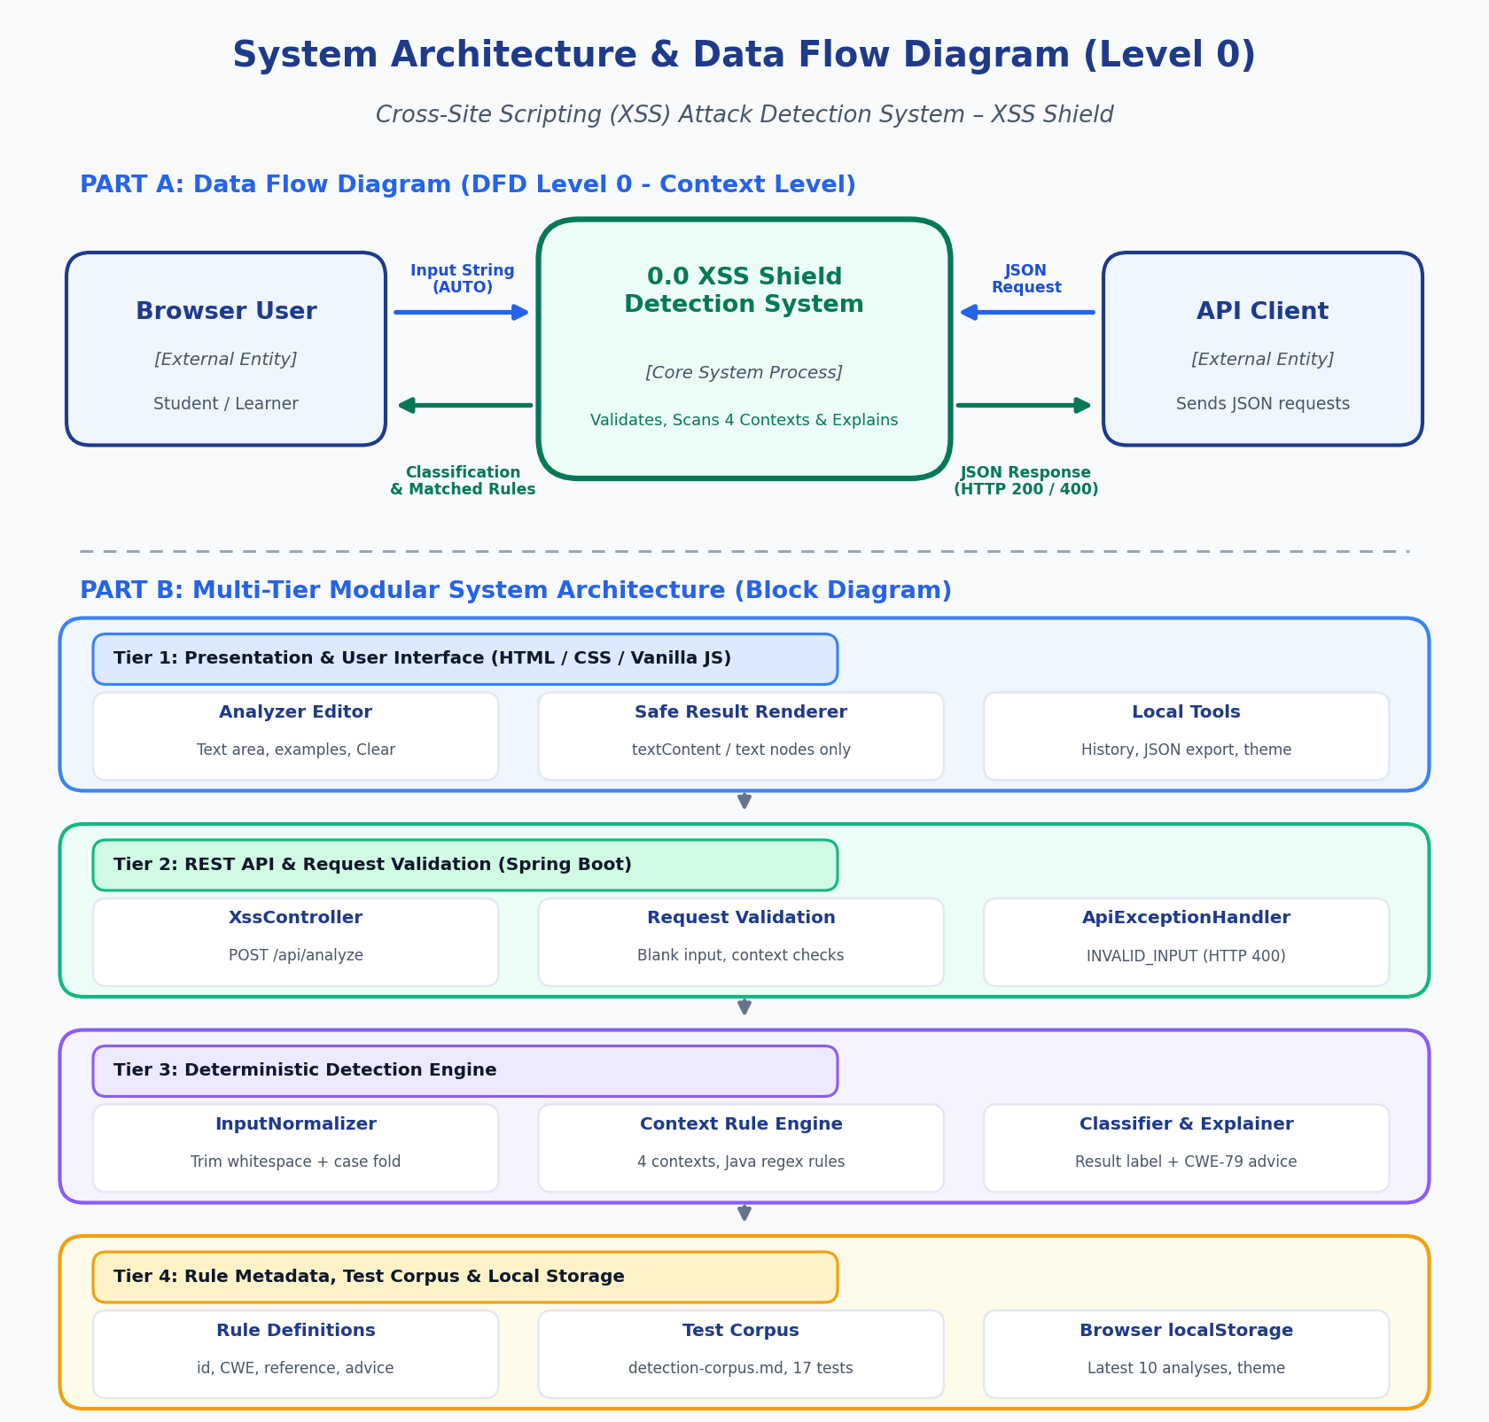
Figure 3.1: Data Flow Diagram (DFD Level 0) & Multi-Tier System Architecture
- DFD Level 0 (Context Level): External users (a browser user or an API client) submit an input string with context AUTO or one explicit context; the core detection system validates, normalizes, scans the supported contexts, and returns the classification, contexts checked, matched rules, recommendations, and an HTTP 200 or HTTP 400 JSON response.
- Tier 1 - Presentation Layer: Static HTML/CSS/vanilla JavaScript UI with a text area, example inputs, analysis summary, matched-rule cards, browser-local history, JSON report export, and a light/dark theme; untrusted text is rendered only with textContent and text nodes.
- Tier 2 - REST API & Validation Layer: Spring Boot with embedded Tomcat; XssController exposes POST /api/analyze, request validation rejects blank input and missing or unsupported context, and ApiExceptionHandler maps unreadable JSON bodies to a structured INVALID_INPUT response (HTTP 400).
- Tier 3 - Deterministic Detection Engine: XssDetectionService with InputNormalizer (trim + case fold) and the context-specific DetectionRule list of Java regular expressions; produces the classification and an XssAnalysisResponse without numeric risk scores or probability percentages.
- Tier 4 - Rule Metadata, Tests & Local Storage Layer: Rule definitions (id, name, explanation, recommendation, CWE, reference), the documented case set (detection-corpus.md) with JUnit/MockMvc tests, and browser localStorage for the latest 10 analyses and the theme preference. No database is used.
4. Technology Stack
Component | Technology / Framework | Version | Role / Description
Frontend / UI | HTML, CSS, vanilla JavaScript | N/A | Responsive single-page analyzer with safe DOM rendering, local history, export, and theme toggle
Backend / Logic | Java, Spring Boot (embedded Tomcat) | Java 17 | REST API, request validation, normalization, and orchestration of the detection service
Detection Engine | Java regular expressions (java.util.regex) | Java 17 | Deterministic, context-specific rules with CWE-79 mapping and security references
API / Data Format | REST, JSON (UTF-8) | N/A | POST /api/analyze with structured responses (HTTP 200 / HTTP 400)
Storage | Browser localStorage | N/A | Latest 10 analyses and theme preference; no database or server-side persistence
Build & Testing | Maven, JUnit, AssertJ, Spring Boot Test, MockMvc | N/A | Automated service and API tests (17 tests) and documented case set
Hardware Requirements | Standard x86_64 CPU | N/A | Any machine that runs Java 17 and a modern browser; no GPU or special hardware needed
5. Dataset Used
The project is a deterministic rule-based analyzer, so it does not train on a dataset. Instead, it is evaluated with a documented set of benign, HTML-like, and XSS-pattern test strings, and every request and response follows a fixed JSON structure:
- Dataset file name: src/test/resources/detection-corpus.md (documented case set, provided in project folder)
- Number of rows: 17 automated tests (13 service tests and 4 API tests) built on the documented cases
- Number of columns: 2 request fields (input, context) and 6 response fields (detected, classification, context, analyzedContexts, matchedRules, message)
- Key columns (5 detailed):
1. input (String, required): The untrusted string to analyze; blank input is rejected as INVALID_INPUT.
2. context (Categorical): AUTO (all four contexts) or one of HTML_BODY, HTML_ATTRIBUTE, URL, JAVASCRIPT.
3. classification (Categorical): KNOWN_XSS_PATTERN, NO_KNOWN_XSS_PATTERN, or INVALID_INPUT.
4. analyzedContexts (List): Every context that was checked for the request.
5. matchedRules (List of objects): id, name, description, recommendation, matched context, cwe, and securityReference of each rule that matched.
- Any additional data collected: None on the server. The browser keeps only the latest 10 completed analyses and the theme preference in localStorage; exported JSON reports contain the submitted input and should be handled as sensitive data.
6. Key Results & Metrics
The detector was evaluated with documented unit and API test cases and a manual browser walkthrough using script, URL, and benign text examples. The project deliberately reports no accuracy percentages or corpus metrics, because the rule set covers a defined subset of XSS techniques:
- Metric 1 [Automated Tests]: 17 automated tests completed (13 service tests and 4 API tests) with no failures or errors.
- Metric 2 [Context Coverage]: All 4 supported contexts (HTML_BODY, HTML_ATTRIBUTE, URL, JAVASCRIPT) are checked automatically per request, covering 8 categories of XSS-related constructs.
- Metric 3 [Demonstrated Results]: <script>alert(1)</script> matched script-related rules in HTML_BODY and JAVASCRIPT; javascript:alert(1) matched the JavaScript URL scheme rule in URL; "Hello, this is normal text." returned NO_KNOWN_XSS_PATTERN; blank input and missing or unsupported context returned INVALID_INPUT with HTTP 400.
- Educational Value Achieved: Shows learners why context matters, gives deterministic and explainable results (rule, context, recommendation, CWE-79, reference) instead of arbitrary scores, keeps submitted strings inert, and clearly states that it does not replace output encoding, sanitization, Content Security Policy, or a production WAF.
7. Challenges Faced & How Resolved
• Challenge 1: Context-Dependent Interpretation of the Same String:
Problem: The same characters mean different things in an HTML body, an attribute, a URL, or JavaScript, and forcing users to choose the context in advance is error-prone because the analyzer cannot know where a separate application will place the string.
Resolution: Implemented an automatic mode (context = AUTO) in which the service evaluates the rules of all four supported contexts and labels every match with its rule context, explanation, and security reference, while still allowing API clients to request one explicit context.
• Challenge 2: Handling Untrusted Strings Safely and Honestly:
Problem: A tool that displays XSS payloads can itself become an XSS vector, and pattern matching can give a false sense of security when nothing matches.
Resolution: The backend never executes input and the frontend uses textContent and created text nodes (no innerHTML); links are limited to approved HTTPS OWASP/MITRE hosts, and results state that a match is not proof of exploitability and no match is not proof of safety, with no numeric risk scores.
Output Images
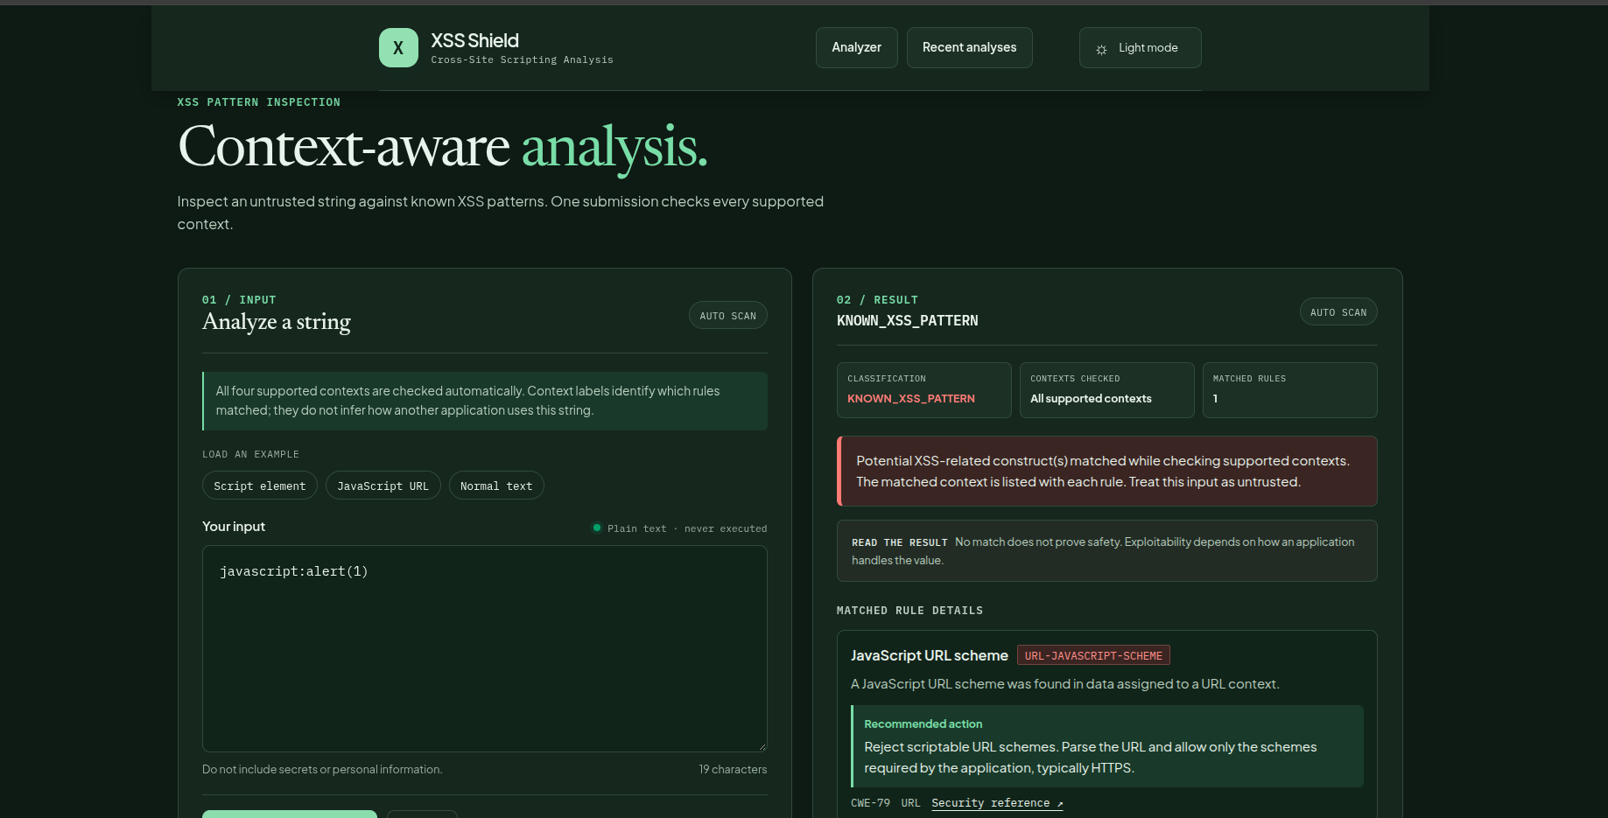

8. References
[1] OWASP Foundation. (n.d.). 'Cross Site Scripting Prevention Cheat Sheet.' OWASP Cheat Sheet Series. https://cheatsheetseries.owasp.org/cheatsheets/Cross_Site_Scripting_Prevention_Cheat_Sheet.html
[2] OWASP Foundation. (n.d.). 'DOM based XSS Prevention Cheat Sheet.' OWASP Cheat Sheet Series. https://cheatsheetseries.owasp.org/cheatsheets/DOM_based_XSS_Prevention_Cheat_Sheet.html
[3] OWASP Foundation. (n.d.). 'XSS Filter Evasion Cheat Sheet.' OWASP Cheat Sheet Series. https://cheatsheetseries.owasp.org/cheatsheets/XSS_Filter_Evasion_Cheat_Sheet.html
[4] MITRE Corporation. (n.d.). 'CWE-79: Improper Neutralization of Input During Web Page Generation (Cross-site Scripting).' https://cwe.mitre.org/data/definitions/79.html
[5] Spring Boot Project. (n.d.). 'Spring Boot Reference Documentation.' https://docs.spring.io/spring-boot/
Learner Signature: Krishna Gupta Date: 01-11-2026

