

Rollun LC
30 N Gould St STE 4370 Sheridan WY 82801
www.rollun.com llc@rollun.com
T: (307) 920-0149

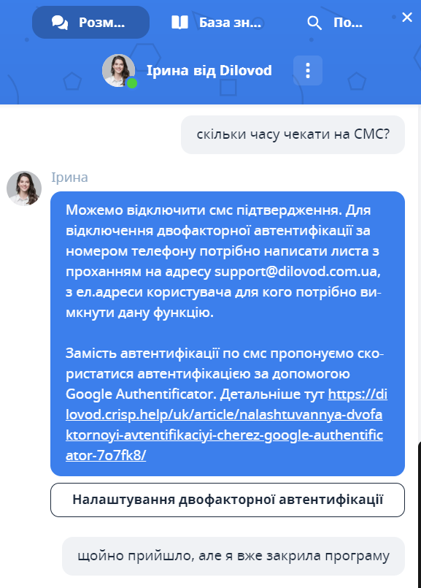
https://dilovod.crisp.help/uk/article/nalashtuvannya-dvofaktornoyi-avtentifikaciyi-cherez-google-authenticator-7o7fk8/

