Section 7 Web Development with Spring MVC

Lesson 98 – Create a Recipe Project using Spring boot

Assignment link
Git Cheatsheet
Flashcards

Drawing 1: assignment
• Use Spring Initializr to create a new Spring Boot project
• Use Spring Boot v2
• Add “DevTools” (under core)
• Add “Web” (Under Web)
• Add “Thymeleaf” (Under Template Engines)
• Add JPA and H2 (Under SQL)

- I created a Maven project using https://start.spring.io/
  - java -. maven – 2.7.8 -
  - <groupId>guru.springframework</groupId>
  - <artifactId>recipe</artifactId>
  - <name>recipe</name>
  - <description>A Spring Boot Recipe Project</description>

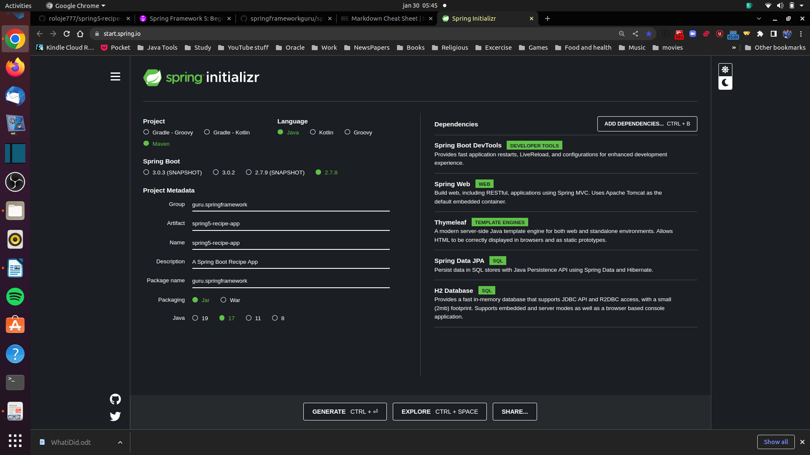

- Named my project folder same as artifactId – recipe
- extracted contents to the project’s current location.
- made it a git reposotory,a README.md,created a master branch and an .gitignore file
> git init
>git switch -c master
  - > add and commit changes
  - > git add .
  - > git commit -m “add recipe project”
- created a new github Repository named spring-5-recipy-app.
> git remote add origin git@github.com:roloje777/spring5-recipe-app.git
Note I used ssh as its set not to ask passwords everytime
- Pushed my local master branch to gitub.
> git push origin master
- open project in IDE (IntelliJ) and commit changes to this file

Lesson 100 – Introduction to Thymeleaf

Introduction to Thymeleaf

<!DOCTYPE html>
<html lang="en" xmlns:th="http://www.thymeleaf.org">
<head>
<meta charset="UTF-8"/>
<title>Recipe Home</title>
</head>
<body>
<h1>My Recipes!</h1>
</body>
</html>

You can see right at the top DOCTYPE html. The second line there,
you can see that we are declaring an XML namespace for Thymeleaf.

Lesson 101 Create Index Page

- Create a controller

Drawing 2: IndexController.java
package guru.springframework.controllers;
import org.springframework.stereotype.Controller;
import org.springframework.web.bind.annotation.RequestMapping;
/*
Tells Spring that this is a Bean
*/
@Controller
public class IndexController {
/*
@RequestMapping({"","/","/index"}) is the URL path to the index.html page
return "index" name must match the actual htm file name
*/
@RequestMapping({"","/","/index"})
public String getIndexPage(){
return "index";
}
}

- Create the View (index.html)

Drawing 3: ./resources/templates/index.html
<!DOCTYPE html>
<html lang="en" xmlns:th="http://www.thymeleaf.org">
<head>
<meta charset="UTF-8"/>
<title>Recipe Home</title>
</head>
<body>
<h1>My Recipes!</h1>
</body>
</html>

Lesson 132 One to One JPA Relationship

one-to-one-jpa branch

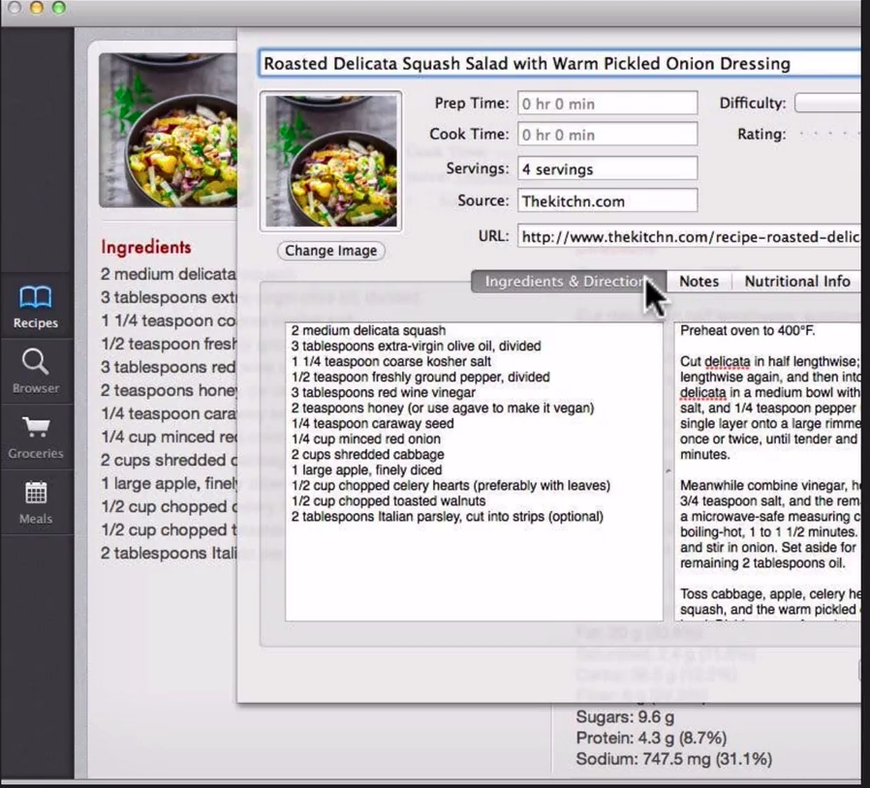Figure 1: Model / Domain taken from Gui interface for example

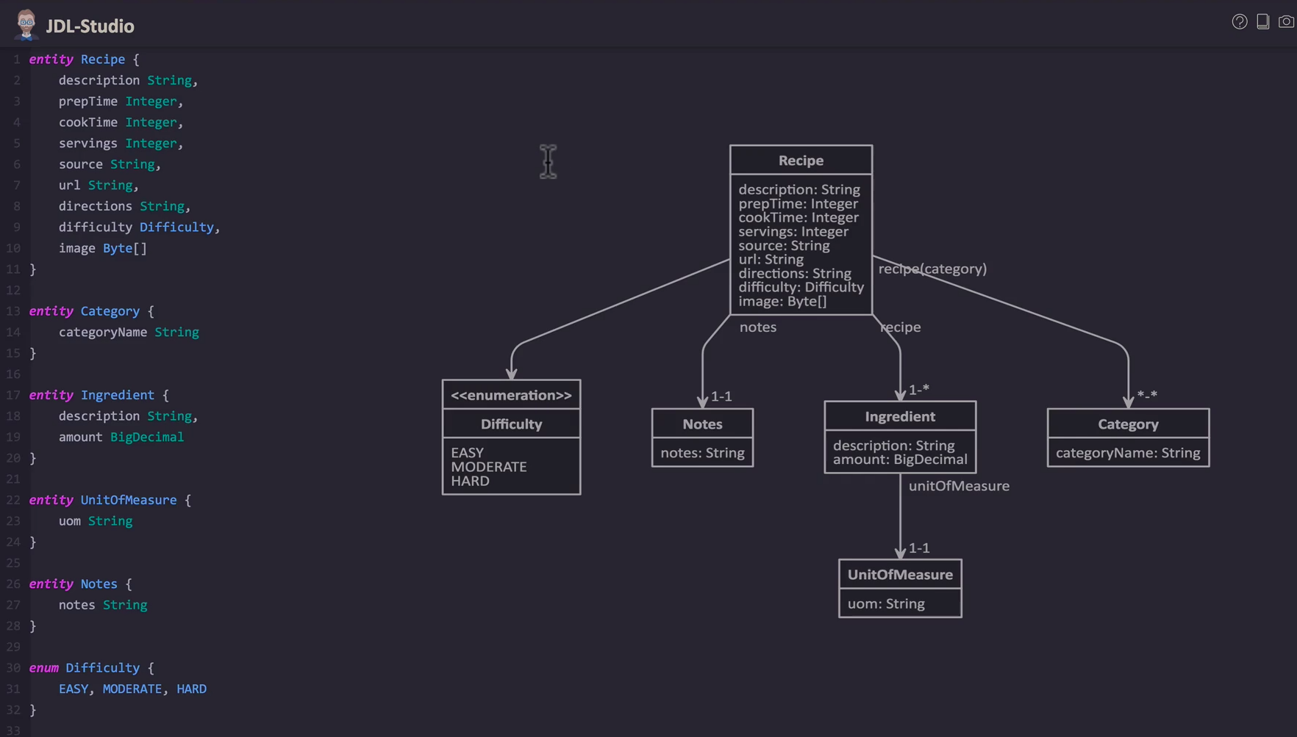Figure 2: Entity Diagram using JDL-Studio

In this lesson we will map the one-to-one relationship between the Recipe and the Notes entities that are classes (objects) in Java.
Note that the owner in the relationship is the recipe and the cascading is set to all.
Also it is using a bi -directional relationship,.

Types of Relationships
•
Many to One - @ManyToOne
•
•
The inverse relationship of One to Many
Many to Many - @ManyToMany
• Many entities are related to many entities
• Each has a List or Set reference to the other
• A join table is used to define the relationships

Unidirectional vs Bidirectional
•
Unidirectional is one-way
•
•
Mapping is only done one way. One side of the
relationship will not know about the other
Bidirectional is two way
• Both sides know about each other
• Generally recommended to use Bidirectional, since you
can navigate the object graph in either direction

“Owning Side”
• The Owning side in the relationship will hold the
foreign key in the database
• One to One is the side where the foreign key is
specified
• OneToMany and ManyToOne is the ‘Many’ side
• ‘mappedBy’ is used to define the field with “owns” the
reference of the relationship

JPA Cascade Types
• JPA Cascade Types Control how state changes are cascaded
from parent objects to child objects.
• JPA Cascade Types:
• PERSIST - Save operations will cascade to related entities
• MERGE - related entities are merged when the owning entity
is merged
• REFRESH - related entities are refreshed when the owning
entity is refreshed
• REMOVE - Removes all related entities when the
owning entity is deleted
• DETACH - detaches all related entities if a manual
detach occurs
• ALL - Applies all the above cascade options
By default, no operations are cascaded

See notes here

- see use of tags when craeting the entities on the object model
  - @Entity – class is an entity
  - @ID – primary key for the entity
  - @@GeneratedValue(strategy = GenerationType.IDENTITY) – Auto generate a primary key
  - @OneToOne – a One to one relationship
  - @OneToOne(cascade = CascadeType.ALL) – opne to one relationship set at owner with cascade type set to all

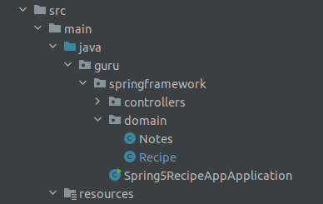Figure 3: Note some use model other domain as the package

See tha actual POJO entities here, note thje comments etc

Lesson 133 One To Many JPA Relationships

branch one-to-many-jpa

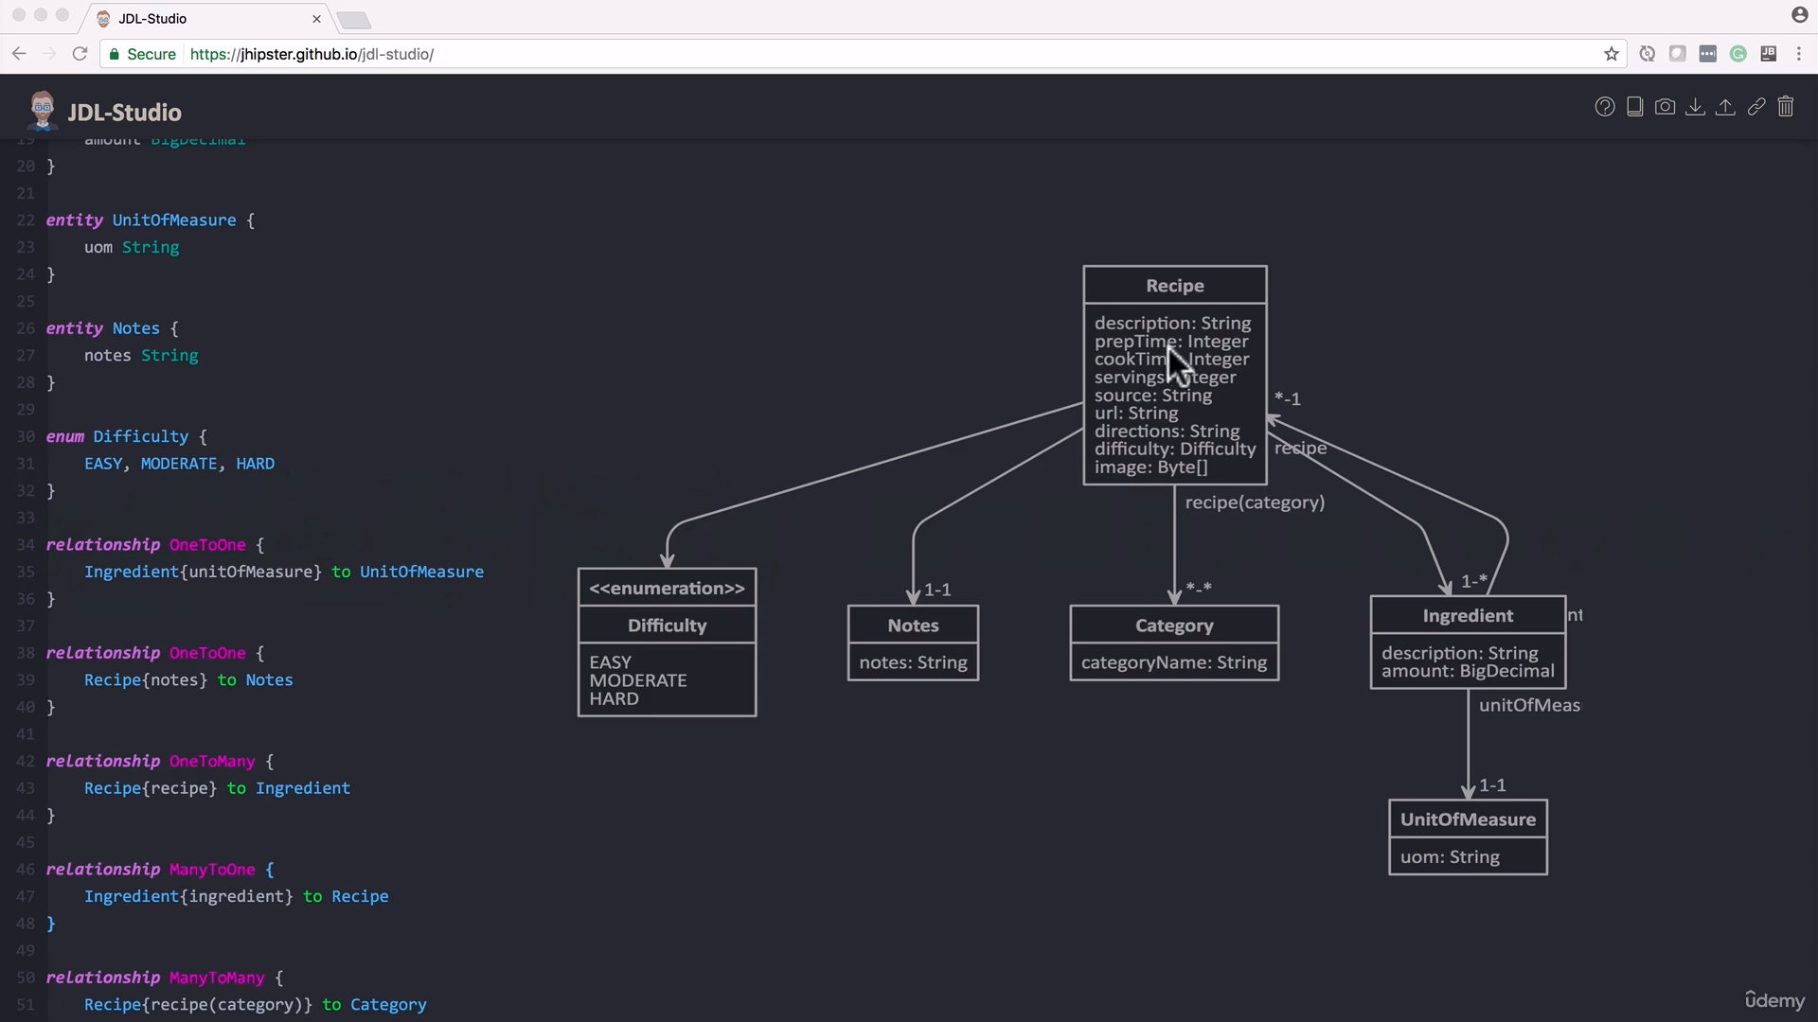

- Note changes made for Recipe to Engredient relationship. Its now bi-directional with a
Recipy – Engredient (1 - *) one-to-many. So you will have a collection of recipies in the Recipe entity
@OneToMany(cascade = CascadeType.ALL, mappedBy = "recipe")
private Set<Ingredient> ingredients;

mappedBy - The field that owns the relationship. Required unless the relationship is unidirectional.
  - Engredient – Recipe (* - 1) many-to-one – só you will have a Recipy reference variable in the EntityObject

@ManyToOne
private Recipe recipe;

Okay, I've gone in and made a small adjustment to the model that we've been looking at.
So we are going to be looking at one to many and many to one relationships in this video.
And what I did is we have the Recipe object which is a one-to-many relationship to Ingredient but we want to make this a
bi-directional relationship.
So we need to get that mapping back from Ingredient to Recipe and that'll be many-to-one.
So we're going to go through and set this up so the Recipe is going to be the owner and he will own the relationship
but Ingredient, we want to be able to navigate back to the Recipe from Ingredient in this case.
And you can see there the mapping between the the two entities has been updated where between Recipe and Ingredient, we have a
one-to-many relationship and then Ingredient has a many to one relationship.
So we're going to go in and configure this now.
I'll show you how to set it up inside of IntelliJ.
So I've gone in and I've created the Ingredient object and I have not created anything further.
So we'll step through creating placeholder in there for UnitOfMeasure which we'll get to in a future video and him as an entity.
So we're going to use the Entity annotation and then I have a we want to add in a property for the Recipe that he belongs to.
So now we have this relationship between the two and we want to add in the basic getter and setter.
I'm going to hold off on that.
We also want to add in a Long property for id.
And again we're going to use the strategy, GenerationType IDENTITY which will get generated from the database.
So now I'm going to go in and add in the getter and setter.
So this command in, getters and setters, highlight all those.
So now our Ingredient class is set up and it's going to be set up as an entity in JPA.
So now we want to modify the Recipe class.
@OneToMany(cascade = CascadeType.ALL, mappedBy = "recipe")
private Set<Ingredient> ingredients;

o we want to annotate this using OneToMany.
Now we want the Recipe to own this. So now we want to add in a cascade type and it'll persist all operations.
Now we want to do a mappedBy.
mappedBy = "recipe"
The field that owns the relationship. Required unless the relationship is unidirectional.
IntelliJ intellisense would come up but in this case we want to say the property on the child class.
So that's going to be Recipe.
So that defines the relationship from Recipe class and we're saying that this Recipe will get stored on a property on the child or the set of ingredients on each object of Ingredient is going to be a property called recipe.
So jump back over here to Chrome.
That completes this direction of the relationship so from Recipe to Ingredient.( 1 - * in Recipe Ingredient figure above)
So we are getting a set there of ingredients coming back and I'm using set there so I get a unique set of ingredients.
That's my preferred, some people like to use lists and there's nothing wrong with that but just from experience and something like this, I do prefer to use a Set.

@ManyToOne
private Recipe recipe;

Now we need to set up the inverse side of the relationship.
We're going to use many-to-one and that establishes the relationship so we do we don't want to do any type of cascade here because obviously, if we delete an ingredient, we don't want that to cascade up and delete the recipe. So we want to be able freely
delete ingredients that are assigned to recipe but not the other way around. So we definitely don't to do the cascading
here. So that's why it's default action is none.
So just to quickly recap, we defined this recipe, we define this relation to between a recipe and ingredient and it's a bi-directional relationship. I mean we can navigate the object graph from either direction. So a recipe is going to have many ingredients
while an ingredient will have just one recipe and we define the relationships.
So if we look at Recipe, we set up a set property and you'll see down here I did that and getters and setters so you'll will see that get checked in. And we are using CascadeType of ALL and saying map by recipe and that is the target property on the Ingredient class. So if we look over at Ingredient, I have a property called recipe and so that defines that direction. Now to define the inverse, we are using the ManyToOne annotation to say that it goes back to a recipe and we are not using any cascade there because we don't want to have any type of delete operation cascade back to the parent object which is recipe.

See changes here

Lesson 133 + 134 Create one-to-one relationship
Branch here

Create Unit of Measure Entity
• Create a unidirectional relationship from
Ingredient to Unit of Measure
• DO NOT cascade persistence events from
Ingredient to Unit of Measure

Drawing 4: Ingredient.java
@Entity
public class Ingredient {
..
/*
FetchType is EAGER by default.
This is just a way to show other developers the intent
Tells Hibernate I want you to get it every time.
*/
@OneToOne(fetch=FetchType.EAGER)
private UnitOfMeasure uom;

…

public UnitOfMeasure getUom() {
return uom;
}
public void setUom(UnitOfMeasure uom) {
this.uom = uom;
}

Drawing 5: UnitOfMeasure.java
package guru.springframework.domain;
import javax.persistence.*;
@Entity
public class UnitOfMeasure {
@Id
@GeneratedValue(strategy = GenerationType.IDENTITY)
private Long id;
private String description;
public Long getId() {
return id;
}
public void setId(Long id) {
this.id = id;
}
public String getDescription() {
return description;
}
public void setDescription(String description) {
this.description = description;
}
}

Okay, we are going to step through the assignment step by step and I'm going to complete the assignment. So what we want to do is create a new entity for UnitOf Measure. We're going to create a unidirectional relationship of one-to-one unidirectional relationship from Ingredient to UnitOfMeasure. We are not going to cascade any persistence events from Ingredient to UnitOfMeasure because we definitely don't want to do that. And just toggle over to Chrome here,
we are creating that relationship there in the bottom right hand side of Ingredient to UnitOfMeasure. You can see it's set up as a one-way relationship and it's a one-to-one relationship. So we just need to go in and complete this. I'm going to toggle over to IntelliJ now. So I have a bunch of stuff open as usual and I am going to go in and first thing I'm going to do is create a new branch here. I'm going to call that one-to-one-jpa-assign-review and get that in to GitHub for you guys if want to check this in. Now the first thing that we want to do is create this UnitOfMeasure class here. I'm going to come in and I'm cheating it. I copied that to the clipboard and say new Java
class, paste that in, UnitOfMeasure, say ok, yes and by my erd we have one property, uom String. Let's call that description instead. Now we also want to make this an entity. I'm using the javax persistence Entity annotation and we also want to give it an id value for the database.
And that property we want to annotate with the Id annotation, then we're also going to use the GeneratedValue and a GenerationType of IDENTITY. So that creates our POJO. I'm going to come in here also hitting command N for getter and
setter. We're going to generate those. Shift and arrow down to highlight both properties, now you can just hit enter and we see that IntelliJ goes ahead and creates the getters and setters for that. Little ceremonial code that we get to create
in Java. Now we want to go in and modify our Ingredient class. So I'd already stubbed this out so now we have that property and we do need to set up the getter and setter. So I'm going to come down to the bottom. Do a command N getter
and setter. So now we can access that property okay and now what we want to do is say a one-to-one and I'm going to show you something here. Now I'm pretty sure on the one-to-one, the FetchType is going to be eager but I'm going to
explicitly do that and I'm just doing that to show you how you can set this FetchType there. So we do want that loaded every time. That is the default behavior but sometimes doing something like this, it's handy to show the intent.
So you're saying hey I want this as one-to-one and by that way, Hibernate I want you to get it every time. So I want you use the eager fetch type and might not be apparent even though it is the default for somebody else reading the
code coming behind you, that could be handy for them to trigger in their memory. Yeah, this is going to be retrieved every time from the database.
So let's double check the assignment. So we created a UnitOfMeasure which we did. We created a unidirectional relationship from Ingredient to UnitOf
Measure. We did that and we did not to a cascade operation. So just to recap the diagram. So we created the Ingredient, a relationship from Ingredient as a one to one from UnitOfMeasure. And we will do a quick code review of that. So we set up unit to measure, pretty simple POJO here as property of id, description, getters and setters, annotated with the Entity annotation, Id, generated values thing that we're going to get a id value from the database and then Ingredient. We added in that property UnitOfMeasure and we annotated it with the one-to-one annotation. And then inside of IntelliJ, I can come in and say commit directory, adding in the comment, completing assignment and I like to just do optimized imports.
You can optionally do perform code analysis check to do this. That is the default of IntelliJ. I usually override it to just cleaning up the imports and now we can say go ahead commit and push and that's going to push it up to GitHub where it will be available for you to check out.

Lesson 136 JPA Enumerations

branch jpa-enumerations

Drawing 6: Dificulty.java
package guru.springframework.domain;

public enum Difficulty {

EASY, MODERATE, KIND_OF_HARD, HARD
}

Drawing 7: Recipe.java

@Enumerated(value=EnumType.ORDINAL)
private Difficulty difficulty;

setIngredients(Set<Ingredient> ingredients) {
this.ingredients = ingredients;
}

public Difficulty getDifficulty() {
return difficulty;
}

public void setDifficulty(Difficulty difficulty) {
this.difficulty = difficulty;
}
}

@Enumerated(value=EnumType.ORDINAL)
private Difficulty difficulty;

… is important about how it gets persisted in the database.
ORDINAL is the default and that's going to get, if you don't specify anything there that is what gets taken and what's going to happen in the database if we do use ORDINAL. Let's bring up difficulty again. It will get persisted as one two and three and that is the default behavior. Now if we use STRING, it's going to get that String value of the enum and persisted as a
String. ( EASY, MODERATE,HARD)
ORDINAL will persists as (1,2,3,4) now if you add say ( EASY, MODERATE, KIND_OF_HARD, HARD), it will change the persisted value of HARD to 4 and we don’t want that…

see changes here

Lesson 137 Many To Many RelationShip

many-to-many-jpa-example

how to set up a bi-directional many to many.(Recipe – Ingredient)
specify a join table. This will create only one table in the databse for the relationship instead of two tables.
we need to do the opposite way and use the inverseJoinColumns.
Drawing 8: Recipe.java
@ManyToMany
@JoinTable(name = "recipe_category",
joinColumns = @JoinColumn(name = "recipe_id"),
inverseJoinColumns = @JoinColumn(name = "category_id"))
private Set<Category> categories;

So over here I need to tell it mappedBy
Drawing 9: Category.java
..
@ManyToMany(mappedBy = "categories")
private Set<Recipe> recipes;

So now I have one table RECIPE_CATEGORY, so rather than
having two tables

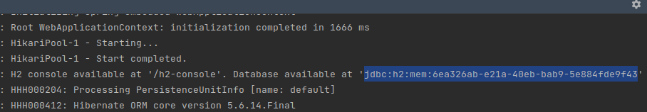

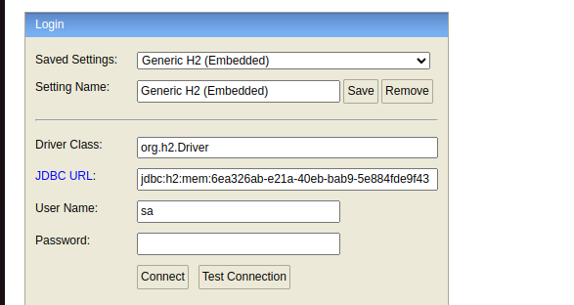

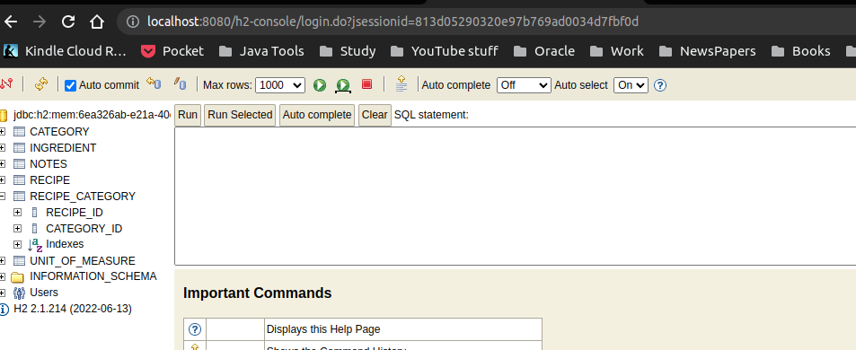

So what I did is I created a many-to-many relationship and I'm saying
this is mappedBy categories and this is going to be on the join table from that
set. So from the other side of the relationship and that categories is
going to be this property name. Now on this side, I told a join able to name
the table as recipe category which gives us this value here. That's why it's named
recipe category, and now I set up to join columns so from this side of the
relationship, we are going to have a join column called recipe id and on the other
side for the categories, we're going to have category id.

see changes here

Lesson 138 Creating Spring Data Repositories
create-spring-data-repositories

Now we set up Recipe to cascade down to Notes and Ingredient.
So all operations between Recipe, so if we do any updates on Recipe and anything
on the child objects of notes and ingredients of Recipe, those
will get persisted down through the JPA mapping.
..
We went in and put this cascade all on those relationships.
So for ingredients and notes, we are using a CascadeType of ALL. So for that,
we set that up because that Recipe is going to be our primary object and we'd
probably won't be working with ingredients independently or notes
independently.

Drawing 10: Recipe.java
..
@OneToMany(cascade = CascadeType.ALL, mappedBy = "recipe")
private Set<Ingredient> ingredients;

..
@OneToOne(cascade = CascadeType.ALL)
private Notes notes;

Now Category, that is
something is going to be maintained independent of Recipe as well as UnitOf
Measure. We're using that as a reference table. So I don't see a need to set up
you know to measure either. So what we can do is just set up Spring Data
repositories for Recipe, Category and UnitOfMeasure.

Setting up a Java class called Recipe
Repository. And this is going to be an interface. I'll say okay there. I'm going to
add that to Git for you guys and now we're going to use the Spring Data CRUD
Repository and you can see it takes in two generics there - the T and the ID. So
the T is going to be the entity type and the ID is going to be the ID type of the
entity and this way, Spring Data will know how to construct this by using
reflection and Java generics. So I'm going to go ahead and hit enter there
and we want to add in the Recipe and everything that we did we used a Long for
the ID property. So that gives us the crud repository for recipes. Now we need
to repeat that for UnitOfMeasure and Category.

Drawing 11: Thre three Repository Interfaces that extends Springs CrudRepository
public interface UnitOfMeasureRepository extends CrudRepository<UnitOfMeasure, Long> {
}

public interface RecipeRepository extends CrudRepository<Recipe, Long> {
}

public interface CategoryRepository extends CrudRepository<Category, Long> {
}

see changes here

Lesson 139 Database initialization with Spring

Database-initialization
Here we create a data.sql file in the class path “src/main/resources/data.sql” that Spring boot will use to create a populate the tables
Drawing 12: data.sql
INSERT INTO category (description) VALUES ('American');
INSERT INTO category (description) VALUES ('Italian');
INSERT INTO category (description) VALUES ('Mexican');
INSERT INTO category (description) VALUES ('Fast Food');
INSERT INTO unit_of_measure (description) VALUES ('Teaspoon');
INSERT INTO unit_of_measure (description) VALUES ('Tablespoon');
INSERT INTO unit_of_measure (description) VALUES ('Cup');
INSERT INTO unit_of_measure (description) VALUES ('Pinch');
INSERT INTO unit_of_measure (description) VALUES ('Ounce');

Note, I also had to add the following to the application.properties file, as it through errors if not added.
Got from Q@A
spring.jpa.defer-datasource-initialization=true

Now when I run the application it populates the two tables with that data
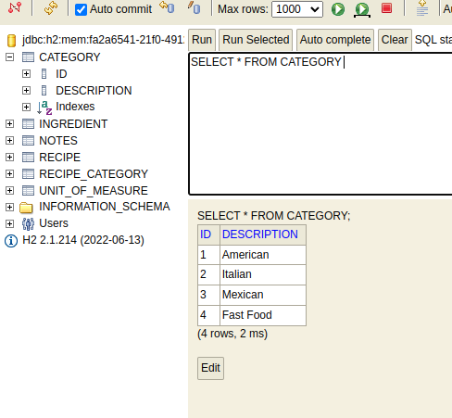
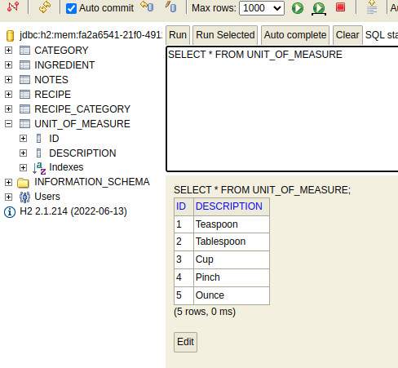

see changes here

Lesson 140 Spring Data JPA Aquery Methods
jpa-query-methods
Here we the String JPA interface to use autogenerated methods to query out database.
Spring JPA Repository Injection
With Spring Data JPA, listing repositories as properties allows them to be made available to other classes. This functionality is facilitated by the repository instance being injected into the class at runtime.

Se set up the repositories and inject them on out conroller, then use its methods to retirev the information from the database.
Drawing 13: Implementation
public interface CategoryRepository extends CrudRepository<Category, Long> {

Optional<Category> findByDescription(String description);
}
--------------------------
public interface UnitOfMeasureRepository extends CrudRepository<UnitOfMeasure, Long> {

Optional<UnitOfMeasure> findByDescription(String description);
}
-----------------------------
@Controller
public class IndexController {

private CategoryRepository categoryRepository;
private UnitOfMeasureRepository unitOfMeasureRepository;

public IndexController(CategoryRepository categoryRepository, UnitOfMeasureRepository unitOfMeasureRepository) {
this.categoryRepository = categoryRepository;
this.unitOfMeasureRepository = unitOfMeasureRepository;
}

@RequestMapping({"", "/", "/index"})
public String getIndexPage(){

Optional<Category> categoryOptional = categoryRepository.findByDescription("American");
Optional<UnitOfMeasure> unitOfMeasureOptional = unitOfMeasureRepository.findByDescription("Teaspoon");

System.out.println("Cat Id is: " + categoryOptional.get().getId());
System.out.println("UOM ID is: " + unitOfMeasureOptional.get().getId());

return "index";
}

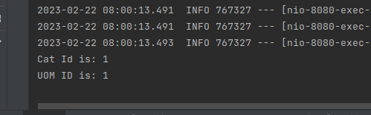Figure 4: Outputs on console

see changes here

Lesson 141 + 142 Assignment Display list of Recipes on Index Page

branch my-lesson-141-assignment

Display List of Recipes
• Use ‘Perfect Guacamole’ and ‘Spicy Grilled Chicken
Tacos’ from www.simplyrecipes.com for source data
• Add any needed Unit of Measures to data.sql
Drawing 14: data.sql
INSERT INTO unit_of_measure (description) VALUES ('Each');
INSERT INTO unit_of_measure (description) VALUES ('Clove');

• Use Bootstrap class to create recipes on startup

Drawing 15: Recipe.java
// so it allows large strings
@Lob
private String directions;

Note – added @Lob to allow for very large String valeus in Database, as per Johns example

Drawing 16: guru.springframework.bootstrap.DataLoader.java
@Component
public class DataLoader implements CommandLineRunner {

// add repository

...
private final RecipeRepository recipeRepository;
...

public DataLoader(CategoryRepository categoryRepository, UnitOfMeasureRepository unitOfMeasureRepository, RecipeRepository recipeRepository) {
this.categoryRepository = categoryRepository;
this.unitOfMeasureRepository = unitOfMeasureRepository;
this.recipeRepository = recipeRepository;
}
...
// load the data and save to repository
@Override
public void run(String... args) throws Exception {
// Perfect Guacamole
// Recipe perfectGuacamole = recipeRepository.save(new Recipe());
Recipe perfectGuacamole = new Recipe();
...
perfectGuacamole.setPrepTime(10);
...
// save to repository
perfectGuacamole = recipeRepository.save(perfectGuacamole);
...
}
}

Both can be used for the same thing. ApplicationListener is part of Spring Framework, while CommandLineRunner is part of Spring Boot.

So if you have to work on a Spring Framework application without Spring Boot, you will have to use ApplicationListener.

When will we use ApplicationReadyEvent and when we use ContextRefreshedEvent?
Again, ContextRefreshedEvent is part of Spring Framework, while ApplicationReadyEvent is Spring Boot specific.

So if you want to keep your code generic and not tied to Spring Boot, go with ContextRefreshedEvent.

Note John used the ApplicationListener while I used the CommandLineRunner

• Create Service to return recipe list to controller
Drawing 17: Service layer
public interface RecipeService {

public List<Recipe> getRecipes();
}

@Service
public class RecipeServiceImpl implements RecipeService {
private final RecipeRepository recipeRepository;

public RecipeServiceImpl(RecipeRepository recipeRepository) {
this.recipeRepository = recipeRepository;
}

public List<Recipe> getRecipes(){

List<Recipe> list = new ArrayList<>();
recipeRepository.findAll().forEach(list::add);
return list;
}
}

Drawing 18: IndexController
@Controller
public class IndexController {
private CategoryRepository categoryRepository;
private UnitOfMeasureRepository unitOfMeasureRepository;
private RecipeService recipeService;
public IndexController(CategoryRepository categoryRepository,
UnitOfMeasureRepository unitOfMeasureRepository,
RecipeServiceImpl recipeService
) {
this.categoryRepository = categoryRepository;
this.unitOfMeasureRepository = unitOfMeasureRepository;
this.recipeService = recipeService;
}

@RequestMapping({"","/","/index"})
public String getIndexPage(Model model){
…
model.addAttribute("recipes",recipeService.getRecipes());
return "index";
}

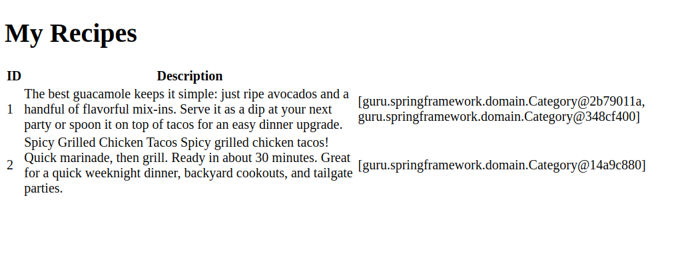
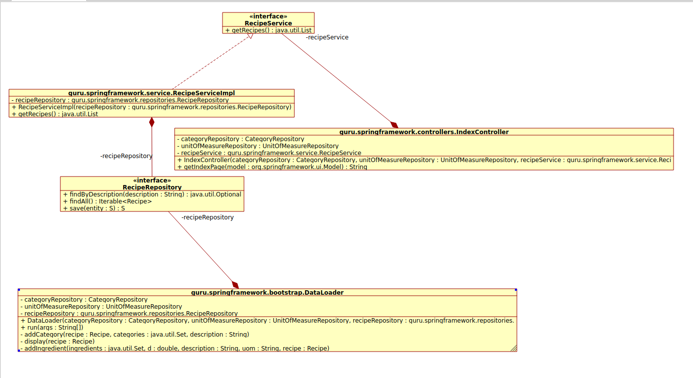Figure 5: class diagram

see changes here

• Pass list to Thymeleaf view to display on index page
Drawing 19: index.html
<!DOCTYPE html>
<html lang="en" xmlns:th="http://www.thymeleaf.org">
<head>
<meta charset="UTF-8"/>
<title>Recipe Home</title>
</head>
<body>
<h1>My Recipes</h1>
<table>
<tr>
<th>ID</th>
<th>Description</th>
</tr>
<tr th:each="recipe : ${recipes}">
<td th:text="${recipe.id}">123</td>
<td th:text="${recipe.description}">description</td>
<td th:text="${recipe.categories}">category</td>
</tr>
</table>
</body>
</html>

Lesson 143 – Using setters for JPA bi-directional relations ships

Using_setters-on-pojo

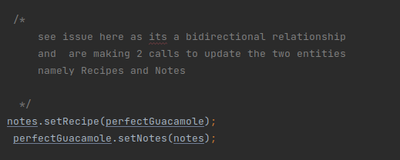Figure 6: DataLoader.java

Asone can see, in a bi-directional relationship we have to set up both relationships data.
This can be problamatic as we may forget to set up both sides.

A better way is to set up the one side, só that it then automatically sets up the other entity.

Drawing 20: Recipe.java
public Notes getNotes() {
return notes;
}
public void setNotes(Notes notes) {
this.notes = notes;
notes.setRecipe(this); // added for bi-directional update from one location
}

We change then SetNotes só that when we update Recipe pojo, it then updates the Notes pojo.

Drawing 21: DataLoader.java
...

/*
setNotes no longer needed to be called
*/
// notes.setRecipe(perfectGuacamole);
perfectGuacamole.setNotes(notes);
…

//set Notes
notes = new Notes();
notes.setRecipeNotes("The ancho chiles I use in the marinade are named for their wide shape.");
/*
notes no longer needed to be called
*/
// notes.setRecipe(chicken);
chicken.setNotes(notes);

Now I did some refactoring by adding a untility method in Recipe addIngredients() and initialized the Hashset when the classes object is created.
No that the ingredients are updated from a call to recipe
Drawing 22: Recipe.java
@OneToMany(cascade = CascadeType.ALL, mappedBy = "recipe")
private Set<Ingredient> ingredients = new HashSet<>(); // added so that I don't have to create object outside class

/*
Utility method added so One can add ingredients from the recipe jojo
instead in the ingriendient pojo
*/
public Recipe addIngredient(Ingredient ingredient){
ingredient.setRecipe(this);
this.ingredients.add(ingredient);
return this;
}

Now I populate the ingriendents using the following ion the DataLoader
Drawing 23: DataLoader.java

...
// refactored to make use the addIngrients untlity method
addIngredient(0.25,"kosher salt, plus more to taste","Teaspoon",perfectGuacamole);
addIngredient(1,"fresh lime or lemon juice","Tablespoon",perfectGuacamole);

…
private void addIngredient(double d, String description, String uom, Recipe recipe){
Ingredient ingredient = new Ingredient();
ingredient.setAmount(new BigDecimal(d));
ingredient.setDescription(description);
//ingredient.setUom(unitOfMeasureRepository.findByDescription(uom).get());
unitOfMeasureRepository.findByDescription(uom).ifPresent(u -> ingredient.setUom(u));
recipe.addIngredient(ingredient); // calls utilty method
}

See changes here

Section 9 Project Lombok

Lesson 162 – Adding Project Lombok and IDE Configuration
Notes on Lombok

Here I’ll add the lombok dependencies to the pom file and to the setting of the IDE addons.

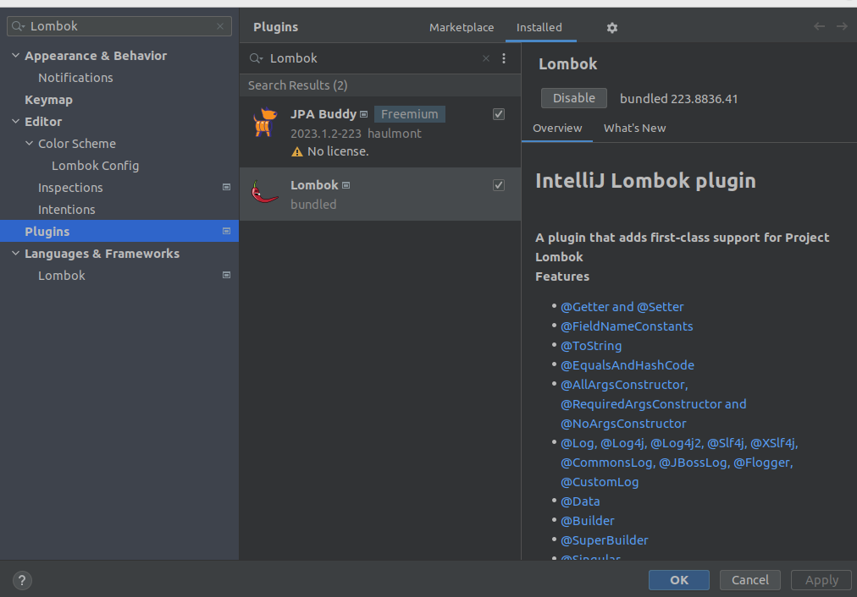

<dependency>
<groupId>org.projectlombok</groupId>
<artifactId>lombok</artifactId>
</dependency>

See changes here

Lesson 163 Using Project Lombok

adding-project-lombok
Here we use the @Data to automate the getters,setters etc
Note that if there are constructors or getters and setters, lombok will not override those.
So it is mainly used for the auto get=neration or “boiler plate” code.
• @Data
• Generates typical boilerplate code for POJOs
• Combines - @Getter, @Setter, @ToString, @EqualsAndHashCode, @RequiredArgsConstructor
• No constructor is generated if constructors have been explicitly declared.

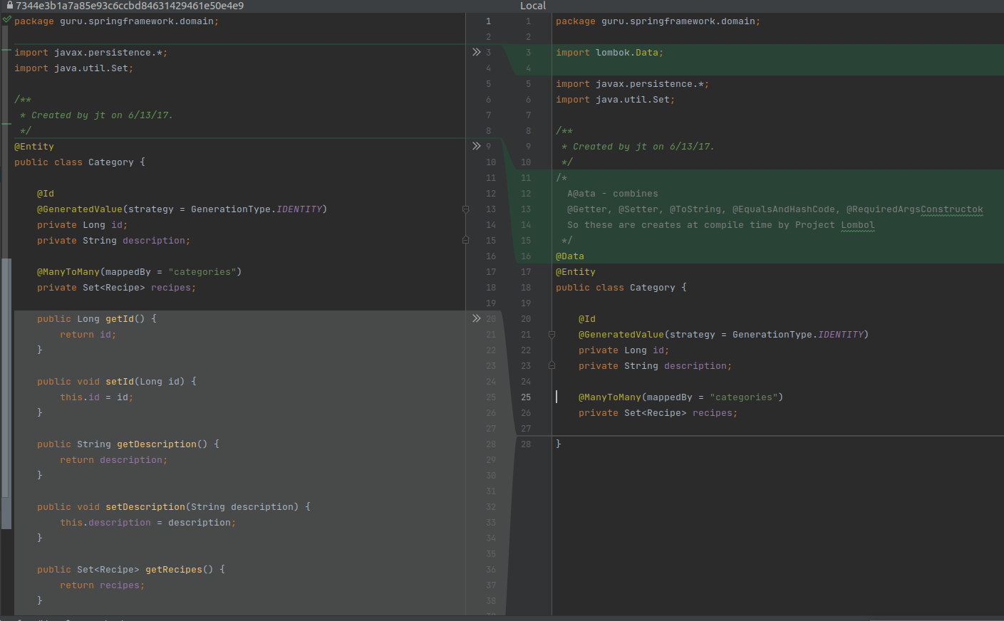

Next I add a Logger using slf4logger provided by lombok
• @Log - Creates a Java util logger - Java util loggers are awful
• @Slf4j - Creates a SLF4J logger.
• Recommended - SLF4J is a generic logging facade
• Spring Boot’s default logger is LogBack

package guru.springframework.service;
import guru.springframework.domain.Recipe;
import guru.springframework.repositories.RecipeRepository;
import lombok.extern.slf4j.Slf4j;
import org.springframework.stereotype.Service;
import java.util.ArrayList;
import java.util.List;
/*
• @Log - Creates a Java util logger - Java util loggers are awful
• @Slf4j - Creates a
*/
@Slf4j
@Service
public class RecipeServiceImpl implements RecipeService {
private final RecipeRepository recipeRepository;
public RecipeServiceImpl(RecipeRepository recipeRepository) {
this.recipeRepository = recipeRepository;
}
public List<Recipe> getRecipes(){
log.debug("I'm in the service");
List<Recipe> list = new ArrayList<>();
recipeRepository.findAll().forEach(list::add);
return list;
}
}

See changes here

Lesson 165 – Refactor to Project Lombok

refactor-for-project-lombok
Add Lombock to the rest of the classes

see changes here

Lesson 166 Gotchas with Project Lombol

lombok-gotchas

When using project Lombok ther are some gotchas such as circula references in a bi-directional relationshiop that will result in a stack overflow.

To sort that out we excluse certain properties do avoid circlular references

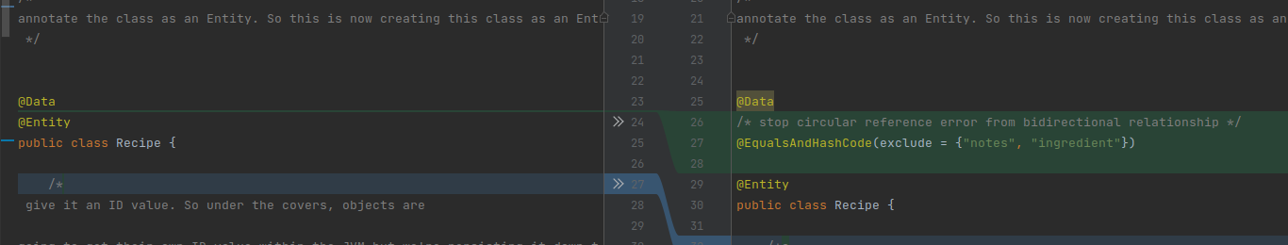
“we're seeing effectively a circular reference get created because of the
bi-directional relationship and I'm excluding out notes in category so we
can exclude out recipe. So it doesn't switch back on itself in that hashcode
function and cause the the stack overflow…”

Nother issue is with lazy intitialization do data…

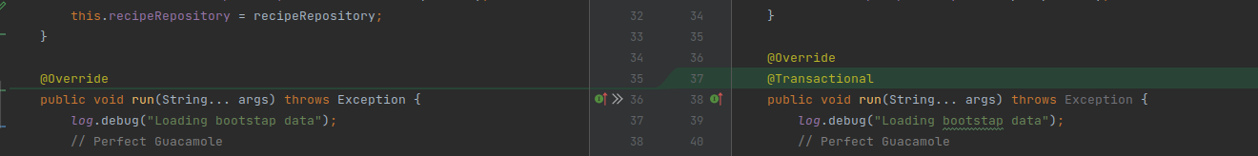

one other problem and it's kind of a strange one
because it's a intermittent and I'm not seeing it all the time but I got the
exception up here. You may encounter this as well. That's why I'm appending to this
video this problem here. You can see here we have a lazy initialization exception
and what's happening is in our bootstrap class, we are doing this getRecipes()
method and what's going to happen in that, each time we go in and out of the
Spring Data JPA repositories, we are going in and out of
a Hibernate transaction. So the lazy collections need to get initialized within
a transaction and within the same Hibernate session. And that the
problem is we're getting this thrown because we are getting it outside of
that and I find it kind of curious that it's happening this way because I do run
sometimes and sometimes not. So I prefer to see things that are binary and their
failure not kind of random. But I think it's just a timing issue with the
threads and how it's working in the transactional context. Now a very easy
way around this, is we are going to utilize a new annotation called transactional.
And this is part of the Spring Framework we really haven't gotten into
transactions, but by doing this on the application event, now we're going to
direct the Spring Framework to create a transaction around this method. So now
everything is going to happen in the same transactional context and we won't
see this lazy initialization exception.”

I also had a further issue with Nullpointer exceptions thrown and that was due to the toString(0 methid of Lombok usewd by @Data.

I found that if I overrode the toString in Categories all was fine.
Further investigation to this I found that I had aded categories to my index.html and it was calling toString giving a null pointer.
I removed that and npo longer had an issue with ToString called by Lombok.

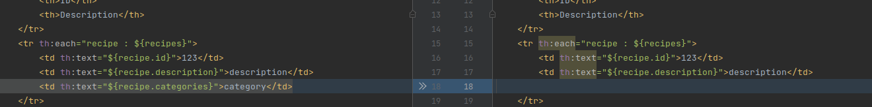
Note
• @Data
• Generates typical boilerplate code for POJOs
• Combines - @Getter, @Setter, @ToString, @EqualsAndHashCode, @RequiredArgsConstructor
• No constructor is generated if constructors have been explicitly declared

see changes here

Section 10 - Testing Spring Framework

Lesson 171 Using Bootstrap CSS

Here we use Bootstap CSS via CNN ref to embelish our table index.html

Branch bootstrap-css
Commit add bootstrap css

