**OTHER POSSIBLE TABLES AND GRAPHS**

* *Success HIT RATE by Category (Music beats any other category with a 77% hit rate).*
* *Success HIT RATE by Country (The US success hit rate is 75%)*
* *Graph that compares GOAL with STATE (higher goals are more likely to fail). This can also be a table.*
* *Add a column that subtracts End Date with Created Date in order to measure how quickly a project reaches its goal. Filtering only successful projects we could graph this amount of days versus goal (and this might tell us which are the most successful projects in terms of Goal and Time to reach that goal).*

*DATA LIMITATIONS

- There is no way to measure ROI as an additional success indicator.

- There are some projects with a very low pledge goal (less than 100 USD); this outliers can produce irrelevant ratios.

- Backer´s Country of origin, age or profile is unknown.

- Information from years 2015 and 2017 is incomplete.

*A total of 37k backers,*

*74% from the US; other countries like Mexico had only 12 projects; none of them successful; with only 106 backers.*

THIRD CONCLUSION

**Launching date is not a determining factor in project success.**

Historically there are certain months of the year where more projects are created (December being the lowest).

SECOND CONCLUSION

**74% of all projects are from the US**

With GB and CA in a far second place, and third place, the US accounts for most of the projects in the platform.

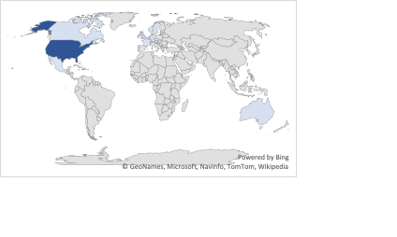



FIRST CONCLUSION

**63% of all projects are art related.**

Film & video, music and theater are the most popular categories; on the downside, journalism has no successful projects.

**KICKSTARTER**

Analysis of 4000 past projects (2009 to 2017) in order to discover trends.

*By Rolando Ramos Peart*