|  |
| --- |
| Rolustech |
| Survey Generation Tool |
| Technical Detail |

Contents

General Information 3

Target Sugar flavours 3

Modules 3

Surveys 3

Responses 3

Questions 3

Questions_Answers (hidden) 4

Relationships 4

Dropdowns 4

Survey Form 5

Sending survey form to recipients 5

Receive Survey Responses 5

UI Mockups 6

Survey create/edit view 6

Survey Detail View 7

Analyze Responses 8

## General Information

This document describes technical details of Survey Tool.

## Target Sugar flavours

SuiteCRM

## Modules

1. Surveys
2. Responses
3. Questions
4. Questions_Answers (hidden)

### Surveys

Fields:

|  |  |  |  |
| --- | --- | --- | --- |
| Name | Type | length | Other |
| Title/name | varchar | 500 | Default field |
| theme | varchar | 255 |  |
| email_template | enum | 36 | Options will be rendered dinamically using function in vardef |
|  |  |  |  |
|  |  |  |  |
|  |  |  |  |
|  |  |  |  |

### Responses

Fields:

|  |  |  |  |
| --- | --- | --- | --- |
| Name | Type | Length | Other |
| name | varchar | 255 | Response # <response_no> |
| Response_no | int |  | Auto_increment |
| respondent | relate |  | Related field of Contacts module |
| Date_submitted | datetime |  | Change label of date_entered |
| status | enum |  | Complete, Partial, Empty |
| Survey_id | Varchar | 36 | Related field of Survey module |

### Questions

Fields:

|  |  |  |  |
| --- | --- | --- | --- |
| Name | Type | Length | Other |
| Name/Question Text | varchar | 36 | Default field. Would contain question text. |
| Survey_id | Varchar | 36 | Related field of Survey module |
| type | Varchar | 255 | Would contain question type (Text, textfield, multichoice, radio, checkbox, date) |
| options | Varchar | 510 | Optional. Would contain comma separated values when type is multichoice, radio or checkbox |
| required | bool | 1 |  |

### Questions_Answers (hidden)

This module is for analysis purpose.

Fields:

|  |  |  |  |
| --- | --- | --- | --- |
| Name | Type | Length | Other |
| Question_id | varchar | 36 | Related field of Questions module |
| Answer | Text | 9000 |  |
| respondent | Varchar | 36 | Related field of Contacts module |

## Relationships

|  |  |  |
| --- | --- | --- |
| Module1 | Module2 | Type |
| Surveys | Contacts/Leads | Many-many |
| Surveys | Responses | One-many |
| Surveys | Questions | One-many |
| Questions | Questions_Answers | One-many |
| Contacts/Leads | Questions_Answers | One-many |
| Contacts/Leads | Responses | One-many |
|  |  |  |

## Dropdowns

#### Status:

* Complete
* Partial
* Empty

#### Type:

* TextField
* TextArea
* Multiple Choice
* Radio
* Date

#### Email Template

Options would be fetched from Email templates module dynamically. You can use 'function' in vardef. See example below

<https://developer.sugarcrm.com/2011/04/13/howto-populate-enum-values-from-a-database-table/>

## Survey Form

On hitting save while creating Survey, system will generate an html file and save in <root>/survey-forms directory with the name equals to GUID of survey. Survey html form would have hidden survey_id, recepient_email_address. Id attribute of question fields would be their GUID.

## Sending survey form to recipients

Send link to the survey form placing it in selected email template.

## Receive Survey Responses

Create an entry point "receive_survey_responses". Survey form will be submitted to this entry point.

* Insert records in Responses module.
* Create relationship of response with contact/lead who submitted the response. Respondent can be identified through his/her email address.
* Create relationship of response with survey.
* Insert records in Questions_Answers module.
* Create Questions_Answers records relationships with contact/lead, and Question record.

## UI Mockups

### Survey create/edit view

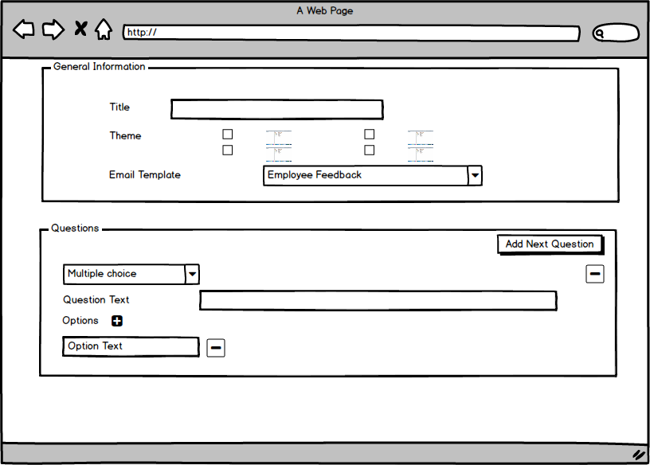

### Survey Detail ViewD:\SurveyGenerationTool\SurveyDetailView.png

### 

### Analyze Responses View

### D:\SurveyGenerationTool\AnalyzeResponses.png