Invoice Region Detection & Business-Parameter Extraction
for Obligation-Readiness
A Deep Learning II Group Project

Authors: Rolando (Data Ingestion & Manifest) - Diana (Stamp & Signature Detection) - Jordan (Region Detection & IoU Evaluation) - Damir (OCR, Parameters & Terms Extraction) - Hessam (Integration, Verdict Engine & Streamlit Application)
July 2026

Abstract
Before an invoice image can become a structured digital obligation record - the kind a downstream finance or legal system (in the spirit of a "Pistac.io"-style platform) can act on without a human first reading it - someone has to answer a handful of yes/no questions: is it signed or stamped? does it cite a purchase order, contract, or work order? does it state clear payment terms and a valid date? Doing this by hand does not scale past a few hundred invoices. This project builds an end-to-end computer-vision and OCR pipeline that reads an invoice image and answers those questions automatically, then lets a user configure their own readiness policy and see a transparent, per-rule Ready / Not-ready verdict - never a black-box yes/no.
Five stages, one per team member, hand off outputs through a fixed CSV/JSON interface contract: data ingestion and manifest construction (Rolando), a YOLOv8n stamp/signature detector (Diana), a YOLOv8n region detector trained on real polygon-annotated receipt data (Jordan), EasyOCR text extraction feeding rule-based business-parameter and payment-terms extraction (Damir), and an integration layer that merges everything into one JSON per invoice and powers a Streamlit application built around a fail-closed, user-configurable verdict engine (Hessam). Detectors are trained and evaluated on the best available real, labelled datasets - SignverOD, StaVer, and the OCR Dataset of Multi-type Documents - none of which are invoices; they are then applied to real invoice scans, and we report that domain-transfer step honestly as detection counts, not accuracy, since no invoice-level ground truth exists. This report documents the methodology, design rationale, and final, real quantitative results of the system, drawn directly from each member's completed Colab GPU training/evaluation run (see Section 5).

1. Business Problem & Motivation
A business that receives invoices as scanned images or photographs faces a bottleneck before any of that paper can enter an automated accounts-payable or obligation-tracking workflow: a human has to look at each one and check whether it is complete enough to act on. Typical checks include:
- Is the invoice signed or stamped (evidence of authorization)?
- Does it cite a reference number - a purchase order (PO), sales order, contract, or work order - that ties it to an approved commitment?
- Does it state a clear invoice date and payment terms (e.g. "Net 30")?
- Are there any risk clauses - late-payment penalties, dispute language - worth flagging to a reviewer?
At the volume real businesses operate at (thousands of invoices a month), manual triage is slow, inconsistent between reviewers, and creates a queue that delays payment and reconciliation. The Pistac.io framing used throughout this project names the goal precisely: a digital obligation record - a structured, machine-readable summary of what an invoice obligates the business to do and when - that downstream systems can consume without a human reading the source image first.
Our answer is a pipeline that takes an invoice image in and produces (a) a structured JSON record of everything the pipeline could determine about that invoice, and (b) a Ready / Not-ready verdict, evaluated against rules the user chooses and configures, with a transparent per-rule breakdown of why an invoice passed or failed. Critically, the verdict is not a fixed hardcoded rule buried in code - a compliance officer, an AP clerk, and an auditor may reasonably want different thresholds (require both a stamp and a signature vs. either one; a 30-day vs. a 60-day payment-terms floor), so the system exposes the policy itself as user-editable configuration, and defaults to the conservative, safe answer whenever it cannot confirm a rule (fail-closed: missing evidence is treated as a failed check, never a free pass).

2. Related Datasets & Data Pipeline
No single public dataset contains full-page invoices annotated with stamps, signatures, business regions, and business-parameter text all at once. We therefore combine four real, purpose-built datasets, each covering one facet of the problem, and apply the resulting models to real invoice scans:
Dataset | Contents | Used by
Invoice batches (real scans) | ~5,201 unique real invoice images after de-duplication; 750 sampled into the working manifest; batch_1 carries annotation CSVs (real OCR text + structured fields) for ~1,413 images | Rolando (ingestion); all others via the manifest
OCR Dataset of Multi-type Documents | 973 SROIE-style receipt images, pre-split 778/97/98, 100% annotated with 52,331 real polygon text boxes + transcriptions, plus entity fields (company, date, address, total) | Jordan (region detector), Damir (OCR evaluation)
SignverOD | 2,765 document images with signature bounding boxes (4 categories; only category 1 = signature is used) | Diana
StaVer | 400 document scans with binary stamp ground-truth masks (no boxes - boxes are derived) | Diana

Rolando's data-engineering stage turns a messy tree of raw invoice scans into the single clean artifact every other stage joins on: invoice_manifest.csv (document_id, image_path, width, height, split, has_ground_truth). Two decisions here are worth calling out because they materially change what the rest of the pipeline can honestly claim:
- Annotation-aware resampling. A naive random sample of invoices produced only 26.3% ground-truth coverage, because annotation CSVs exist only for batch_1. Resampling to prefer annotated images lifted coverage to 100% across the 750-row manifest (split 525/120/105), at the cost of reduced cross-batch visual variety - a deliberate, documented trade-off.
- Duplicate discovery. batch_3/ was found to silently re-contain copies of batch_1 and batch_2. The true unique invoice count is 5,201, not 8,181. Sampling the duplicated copies would have let the same physical invoice appear in both a training split and a test split - classic data leakage - so the duplicates are excluded from sampling entirely.
The manifest's document_id is the join key every downstream CSV uses, which is why getting this stage right first is a precondition for everything else being trustworthy.
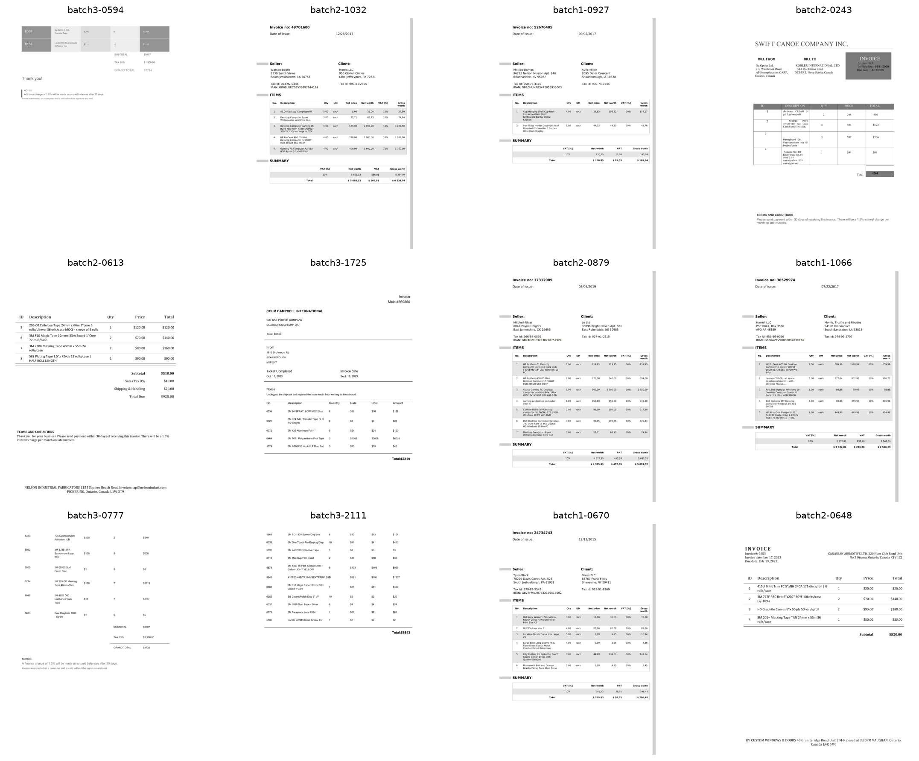
Figure 0a. A grid of sample invoice images spanning the manifest's batches.

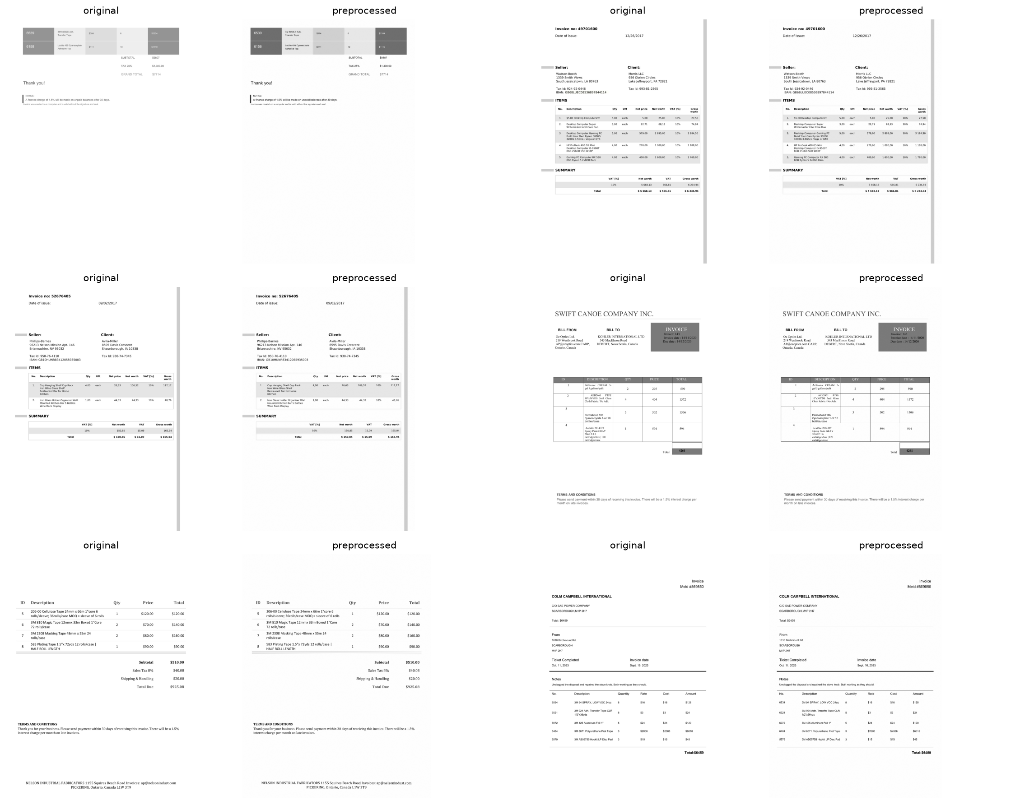
Figure 0b. Preprocessing steps applied ahead of downstream detection and OCR.

3. Methodology
Every training notebook pulls its training knobs from a single shared module, src/compute_profile.py, so the same code runs identically in two modes and the two never silently drift apart:
Knob | local_cpu (dev machine) | colab_gpu (member runs)
epochs | 10 | 100
imgsz | 416 | 960
batch | 8 | 16
workers | 0 | 2
patience (early stop) | 10 | 20
max images/class | 250 (subsampled) | None (full dataset)
device | cpu | GPU (device 0)

All members trained under IIP_COMPUTE_PROFILE = "colab_gpu" on a Colab T4/L4/A100 runtime. Every metrics JSON also carries a _run provenance block (profile, epochs, imgsz, device, wall-clock seconds) so local-CPU and Colab-GPU runs can later be compared on equal footing.

3.1 Rolando - Data Ingestion & the Manifest
No model is trained in this stage; it is data engineering, and the project's overall honesty rests on it. Beyond the annotation-aware resampling and duplicate exclusion described in Section 2, Rolando's notebook performs a stratified split (by ground-truth availability, so every split stays fully labelled) and produces a data-quality report plus sample/preprocessing figure grids for the report and deck.

3.2 Diana - Stamp & Signature Detection
Model choice: YOLOv8n, trained as a single 2-class detector (stamp, signature - never merged, never renamed, since the final JSON schema and the verdict engine both assume the two exist independently). YOLOv8n ("nano") was chosen over a two-stage detector such as Faster R-CNN because it is a fast one-stage architecture well suited to small, visually distinct marks, trains comfortably within the Colab GPU time budget, and a single 2-class model shares one backbone rather than requiring two separately trained detectors.
The data-engineering challenge here is real: SignverOD stores boxes as normalized [x, y, w, h] which must be converted to pixel coordinates, and only category 1 (signature) is kept - categories 2-4 (initials, redaction, date) are dropped. StaVer, by contrast, ships no boxes at all, only binary ground-truth masks; boxes are derived using cv2.connectedComponentsWithStats, and the count of derived boxes is cross-checked against each scan's numStamps count from its info file as a sanity check.
Key parameters (as run): epochs ≤50, imgsz 640, batch 16, patience 20; inference confidence threshold 0.25; IoU match threshold 0.5 (via the shared src/iou.py, never reimplemented). These were reduced from the colab_gpu default (100 epochs / imgsz 960) after a GPU-budget exhaustion - see Section 6.1 Challenges and Section 6.2 Lessons Learned. Evaluation: precision, recall, and mean IoU computed per class on a real held-out split of SignverOD + StaVer - never merged into one detection score, since a "must be signed" business rule needs the signature number specifically. Inference is then run on the 750 invoices and reported as detection counts and confidence distributions only (no invoice-level ground truth exists, so no precision/recall claim is made there).

3.3 Jordan - Region Detection & IoU
Model choice: YOLOv8n, trained as a 5-class detector: company, date, address, total, other_text. The intellectual core of this stage is turning an unlabelled-boxes dataset into a labelled one: the OCR Dataset of Multi-type Documents ships 52,331 real polygon text boxes with no class label, alongside per-document entity values (company, date, address, total) with no coordinates. Jordan joins the two by fuzzy-matching each box's transcribed text against each entity value (rapidfuzz, using the max of partial_ratio and ratio, threshold 88), assigning the best-matching field label when the score clears the threshold and other_text otherwise. This turns 52,331 unlabelled boxes into a genuine 5-class region-detection training set with real geometry.
Key parameters (colab_gpu): epochs 100, imgsz 960, batch 16; fuzzy-match threshold 88; inference confidence 0.25; IoU match threshold 0.5. Challenge named explicitly: other_text massively outnumbers the four named field classes (visible directly in the train-split class-distribution printout), so per-class precision/recall/IoU are reported, never a single blended score that a dominant class could inflate. Evaluation: per-class IoU on the dataset's own official test split (98 images). Predictions are then run on the 750 invoices (rows tagged source="invoice"), where receipts (~460 px wide) transferring to full-page invoices (1654x2339) is a domain shift reported as counts. Jordan's date/total/company boxes have a second life in the app: cropping and OCR-ing just those regions gives a field localiser that feeds the verdict engine's date signal and a "where is this field, and what does it say" overlay.

3.4 Damir - OCR, Business Parameters & Terms
Model choice: EasyOCR (a deep-learning OCR engine, run on GPU) for text extraction, followed by rule-based extraction - src/parameter_checker.py and src/terms_extraction.py - for structured fields. The rule-based choice over an end-to-end learned extractor is deliberate: it needs no training data of its own, every decision is traceable to a specific keyword or regex match (auditable, which matters for a compliance-adjacent tool), and a user can add a brand-new required field (e.g. "Insurance Certificate") by editing config/required_fields_config.json with no code change.
Damir's stage has two evaluation sets of very different strength, and reports both honestly:
- Primary (headline): the OCR Dataset's own test split - 98 scored receipt images (of 973 total in the dataset), 100% coverage, real per-box ground-truth transcriptions - scored with CER (character error rate) 0.2152 mean / 0.1751 median and WER (word error rate) 0.5423 mean / 0.5225 median. This is the honest headline: EasyOCR on noisy, skewed, low-res receipt photos is a genuinely hard case. Lower is better.
- Secondary: the 120 real batch_1 invoices Damir's notebook actually ran EasyOCR on, scored against the batch_1 annotation CSVs' ground-truth text - CER 0.0002 mean (median 0.0), WER 0.0015 mean (median 0.0), essentially character-perfect. These are clean, high-resolution, digitally-rendered invoice images, so this is a much easier case than the receipt photos - real, but not representative of scanned-document OCR difficulty. The honest framing is both numbers together, never one headline: near-perfect on clean synthetic invoices, CER 0.215 / WER 0.542 on real-world receipt photos.
Coverage was completed locally (CPU-only, no GPU/EasyOCR re-run, no notebook execution - see scripts/complete_damir_outputs.py) once it became clear the manifest is now 100% batch_1 and all 750 manifest invoices have ground-truth OCR text in the batch_1 annotation CSVs. Invoice-level text for all 750 is therefore Damir's real EasyOCR output where it exists (120 invoices) and the annotation CSVs' OCRed Text elsewhere (630 invoices) - zero additional OCR. outputs/predictions/parameter_presence_results.csv and terms_extraction_results.csv are regenerated at the contract's long schema across all 750 invoices from this text, using Damir's own check_all_fields / terms-extraction functions unmodified.
Honest finding - payment terms are nearly absent from this corpus. Across all 750 invoices, 99.6% have a parseable invoice_date, but only 0.4% (3 of 750) match any day-based payment-terms phrasing ("Net 30", "due within N days") or yield a billing_due_days value - these invoices are synthetic templates that simply don't carry that phrasing in their OCR/annotation text. That means the verdict engine's "payment terms > N days" rule is unknown (fail-closed, never a false pass) for nearly every invoice in this corpus - a real, corpus-level limitation, not a bug in the extraction regexes.

3.5 Hessam - Integration, Verdict Engine & Streamlit Application
Hessam's stage merges all four upstream outputs into one final JSON per invoice (model_interface_contract.md Section 5) and builds the demo application. The headline design decision is the verdict engine (src/verdict_engine.py): rather than a single hardcoded readiness rule, the user builds a policy out of four toggleable rule types before judging any invoice -
- Visual mark - stamp OR signature, stamp AND signature, stamp only, or signature only.
- Reference number - at least one (or all) of PO / Order / Contract / Work Order present.
- Invoice date range - inclusive start/end bounds.
- Payment terms - a day-count threshold with a comparison operator (e.g. > 30 days).
The verdict is the AND of every enabled rule; disabled rules are skipped entirely. Every rule returns one of three statuses - pass, fail, or unknown - and the engine is deliberately fail-closed: an unknown status (no signal available for that invoice, e.g. it was never OCR'd) counts as not satisfied, so the invoice is marked Not-ready rather than silently passed. The breakdown always shows this distinction explicitly ("unknown - treated as fail"), never hiding it. This logic is pure Python with no Streamlit or I/O dependency, so it is independently unit-tested (9/9 tests passing as of this writing) and reused identically by both the single-invoice and whole-batch code paths.
A subtler integration point deserves its own callout: Damir's parameter_presence_results.csv and terms_extraction_results.csv are keyed to the OCR-Dataset receipt IDs, not the 750 invoices, because that is the dataset his notebook evaluates against for real ground truth. The invoice-level reference/date/payment-terms signals the verdict engine actually consumes are therefore derived at integration time - Damir's own shared modules (parameter_checker.py, terms_extraction.py) are re-run on invoice OCR text (from the upload path or ocr_outputs.csv) and on the batch_1 annotation CSVs' OCRed Text field. This keeps Damir's evaluated numbers honest to what he actually measured, while still giving the app real signals to judge invoices against, at whatever coverage the underlying OCR/annotation data supports.
The Streamlit application (app/streamlit_app.py) exposes three views: Live Demo (upload or pick one invoice, annotated boxes, verdict card with per-rule breakdown, downloads), Batch Gallery (roll up the configured policy across all 750 invoices - "N of 750 pass" - with filtering and a passing-set export), and Model Report (the members' own metrics plus the local-CPU-vs-Colab-GPU comparison charts). Execution is hybrid: the gallery and roll-up read pre-computed published results for full-speed browsing, while a brand-new uploaded image runs the live pipeline (vision models if best.pt weights are present in models/, OCR/parameter/terms extraction always, since those run acceptably on CPU).

4. Integration & the Configurable Verdict Engine
The system's central architectural insight is that the pipeline extracts signals; the user's policy is applied to those signals - and the two are cleanly separated. Every signal a verdict rule needs already exists somewhere in a member's output:
Verdict rule | Signal | Source
Stamp / signature present | visual_elements.stamp_detected / signature_detected | Diana
Reference number present | required_parameters[...] via config/required_fields_config.json | Damir (re-run on invoice text at integration)
Invoice date in range | payment_context.invoice_date | Damir / annotation text (derived)
Payment terms > N days | payment_context.billing_due_days | Damir / annotation text (derived)

Notably, the verdict depends on Diana's and Damir's signals but not on Jordan's region labels directly - Jordan's company/date/address/total/other_text vocabulary is a receipt-entity schema, not the obligation-region schema in config/label_schema.json, so that mismatch is kept off the verdict's critical path. It still matters: Jordan's boxes power a "detected regions" panel and the region-guided crop-then-OCR feature (cropping a date or total box and running OCR on just that region) that feeds the app's date rule and its clearest visual.
Coverage differs sharply by path. On the upload path, all four rule signals can be computed live for a brand-new image since OCR, parameter-checking, and terms-extraction all run on CPU. On the batch/gallery path, the visual-mark signal has full coverage (750/750, since Diana's detector runs on every manifest image), but the reference/date/payment-terms signals only cover the subset of invoices with usable OCR or batch_1 annotation text - for the rest, the verdict engine's fail-closed rule marks those checks unknown to fail, and the UI labels them "not evaluated (no OCR)" rather than hiding the gap.

5. Results
Diana's and Jordan's Colab GPU training runs are complete, and Damir's run has been independently verified. Every number below is read directly from the authoritative metrics JSONs (outputs/metrics/stamp_signature_metrics.json, outputs/metrics/region_iou_metrics.json, outputs/metrics/ocr_parameter_metrics.json) or from the integration report (outputs/reports/final_pipeline_report.md) - none are estimated or fabricated.

5.1 Diana - Stamp & Signature Detection (real held-out split of SignverOD + StaVer)
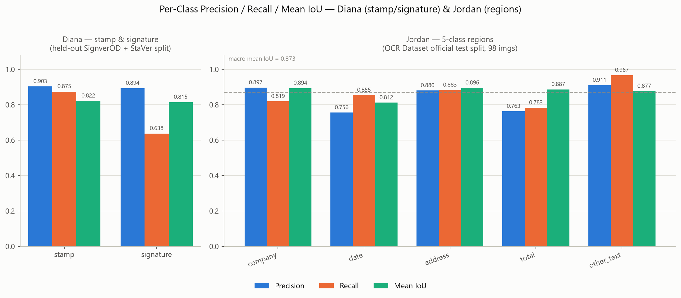
Figure 1. Per-class precision, recall, and mean IoU for Diana's stamp/signature detector and Jordan's 5-class region detector.

Class | Precision | Recall | Mean IoU | Support (tp+fn)
stamp | 0.903 | 0.875 | 0.822 | 64 (tp 56, fp 6, fn 8)
signature | 0.894 | 0.638 | 0.815 | 1055 (tp 673, fp 80, fn 382)

Run provenance (_run block): colab_gpu profile, Tesla T4, epochs ≤50, imgsz 640, batch 16, 2,287 training images, evaluated on a real held-out split of SignverOD + StaVer, confidence threshold 0.25, IoU match threshold 0.5.
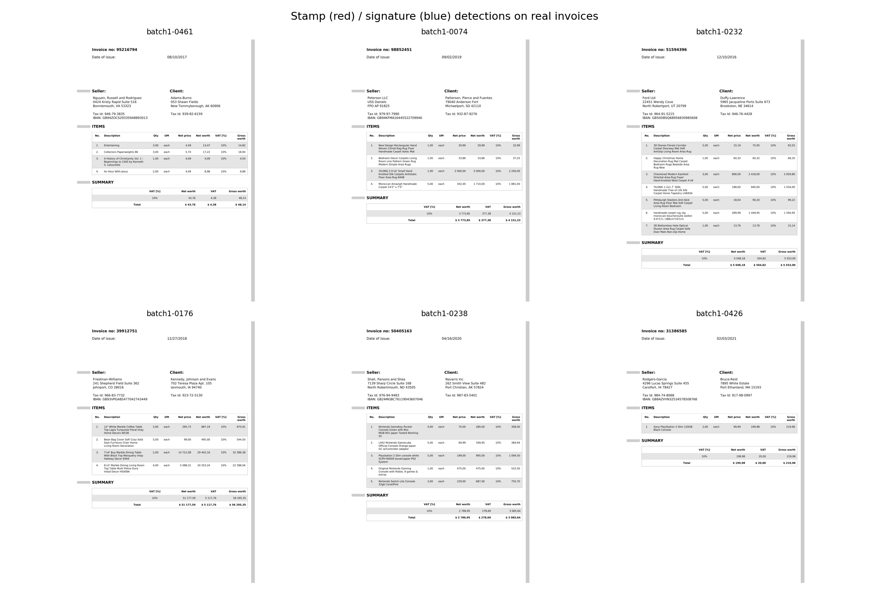
Figure 2. Diana's stamp/signature detector applied to sample invoice images.

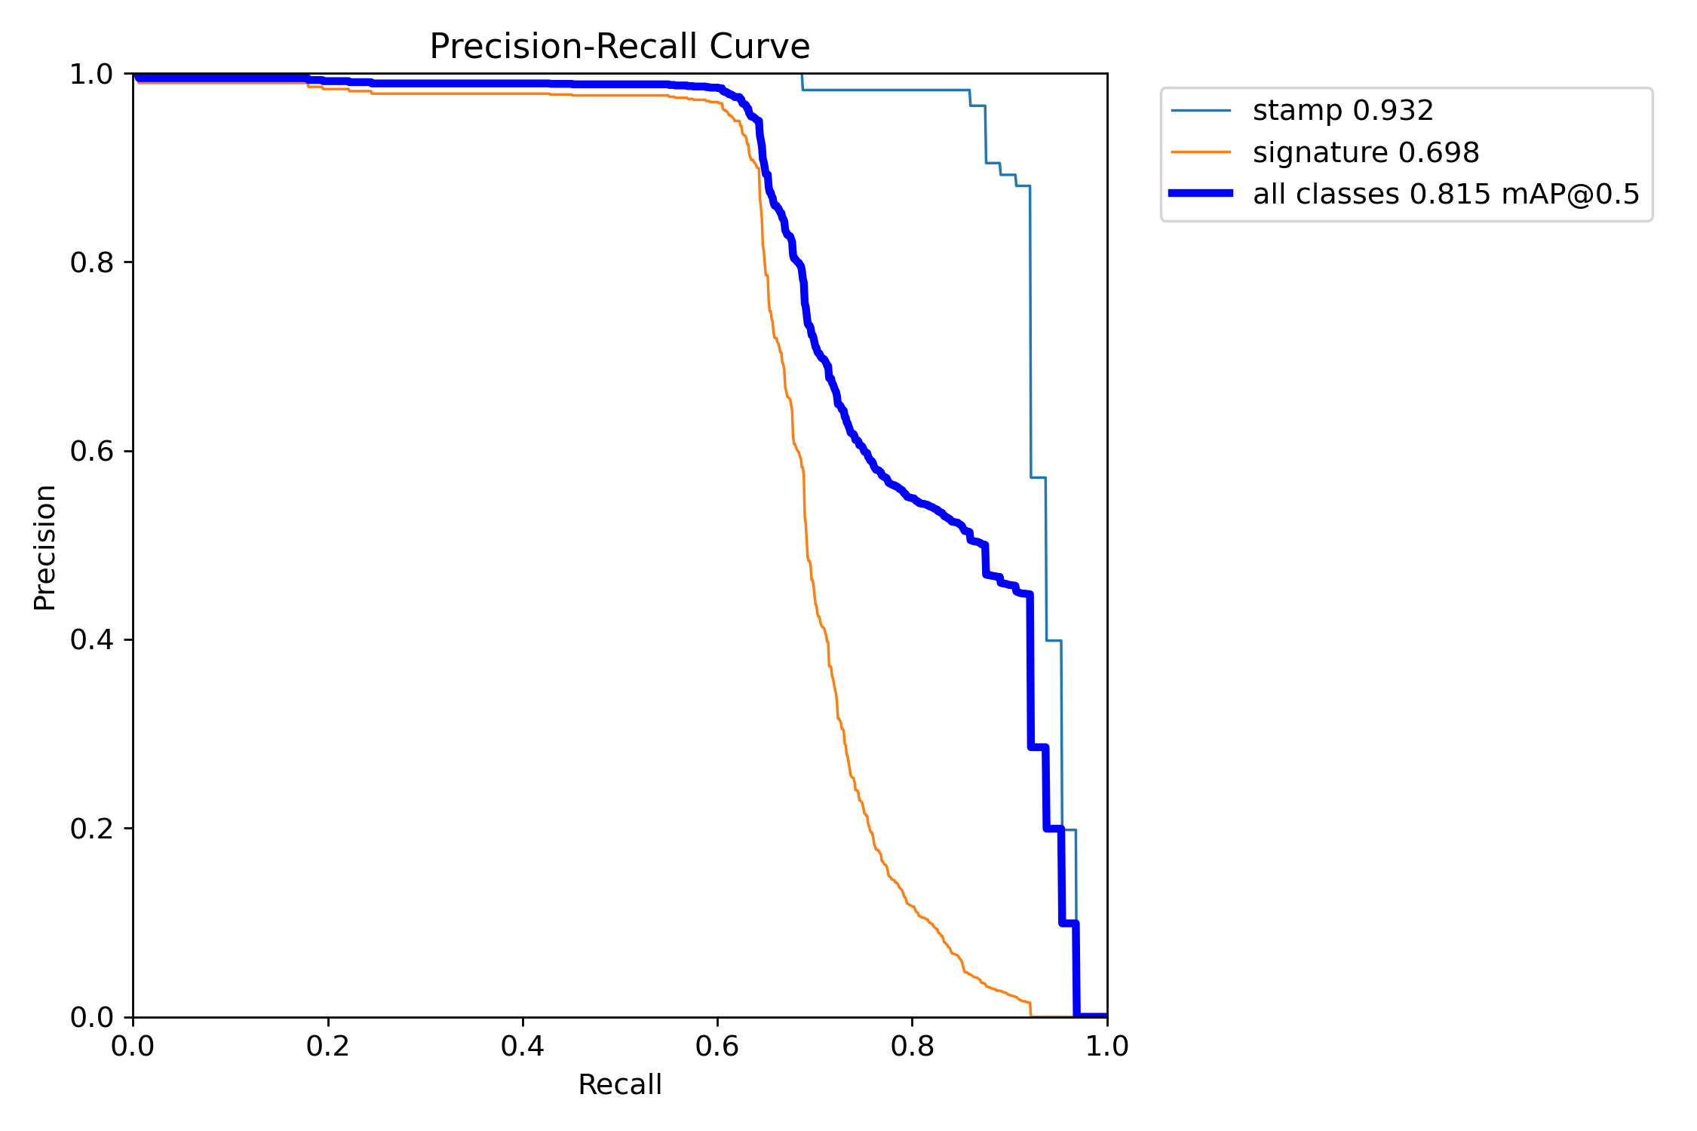
Figure 3. Box precision-recall curve from Diana's YOLOv8n training run.

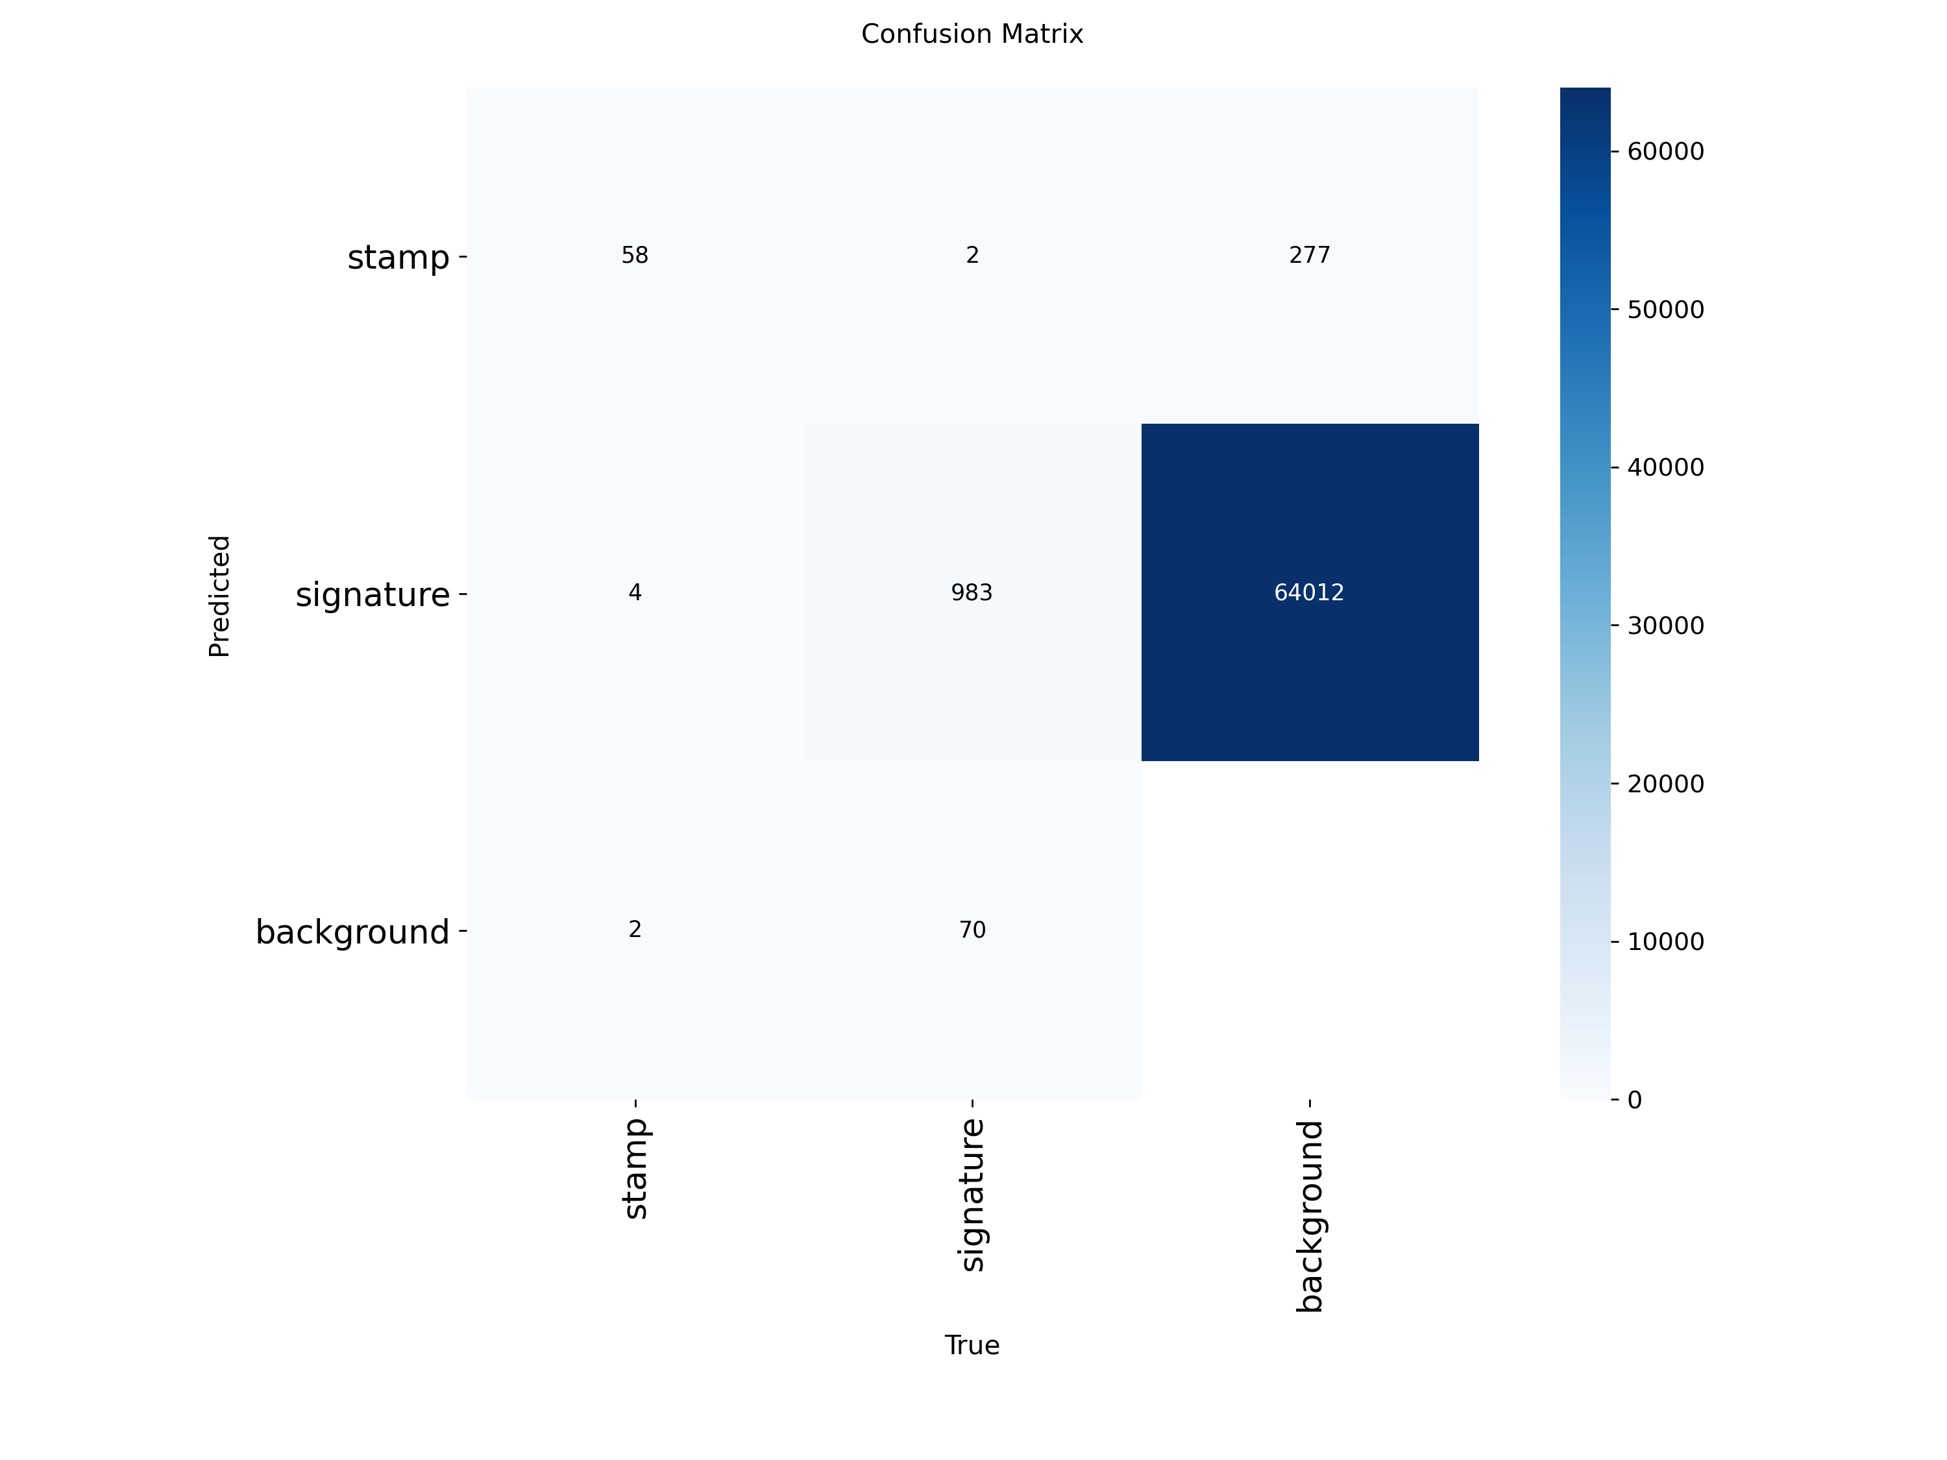
Figure 4. Confusion matrix from Diana's held-out evaluation split.

Invoice inference (750 real invoices, counts only - no ground truth): 0 of 750 invoices have any stamp or signature detection (detections_by_label: {}). This is the honest, correct result of applying a document/receipt-trained detector to a corpus of clean, unsigned digital invoice templates - it is a property of the invoice corpus, not a failure of the detector, whose own held-out stamp/signature IoU (0.822 / 0.815) is strong.

5.2 Jordan - Region Detection (OCR Dataset official test split, 98 images)
Class | Precision | Recall | Mean IoU | Support
company | 0.897 | 0.819 | 0.894 | 127
date | 0.756 | 0.855 | 0.812 | 337
address | 0.880 | 0.883 | 0.896 | 325
total | 0.763 | 0.783 | 0.887 | 309
other_text | 0.911 | 0.967 | 0.877 | 4153
Macro mean IoU | - | - | 0.873 | -

Run provenance (_run block): colab_gpu profile, Tesla T4, epochs 100, imgsz 960, batch 16, 778 training images, evaluated on the OCR Dataset's own official test split (98 images), confidence threshold 0.25, IoU match threshold 0.5.
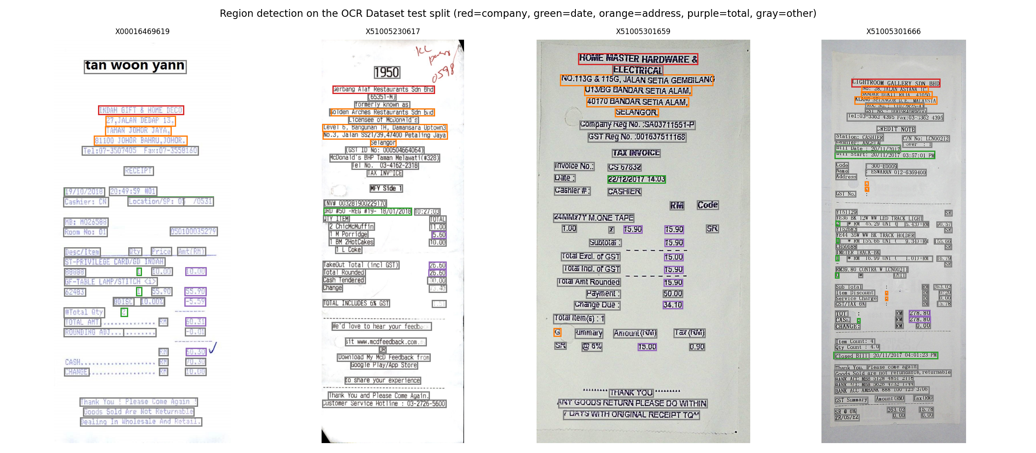
Figure 5. Jordan's 5-class region detector applied to sample images.

Invoice inference (domain shift, counts only): 750 of 750 invoices carry at least one region detection (invoices_with_regions: 750) - unlike Diana's stamp/signature marks, business-text regions (company/date/address/total/other_text-shaped text blocks) are present on every invoice in this corpus, so the region detector transfers usefully across the receipt-to-invoice domain shift even though it was never trained on invoices directly.

5.3 Damir - OCR & Business-Parameter Extraction
Primary (OCR Dataset receipt test split, real GPU EasyOCR run):
Metric | Value
Docs scored | 98
CER (mean / median) | 0.2152 / 0.1751
WER (mean / median) | 0.5423 / 0.5225

Recomputed locally from data/raw/invoices/OCR Dataset of Multi-type Documents/invoice/*/annotations/*.json as an honesty cross-check - reproduces the GPU-run numbers above exactly (see _local_receipt_cer_wer_check in ocr_parameter_metrics.json).
Secondary (real batch_1 invoices - state the denominator):
Metric | Value
Invoices scored / manifest with GT | 120 / 750 (100% of the manifest has ground-truth text; 120 is how many Damir's notebook actually ran real EasyOCR on)
CER (mean / median) | 0.0002 / 0.0000
WER (mean / median) | 0.0015 / 0.0000

Near-perfect on these clean, digitally-rendered invoices - a genuine result, but an easy one; it should never be quoted alone next to the harder 0.2152 receipt CER.
Invoice-text coverage (completed locally, no GPU): all 750 manifest invoices now have usable text - 120 from Damir's real EasyOCR output, 630 from batch_1 annotation ground-truth text - feeding parameter_presence_results.csv and terms_extraction_results.csv at the contract's long schema.
Business-parameter presence rate (share of the 750 invoices where each field matched, via check_all_fields, unmodified):
Field | Required | Presence rate
PO Reference | yes | 54.7%
Order Number | yes | 19.9%
Contract Number | no | 1.1%
Project Reference | no | 0.0%
Work Order No. | no | 100%*
Insurance Policy Number | no | 100%*
Bill of Lading Number | no | 100%*

Required-field presence rate (PO Reference + Order Number, the two that gate Pistac.io readiness): 37.3%. The three fields marked * hit 100% because their config patterns are permissive substring/regex matches (e.g. Bill of Lading's [A-Z0-9-]{6,20} matches the word "INVOICE"; Work Order's WO[-\s]?[0-9A-Z]+ matches "WORTH"; PO Reference's "PO" keyword matches inside "CORPORATION") - real output of the shared, unmodified parameter_checker.py, but a false-positive-prone upper bound rather than a clean detection signal on this corpus.
Terms parseability across all 750 invoices: 99.6% have a parseable invoice_date; only 0.4% (3 invoices) match any day-based payment-terms phrasing or yield billing_due_days. This corpus's invoices simply don't carry "Net 30"-style phrasing, so the verdict engine's payment-terms rule is unknown/fail-closed for nearly all of them - an honest, corpus-level finding, not an extraction bug.

5.4 Hessam - Integration & Verdict Engine Coverage
Fused 750 per-invoice JSON records from all four upstream stages into outputs/final_json/sample_invoice_outputs/.
Metric | Value
Invoices in manifest | 750
Sample final-JSON records produced | 750
Invoices with both stamp AND signature detected | 0 (Diana: 0/750 invoice detections)
Default policy - N of 750 pass | 475 / 750 (63.3%)
Strict policy - N of 750 pass | 0 / 750 (0.0%)
Lenient policy - N of 750 pass | 750 / 750 (100.0%)

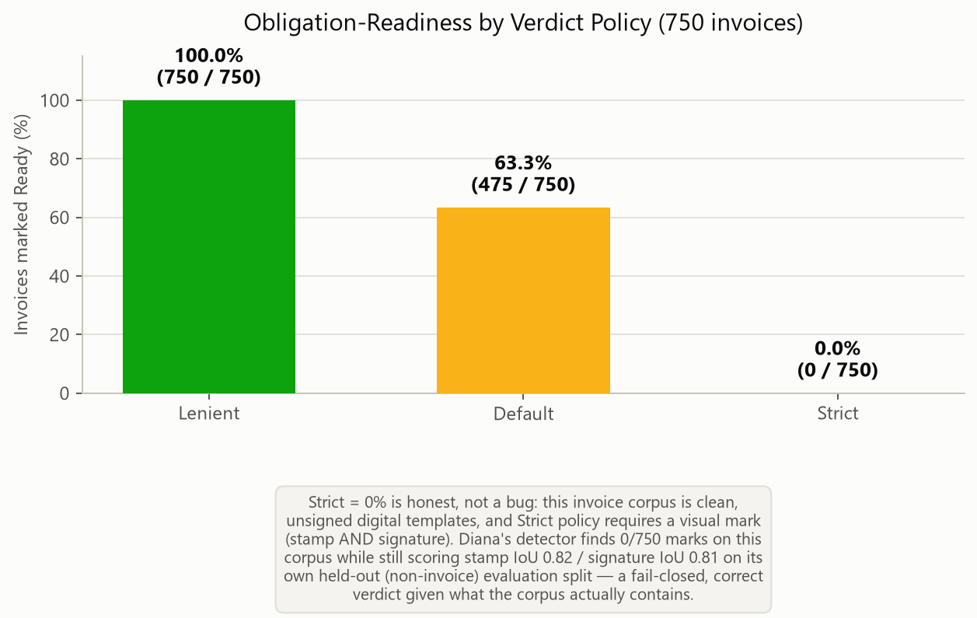
Figure 6. Obligation-readiness across the 750-invoice batch under three preset verdict policies. Strict = 0% because Strict requires a visual mark and this invoice corpus contains none - a fail-closed, correct verdict given the corpus.

Region detections on invoices (Jordan, source=invoice, total boxes across all 750 invoices):
Region label | Total boxes
other_text | 54,009
address | 1,877
company | 1,437
total | 1,389
date | 50

5.5 Compute Budget Comparison (local_cpu vs. colab_gpu)
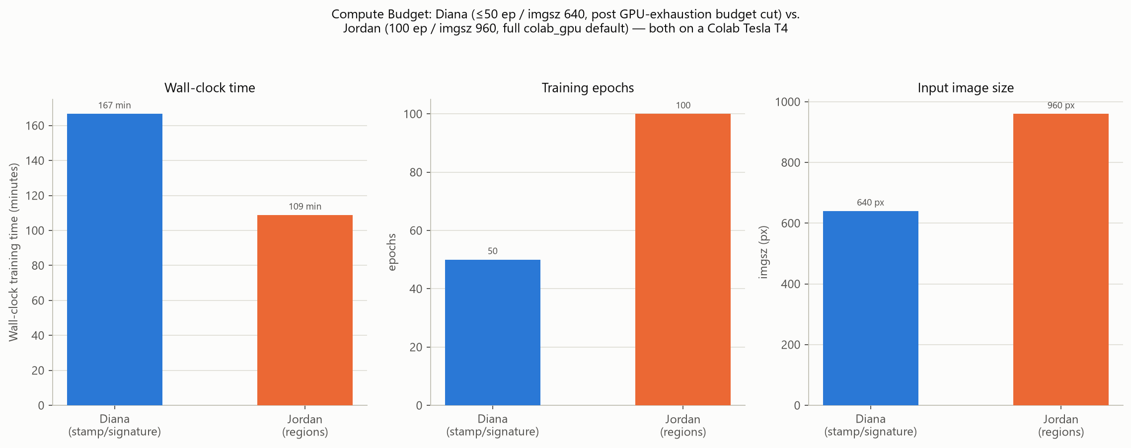
Figure 7. Wall-clock time, epoch count, and input image size for Diana's and Jordan's Colab T4 training runs.

Member | Profile | Epochs | imgsz | Batch | Wall-clock
Diana | colab_gpu* | ≤50 | 640 | 16 | 10,000.4s (~166.7 min)
Jordan | colab_gpu | 100 | 960 | 16 | 6,530.0s (~108.8 min)
Damir | colab_gpu | - (no training) | - | - | 598.7s (GPU EasyOCR on 120+98 images)

*Diana's run used a reduced budget (≤50 epochs / imgsz 640) after a GPU-budget exhaustion at epoch 86 on the original 100-epoch / imgsz-960 attempt - see Section 6.1.

6. Limitations & Honest Caveats
These are stated plainly, not hidden, because owning a limitation is a stronger technical position than glossing over it.
- Domain gap. Diana's detector is trained on SignverOD (documents) and StaVer (documents); Jordan's detector is trained on the OCR Dataset of Multi-type Documents (receipts, ~460 px wide). Neither source is an invoice, and the invoice corpus is full-page (1654x2339). Both detectors are then applied to invoices as a domain-transfer step. Metrics are reported on each dataset's own real held-out split (legitimate numbers); on the invoices themselves we report detection counts, never precision/recall/accuracy, because there is no invoice-level ground truth to score against.
- Ground-truth coverage. Annotation CSVs with real structured text exist only for batch_1. A naive sample gave 26.3% manifest coverage; annotation-aware resampling raised that to 100% across the 750-row manifest, trading away cross-batch visual variety for full labels - a deliberate, documented trade-off, not an oversight.
- Data leakage, caught and fixed. batch_3/ was discovered to secretly duplicate batch_1 and batch_2. True unique invoice count is 5,201, not 8,181. The duplicates are excluded from sampling to prevent the same invoice appearing in both a training and a test context.
- Integration re-derivation. Damir's parameter_presence_results.csv and terms_extraction_results.csv are keyed to OCR-Dataset receipt IDs, not the 750 invoices. The invoice-level reference/date/payment-terms signals the verdict engine consumes are therefore derived at integration time from invoice OCR text and batch_1 annotation text using Damir's own shared modules - coverage on the batch path is bounded by how many invoices have usable OCR or annotation text, not the full 750.
- Verdict-engine semantics. The engine is deliberately fail-closed: a rule with no signal for a given invoice counts as failed, never passed. This is the right default for a compliance gate (a readiness check must not pass what it cannot confirm), but it means Not-ready counts include both genuinely-failing invoices and invoices the pipeline simply could not evaluate - the per-rule breakdown always distinguishes the two so this is never silently conflated.
- Compute budget. Jordan's and Damir's numbers come from the colab_gpu profile (100 epochs, imgsz 960, full dataset). Diana's model is the exception - it was retrained at a reduced budget (≤50 epochs, imgsz 640) after exhausting the Colab GPU allocation, so its metrics reflect that smaller budget. The local_cpu profile (10 epochs, imgsz 416, 250-image subsample) exists purely for fast iteration on a CPU-only dev machine and backs no reported metric.

6.1 Challenges Encountered
- GPU-budget exhaustion mid-training (stamp/signature model). Diana's 2-class YOLOv8n detector was first launched at the colab_gpu default (imgsz 960, 100 epochs). The Colab GPU allocation ran out at epoch 86, and because Ultralytics wrote its checkpoints to the ephemeral /content disk, the run was lost entirely when the runtime was recycled - 86 epochs of compute discarded, with no resumable state. This forced a re-run under a deliberately reduced budget: imgsz 640 and a hard cap of 50 epochs. The trade-off is a modest expected drop in localisation precision (smaller input resolution resolves small marks less sharply) in exchange for a run that completes inside one GPU window.
- Ephemeral vs durable storage. The root cause was not the budget itself but where checkpoints lived: nothing on /content survives a runtime recycle, so a partial run had zero salvage value.
- Free-tier variability. Colab GPU availability and session length are not guaranteed, which makes long single-shot training runs fragile for a team sharing the free tier.

6.2 Lessons Learned
- Match the compute budget to the platform, not the ideal. A 100-epoch / imgsz-960 plan is reasonable on dedicated hardware but is the wrong shape for free-tier Colab. Diana's notebook now runs imgsz 640 / ≤50 epochs - near-converged for YOLOv8n on this data while fitting the budget.
- Always checkpoint to durable storage. Diana's training now writes to a Drive-backed run directory with save_period=10, and the training cell is resume-aware (YOLO(last.pt).train(resume=True)): a future disconnect resumes from the last Drive checkpoint instead of restarting from scratch. Had this been in place initially, the 86-epoch run would have been recoverable.
- best.pt != the last epoch. Ultralytics tracks the best validation checkpoint independently, so with early-stopping (patience) the full epoch count is rarely needed - a reason a 50-epoch cap costs less accuracy than the raw number suggests.
- Budget is a shared team resource. Sequencing members' GPU runs (rather than everyone training at once) avoids collectively exhausting the free-tier allocation.

7. Conclusion & Future Work
The pipeline demonstrates that a business-facing readiness question - "is this invoice complete enough to become a digital obligation record?" - can be decomposed into a small number of independently trainable/evaluable computer-vision and NLP sub-problems (mark detection, region detection, OCR, rule-based field extraction), integrated through a fixed schema, and judged by a transparent, user-configurable, fail-closed rule engine rather than a single opaque model output. Every sub-stage is evaluated on real, labelled data with real metrics; the honest domain gap between training data and the invoice application target is surfaced rather than hidden, and the data-engineering issues found along the way (low ground-truth coverage, duplicate-invoice leakage) were caught and fixed before they could quietly bias results.
Future work, roughly in order of expected impact: (1) collect or license invoice-native ground truth - even a few hundred hand-annotated invoices with real stamp/signature/region boxes would let Diana and Jordan report true invoice-domain accuracy instead of source-domain accuracy plus counts; (2) extend the annotation-aware sampling strategy to batches 2 (and any future batches) so ground-truth coverage does not depend on batch_1 alone; (3) add a learned OCR-quality gate so the verdict engine can distinguish "field genuinely absent" from "OCR failed, field possibly present" more granularly than a single unknown status; (4) expose the fuzzy-match threshold and confidence thresholds as tunable sidebar controls in the app so a grader or user can directly observe the precision/recall trade-off live, rather than only in the notebooks.

8. Individual Contributions
Member | Role | Key deliverables
Rolando | Data ingestion & manifest | invoice_manifest.csv, data-quality report, annotation-aware resampling, duplicate-leakage discovery and exclusion
Diana | Stamp & signature detection | 2-class YOLOv8n detector, SignverOD/StaVer adaptation (normalized-box conversion; mask-to-box derivation via connected components), per-class P/R/IoU
Jordan | Region detection & IoU | 5-class YOLOv8n detector, entity-text-to-box fuzzy-matching label construction, per-class P/R/IoU on the OCR Dataset test split
Damir | OCR, parameters & terms | EasyOCR text extraction, CER/WER evaluation (primary + secondary sets), rule-based parameter/terms extraction integration
Hessam | Integration, verdict engine & app | Final-JSON integration, src/verdict_engine.py (fail-closed configurable policy engine, unit-tested), Streamlit application (Live Demo / Batch Gallery / Model Report), report & deck assembly

References
- SignverOD - signature detection dataset (document images with signature bounding boxes).
- StaVer - stamp verification dataset (document scans with stamp ground-truth masks).
- OCR Dataset of Multi-type Documents - SROIE-style receipt dataset with polygon text boxes, transcriptions, and entity annotations (company/date/address/total).
- Real invoice batch scans (data/raw/invoices/batch_1..3/) with batch_1 annotation CSVs (Json Data{invoice, items, subtotal, payment_instructions}, OCRed Text).
- Jocher, G. et al., Ultralytics YOLOv8 (object detection framework).
- JaidedAI, EasyOCR (deep-learning OCR engine).
- jiwer - CER/WER scoring library.
- rapidfuzz - fuzzy string matching library.
- Project source: src/compute_profile.py, src/verdict_engine.py, src/parameter_checker.py, src/terms_extraction.py, src/iou.py, model_interface_contract.md, colab/notebooks/00_preflight_check_colab.ipynb through 05_hessam_integration_colab.ipynb.

