**Specification and Design Report**

**Student's Name: Roland Hudson**

**Student's Number:** H00056278

**Student's Email Address:** roland.hudson@online.liverpool.ac.uk**Project Title: Big Climate Data Analytics: Effective Knowledge Discovery from Colombia’s Weather Data**

**DA Class ID:** UKL1.CKIT.702.H00028508

**Name of DA: Yuri Demchenko**

**Name of GDI: Taly Sharon**

**Name of SSM:**

# The Specification:

The goal for the project is a big climate data analytic system that enables knowledge-discovery (KD) to support decision making in the design and construction of buildings in Colombia. Specifically, the project aims to enable the search for patterns in climate data that can be linked to localized, climate-responsive design and construction strategies. Application of these strategies can lead to buildings that perform better in terms of production costs, life-time running costs (reduced heating and cooling) and occupant comfort.

Low-energy construction strategies exist that can minimize or remove the need for heating and cooling through, for example; orientation of buildings, sizing and positioning of openings, choice of materials and use of passive heating and ventilation. These techniques require an understanding of local and regional climate conditions across different time frames. The project proposes that knowledge discovery applied to weather data can link specific design strategies with a specific location and time frame.

Detecting climate patterns in the Colombian context is challenging due to weather variations caused by extreme changes in altitude over short distances, proximity to different ocean bodies and phenomena such as el niño and la niña. This underlying complexity is complicated further by subtle and inconsistent seasonal patterns associated with tropical latitudes.

The Colombian context contrasts with Northern and Southern latitudes where consistent seasonal variation dominates the climate making it easier to identify what design strategy to apply. Colombia’s complex climate patterns make identifying appropriate, localized, low-energy construction strategies difficult. Typical construction is often unable to cope with regional and daily variations in weather, people live and work in uncomfortable conditions often too hot and too cold. To correct these issues heating and cooling need to be installed which is expensive, costly to run and produces emissions.

The project proposes that by combining a big data workflow management infrastructure with spatiotemporal data mining techniques localized approaches to building design and construction that respond to the unique weather conditions in Colombia can be identified.

To achieve this goal a big data system is proposed that follows current best practices for the storage, processing, analysis, management and visualization of the data. Specific focus will be on enabling the analytics and visualization that enables KD through Data mining. Knowledge from the data will support decision making for the design and construction of buildings to potentially improve living conditions (quality of life and wellbeing) and reduce energy consumption in buildings.

# System actors

The primary actor in the system is an Environmental Designer (ED), an architect or engineer whose aim is to develop energy-efficient designs for buildings in specific geographical locations. The ED’s goal is to minimise the need for heating and cooling systems while maintaining thermal comfort for occupants reduce energy consumption.

To achieve these aims the ED needs to understand the interrelationship of occupant’s thermal comfort, topography, local weather conditions, annual solar path and larger scale climatic patterns and examining how these interact with the anticipated usage patterns of the building.

Equipped with this knowledge the ED can apply a hierarchy of design strategies to develop the design. The first level relates to designing the form and fabric of the building (for example the location, orientation, materials of the building). The next level involves identification of potential passive strategies (for example, designing direct solar heating and natural ventilation into a building). The final level is the specification of mechanical systems to heat and cool, potentially using renewable energy sources. The first two levels are the concern of this project.

Other actors identified are a system administrator and data scientist. The administrator’s role is the configuration of systems settings such as access and security. The data scientist working in the field of environmental design is also identified as a system user. In this case the use is like the ED but with additional goals of management of the datasets, developing and managing new analytical techniques, visualisation and statistical methods that the ED has access to.

# Complexity of existing workflow

The current workflow for the ED is a multi-step approach:

1. Analysis of climate data - analysis of historical weather data compiled into files representing typical meteorological years (TMY) with a range of variables stored for each hour of the year.
2. Biological evaluation – data is plotted on a psychrometric chart (physical and thermal properties of moist air) to diagnose the hours of the year lying outside a predefined zone of thermal comfort.
3. Identifying technological solutions (design strategies) – in response to the biological evaluation technological approaches can be identified to ensure more time within the comfort zone. For example; site selection and orientation to gain or minimise solar radiation.
4. Developing the architectural application – the designer synthesises the previous three steps into a design proposal.
5. Simulation may be undertaken to confirm the design approach or optimise a chosen strategy.

The ED must also consider usage patterns of the building making the process more complex. Buildings are rarely occupied constantly, depending on use, occupancy can vary daily (residential buildings are often occupied evenings and night time), weekly (office buildings not in use at weekends) and through the year (schools and universities have seasonal holiday periods). The design approach for two buildings with different uses in the same location will not be the same. Zones within certain buildings will have different orientations, usage patterns and activity types, each zone will have varied design needs.

# General Use Case Analysis

The ED’s goal is to run an analytic or data mining technique on a set of climate data to identify patterns that can be visualised and linked to with specific design strategies. An example analysis / data mining problem could be framed as:

*For the coastal regions of Northern Colombia what design strategies can be identified for afternoon weather conditions during the first three months of the year, using a k-means clustering approach. Visualise the clusters on a map and indicate the design strategies and considerations applicable to each cluster.*

To address this broad aim data storage, analytical processing and visualisation should be developed as a proof-of-concept using a public cloud based infrastructure as a service (IaaS) to take advantage of the low-cost capital investment, flexible infrastructure, performance and the potential for collaboration.

The ED should be able to define this process via an online interface that allows the storage, editing and reuse of previously defined processes. The ED requires the ability to start, pause, stop and cancel the analysis process. Prediction of runtime and monitoring of workflow progress is also required. Results should be stored and accessible for online visualisation and statistical summary and comparison. Resulting graphics and summaries should be available for download in formats for use in excel and as high-quality images and vector graphics for use in reports once the process is complete.

This general use case can be subdivided into four phases:

## 1. Define workflow

To define a process or work-flow the ED must be able to specify a dataset or collection of datasets selected from a set of preloaded data. From the data the ED needs to define a geographical region or single point to study. The ED requires a high level of control of the temporal dimensions of the data. They will define the start and end dates and may need to specific that analysis takes place on recurring time-periods within the data (such as an afternoon in a specific season). The ED needs to specify which variables from the data to analyse and potentially assign a weight to each to define its relevant importance. Once the dataset and spatial and temporal subset has been defined and the dimensionality specified, the ED will select an analytic or data mining technique from a set of predefined (and described) methods. At any point in this process the ED may need to save, save as and or editing the defined work-flow.

## 2. Run workflow + monitor resources

Once the work-flow is defined the ED may need an estimate of how long the selected analytics will take. The workflow will then be submitted for processing and its progress will be monitored in terms of its status (ready, executing, staging, completed). The ED may also need to monitor the state of processing resources. During processing the should be able to stop, pause or cancel the workflow.

## 3. Output + visualise results

Following analysis results from the workflow shall be stored and accessible to the ED. Numerical and statistical summaries of the results will be generated by the ED using one of a range of predefined methods. These results would be stored and available for download in formats that can be further analysed or shared in spreadsheets. The ED may need to use simple visualisation of results (histograms, pie charts, line charts). Visualisation tools should include the ability to represent results by geospatial mapping. The graphics generated will be downloaded as high-quality images or vector graphics and used in reports. Within the interface the ED may need to compare two or more visualisations side-by-side to undertake a visual analysis. The ED also needs to share visualisation results with collaborators by providing a secure link to a webpage where the graphics can be viewed and download.

## 4. Manage design strategies

The design strategies specific to individual ED’s, it is necessary, therefore, to manage the predefined general design strategies used by the system. Some EDs will wish to add new strategies, removing unwanted strategies and editing existing ones. A standard unambiguous method for describing a strategy is required.

# Requirements

## Infrastructure

1. The system must be based on a cloud infrastructure.
2. The infrastructure must support data processing and analytics with Hadoop, Apache Spark and Apache Mahout.
3. The system should be accessed via a web interface designed for desktop use.
4. The system should provide a secure access system configurable to define varying roles and permissions for users.

## Workflow definition

Users shall be able to create new analytic workflows.

Users shall be able to save, open and edit previously saved workflows.

Users shall be able create new tasks and add them to a workflow.

Within a workflow definition the user must be able to prescribe:

* dataset(s) to use
* spatial subset
* temporal subset
* variables to use
* weighting of variables
* analysis / data mining method to use

## Workflow control + monitoring

The system should be able to estimate processing time for a workflow.

The user must be able to start, stop and cancel running workflows.

The system should provide an interface for monitoring workflow status.

The system should provide information on the status of the cloud resources.

## Output + visualise results

The system must provide methods to numerically summarise results using predefined statistical techniques.

Numerical summaries must be available to download in a standard spreadsheet format.

The system must provide the ability to visualise results with simple graphs.

The system must provide a method to visualise georeferenced results on a map.

Graphs and maps should be defined in a format that can be downloaded and inserted into reports.

The system should allow users to compare multiple visualisation results, on screen simultaneously.

The system should provide a method of sharing results securely as an isolated webpage that does not allow access to the user’s private area.

## Management of design strategies

Design strategies must be defined in domain standard way.

Users should be able to define and add new design strategies.

Users should be able to edit and delete existing design strategies.

# Literature Survey:

## Challenges for big data analytics applied to climate science and construction

The use of big data analytics is underutilised in the domain of weather data (Jain and Jain, 2017), better big data weather forecasting could benefit the construction industry by helping build more efficient buildings and provide an “*improved quality of life”.* The construction industry is responsible for massive amounts of greenhouse gases (Dimoudi and Tompa, 2008). Through their lifecycle buildings consume 50% of all total energy demand and contribute 50% of all CO2 emissions.

Primary goal for environmental construction is to reduce the energy consumed by buildings, estimated to be around 40% of the total global energy consumption (Omer, 2008). Much of this energy is expended on heating lighting and cooling. Energy efficiency can be defined as the minimising the amount of energy consumed to achieve thermal comfort for occupants. Currently the energy required to maintain thermal comfort accounts for 60-70% of energy consumed in non-industrial buildings (Omer, 2008). Better understanding of human response to climatic context (bioclimatic design) can result in buildings that require less energy for heating and cooling (Olgyay and Olgyay, 2015, p11).

## Low Energy Environmental Design Strategies

### Human thermal comfort

Can be understood as a combination of temperature, relative humidity, air movement and radiant temperature, giving a state of mind where a person requires no change in current conditions (ASHRAE, 2013) or a state where minimal extra energy is require to maintain the human balance (Manzano-Agugliaro *et al.*, 2015).

### Psychrometric chart

Is used to map interrelationships of thermal conditions of the environment (figure 1). A zone of human thermal comfort can be plotted following standard guidelines (ASHRAE, 2013). Hourly data points can be plotted on the chart, where they fall outside of the comfort zone the design of the building and/or services must be adapted to provide comfort.

The psychrometric chart was adapted by Givoni (1992) as the building bioclimatic chart and later Manzano-Agugliaro *et al.* (2015) to include specific zones representing strategies that can be applied to a design to extend the zone of comfort. Conventional heating and air conditioning are recommended only at extremes. The strategies include what Lechner (2009, p9) describes as tier 1: basic building design (building orientation, position and size of openings, material specification) and tier 2: passive systems (passive solar heating, night-time flush cooling). Correct design decision making at these levels can reduce building energy consumption by up to 80% (Lechner, 2009, p9).

Each design strategy can be further specialised into a series of instrumental techniques (Manzano-Agugliaro *et al.,* 2015) which can include regionally specific and traditional construction and more experimental methods. Climate Consultant software (Milne, Liggett and Benson, 2009) generates a prioritised subset of recommendations from a set of 68 design guidelines each associated with a zone on the psychrometric chart.

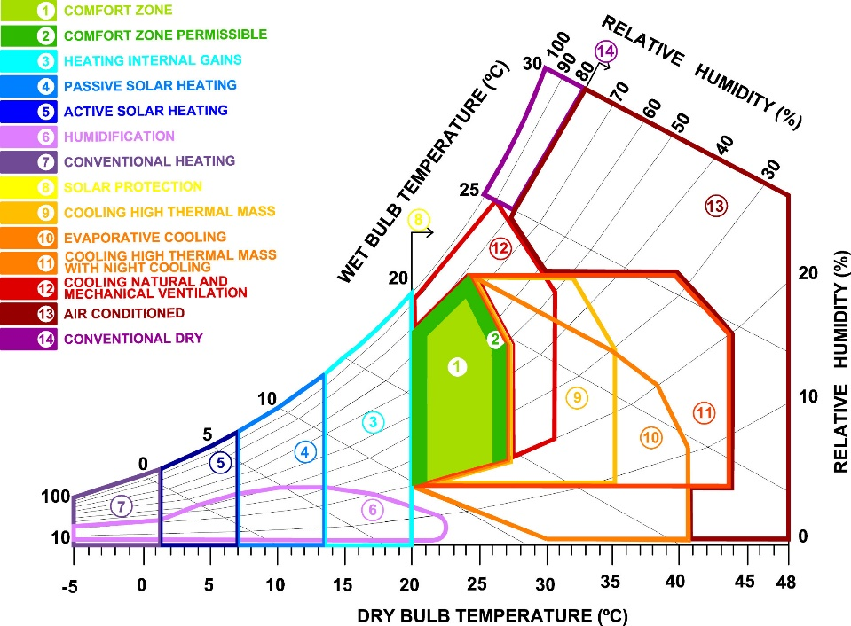

Figure 1. Manzano-Agugliaro *et al.* (2015) adapted version of the psychrometric chart.

## Weather data is spatiotemporal

Data collected for climate science is classed as spatiotemporal (ST) data (Atluri, Karpatne and Kumar, 2017). Mining and knowledge discovery with ST data differs from classical data mining due to its properties and the variety of data types (Faghmous and Kumar, 2014). ST data is heterogenous, it is not identically-distributed, instead ST data demonstrates non-stationarity in space and time. Auto-correlation exists in ST data two nearby locations are not independent but are correlated. ST data can be categorised into four types; event data (start and end of heavy rainfall), trajectory data (path of a cyclone), point data (temperature measured in a moving set of weather balloons) and raster data (temperature measured across a fixed set of weather stations).

Classical data mining uses features with labels (Atluri, Karpatne and Kumar, 2017) in ST instances can be defined as points, trajectories, time-series, spatial maps and raster. Search for similarities between these instances involves clustering, classification, pattern discovery and relationship mining.

Various data mining methods applicable to climate data are described by Atluri, Karpatne and Kumar (2017). *Relationship mining* involves linking changes in one variable to other phenomena. *Clustering* on instances and

ST-DBSCAN is recommended for finding anomalies. *Frequent pattern mining* includes searching *motif patterns* in time-series and in networks for sets of distant locations experiencing similar climatic conditions with consistent temporal activity. Change detection can identify transitions or deviations in behaviour. Faghmous and Kumar (2014) add *network based analysis* to undertake relationship and pattern mining in gridded and non-gridded climate data sets. *Pattern mining* for Faghmous and Kumar includes searching for user defined patterns, empirical orthogonal functions and spatiotemporal clustering.

## Examples of applied ST data mining methods applied to climate data

* Clustering methods have been successfully applied to climate classification (Forsythe, Blenkinsop and Fowler, 2015) (Netzel *et al.*, 2016)
* Self-organising maps (SOM)’s have been used to extract features from data (Liu, Weisberg and Mooers, 2006) and applied to metrology and oceanography (Liu and Weisberg, 2011)(Liu and Weisberg, 2005).
* Delta-maps (Fountalis, Bracco and Dovrolis, 2014) (Bracco *et al.*, 2017) group nodes in a network according to homogeneity, these have beenapplied to precipitation and sea surface temperatures. Robustness analysis of networks generated can be evaluated using link maps, area strength and s-core decomposition.

## Challenges for ST data mining

Dealing with interdependencies at multiple scales within climate data is complex and means global studies cannot be used to understand long-term local impacts (Faghmous and Kumar, 2014). Relationships in climate data may be long range and multivariate, many space-time-variable subsets exist where relationships may be found. This spatiotemporal variability makes clustering with ST data challenging. Similarly, anomalies and extremes in climate data need to be understood as multivariate cumulative extremes. Faghmous and Kumar suggest better methods are needed for validation of ST data mining. Significance testing needs randomization tests that do not break the inherent autocorrelation and performative measures are required to compare unsupervised STDM.

For Atluri, Karpatne and Kumar (2017) key challenges involve finding methods for combining multi-modal data sets and controlling granularity of partitioning to ensure substructures are not overlooked.

The need to integrate domain theory and expertise is acknowledged (Karpatne *et al.*, 2017) as a key strategy that could accelerate knowledge discovery in data science particularly where complex physical phenomena are involved. The potential for knowledge discovery in climate science has not yet been fully realised (Bracco et al., 2017).

## Knowledge discovery with climate data

Knowledge Discovery in Data is defined as (Begoli and Horey, 2012) 1. Collection, storage and organisation of data. 2. Understanding and application of analytic methods. 3. Understanding the problem domain. To enable knowledge discovery Begoli and Horey recommend applications are made to allow researchers easy ways to interact, explore and analyse data. A variety of analysis methods should be supported inclung statisitical, data mining, machine learning, visualisation and visual analysis. Different data storage and processing mechanisms should be provided to support a variety of intermediate data structures (structured and semi-structured) required by different ananlysis methods. Data should be made as accessible as possible by using open standards, lightweight architecture and APIs to expose results.

# Workflow management for scientific big data systems

An approach for supporting scientific data analysis on large data sets in the cloud is workflow management systems (WMSs) (Zhou, He and Ibrahim, 2016). These processing tools enable acquisition of resources, scheduling of tasks, execution of data analysis and visualisation on distributed resources. Workflows are defined as a series of linked tasks in the form of directed acyclic graph (DAG).

Specific WMS platforms exist (see Askalon, Kepler, Taverna and Pegasus) some provide a graphical interface to assemble workflows costing of loops, conditionals and graph constructs. Originally developed for grid computing many have been extended to take advantage of the cost-effectiveness of cloud platforms and applicable to climate science (figure 2) (Rodriguez and Buyya, 2017).

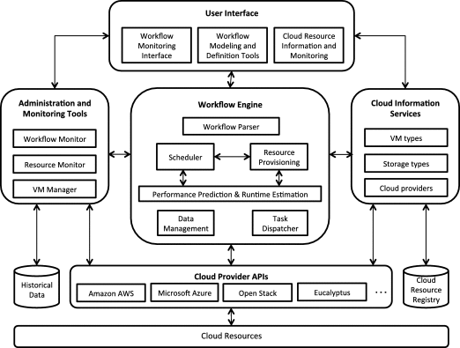

Figure 2. Reference architecture of a WMS (Rodriguez and Buyya, 2017).

# Big data Tools

## General applications on Weather Data

Several precedents exist describing the application of big data tools to process and undertake simple analysis on climate data. Three tools frequently occur in the literature Hadoop, Apache Spark and MapReduce.

* Apache Spark was used to process at-rest weather data to determine averages for a range of variables across a set of weather stations (Jayanthi and Sumathi, 2017).
* Hadoop and Spark were used to find points with similar weather conditions using Euclidean distances based on weather attributes using the NOAA hourly land based data set (Rodenburg and Maria Fiore, 2017).
* MapReduce was compared to Spark to calculate minimum, maximum and average values of weather parameters using data from NOAA (Chouksey and Chauhan, 2017). For smaller datasets differences in performance were less pronounced, above 8GB Spark was faster.
* Hadoop and MapReduce were used on NOAA data (Dagade *et al.*, 2015) to compare the performance of Pig and Hive to average data for each station for a single variable.
* MapReduce was used to process NOAA data (Varghese and Riyaz, 2015).
* K-means with MapReduce was used to cluster weather data from China (Fang *et al.*, 2014). Different size datasets were tested to evaluate processing speeds (250mb-2GB) and compared against another clustering algorithm.

## More specific applications

A self-organising map (SOM) (a type of artificial neural network trained using unsupervised learning) was implemented using Apache Spark and analysed IoT data (Jayaratne *et al.*, 2017). MapReduce enabled prediction using an artificial neural network and k-means clustering with air quality data stored with HBase, in an implementation designed to support decision making in traffic regulations in Marrakesh (El Fazziki *et al.*, 2015).

# Big data application architecture and components

Avci Salma, Tekinerdogan and Athanasiadis (2017) define a big data feature model and a generic reference architecture that can be developed into an application architecture using domain-driven design. Features and architecture components can be selected based on design rules determined by the domain.

# Conduct of the Project*:*

## Research methods

### Literature review:

Low energy architectural design strategies to link weather patterns and design criteria. Weather data, spatiotemporal data mining, knowledge discovery with weather data. Workflow management for scientific big data systems. Big data tools and applications in climate science. Big data application architecture and components.

### Application development:

UML based agile model driven development design

### Qualitative evaluation of artefact by domain experts:

Presentations to and interviews with domain experts

### Quantitative evaluation of output from artefact results:

Statistical comparison of different knowledge discovery methods. Quality measures for methods applied (distance metrics for clustering). Results of test cases (identified by domain experts) checked against expected results. Results interpreted by domain experts.

## Data required:

Four data sets have been identified and examined

1. Hourly station based data captured during daytime hours from NOAA’s Integrated Surface Hourly Data Base. Variables available: wind direction and speed, precipitation, temperature dew point temperature, cloud cover, relative humidity (NOAA, no date).

2. Hourly station based data from Colombia’s metrological service (IDEAM) starting in 2008. Variables available: temperature, relative humidity, wind speed, wind direction, solar radiation.

3. Monthly gridded data from CRU-TS 3.0 Climate Database for 1901-2008. Variables available: cloud cover, diurnal temperature range, frost day frequency, precipitation, daily mean temperature, monthly average daily minimum temperature, monthly average daily maximum temperature, vapour pressure, wet day frequency (Cgiar-csi.org., 2012).

4. Daily gridded data from CCMP Version-2.0 for 1988-2014. Variables available: wind speed and wind direction (Wentz *et al.*, 2015).

## New skills

Use of Amazon’s Web Services AWS and SDKs.

## Design methods

The design process is broken into three major development increments. Each increment lasts approximately 1 month and follows Agile Model Driven Development (AMDD) with UML (Ambler, 2004). First, over several days, high-level modelling will be used to understand the scope, requirements and potential architecture of the system. This is followed by a series of construction iterations each of which begins with a planning phase. Requirements will be ranked by priority and the highest priority implemented first. On a time-scale of hours models will be produced to explore what should be built for the iteration and to estimate the time required. Issues identified in the planning models will be developed in more detail using just-in-time models, created in less than thirty minutes involving hand-sketched flow diagrams, sequence diagrams and class responsibility cards. Using these modelled details code will be written during the following hours or days using a test-first and refactor approach. The end of the increment coincides with project checkpoints the artefact is reviewed against the evaluation criteria described below and checked by the DA. Review of the second and third increments includes evaluation by domain experts.

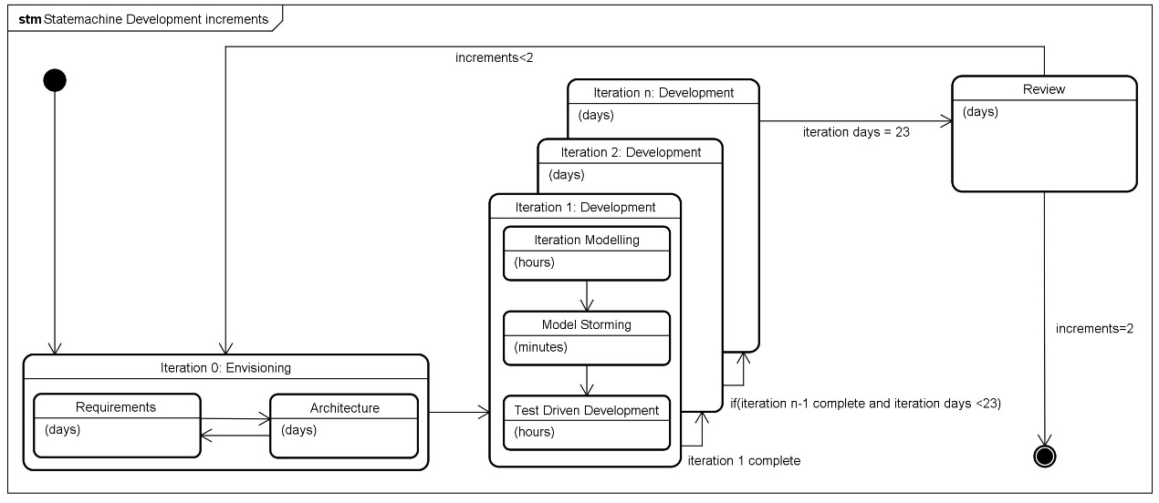

Figure3. Development increments (extended from Ambler, 2004, p119).

## Software

Visual Studio Community, eclipse, AWS .net + java SDKs,AWS EMR, AWS S3 storage, AWS EC2, AWS Identity and Access Management, D3.js

## The Design:

### Architecture overview

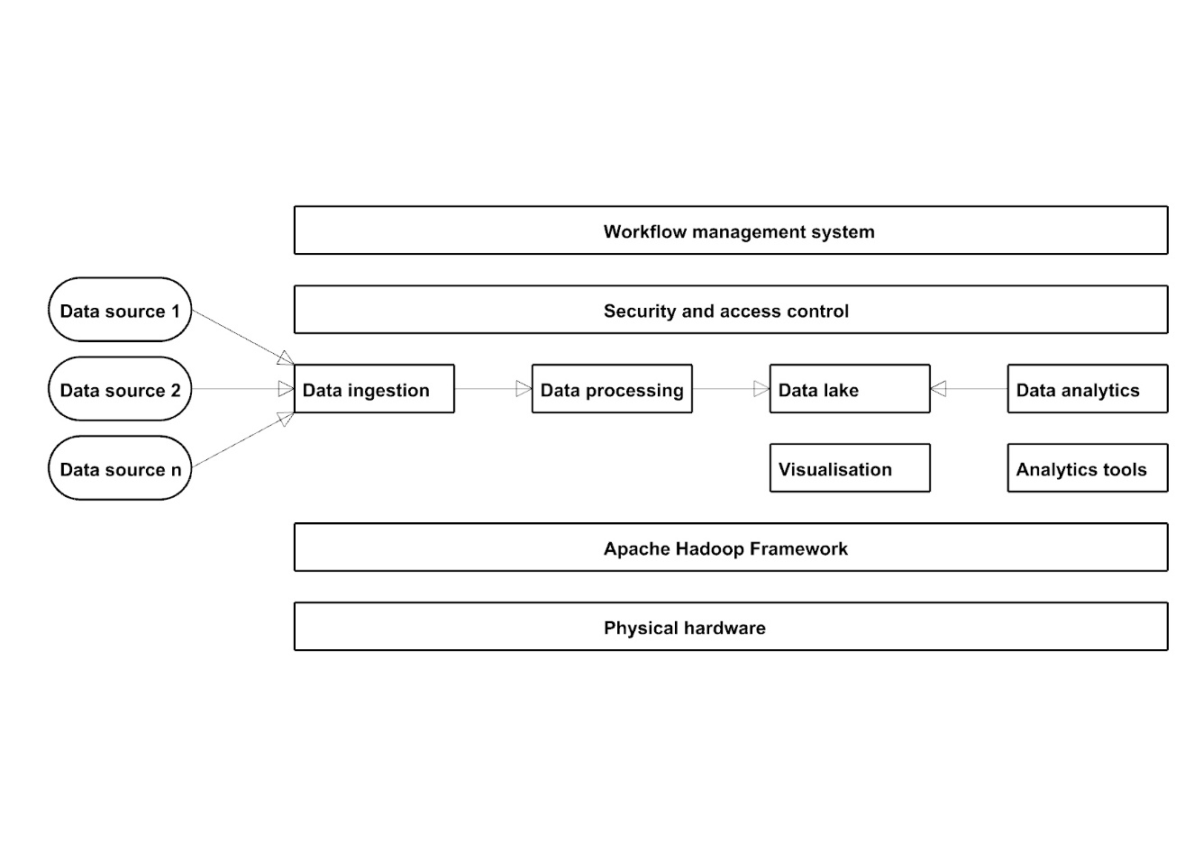

Figure 4. Proposed architecture overview based on Hadoop framework (extended from: Lopes, Palmer and O’Sullivan, 2017).

### System components overview

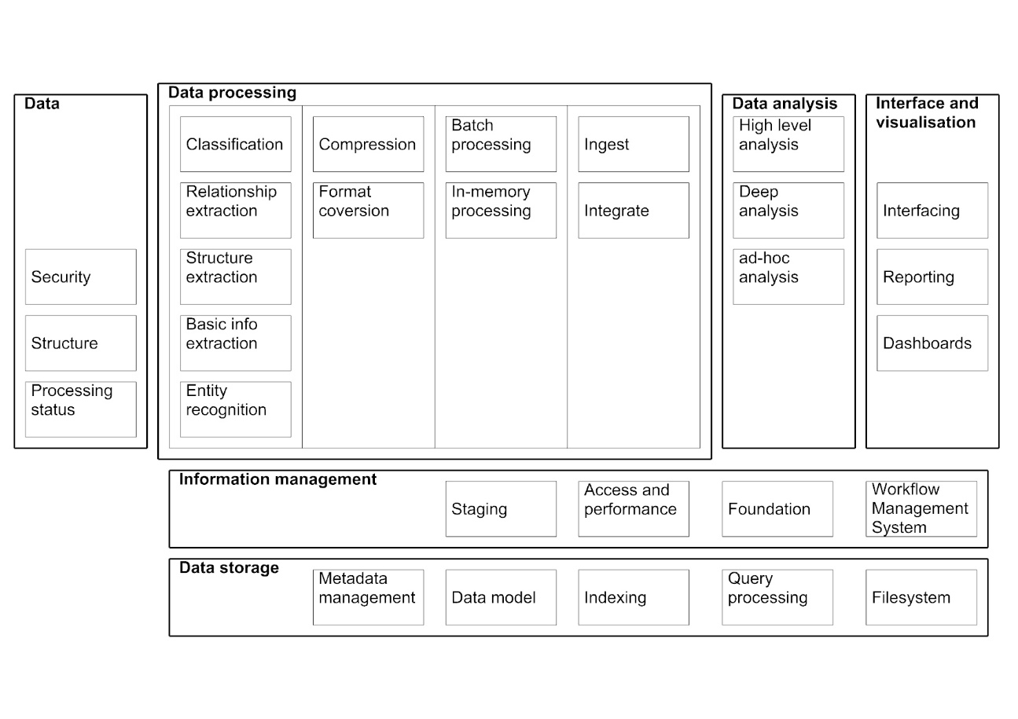

Figure 5. System components overview based on big data reference architecture (extended from: Avci Salma, Tekinerdogan and Athanasiadis, 2017).

### Architecture for WMS

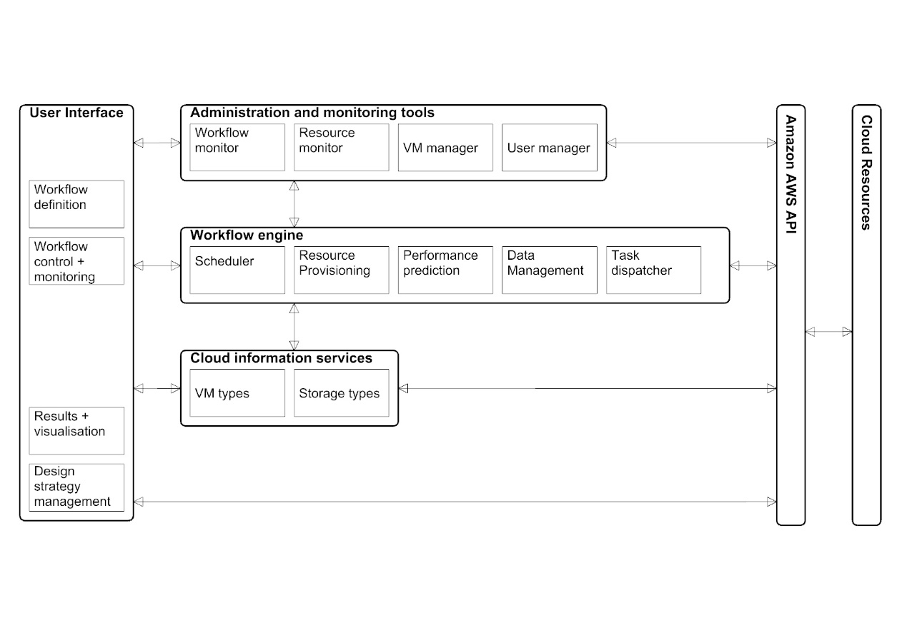

Figure 6. Architecture for the WMS (adapted from: Rodriguez and Buyya, 2017).

### Class diagram for the WMS

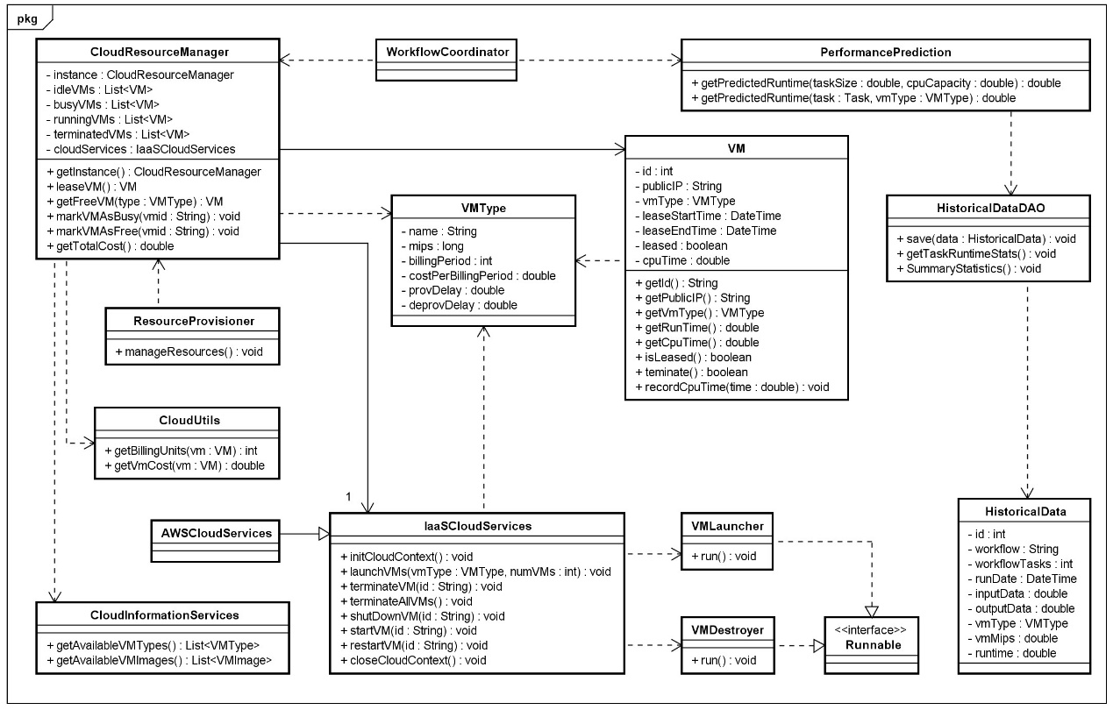

Figure 7. Classes for the workflow management system (adapted from: Rodriguez and Buyya, 2017).

### Sequence Diagrams for General use case analysis

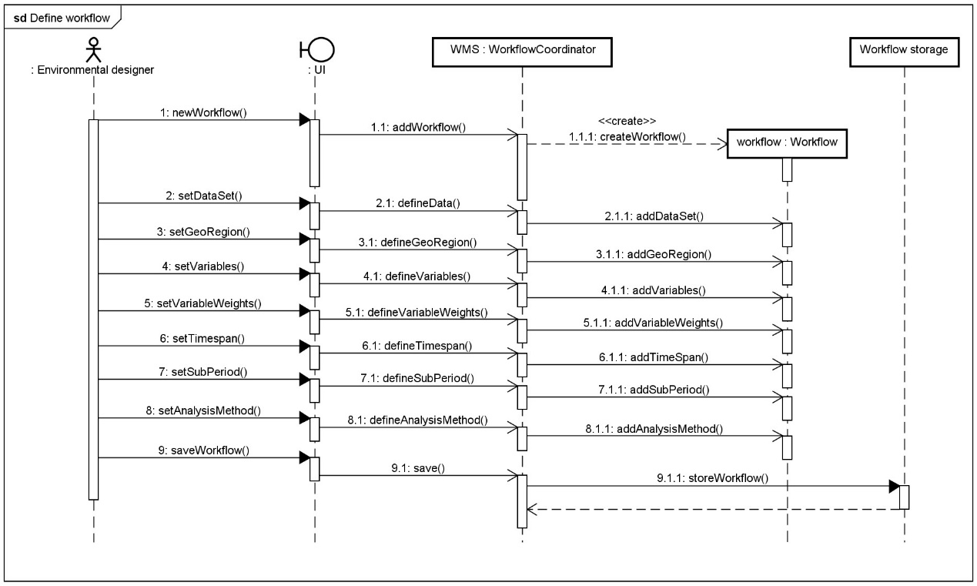

Figure 8. Sequence diagram for defining a workflow.

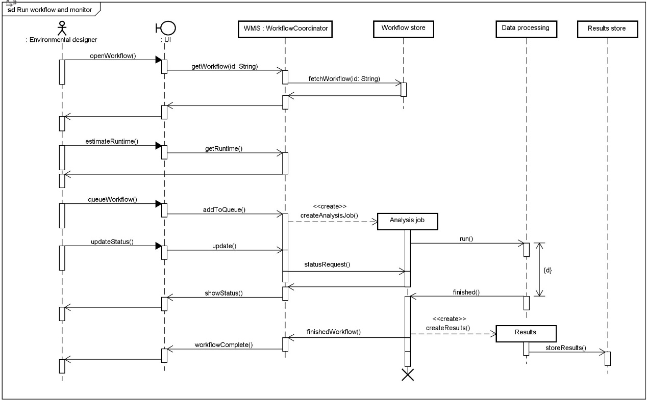

Figure 9. Sequence diagram for running and monitoring a workflow.

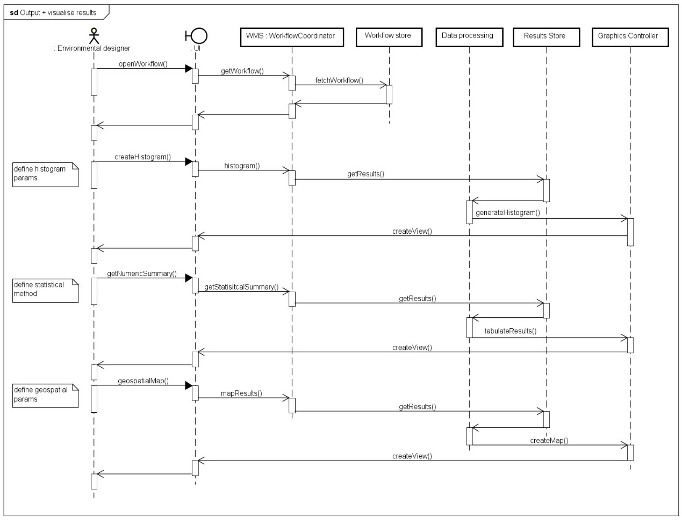

Figure 10. Sequence diagram for visualisation and output of results.

### Evaluation

The system is intended to produce recommendations for environmental design strategies based on the analysis of a set of weather data. The hypothesis to be tested is that design strategies can be linked with patterns discovered in weather data at various spatiotemporal scales and with different subsets of variables. It is proposed that this can be tested using a big data architecture that enables data analytics over large sets of weather data. Colombia is chosen for a test case as the tropical climate combined with the extreme topography and proximity to oceans.

Products of the system will be decomposed for evaluation; weather patterns will be assessed both quantitively and qualitatively and matching of recommended design strategies and the patterns evaluated qualitatively.

Several metrics exist to express the completeness and homogeneity of clusters discovered through analytics. Validity-measure or V-measure expresses how well both completeness and homogeneity are satisfied (Rosenberg and Hirschberg, 2007). Other metrics capture one or the other and include Purity, Entropy, Rand Index, misclassification index, f-measure, silhouette coefficient and cluster distortion of clusters can be calculated.

Delta-maps and self-organising maps can be quantitatively evaluated using average quantization errors and topographic errors (Liu, Weisberg and Mooers, 2006). Network metrics (Fountalis, Bracco and Dovrolis, 2014) such as link-maps represent edge strength between areas, strength of areas can be defined as the weighted sum of the number of links, network significance can be defined by s-core decomposition by progressively removing lower strength areas

For results of all analysis methods visual inspection of graphical output will play an important role in evaluation of the system. Including interactive graphical representations will allow dynamic exploration of spatiotemporal results. Use of correlation matrices, 2D scatter plots and plotting georeferenced zones on maps will amplify knowledge discovery and allow products of the artefact to be presented to domain experts. Qualitative evaluation of the artefact and the products (patterns and recommendations) will be undertaken by identifying very specific use cases and developing walkthroughs.

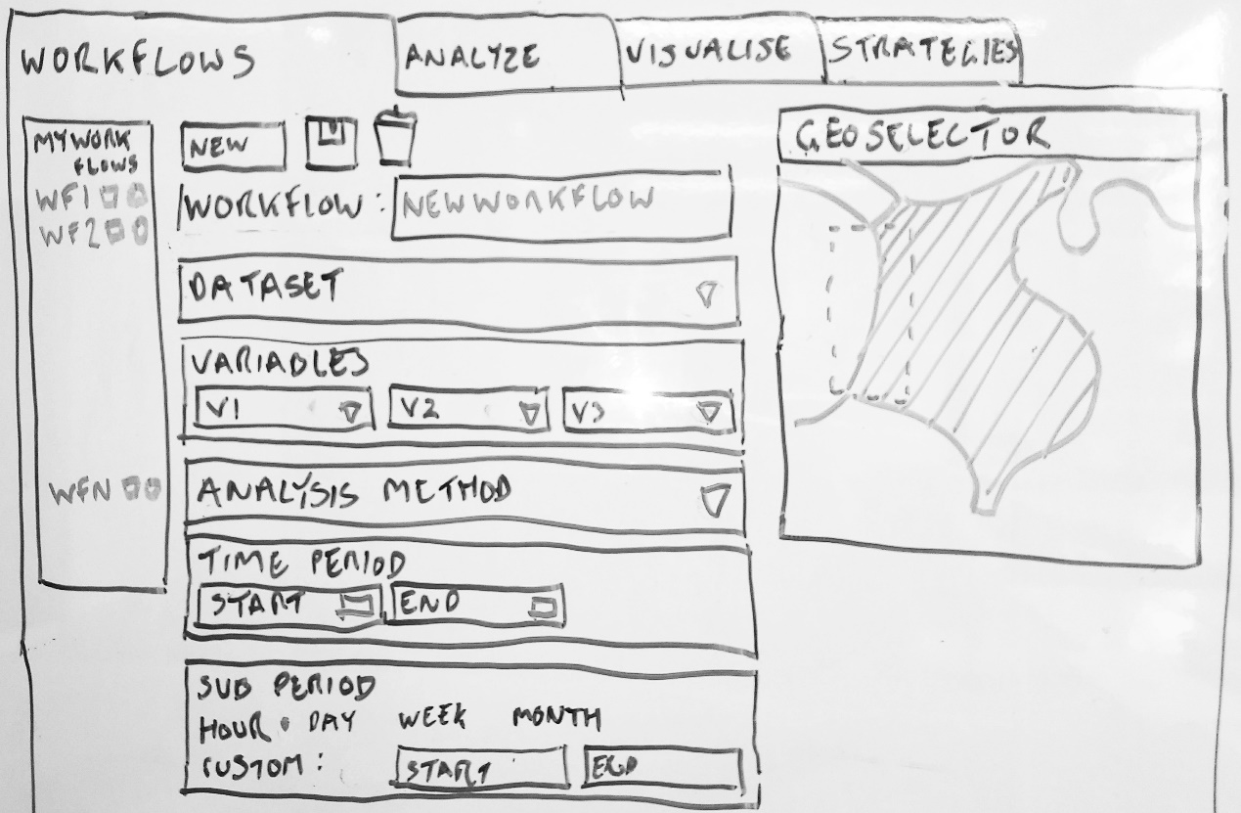

Figure 11. Sketched Interface design.

### Data structures

Document based noSQL storage will be used for initial prototypes, mongoDB and couchDB are potential candidates as they provide geospatial commands. Example documents for a weather station data and a weather record would look like:

|  |  |
| --- | --- |
| Weather station | Weather record |
| {  "_id": ObjectId("5acffd17ff5df66734f6464b"),  "stationCode": 20502345,  "stationName": "el dorado airport",  "latitude": 10.991427,  "longitiude": -74.063284,  "elevation": 345  } | {  "_id": ObjectId("7ff5df66734f6464b5acffd1"),  "stationCode": 20502345,  "time": ISODate("2005-08-31T14:40:00Z"),  "temperature": 24.5,  "relativeHumidity": 64.5,  "windDirection": 15,  "windSpeed": 2.4  } |

### Algorithms

The main algorithms for the proposed data analytics are SOMs, Delta-maps and clustering plus the methods for evaluating the results of these (discussed above).

**Statement of Deliverables:**   
Literature review

UML documentation of the system development process:

* Requirements list
* Use case diagrams
* Package diagrams
* Class, object and component diagrams
* Deployment diagram
* Sequence diagrams
* Test plans
* Test cases

Climate big data analytic system that enables knowledge-discovery.

Example recommendations for construction strategies given a geographical location and the associated weather data.

Visualisation of results / output.

Set of statistical test results of outputs from the application.

Analysis of results and system by domain expert(s).

Generalised, transferable description of system architecture.

***Plan****:   
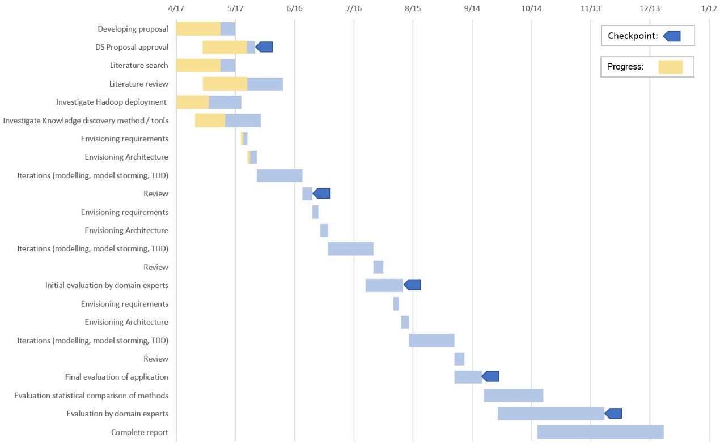*

*Figure 12. Gantt chart of proposed activities*

**References**

Ambler, S. W. (2004) *The object primer : agile modeling-driven development with UML 2.0*. Cambridge University Press.

ASHRAE (2013) *2013 ASHRAE Handbook: Fundamentals*, *ASHRAE*. doi: 10.1163/ej.9789004155947.i-937.23.

Atluri, G., Karpatne, A. and Kumar, V. (2017) ‘Spatio-Temporal Data Mining: A Survey of Problems and Methods’, *ACM Comput. Surv*, 1(1). doi: 10.1145/nnnnnnn.nnnnnnn.

Avci Salma, C., Tekinerdogan, B. and Athanasiadis, I. N. (2017) ‘Chapter 4 – Domain-Driven Design of Big Data Systems Based on a Reference Architecture’, in *Software Architecture for Big Data and the Cloud*, pp. 49–68. doi: 10.1016/B978-0-12-805467-3.00004-1.

Begoli, E. and Horey, J. (2012) ‘Design principles for effective knowledge discovery from big data’, in *Proceedings of the 2012 Joint Working Conference on Software Architecture and 6th European Conference on Software Architecture, WICSA/ECSA 2012*, pp. 215–218. doi: 10.1109/WICSA-ECSA.212.32.

Bracco, A. *et al.* (2017) ‘Advancing climate science with knowledge-discovery through data mining’, *npj Climate and Atmospheric Science*, 1(1), p. 4. doi: 10.1038/s41612-017-0006-4.

Cgiar-csi.org. (2012) *CRU-TS v3.10.01 Historic Climate Database for GIS | CGIAR-CSI.* Available at: http://www.cgiar-csi.org/data/uea-cru-ts-v3-10-01-historic-climate-database (Accessed: 5 November 2017).

Chouksey, P. and Chauhan, A. S. (2017) ‘Weather Data Analytics using MapReduce and Spark’, *International Journal of Advanced Research in Computer and Communication Engineering*, 6(2). doi: 10.17148/IJARCCE.2017.6210.

Dagade, V. *et al.* (2015) ‘Big Data Weather Analytics Using Hadoop’, *International Journal of Emerging Technology in Computer Science & Electronics*, 14(2), pp. 976–1353. Available at: https://pdfs.semanticscholar.org/f2e4/918444be9b30f29132e93ce02d29ccf26eda.pdf (Accessed: 29 May 2018).

Dimoudi, A. and Tompa, C. (2008) ‘Energy and environmental indicators related to construction of office buildings’, *Resources, Conservation and Recycling*, 53(1–2), pp. 86–95. doi: 10.1016/j.resconrec.2008.09.008.

Faghmous, J. H. and Kumar, V. (2014) ‘Spatio-temporal Data Mining for Climate Data: Advances, Challenges, and Opportunities’, in Chu, W. (ed.) *Springer Berlin Heidelberg*, pp. 83–116. doi: 10.1007/978-3-642-40837-3_3.

Fang, W. *et al.* (2014) ‘Meteorological data analysis using MapReduce.’, *The Scientific World Journal*, 2014, p. 646497. doi: 10.1155/2014/646497.

El Fazziki, A. *et al.* (2015) ‘A multi-agent framework for a hadoop based air quality decision support system’, in *CEUR Workshop Proceedings*, pp. 45–59.

Forsythe, N., Blenkinsop, S. and Fowler, H. J. (2015) ‘Exploring objective climate classification for the Himalayan arc and adjacent regions using gridded data sources’, *Earth System Dynamics*, 6(1), pp. 311–326. doi: 10.5194/esd-6-311-2015.

Fountalis, I., Bracco, A. and Dovrolis, C. (2014) ‘Spatio-temporal network analysis for studying climate patterns’, *Climate Dynamics*, 42(3–4), pp. 879–899. doi: 10.1007/s00382-013-1729-5.

Givoni, B. (1992) ‘Comfort, climate analysis and building design guidelines’, *Energy and Buildings*, 18, pp. 11–23. Available at: https://ac-els-cdn-com.liverpool.idm.oclc.org/037877889290047K/1-s2.0-037877889290047K-main.pdf?_tid=67644909-7d5e-4718-b47f-80732d024251&acdnat=1527603110_130b2a2e77cd97d48361202940532374 (Accessed: 29 May 2018).

Jain, H. and Jain, R. (2017) ‘Big data in weather forecasting: Applications and challenges’, in *2017 International Conference on Big Data Analytics and Computational Intelligence (ICBDAC)*. IEEE, pp. 138–142. doi: 10.1109/ICBDACI.2017.8070824.

Jayanthi, D. and Sumathi, G. (2017) ‘Weather data analysis using spark — An in-memory computing framework’, in *2017 Innovations in Power and Advanced Computing Technologies (i-PACT)*. IEEE, pp. 1–5. doi: 10.1109/IPACT.2017.8245142.

Jayaratne, M. *et al.* (2017) ‘Apache spark based distributed self-organizing map algorithm for sensor data analysis’, in *IECON 2017 - 43rd Annual Conference of the IEEE Industrial Electronics Society*, pp. 8343–8349. doi: 10.1109/IECON.2017.8217465.

Karpatne, A. *et al.* (2017) ‘Theory-Guided Data Science: A New Paradigm for Scientific Discovery from Data’, *IEEE Transactions on Knowledge and Data Engineering*, 29(10), pp. 2318–2331. doi: 10.1109/TKDE.2017.2720168.

Liu, Y. and Weisberg, R. H. (2005) ‘Patterns of ocean current variability on the West Florida Shelf using the self-organizing map’, *Journal of Geophysical Research: Oceans*, 110(6), pp. 1–12. doi: 10.1029/2004JC002786.

Liu, Y. and Weisberg, R. H. (2011) ‘A Review of Self-Organizing Map Applications in Meteorology and Oceanography’, in Igadwa Mwasiagi, J. (ed.) *Self Organizing Maps - Applications and Novel Algorithm Design*. www.intechopen.com. doi: 10.5772/13146.

Liu, Y., Weisberg, R. H. and Mooers, C. N. K. (2006) ‘Performance evaluation of the self-organizing map for feature extraction’, *Journal of Geophysical Research: Oceans*, 111(5). doi: 10.1029/2005JC003117.

Lopes, D., Palmer, K. and O’Sullivan, F. (2017) ‘Chapter 10 – Big Data: A Practitioners Perspective’, in *Software Architecture for Big Data and the Cloud*, pp. 167–179. doi: 10.1016/B978-0-12-805467-3.00010-7.

Manzano-Agugliaro, F. *et al.* (2015) ‘Review of bioclimatic architecture strategies for achieving thermal comfort’, *Renewable and Sustainable Energy Reviews*. Pergamon, 49, pp. 736–755. doi: 10.1016/J.RSER.2015.04.095.

Milne, M., Liggett, R. and Benson, A. (2009) ‘Climate Consultant 4.0 develops design guidelines for each unique climate’, *American Solar Energy Society Meeting*. Available at: http://www.energy-design-tools.aud.ucla.edu/papers/ases09-milne.pdf (Accessed: 10 April 2018).

Netzel, P. *et al.* (2016) ‘On Using a Clustering Approach for Global Climate Classification’, *Journal of Climate*, 29(9), pp. 3387–3401. doi: 10.1175/JCLI-D-15-0640.1.

NOAA (no date) *Land-Based Station Data | National Centers for Environmental Information (NCEI) formerly known as National Climatic Data Center (NCDC)*. Available at: https://www.ncdc.noaa.gov/data-access/land-based-station-data (Accessed: 5 June 2018).

Olgyay, V. and Olgyay, A. (2015) *Design With Climate: Bioclimatic Approach to Architectural Regionalism*. Princeton University Press.

Omer, A. M. (2008) ‘Energy, environment and sustainable development’, *Renewable and Sustainable Energy Reviews*, 12, pp. 2265–2300. doi: 10.1016/j.rser.2007.05.001.

Rodenburg, B. and Maria Fiore, M. (2017) *Detecting Weather Twins using Apache Spark*, *LSDE: Large Scale Data Engineering 2017*. Available at: https://event.cwi.nl/lsde/2017/showcase_n2.shtml (Accessed: 29 May 2018).

Rodriguez, M. A. and Buyya, R. (2017) ‘Chapter 18 – Scientific Workflow Management System for Clouds’, in *Software Architecture for Big Data and the Cloud*, pp. 367–387. doi: 10.1016/B978-0-12-805467-3.00018-1.

Rosenberg, A. and Hirschberg, J. (2007) ‘V-Measure: A conditional entropy-based external cluster evaluation measure’, pp. 410–420. Available at: http://www.aclweb.org/anthology/D07-1043 (Accessed: 6 June 2018).

Varghese, S. M. and Riyaz, P. . (2015) ‘Leveraging Map Reduce With Hadoop for Weather Data Analytics’, *IOSR Journal of Computer Engineering Ver. II*, 17(3), pp. 2278–661. doi: 10.9790/0661-17320612.

Wentz, F. . *et al.* (2015) *Remote Sensing Systems Cross-Calibrated Multi-Platform (CCMP) 6-hourly ocean vector wind analysis product on 0.25 deg grid, Version 2.0, [subset: CCMP V2.0 Level-3.5].* Santa Rosa, CA: Remote Sensing Systems. Available at: www.remss.com/measurements/ccmp (Accessed: 5 November 2017).