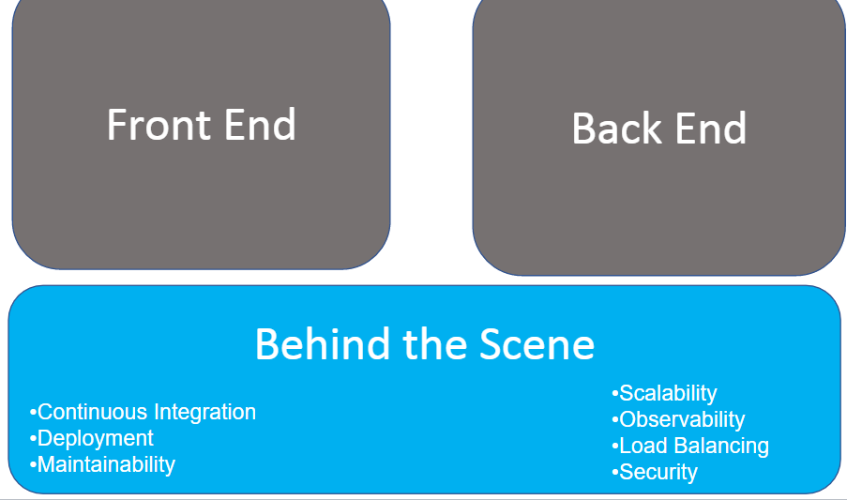
Make sure to cover all above bullet points

Software

Frontend
React has been chosen for the front-end framework, a JavaScript framework for building user interfaces. It is the most popular front-end framework used in services such as Twitter and Facebook. As it is the most popular, support for documentation is good, which is one of the major reasons that I chose this technology. Another major reason is that React is component based, and components can be reused to reduce repeated code. It is evident that there wlil be lots of reused components during development, when looking at the wireframe sketches for e-clinic (see below section). Components such as the message input box will be reused in multiple places, such as in the section for sending new messages or section for replying to existing messages. Another components that will be reused are the appointment cards for each upcoming appointment, and will be rendered with different ‘props’ passed to the component to render information for respective clients. Hence, this component functionality of React will aid with agile development, in that new ideas can be constantly integrated easily into the reusable component for far reaching effect.
For the backend, ASP.NET was chosen because of the above choice of using React. ASP.NET can be configured to function as

Backend
- No async calls to Mongodb needed since no calls to external services that are expensive
- Use record types for entities (value based equality support)

Behind the scenes
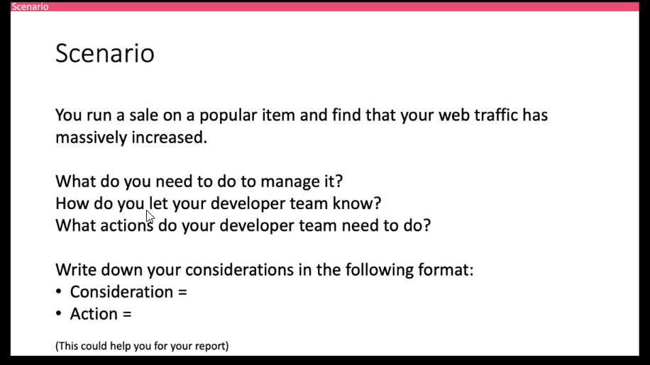

Scalability and observability

Communication solution (talk to devs)
Technical solution
Combination of above

Biblio
Redirect action not working
https://stackoverflow.com/questions/39459348/asp-net-core-web-api-no-route-matches-the-supplied-values

