Printshop Workflow Automation System
P.W.A.S

Deliverable #2 – Part I
System Design Document

Presented by:

Dulcardo Arteaga • Naveen Gowda • Larissa Guerrero
Erik Kessler • Lenny Markus • Javier Mesa • Rolando Vicaria

1. Introduction

1.1 Overview of the system
XYZ Printing Co. (Henceforth referred to as "the customer") is a printing company specializing in commercial gang runs (See 1.4 for a complete explanation on this). The customer is currently experiencing a surge in production, but finds itself frequently stumbling due to human caused errors. It was determined that most errors stem from their complicated order acceptance system, as well as decentralized and unorganized production workflow. The proposed system is meant to address these problems, allowing the customer to do more with the current resources that they have.

1.2 Purpose of the system
To facilitate and automate production for the customer. To provide a uniform interface for customer order submission, order tracking, employee workflow, and management activities that will enhance productivity and efficiency.

1.3 Design goals
Throughout development, it must be kept in mind by all teams that the main goal of this system is to make production more efficient for the customer. All design and development decisions must be centered around this goal. The system must be robust, reliable and intuitive for its users, so that all processes can be accomplished quickly. The interface must be clean, easy to understand, and convey all necessary information to the users. The project will be considered a success if the customer is able to speed up production to one business day on all orders.

1.4 Definitions, acronyms, and abbreviations
- PWAS: Printshoop Workflow Automation System. Name of the system.
- Client: Person placing an order with XYZ Printing co.
- Worker: Employee of XYZ Printing co. that can processes incoming orders at various stages of production
- Customer Service: Employee of XYZ Printing co. whose purpose is to assist Clients with order placement & tracking.
- Admin: Employee of XYZ Printing co. with access to all sections of the system, and is able to manage other users.
- Order: Refers to a job placed by a client.

1.5 References
It is recommended that all teams involved in the project read the following documents so that more familiarity with the problem domain is achieved:
- http://www.howstuffworks.com/offset-printing.htm
- http://en.wikipedia.org/wiki/Gang_run_printing

2. Current software architecture
Currently, there is no dedicated software in use by the customer. The current system consists of a number of procedures and non-connected systems that have been created ad-hoc to cope with a steady increase in production. Orders are accepted through e-mail, ftp, actual delivery of media, etc. Work is sorted and scheduled manually, and orders are assigned verbally. When job owners need to track an order, they must call the plant directly, and somebody must physically go to the production area to check the status of the order.

Direct comparison to other existing systems is not possible at this time, since similar systems are not available commercially (There are a few commercial systems, but none that could be found offers a comprehensive solution; instead they only focus on particular problems areas.) It is known that complete systems exist, but these are proprietary, and closely guarded trade secrets.

Our proposed system architecture arises from a thorough analysis of the customer's needs, and desired goals, rather than imitation of other programs and systems.

3. Proposed software architecture
The proposed system will implement a three-tiered architecture, separating interface, program logic and storage.

3.1 Overview
The interface to the system will be presented through a web browser. There will be no other way for users to interact with the system. The logic layer consist of the web server, which will be hosted in-house by the customer, it will process all calls from the interface, as well as storing and retrieving data on the storage layer. This last layer will consist of a Database Engine, and a wrapper class.

3.2 Subsystem decomposition
The PWAS system utilizes a traditional three-tier design, comprised of: the interface, application logic, and storage. In this case, the interface is the PWASWebClient, a standard web-browser, communicating with the PWASWebServer via http. The PWASWebServer is a standard web-server, driven by custom application logic. This PWASWebServer will use a storage system (realized by a database) to store persistent objects via ODBC.
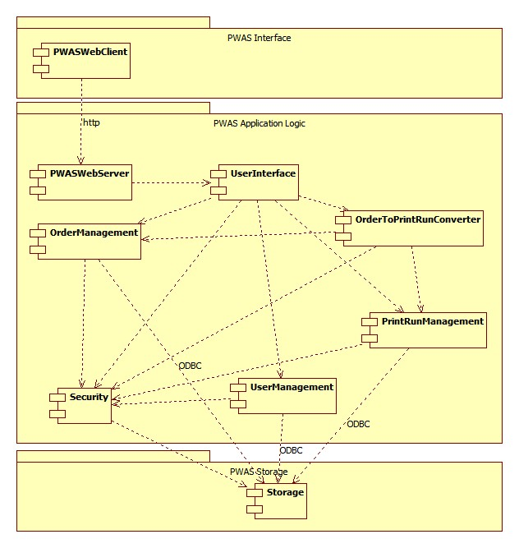
Figure 1 – Subsystem Decomposition for PWAS

PWAS Interface Tier:
PWASWebClient - The PWASWebClient is a Web browser, running on the end-user's machine. This provides the graphical interface between the user and the system. This subsystem communicates with the PWASWebServer subsystem, to receive html files, which it renders into a user-friendly graphical interface.
PWAS Application Logic Tier:
PWASWebServer - This subsystem is responsible for generating the web-page for each user request and contains the code to handle the multiple asynchronous network connections for each simultaneous customer connection. This subsystem communicates with the PWASWebClient and UserInterface subsystems to generate a html file (as directed by the UserInterface subsystem) and send it to the appropriate user over the network (an instance of the PWASWebClient subsystem).
UserInterface - This subsystem contains the layout and logical design of the website. It is the main 'driver' of the system, directing use of most other subsystems. For example, it communicates with the OrderManagement subsystem whenever a user needs to view or edit order information. Similarly, it communicates with the PrintRunManagement and UserManagement subsystems, to direct access to the PrintRun or User objects; additionally, it uses the OrderToPrintrunConverter to attach customer orders to a particular PrintRun. Finally, this subsystem communicates with the Security subsystem, in order to authenticate users and authorize their requests.
OrderManagement - This subsystem deals with all aspects of customer orders, such as viewing and editing order information. This subsystem is primarily used by the UserInterface subsystem, and communicates with the Security subsystem to authorize access to customer order objects.
OrderToPrintrunConverter - The OrderToPrintrunConverter is used by the UserInterface to attach one or more customer Orders to a PrintRun. It communicates with both the OrderManagement and PrintRunManagement subsystems to accomplish this task.
PrintRunManagement - This subsystem deals with all aspects of PrintRun objects, such as viewing and editing PrintRun information. This subsystem is primarily used by the UserInterface subsystem, and communicates with the Security subsystem to authorize access to PrintRun objects.
UserManagement - This subsystem deals with all aspects of User objects, such as viewing and editing User information. This subsystem is primarily used by the UserInterface subsystem, and communicates with the Security subsystem to authorize access to User objects.
Security - The Security subsystem has two primary functions: to authenticate users (by checking their username and password combination) and to authorize access to other subsystems. For example, the OrderManagement subsystem will call the Security subsystem whenever a request is made to edit a order. If that user's role allows them this access, the OrderManagement subsystem will make the update, otherwise, the update is denied.
PWAS Storage Tier:
Storage - The Storage subsystem is used by the OrderManagement, PrintRunManagement, UserManagement, and Security subsystems to manage persistent data objects. This subsystem can be used to retrieve, update, or add new persistent data objects, such as Users, Orders, or PrintRuns. The Security subsystem uses it to look up username and password combinations, and retrieve information about which user roles can access which functionality
3.3 Hardware/software mapping
There are three types of nodes that will host various components of the system: the ClientMachine, the WebServer and the Database. These nodes are one-to-one mappings of each tier in the traditional three-tier design, described in section 3.2.
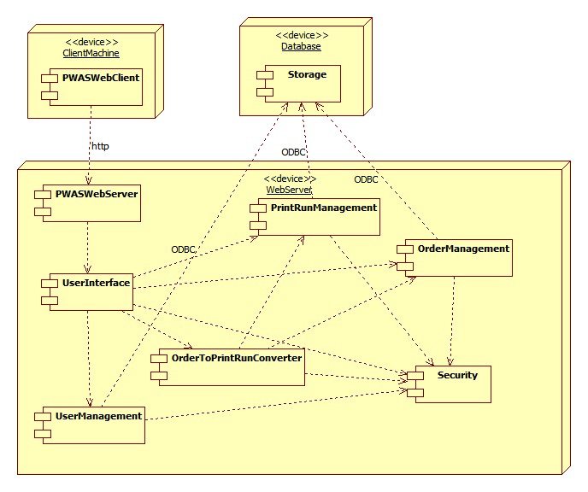
Figure 2 – Hardware to Software Mapping for PWAS
The ClientMachine hosts the PWASWebClient, which is a standard supported web-browser, such as Internet Explorer 8 or Firefox 3.5. Typically, this is a end-user's internet-connected personal computer or a company-owned PC that is being used by a worker. This is the physical embodiment of the PWAS interface tier.

The WebServer hosts several subsystems: PWASWebServer, UserInterface, OrderManagement, OrderToPrintrunConverter, PrintRunManagement, UserManagement and Security. Working in concert, as directed by the business logic in the UserInterface, these subsystems comprise the application logic tier. This machine is owned by the company and exists on a internal network. It communicates with the ClientMachine via http, and the Storage machine with ODBC.

The Database hosts the Storage subsystem. This node is independent of the WebServer, but may co-exist on the same machine. Its design-independence allows it to to be hosted elsewhere such as a separate virtual / physical machine, should the need arise.

3.4 Persistent data management
Storage Strategy:
The system will maintain its data using a Relational Database, which will be managed with a Database Management System (DBMS). The DBMS will take care of concurrency and synchronization issues regarding the accessibility of the persistent data.

Persistent Objects:
- Order : Will maintain all the information regarding an Order object
- User : Will maintain all the user information that's part of the user profile such as name, address, and billing information, shipping information, etc.
- Run : Stores all the information regarding a Run
- OrdersToRuns Association : Will maintain a relation between Orders and Runs, to associate each Run with the Orders that are part of that Run.
- Roles : Maintains a definition of Roles, as well as an id, and a description for those Roles.
- RolePermissions : Maintains an association between the roles, the objects that they can act upon, and the actions that can be applied to those objects.

3.5 Access control and security
Upon registration, each user is assigned a role type by the System Administrator. These roles are defined by the Administrator along with the privileges that members of this role type have for system objects. The roles and their respective permissions are stored in the database.

There are four basic role types that are defined by default. These are: Customer, Customer Service, Worker, and Administrator. The objects for which permissions are defined include: Users, Orders, Print Runs, and Roles. The access matrix below summarizes the default actions that each of the role types are authorized to perform on each of the system objects.

Object  Actor | User | Order | Run | Roles
Customer | <<create>>  Edit profile | <<create>>  Pay  Track
Customer Service | <<create>>  Edit profile | <<create>>  Pay  Track
Worker | <<create>>  Edit profile | Add to run  Update status  View | <<create>>  Edit  Update status
Administrator | <<create>>  Edit profile  Manage users | Manage orders |  | <<create>>  Edit permissions

Figure 3 – Access Matric for PWAS

As part of the registration process, users will be required to provide a user name and password which will serve for future authentication to the system. All data transmissions will be carried over a secure HTTPS connection to ensure the privacy of personal customer information, such as profile information and order information.

The controls and buttons that a user sees on the interface are subject to the user's access authorization. A user is not presented with controls or options that are beyond their access scope. In addition to this, all actions are authorized again at time of execution to ensure that users are not trying to access views or controls outside of their access scope.

The following is a more detailed explanation of the roles and role permissions of PWAS:

Role Ids:
1 - customer
2 - customer service
3 - worker
4 - administrator
Permissions:
0 - no access
1 - own
2 - all

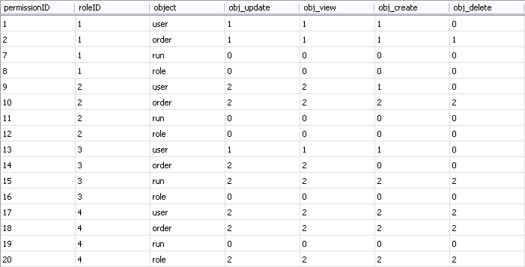
Figure 4 – Roles and Role Permissions for PWAS

3.6 Global software control
The internal control flow of PWAS is event-driven. This is because the web server objects wait for requests from the web browser. When a request is received, the web server processes it and dispatches it to the appropriate page controller. We use page controllers to realize the boundary and control objects of PWAS. A preprocessor then generates views from the different page controllers. These controllers then invoke methods on entity objects and storage objects to allow for the functionality of our system.

3.7 Boundary conditions
The starting, shutdown and installing of the PWAS define the boundary conditions.

Installing: Since PWAS is a web-based application, it does not need explicit installation execution. Instead PWAS files need to be copied to the WebServer.

Starting: The Administrator starts up the WebServer service making the PWAS system available to customers/workers. At this point the customers can connect to PWAS system by opening a web browser with PWAS web page address.

Shutdown: The Administrator shuts down the WebServer's service.

Exception Handling: System maintenance will be done on weekends, between 12am and 7am, occurring less than twice per month and during this period the WebServer services will be shut down.

4. Subsystem services

UserManagement Subsystem: This subsystem is responsible for managing different users of the system by taking care of the login information of different users. It provides functions for Register, Log in and Edit accounts. It manages the usernames and passwords of all users of the system for security purposes. This subsystem uses the services of storage subsystem to store and retrieve login information. System administrator and all users of the system communicate with this subsystem.

The operations provided by this subsystem are:
· Register
· Login / Logout
· Edit Profile

OrderManagement Subsystem: This subsystem is responsible for managing orders. It provides functions for Creating, Editing and Saving an Order. The customer can create and save an order. The Administrator has the option of editing the Order information before it is submitted to Printing. This subsystem uses services of User Interface and the Security subsystem to authorize access to editing orders for the User.

The operations provided by this subsystem are:
· Create Order
· Edit Order
· Save Order

OrdertoPrintRunConverter Subsystem: This subsystem is responsible for adding the customer orders to the PrintRun. It provides functions for adding the paid customer orders to the PrintRun. This subsystem uses the services of OrderManagement and PrintRunManagement to execute the task.

The operations provided by this subsystem are:
· AddOrder to PrintRun

PrintRunManagement Subsystem: This subsystem is responsible for managing PrintRun. It provides functions for creating and editing PrintRun. This subsystem uses the services of User Interface and Security subsystem to authorize access to the User.

The operations provided by this subsystem are:
· Create Run
· Edit Run

Security Subsystem: This subsystem has two primary functions: to authenticate users (by checking their username and password combination) and to authorize access to other subsystems.

The operations provided by this subsystem are:
· Authenticate
· Authorize

5. Glossary
- Administrator: A member of the company, who has all the rights of a regular Employee plus other administrative rights such as deleting a user, editing a user's information, etc.
- Customer: A client of the company, who can submit orders for printing, pay those orders, and track the orders as well.
- Company: Specifically, XYZ Printing Co.
- Customer Service: A member of the company who can take an order on behalf of a customer – to act as a proxy for an offline customer.
- Employee: A member of the company, who has all the rights of any User plus other rights such as process customer orders, create print runs, etc.
- Finishing: The part of the company workflow where the cutting and resizing process is taking place.
- Order: A User can create an order and save it into the system, which contains specifications regarding printing details, a file to be printed, and payment information.
- Portal: Web-based interface presented to customer and employees.
- Printing: The part of the company workflow where the print-manufacturing process is taking place.
- Print Run: A single file created by an employee, which is sent to printing.
- System: PWAS is considered the system, and it entails all the software that takes care of the workflow management.

