Assignment 2
DeFi Protocol Development
Ramazan Seilbekov, SE-2412
Part 1 – Advanced Testing with Foundry
Task 1: Foundry Project Setup and Testing

In this task, a full Foundry project was initialized with the standard structure including src, test, and script directories. A custom ERC20 token contract was implemented to support minting, transferring, and approval mechanisms.
A comprehensive test suite was developed. Unit tests were written to validate core ERC20 functionality such as mint, transfer, approve, and transferFrom. Edge cases such as insufficient balance and allowance limits were also tested.
Forge test
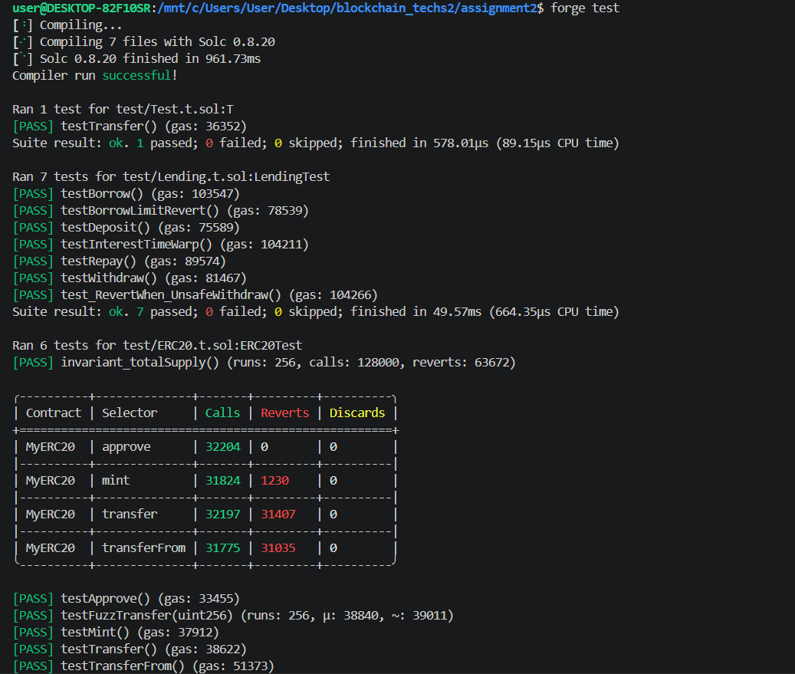
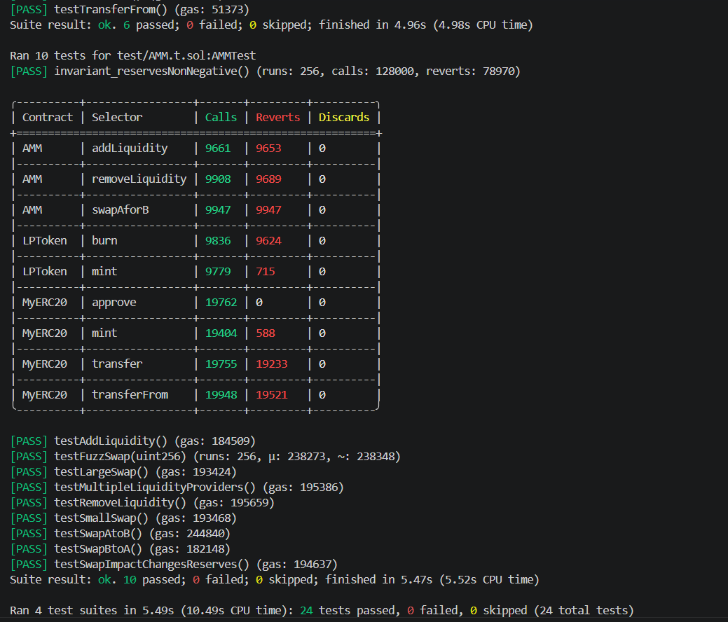

Fuzz testing was implemented for the transfer function, allowing the framework to automatically generate random inputs and validate contract behavior under unpredictable conditions. This improves robustness and helps identify hidden bugs.
Invariant testing was added to ensure critical properties of the system always hold. For example, total supply consistency and balance constraints were verified across multiple random executions.
Forge coverage
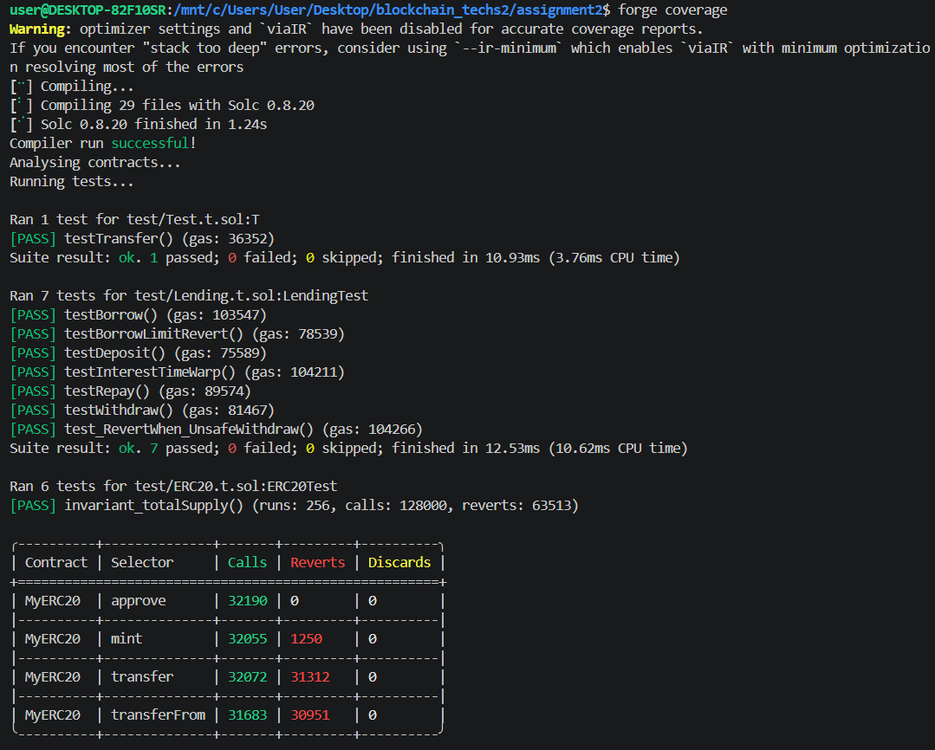
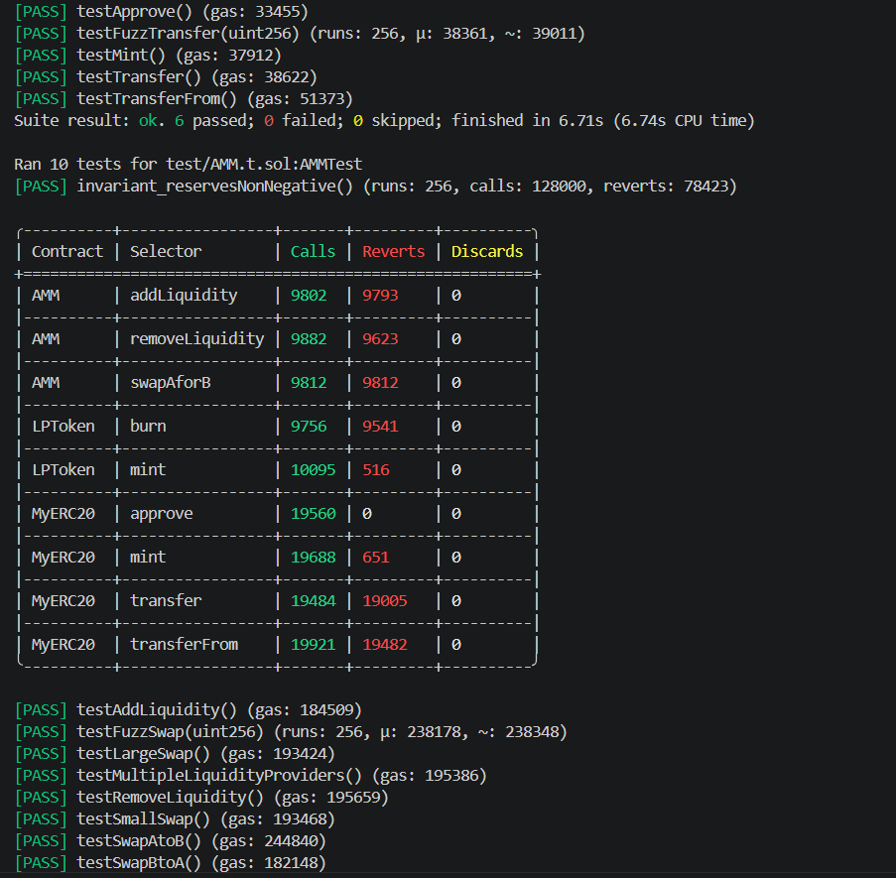
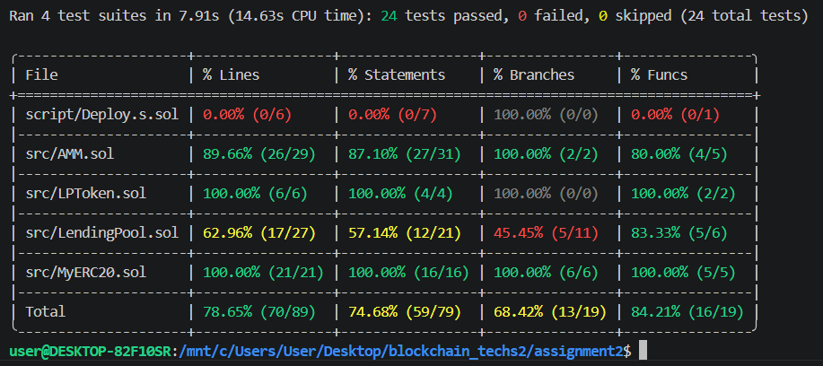

Test coverage was measured using forge coverage, ensuring that most of the contract logic is exercised by tests.
Fuzz testing is useful for exploring unexpected inputs and edge cases, while unit testing is more precise and focuses on known scenarios. Both approaches complement each other and are essential for secure smart contract development.

Task 2: Fork Testing Against Mainnet
Fork testing was implemented using Foundry’s ability to simulate a local copy of the Ethereum mainnet. This allows interaction with real deployed contracts in a controlled environment.
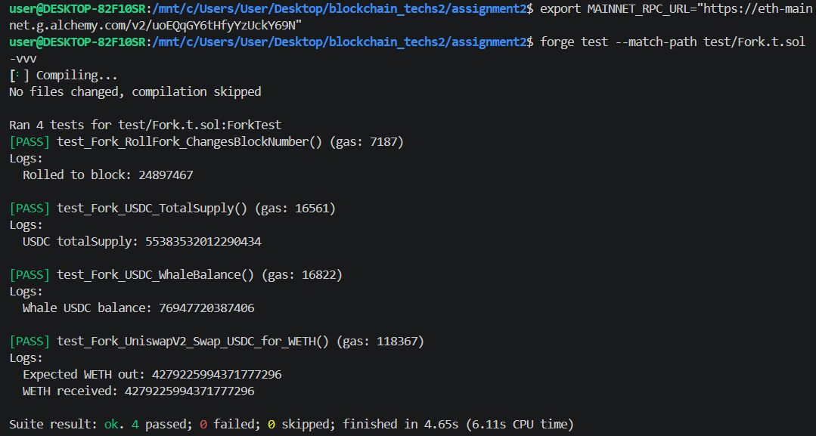
A test was written to read the total supply from the USDC contract, demonstrating how real on-chain data can be accessed. Another test simulated a swap using a Uniswap V2 router contract, verifying integration with an existing DeFi protocol.
Fork testing provides realistic testing conditions and allows developers to validate integrations without deploying to mainnet. However, it depends on external state and may introduce non-determinism if not carefully controlled.

Part 2 – AMM Development
Task 3: Constant Product AMM
A fully functional Automated Market Maker was implemented based on the constant product formula x multiplied by y equals k.
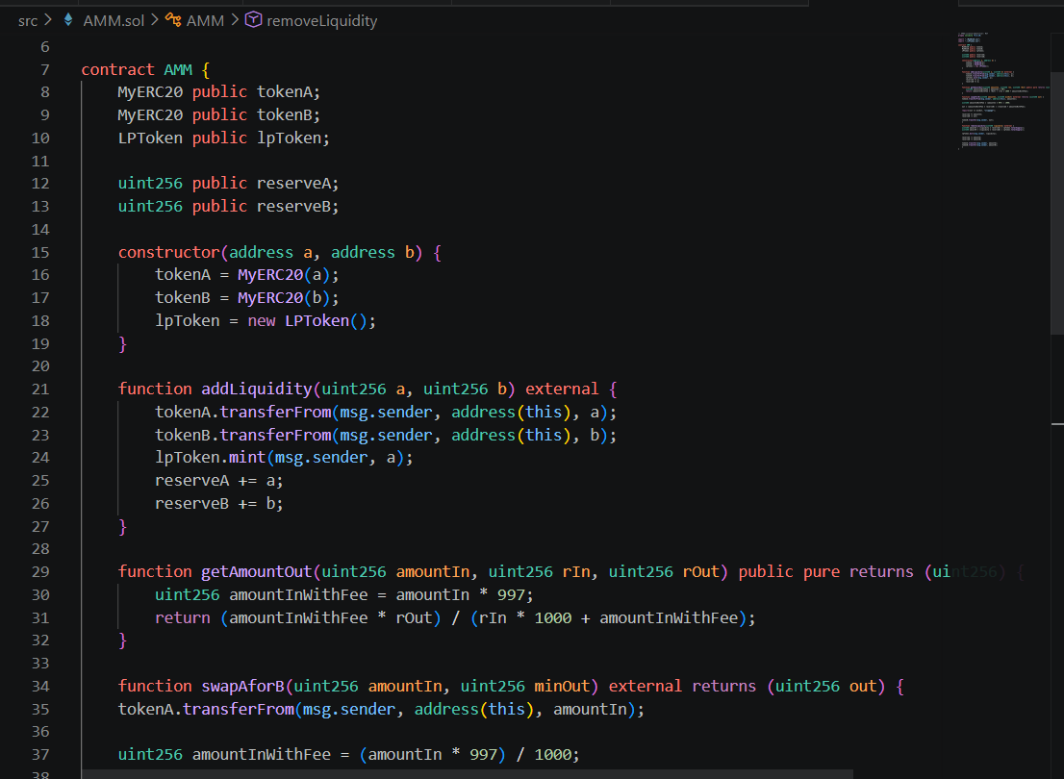
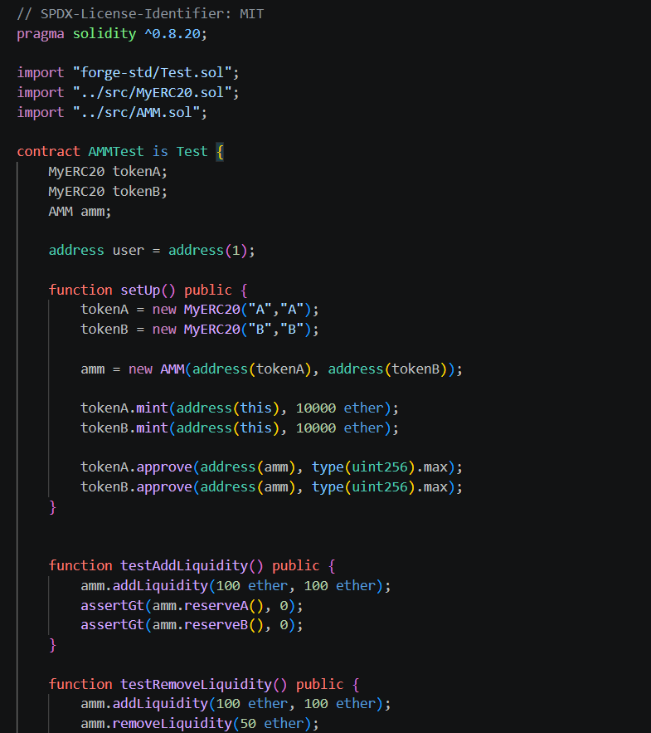
The contract supports liquidity provision through addLiquidity, where users deposit two tokens and receive LP tokens. The removeLiquidity function allows users to burn LP tokens and withdraw their share of the pool.The swap function enables token exchange with a 0.3 percent fee applied. The getAmountOut logic ensures that the constant product invariant is preserved while calculating output amounts.
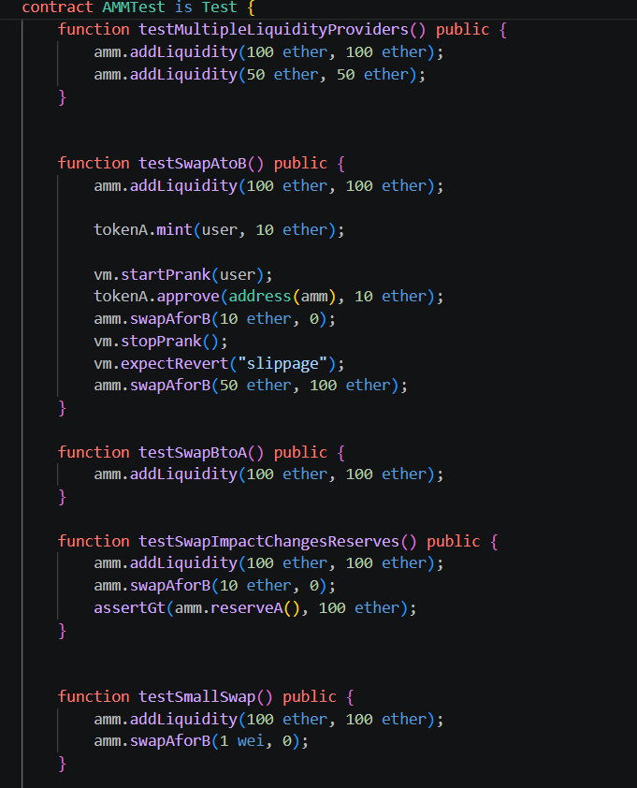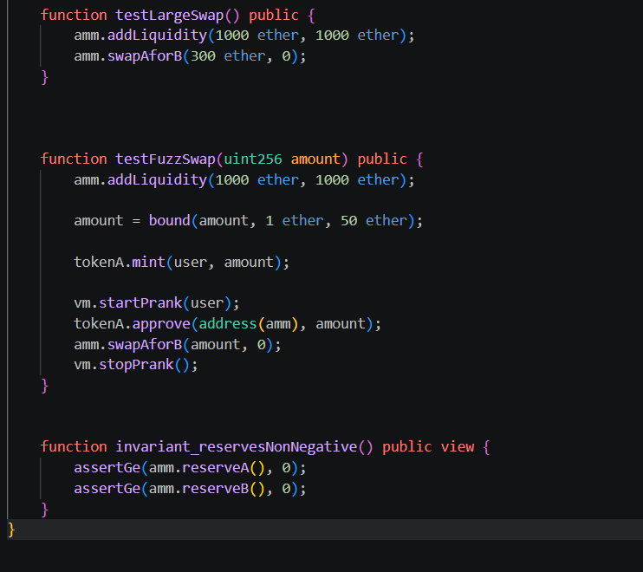
A complete test suite was developed, covering liquidity operations, swaps in both directions, slippage protection, and edge cases such as zero input and large trades. Fuzz testing was also applied to the swap function.
Gas usage was measured for all core operations to evaluate efficiency.

Task 4: AMM Mathematical Analysis
The constant product formula ensures that the product of reserves remains constant after each trade. This creates a self-balancing pricing mechanism where prices adjust based on supply and demand.
The 0.3 percent fee increases the invariant k over time, meaning liquidity providers benefit from accumulated fees. “x * y = k invariant”.
Impermanent loss occurs when the price of tokens changes relative to their initial ratio. For a two times price change, the loss can be calculated using the standard impermanent loss formula, showing that liquidity providers may earn less than simply holding assets.
Price impact depends on trade size relative to pool reserves. Larger trades significantly shift the price due to the curve defined by the constant product.
Compared to Uniswap V2, the implementation lacks advanced features such as oracle support, flash swaps, and optimized gas efficiency. However, it captures the core AMM mechanics.

Part 3 – Lending Protocol Simulation
Task 5: Lending Pool
A simplified lending protocol was implemented. Users can deposit tokens as collateral and borrow against them with a maximum loan to value ratio of 75 percent.
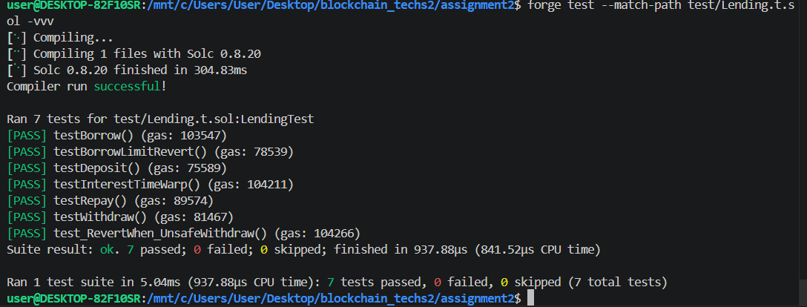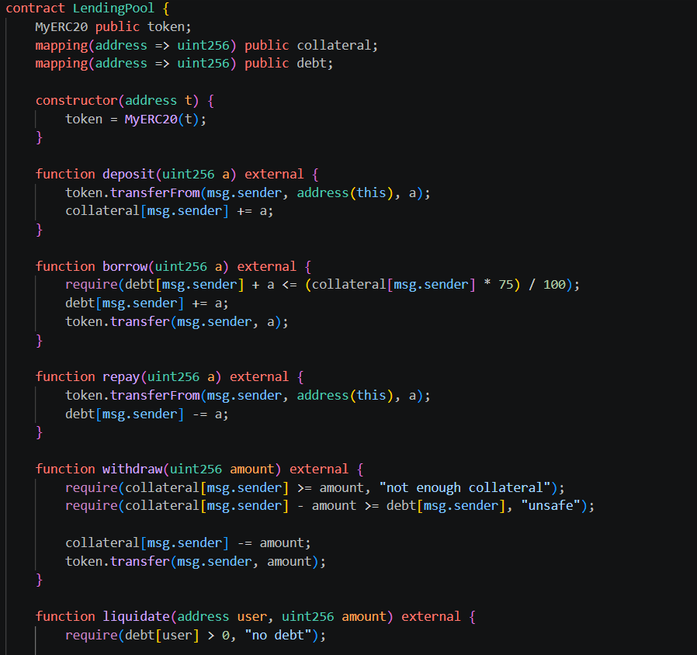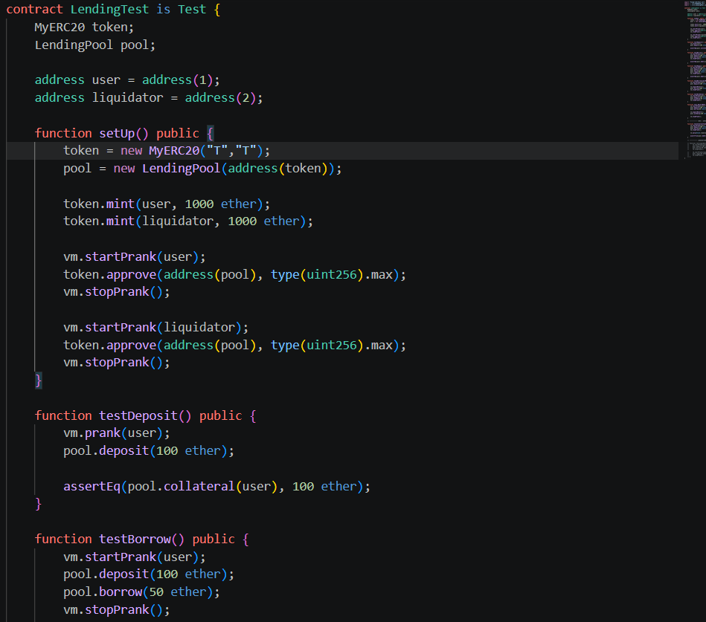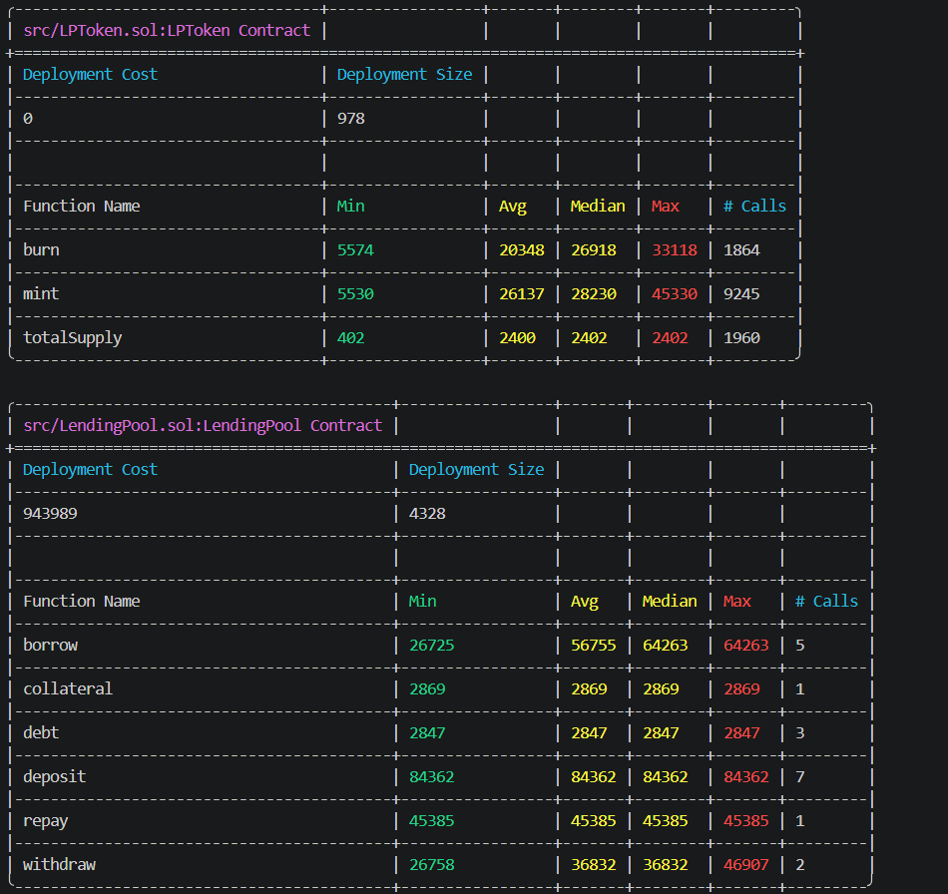
The contract includes functions for deposit, borrow, repay, withdraw, and liquidate. User positions are tracked through mappings that store collateral and debt balances.
A basic interest model was implemented, and time-based behavior was simulated using vm.warp in tests.
Liquidation allows third parties to repay debt and receive collateral if a position becomes unsafe.
Tests cover all major scenarios including borrowing limits, repayments, liquidation conditions, and edge cases such as insufficient collateral.
Part 4 – CI/CD Pipeline
Task 6: GitHub Actions
A CI pipeline was implemented using GitHub Actions. The workflow installs Foundry, compiles contracts, runs tests, and generates gas reports automatically.
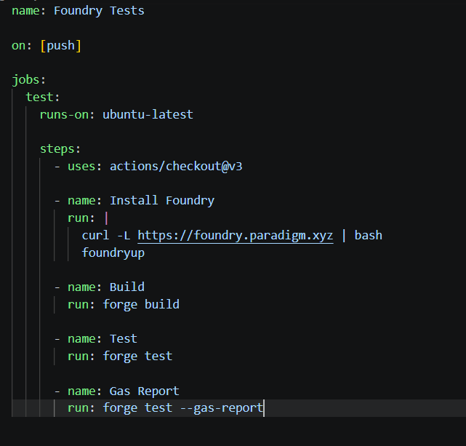
A Slither analysis step was added to perform static security analysis and detect potential vulnerabilities.
The pipeline ensures that all code changes are validated before integration, improving reliability and security.

Conclusion
This project demonstrates the development of core DeFi components including an ERC20 token, an Automated Market Maker, and a lending protocol. Advanced testing techniques such as fuzzing, invariants, and fork testing were applied to ensure correctness and robustness.
The system replicates fundamental mechanisms used in real-world protocols such as Uniswap and lending platforms, providing a strong foundation in smart contract development and DeFi architecture.

