INFS7205: Spatial and Multimedia Databases
Assignment 2 Report
Component 2

23 May 2012

Group 5:

Student Name | Student Number
Andres Felipe Aguirre Quintero | 42703271
Abdullah M. Albarrak | 42753249
Mochamad Ndaru Purnomo Sidi | 42789770
Romaan Khadeer Ahmed | 42794550

Contents

- Environment Setup
- Introduction to SQL Server 2012 Spatial
- Defining Tables
- Inserting Data into Tables
  - Inserting data into "LandBlock"
  - Inserting data into "FuelLoadRegion"
- Index Creation
- Query Execution
- Query Execution Plan
- Map Viewer
- Solutions to Assignment 2
  - Creating Tables:
  - Inserting data into "LandBlock"
  - Inserting data into "FuelLoadRegion"
  - Create spatial index on the attribute GEOMETRY data type to describe the spatial object
  - Answer the following on attribute GEOMETERY in each table using SPATIAL queries:
  - a. Retrieve all regions in LandBlock and FuelLoadRegion
  - b. Find the area size for each region in LandBlock and FuelLoadRegion
  - c. Find all regions of fuel load higher than 30 units
  - d. Find all land blocks which have some region containing fuel load of 30 units or higher
  - e. Find all land blocks within 11 km of the area containing fuel load over 70 units.
- References

Environment Setup

The following are the software and hardware requirements for developing the solution of assignment 1:
- DBMS: SQL Server 2012 Express Edition
- Operating System: Windows 7 Service Pack 1, Windows Server 2008 R2, Windows Server 2008 Server Pack 2, Windows Vista Service Pack 2
- 32 - bit systems: Computer with Intel or compatible 1GHz or faster processor (2 GHz or faster is recommended.)
- Minimum of 512 MB of RAM (2 GB or more is recommended.)
- 2.2 GB of available hard disk space

Introduction to SQL Server 2012 Spatial
SQL Server 2012 is the Microsoft's latest cloud ready information platform [2]. Microsoft included support for spatial data since the release of the product SQL Server 2008. There are two types of spatial data [3]:
- Geometry
- Geography
We use only "GEOMETRY" data type for develop solutions in our assignment. SQL Server supports the geography data type, which stores ellipsoidal (round-earth) data, such as GPS latitude and longitude coordinates. But we do not require this in our assignment. Figure [3] depicts the geometry hierarchy. The spatial types of geometry and geography are indicated in blue.

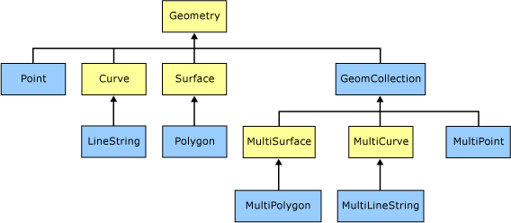

Follows is a screenshot for Microsoft SQL Server Management Studio that simplifies the way of interaction with the databases.

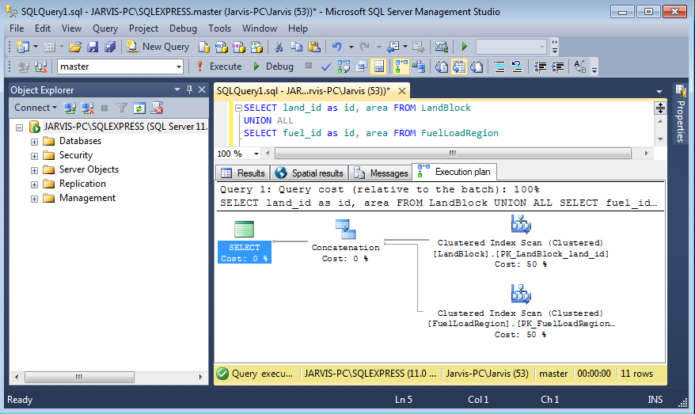

Defining Tables

We create the following tables:

CREATE TABLE LandBlock(
land_id varchar(2),
area geometry,
CONSTRAINT PK_LandBlock_land_id PRIMARY KEY CLUSTERED (land_id)
);

CREATE TABLE FuelLoadRegion (
fuel_id varchar(2),
area geometry,
fuel_load int CHECK (fuel_load >= 0 and fuel_load <= 100),
CONSTRAINT PK_FuelLoadRegion_fuel_id PRIMARY KEY CLUSTERED (fuel_id)
);

The first table defines the LandBlock. It has the following attributes:
- land_id - Uniquely identifies a land block and contains a two character string. Hence the datatype is varchar(2). Also it is made PRIMARY KEY so that it uniquely identifies the record, ensures the value is not null and also satisfies the constraint of having primary key for creating indexes, which we will see below
- area - Includes the points to be stored for a unique land block. Hence the spatial data type is geometry.

The second table defines the FuelLoadRegion. It has the following attributes:
- fuel_id - Uniquely identifies a fuel load block and just like land_id, this also is named using two character string. Hence it is also declared as varchar(2) datatype. It is made PRIMARY KEY to help index on FuelLoadRegion table
- area - Includes the points to be stored for a unique fuel load block. It contains the spatial data with co-ordinate points, hence it is declared of type "geometry"
- fuel_load - Indicates the amount of combustible fuel in integer units between 0 and 100. Hence is declared as integer and the constraint is specified to accept values only between 0 and 100.

Inserting Data into Tables

The data is inserted into the two tables by executing the below SQL statements:

Inserting data into "LandBlock"

INSERT INTO LandBlock(land_id, area)
VALUES ('L1',geometry::STGeomFromText('POLYGON ((0 22, 0 29, 15 22, 0 22))', 0));

INSERT INTO LandBlock(land_id, area)
VALUES ('L2',geometry::STGeomFromText('CURVEPOLYGON(CIRCULARSTRING(3 17, 6 20, 9 17, 6 14, 3 17))', 0));

INSERT INTO LandBlock(land_id, area)
VALUES ('L3',geometry::STGeomFromText('POLYGON ((17 17, 20 17, 22 14, 22 19, 25 11, 17 12, 17 17))', 0));

INSERT INTO LandBlock(land_id, area)
VALUES ('L4',geometry::STGeomFromText('POLYGON ((15 27,25 27, 25 22, 15 22, 15 27))',0));

INSERT INTO LandBlock(land_id, area)
VALUES ('L5',geometry::STGeomFromText('POLYGON ((7 14, 17 14, 17 9, 7 9, 7 14))',0));

INSERT INTO LandBlock(land_id, area)
VALUES ('L6',geometry::STGeomFromText('POLYGON ((1 7, 1 12, 7 12, 7 7, 1 7))',0));

INSERT INTO LandBlock(land_id, area)
VALUES ('L7',geometry::STGeomFromText('POLYGON ((8 7, 14 7, 12.5 0, 8 7))',0));

Inserting data into "FuelLoadRegion"

INSERT INTO FuelLoadRegion (fuel_id, area, fuel_load)
VALUES ('F1', geometry::STGeomFromText('POLYGON((3 29, 13 29, 13 23, 9 23,9 26, 3 26, 3 29))',0), 70);

INSERT INTO FuelLoadRegion (fuel_id, area, fuel_load)
VALUES ('F2', geometry::STGeomFromText('POLYGON((3 25, 5 21, 5 18, 2 18, 2 21, 1 21, 3 25))',0), 20);

INSERT INTO FuelLoadRegion (fuel_id, area, fuel_load)
VALUES ('F3', geometry::STGeomFromText('POLYGON((15 10, 20 10, 20 8, 24 8, 24 6, 29 6, 29 5, 20 5, 20 4, 18 4, 18 8, 15 8, 15 10))',0), 35);

INSERT INTO FuelLoadRegion (fuel_id, area, fuel_load)
VALUES ('F4', geometry::STGeomFromText('CURVEPOLYGON(COMPOUNDCURVE(CIRCULARSTRING(17 23,17.5 22.04, 18.5 21.47),CIRCULARSTRING(18.5 21.47,21 21.04, 22 21),CIRCULARSTRING(22 21,23 21.04, 25.5 21.47),CIRCULARSTRING(25.5 21.47,26.5 22.04, 27 23),CIRCULARSTRING(27 23,26.5 23.96, 25.5 24.53),CIRCULARSTRING(25.5 24.53,23 24.96, 22 25),CIRCULARSTRING(22 25,21 24.96, 18.5 24.53),CIRCULARSTRING(18.5 24.53,17.5 23.96, 17 23)))',0), 40);

The insert operation is used to insert data into the tables. The method "geometry::STGeomFromText" returns a geometry instance from an Open Geospatial Consortium (OGC) Well-Known Text (WKT) representation.[4]

Syntax:
STGeomFromText ( 'geometry_tagged_text' , SRID )
Arguments:
- geometry_tagged_text
Is the WKT representation of the geometry instance you wish to return. geometry_tagged_text is an nvarchar(max) expression.
- SRID
Is an int expression representing the spatial reference ID (SRID) of the geometry instance you wish to return.

The following 'geometry_tagged_text' can be defined:

- Point
- LineString
- CircularString
- CompoundCurve
- Polygon
- CurvePolygon

Collection types include:

- MultiPoint
- MultiLineString
- MultiPolygon
- GeometryCollection

We have used "Polygon" to create all the shapes but ellipse and circle. Ellipse and circle is created using 'CURVEPOLYGON' and ' CIRCULARSTRING' as there is no direct support by SQL Server 2012 to implement a ellipse or circle.

Polygon instances are instances that can be stored in a geometry or geography variable without throwing an exception. The following are accepted Polygon instances[5]:
- An Empty Polygon instance
- A Polygon instance that has an acceptable exterior ring and zero or more acceptable interior rings

The following criteria are needed for a ring to be acceptable.
- The LineString instance must be accepted.
- The LineString instance must have at least four points.
- The starting and ending points of the LineString instance must be the same.

'POLYGON((1 1, 3 3, 3 1, 1 1))';

Circular strings are the basic curve subtype, corresponding to a LineString for linear data. Three points are used to define a segment with the start (first point) and end (third point) points and another point (second point) anywhere along the circular arc. Circular strings can be linked together where the last point of the previous curve becomes the first point of the next curve. Valid circular strings will always

CIRCULARSTRING(0 -23.43778, 0 0, 0 23.43778);

CURVEPOLYGON is a topologically closed surface defined by an exterior bounding ring and zero or more interior rings These polygons are similar to polygons, having at least one ring and zero or more holes (inner rings). Curve polygons are composed of linear strings, circular strings, and/or compound curves. Within a given ring, the first point as defined in a curve polygon component must be identical to the last point in a curve polygon component, just like standard polygon rings[6].

STGeomFromText('CURVEPOLYGON(COMPOUNDCURVE(CIRCULARSTRING(17 23,17.5 22.04, 18.5 21.47),CIRCULARSTRING(18.5 21.47,21 21.04, 22 21),CIRCULARSTRING(22 21,23 21.04, 25.5 21.47),CIRCULARSTRING(25.5 21.47,26.5 22.04, 27 23),CIRCULARSTRING(27 23,26.5 23.96, 25.5 24.53),CIRCULARSTRING(25.5 24.53,23 24.96, 22 25),CIRCULARSTRING(22 25,21 24.96, 18.5 24.53),CIRCULARSTRING(18.5 24.53,17.5 23.96, 17 23)))' ·

Index Creation

We can create the spatial indexes on both tables using the following statements:
CREATE SPATIAL INDEX FuelLandBlock_Index
ON FuelLoadRegion(area)
USING GEOMETRY_GRID
WITH
(
BOUNDING_BOX = ( 0, 0, 30, 30),
GRIDS=(LEVEL_1 = LOW,LEVEL_2 = LOW,LEVEL_3 = LOW,LEVEL_4 = LOW),
CELLS_PER_OBJECT = 16
);

CREATE SPATIAL INDEX LandBlock_Index
ON LandBlock(area)
USING GEOMETRY_GRID
WITH
(
BOUNDING_BOX = ( 0, 0, 30, 30),
GRIDS=(LEVEL_1 = LOW,LEVEL_2 = LOW,LEVEL_3 = LOW,LEVEL_4 = LOW),
CELLS_PER_OBJECT = 16
);

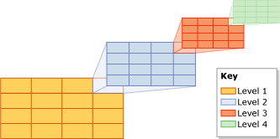

The spatial indexes on SQL Server decompose the space in four levels and use a B-tree to store them.
The first parameter we set, BOUNDING BOX limits the space we are working with so we have to set it to a box that can contain all the objects, the elements outside the BOUNDING BOX won't be indexed. The GRID LEVEL specifies the density of the grid, in LOW level it will split each cell into a 4X4 grid, and the CELLS_PER_OBJECT property establish the maximum number of cells that tessellation can count per object. All parameters can be omitted and they will take the default values, the only exception is the bounding box that needs to be defined explicitly.

When a spatial index is created, it first performs the refactoring of space. It then performs a tessellation process, whereby it fits the space represented by the data into the previously created grid hierarchy without gaps or overlaps. The tessellation process is governed by three rules:
The covering rule | If an object completely covers a cell and overlaps into other cells then the cell is recorded in the index and no other attempt is made to maneuver other objects against that cell
The cells-per-object rule | A limit on the number of objects that tessellation can occur within a given cell. This limitation is enforced in all levels except for Level One and can be customized when creating the index (the maximum values is 8192)
The deepest-cell rule | This rule takes advantage of the hierarchical model mentioned earlier by recording only the information required in the deepest cell

After creating the indexes you have to specify which index will you use in your query (this is because you can have more than 1 index on the same column, each one with different resolutions and density), the way to indicate the index is using WITH(INDEX(name)), for example:
SELECT *
FROM SpatialObject WITH(INDEX(Spatial_Index))
WHERE … (any condition that involves distance, intersection, overlap, or a spatial operation).

In our case the performance of the queries with or without the index is similar. The indexed one is a bit slower because the number of polygons in the table is really low (7 and 4) then the hashing and the tessellation takes even more time than the linear search, in bigger datasets we can see the better performance of the indexes over the non-indexed query.

Query Execution
The traditional SQL syntax for selecting non-spatial records is used to retrieve spatial objects too. The results could be seen as a table or in a map via SQL Server Map Viewer. The following is a simple example for retrieving all land blocks in a table. Note that the land_block items are stored as spatial objects (geometry) in table LandBlocks:
select land_black from LandBlocks;

The output is something similar to this:
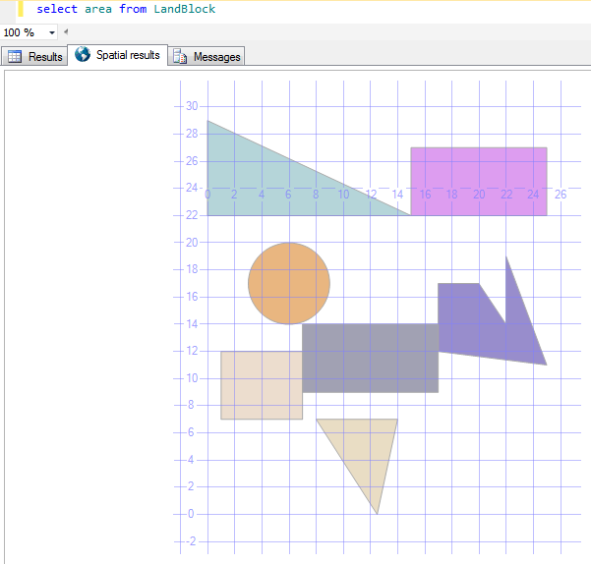
Furthermore, MS SQL Server provides standard spatial operations which make retrieving spatial records more powerful. All these operations start with the keyword “ST” followed by the actual function and the inputs. In following table, the most common spatial operations are shown [8].

No. | Spatial Operation | Syntax | Returned value
1 | STIntersects: Checks if the calling geometry intersects with another geometry | STIntersects( geometry ) | Returns 1 if true, else returns 0
2 | STContains: Checks if the calling geometry contains another geometry | STContains( geometry ) | Returns 1 if true, else returns 0
3 | STArea: returns the area of the calling geometry. | STArea() | Returns the area in square meters.
4 | STDistance: returns the smallest distance between the calling geometry and the other geometry. | STDistance ( geometry) | Returns the distance in meters.
5 | STDifference: returns the difference object between the calling geometry and the other geometry | STDifference( geometry) | Returns an object which represents the difference

Query Execution Plan
This section illustrates the execution plan for the select statements. An example is used to show how the SQL Analyzer calculates the cost to perform the filter and refinement steps. The select statement is as follows:
Find all land blocks which have some region containing fuel load of 30 units or higher.
SELECT L.land_id, L.area
FROM LandBlock L, FuelLoadRegion F
WHERE F.fuel_load>=30 AND (L.area.STIntersects(F.area)=1)

The execution plan:
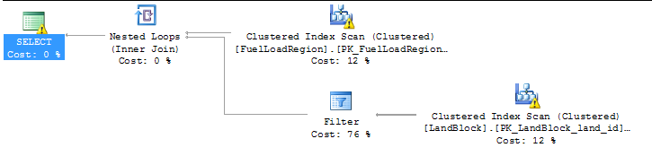

Another example shows how the execution plan differs if there are no spatial functions involved in the select statement. A simple selection for all land blocks and fuel areas in LandBlock and FuelLoadReigons tables:

SELECT land_id as id, area FROM LandBlock
UNION ALL
SELECT fuel_id as id, area FROM FuelLoadRegion

And here is the execution plan without the filter step:
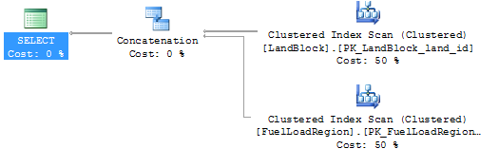

Map Viewer
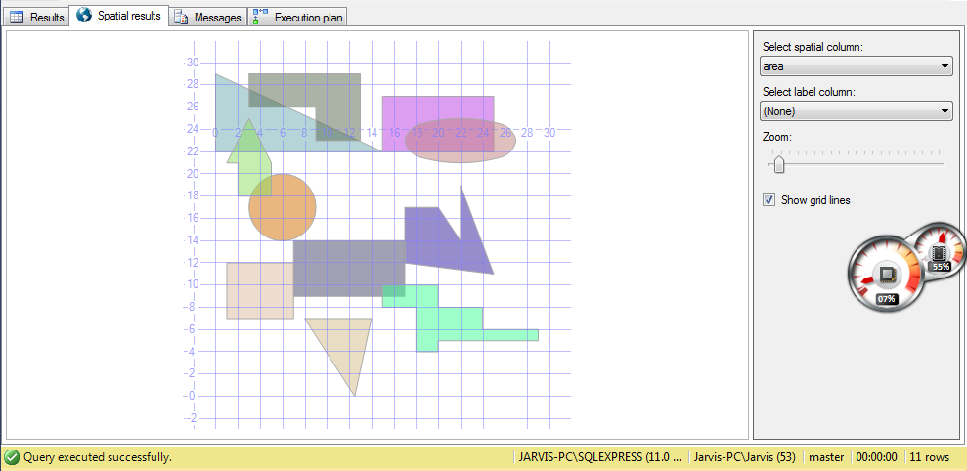

SQL Server Management Studio has a feature called the Spatial Results tab which allows you to visualize the results of a spatial query by Simply executing any script that returns at least one geometry or geography column.
On the right menu of this visualization you can choose the spatial column that you want to be displayed (only 1 column at once), and you can also select a column that contains the label of the spatial objects, other options are for zoom level and drawing coordinate grid lines.
For geography objects (map objects that contains latitude and longitude) it allows you to select 4 different projection systems (Equirectangular, Mercator, Robinson, or Bonne).

As soon as the query is executed, it will display the first spatial column objects in the visualization zoomed out to the boundary box that contains all the elements in this column.

Solutions to Assignment 2
The below diagram shows the land blocks and the regions of fuel load MARKED WITH POINTS.

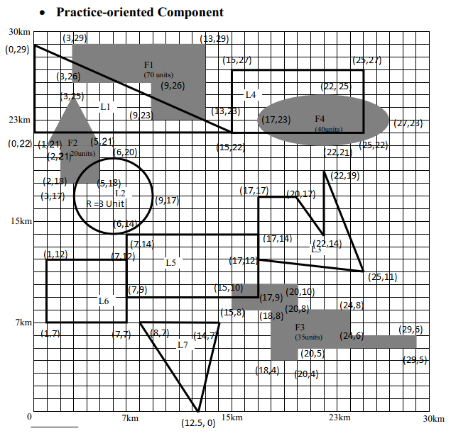

You are required to create two tables. One table is called "LandBlock" to store land blocks and the other table is called "FuelLoadRegion" to store fuel load regions. In these tables, one attribute must be GEOMETRY data type to describe spatial objects.

Creating Tables:

CREATE TABLE LandBlock(
land_id varchar(2),
area geometry,
CONSTRAINT PK_LandBlock_land_id PRIMARY KEY CLUSTERED (land_id)
);

CREATE TABLE FuelLoadRegion (
fuel_id varchar(2),
area geometry,
fuel_load int CHECK (fuel_load >= 0 and fuel_load <= 100),
CONSTRAINT PK_FuelLoadRegion_fuel_id PRIMARY KEY CLUSTERED (fuel_id)
);

Inserting data into "LandBlock"

INSERT INTO LandBlock(land_id, area)
VALUES ('L1',geometry::STGeomFromText('POLYGON ((0 22, 0 29, 15 22, 0 22))', 0));

INSERT INTO LandBlock(land_id, area)
VALUES ('L2',geometry::STGeomFromText('CURVEPOLYGON(CIRCULARSTRING(3 17, 6 20, 9 17, 6 14, 3 17))', 0));

INSERT INTO LandBlock(land_id, area)
VALUES ('L3',geometry::STGeomFromText('POLYGON ((17 17, 20 17, 22 14, 22 19, 25 11, 17 12, 17 17))', 0));

INSERT INTO LandBlock(land_id, area)
VALUES ('L4',geometry::STGeomFromText('POLYGON ((15 27,25 27, 25 22, 15 22, 15 27))',0));

INSERT INTO LandBlock(land_id, area)
VALUES ('L5',geometry::STGeomFromText('POLYGON ((7 14, 17 14, 17 9, 7 9, 7 14))',0));

INSERT INTO LandBlock(land_id, area)
VALUES ('L6',geometry::STGeomFromText('POLYGON ((1 7, 1 12, 7 12, 7 7, 1 7))',0));

INSERT INTO LandBlock(land_id, area)
VALUES ('L7',geometry::STGeomFromText('POLYGON ((8 7, 14 7, 12.5 0, 8 7))',0));

Inserting data into "FuelLoadRegion"

INSERT INTO FuelLoadRegion (fuel_id, area, fuel_load)
VALUES ('F1', geometry::STGeomFromText('POLYGON((3 29, 13 29, 13 23, 9 23,9 26, 3 26, 3 29))',0), 70);

INSERT INTO FuelLoadRegion (fuel_id, area, fuel_load)
VALUES ('F2', geometry::STGeomFromText('POLYGON((3 25, 5 21, 5 18, 2 18, 2 21, 1 21, 3 25))',0), 20);

INSERT INTO FuelLoadRegion (fuel_id, area, fuel_load)
VALUES ('F3', geometry::STGeomFromText('POLYGON((15 10, 20 10, 20 8, 24 8, 24 6, 29 6, 29 5, 20 5, 20 4, 18 4, 18 8, 15 8, 15 10))',0), 35);

INSERT INTO FuelLoadRegion (fuel_id, area, fuel_load)
VALUES ('F4', geometry::STGeomFromText('CURVEPOLYGON(COMPOUNDCURVE(CIRCULARSTRING(17 23,17.5 22.04, 18.5 21.47),CIRCULARSTRING(18.5 21.47,21 21.04, 22 21),CIRCULARSTRING(22 21,23 21.04, 25.5 21.47),CIRCULARSTRING(25.5 21.47,26.5 22.04, 27 23),CIRCULARSTRING(27 23,26.5 23.96, 25.5 24.53),CIRCULARSTRING(25.5 24.53,23 24.96, 22 25),CIRCULARSTRING(22 25,21 24.96, 18.5 24.53),CIRCULARSTRING(18.5 24.53,17.5 23.96, 17 23)))',0), 40);

Create spatial index on the attribute GEOMETRY data type to describe the spatial object

CREATE SPATIAL INDEX FuelLandBlock_Index
ON FuelLoadRegion(area)
USING GEOMETRY_GRID
WITH
(
BOUNDING_BOX = ( 0, 0, 30, 30),
GRIDS=(LEVEL_1 = LOW,LEVEL_2 = LOW,LEVEL_3 = LOW,LEVEL_4 = LOW),
CELLS_PER_OBJECT = 16
);

CREATE SPATIAL INDEX LandBlock_Index
ON LandBlock(area)
USING GEOMETRY_GRID
WITH
(
BOUNDING_BOX = ( 0, 0, 30, 30),
GRIDS=(LEVEL_1 = LOW,LEVEL_2 = LOW,LEVEL_3 = LOW,LEVEL_4 = LOW),
CELLS_PER_OBJECT = 16
);

Answer the following on attribute GEOMETERY in each table using SPATIAL queries:

a. Retrieve all regions in LandBlock and FuelLoadRegion

SELECT land_id as id, area FROM LandBlock
UNION ALL
SELECT fuel_id as id, area FROM FuelLoadRegion

b. Find the area size for each region in LandBlock and FuelLoadRegion

SELECT land_id as id,ROUND(area.STArea(),2) AS block_size FROM LandBlock
UNION ALL
SELECT fuel_id as id, ROUND(area.STArea(),2) AS block_size FROM FuelLoadRegion;

c. Find all regions of fuel load higher than 30 units

SELECT F.fuel_id, F.area
FROM FuelLoadRegion As F
WHERE F.fuel_load > 30;

d. Find all land blocks which have some region containing fuel load of 30 units or higher

SELECT L.land_id, L.area
FROM LandBlock L, FuelLoadRegion F
WHERE F.fuel_load>=30 AND (L.area.STIntersects(F.area)=1)

e. Find all land blocks within 11 km of the area containing fuel load over 70 units.

SELECT L.land_id, F.fuel_id, F.area, L.area.STDistance(f.area) as distance
FROM LandBlock L, FuelLoadRegion F
WHERE L.area.STDistance(f.area)>=11 AND f.fuel_load>=70

References

- System Requirements - http://msdn.microsoft.com/library/ms143506(v=SQL.110).aspx
- Introducing Microsoft SQL Server 2012 - Ross Mistry and Stacia Misner
- Data types - http://msdn.microsoft.com/en-us/library/bb964711(v=sql.100).aspx
- http://msdn.microsoft.com/en-us/library/bb933823.aspx
- http://msdn.microsoft.com/en-us/library/bb895267.aspx
- New Spatial Features in SQL Server Code-Named “Denali” [Ed Katibah (Microsoft) and Milan Stojic (Microsoft)] - SQL Server Technical Article
- SQL Spatial Index Performance http://www.mssqltips.com/sqlservertip/1976/sql-server-2008-spatial-index-performance/
- MSDN Library: http://msdn.microsoft.com/en-us/library/

