**Approach for Machine Learning Modeling**

We can apply various machine learning models to the dataset to predict diabetes status (diabetes) and analyze variable importance. Here's a proposed step-by-step process:

**1. Data Preparation**

* **Feature Selection**: Use numerical and categorical variables as features.
* **Encoding**: Convert categorical variables (e.g., gender, diet_type) into numerical representations using one-hot encoding.
* **Normalization/Scaling**: Normalize numerical variables to ensure they are on similar scales.
* **Train-Test Split**: Split the data into training and testing sets (e.g., 70%-30%).

**2. Machine Learning Models**

* **Baseline Model**: Logistic Regression for simplicity and interpretability.
* **Tree-Based Models**: Decision Trees and Random Forests to understand variable importance and non-linear relationships.
* **Boosting**: XGBoost to optimize predictions further.
* **k-Nearest Neighbors (k-NN)**: A distance-based algorithm for prediction.
* **Neural Networks**: For complex non-linear patterns and interactions.

**3. Model Evaluation**

* Use metrics such as:
  + **Accuracy**: Proportion of correct predictions.
  + **Precision, Recall, F1-Score**: To evaluate performance, especially on imbalanced datasets.
  + **ROC-AUC**: To measure the model's ability to discriminate between classes.

**4. Insights**

* **Feature Importance**: For tree-based models and XGBoost, identify the most influential variables.
* **Prediction Analysis**: Explore how well the model predicts diabetes status and misclassifications.

--------------------------------------------------------------------------------------------------------

**Logistic Regression Model Results:**

1. **Accuracy**: 97.33% - This indicates that the model performs very well in classifying diabetes status.
2. **ROC AUC**: 0.962 - A high score, indicating strong discrimination between the two classes.
3. **Classification Report**:
   * **Precision (Class 1)**: 0.98 - The model is highly precise in identifying cases with diabetes.
   * **Recall (Class 0)**: 0.47 - The model struggles slightly with identifying non-diabetic cases, likely due to class imbalance.
   * **Weighted Average F1-Score**: 0.97 - Overall performance is robust.

**Insights:**

* The model performs exceptionally well on the majority class (diabetic cases).
* Handling class imbalance (e.g., via oversampling or class weighting) could improve recall for non-diabetic cases.

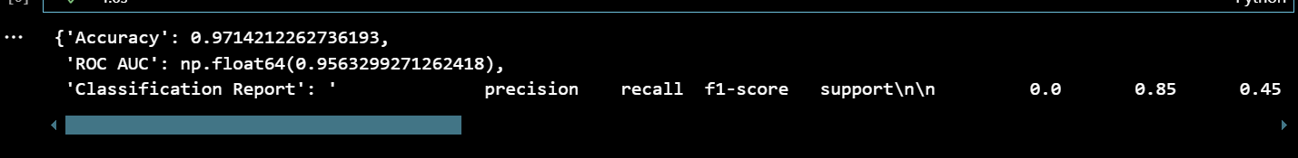

**Random Forest Model Results:**

1. **Accuracy**: 97.23% - Slightly lower than Logistic Regression but still highly accurate.
2. **ROC AUC**: 0.965 - Indicates excellent discrimination between the classes.
3. **Classification Report**:
   * **Precision (Class 1)**: 0.98 - Very precise in identifying diabetic cases.
   * **Recall (Class 0)**: 0.47 - Similar performance for non-diabetic cases as Logistic Regression.
   * **Weighted Average F1-Score**: 0.97 - Overall robust performance.

**Insights:**

* The Random Forest model performs similarly to Logistic Regression, with slightly higher ROC AUC.
* It confirms strong prediction capability for diabetic cases, though it still struggles with non-diabetic recall due to class imbalance.

------------------------------------------------------