**Create HTML pages attached (File: dashboard.png, home.png) using twitter bootstrap.**

**Home.png**

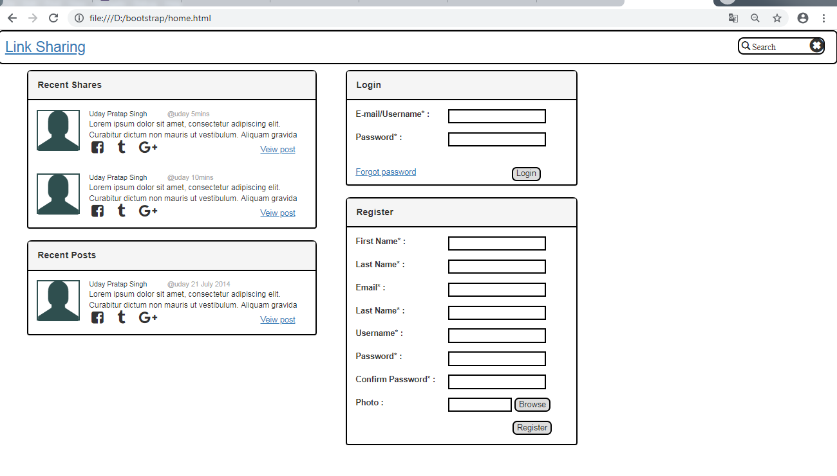

<!--Add place holder-->

<!DOCTYPE html>

<html>

<head>

<title>Try v1.2 Bootstrap Online</title>

<link rel="stylesheet" href="https://maxcdn.bootstrapcdn.com/bootstrap/3.3.7/css/bootstrap.min.css">

<script src="https://maxcdn.bootstrapcdn.com/bootstrap/3.3.7/js/bootstrap.min.js">

</script>

<script src="https://ajax.googleapis.com/ajax/libs/jquery/3.3.1/jquery.min.js" ></script>

<link rel="stylesheet" href="https://cdnjs.cloudflare.com/ajax/libs/font-awesome/4.7.0/css/font-awesome.min.css">

<style>

.left

{

margin-left: 50px;

float: left;

width: 500px;

/*border:1px solid red;*/

}

.right

{

margin-top:10px;

margin-left: 50px;

/* border:1px solid green;*/

width:400px;

margin-left: 600px;

}

.panel > .panel-heading

{

background-image: none;

border-bottom: 2px solid black;

padding:16px;

}

.panel

{

width:100%;

border: 2px solid black;

border-top-left-radius: 8px;

border-top-right-radius: 8px;

margin-top: 2%;

}

.panel-title

{

font-weight:550;

}

.container

{

margin-top: 3%;

}

.user-icon

{

border: 2px solid darkslategray;

height:70px;

font-size: 70px;

float:left;

color: darkslategray;

}

.paragraph

{

margin-left:90px;

font-size: 97%;

}

.name

{

float:left;

margin-left:16px;

font-size: 85%;

text-align: justify;

}

.seen

{

margin-left:225px;

color: darkgrey;

font-size: 85%;

}

.icon

{

margin-left:20px;

}

#view-postLinkid

{

margin-left: 175px;

text-decoration: underline;

}

#panel-r1

{

height:200px;

margin-top:0px;

}

.lbl-div-r1

{

width: 130px;

}

.lbl-div

{

float:left;

width:150px;

}

#pwdResetLinkid

{

text-decoration: underline;

}

#loginBtnId

{

border:2px solid black;

margin-top: 20px;

margin-left: 165px;

font-weight: 500;

}

#pwdResetLink-div

{

float: left;

margin-top: 20px;

}

.text-field

{

margin-left: 10px;

border:2px solid black;

}

input[type="button"] {

border-radius: 8px;

border: 2px solid black;

}

input[type="submit"] {

border-radius: 8px;

border: 2px solid black;

}

#chooseFileId

{

visibility:hidden;

float:left;

}

#filenameId

{

width: 110px;

}

#registerBtnId

{

margin-left: 5px;

}

#header

{

border-radius: 8px;

border: 2px solid black;

height:40px;

padding-left:10px;

padding-top:10px;

font-size: 25px;

padding-bottom: 45px;

}

#headerLinkId

{

text-decoration: underline;

}

#searchBar

{

float:right;

border:2px solid black;

width:150px;

height:30px;

margin-right:20px;

border-radius: 10px;

}

#searchIconId

{

float:left;

font-size: 15px;

padding-top: 5px;

padding-left:4px;

}

#closeIconId

{

float:right;

}

</style>

</head>

<body>

<div id="header">

<a href="#" id="headerLinkId">Link Sharing </a>

<div id="searchBar">

<div id="searchIconId" class="glyphicon glyphicon-search">&thinsp;Search</div>

<div class="glyphicon glyphicon-remove-sign" id="closeIconId"></div>

</div>

</div>

<div class="left">

<div class = "panel panel-default">

<div class = "panel-heading">

<h3 class = "panel-title">

Recent Shares

</h3>

</div>

<div class = "panel-body">

<div class="user-icon glyphicon glyphicon-user"></div>

<div class="name">

Uday Pratap Singh

</div>

<div class="seen">

@uday 5mins

</div>

<div class="paragraph">

Lorem ipsum dolor sit amet, consectetur adipiscing elit. Curabitur dictum non mauris ut vestibulum. Aliquam gravida

</div>

<span class="icon"><i style="font-size:24px" class="fa">&#xf082;</i></span>

<span class="icon"> <i style="font-size:24px" class="fa">&#xf173;</i></span>

<span class="icon"><i style="font-size:24px" class="fa fa-google-plus"></i></span>

<span id="view-postLinkid"><a href="#">Veiw post</a></span>

</div>

<div class = "panel-body">

<div class="user-icon glyphicon glyphicon-user"></div>

<div class="name">

Uday Pratap Singh

</div>

<div class="seen">

@uday 10mins

</div>

<div class="paragraph">

Lorem ipsum dolor sit amet, consectetur adipiscing elit. Curabitur dictum non mauris ut vestibulum. Aliquam gravida

</div>

<span class="icon"><i style="font-size:24px" class="fa">&#xf082;</i></span>

<span class="icon"> <i style="font-size:24px" class="fa">&#xf173;</i></span>

<span class="icon"><i style="font-size:24px" class="fa fa-google-plus"></i></span>

<span id="view-postLinkid"><a href="#">Veiw post</a></span>

</div>

</div>

<div class = "panel panel-default">

<div class = "panel-heading">

<h3 class = "panel-title">

Recent Posts

</h3>

</div>

<div class = "panel-body">

<div class="user-icon glyphicon glyphicon-user"></div>

<div class="name">

Uday Pratap Singh

</div>

<div class="seen">

@uday 21 July 2014

</div>

<div class="paragraph">

Lorem ipsum dolor sit amet, consectetur adipiscing elit. Curabitur dictum non mauris ut vestibulum. Aliquam gravida

</div>

<span class="icon"><i style="font-size:24px" class="fa">&#xf082;</i></span>

<span class="icon"> <i style="font-size:24px" class="fa">&#xf173;</i></span>

<span class="icon"><i style="font-size:24px" class="fa fa-google-plus"></i></span>

<span id="view-postLinkid"><a href="#">Veiw post</a></span>

</div>

</div>

</div>

<div class="right">

<div class = "panel panel-default" id="panel-r1">

<div class = "panel-heading">

<h3 class = "panel-title">

Login

</h3>

</div>

<div class = "panel-body">

<form>

<div class="form-group">

<div class="lbl-div"><label>E-mail/Username* :</label></div>

<div> <input class="text-field" type="text" required></div>

</div>

<div class="form-group">

<div class="lbl-div"><label>Password* :</label></div>

<div> <input class="text-field" type="password" required></div>

</div>

<div id="pwdResetLink-div"><a href="#" id="pwdResetLinkid">Forgot password</a></div>

<div><input type="submit" value="Login" id="loginBtnId"></div>

</form>

</div>

</div>

<!--r2-->

<div class = "panel panel-default" id="panel-r2">

<div class = "panel-heading">

<h3 class = "panel-title">

Register

</h3>

</div>

<div class = "panel-body">

<form>

<div class="form-group">

<div class="lbl-div"><label>First Name* :</label></div>

<div> <input class="text-field" type="text" required></div>

</div>

<div class="form-group">

<div class="lbl-div"><label>Last Name* :</label></div>

<div> <input class="text-field" type="text" required></div>

</div>

<div class="form-group">

<div class="lbl-div"><label>Email* :</label></div>

<div> <input class="text-field" type="email" required></div>

</div>

<div class="form-group">

<div class="lbl-div"><label>Last Name* :</label></div>

<div> <input class="text-field" type="text" required></div>

</div>

<div class="form-group">

<div class="lbl-div"><label>Username* :</label></div>

<div> <input class="text-field" type="text" required></div>

</div>

<div class="form-group">

<div class="lbl-div"><label>Password* :</label></div>

<div> <input class="text-field" type="password" required></div>

</div>

<div class="form-group">

<div class="lbl-div"><label>Confirm Password* :</label></div>

<div> <input class="text-field" type="password" required></div>

</div>

<div class="form-group">

<div class="lbl-div"><label>Photo :</label></div>

<input type="text" class="text-field" id="filenameId">

<input type="button" id="chooseFileBtnId" value="Browse">

<input type="file" name="my_file" id="chooseFileId">

</div>

<div>

<input type="button" value="Register" id="registerBtnId">

</div>

</form>

</div>

</div>

</div>

<script>

$('#chooseFileBtnId').click(function(){

$('#chooseFileId').click();

});

</script>

</body>

</html>

**Dashboard.png**

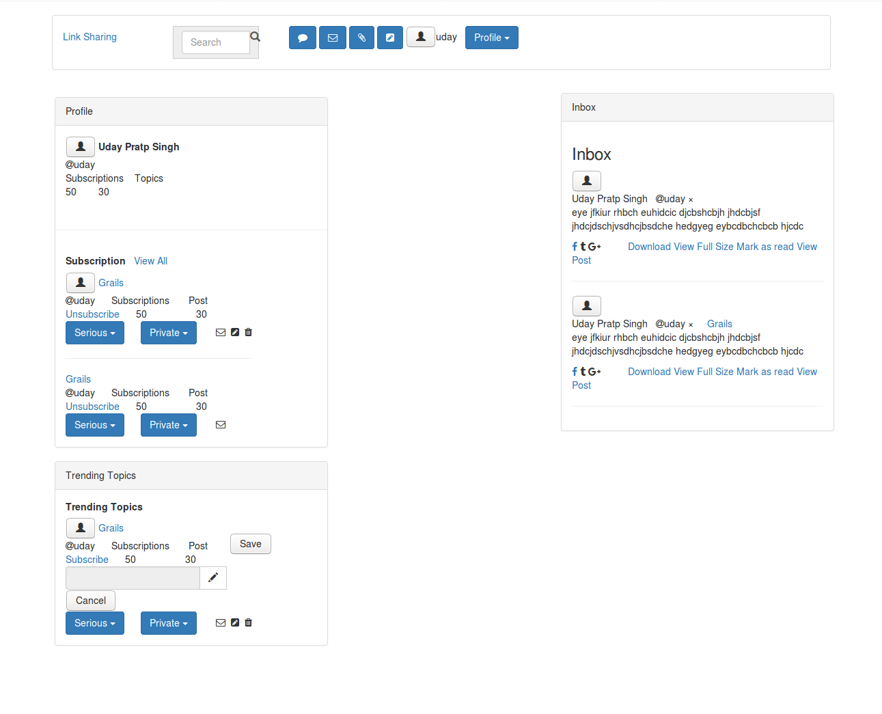

<!DOCTYPE html>

<html>

<head>

<link rel="stylesheet" href="https://cdnjs.cloudflare.com/ajax/libs/font-awesome/4.7.0/css/font-awesome.min.css">

<link rel="stylesheet" href="https://maxcdn.bootstrapcdn.com/bootstrap/3.3.7/css/bootstrap.min.css">

<script src="https://ajax.googleapis.com/ajax/libs/jquery/3.3.1/jquery.min.js"></script>

<script src="https://maxcdn.bootstrapcdn.com/bootstrap/3.3.7/js/bootstrap.min.js"></script>

<script src="home/roma/bootstrap/js/myscript.js"></script>

<style>

.header

{

display: block;

border-radius: 6px;

margin-top: -58px;

}

.main-right

{

margin-right: 70px;

height: 10px;

width:80px;

margin-top: 14px;

}

.main-left

{

float:left;

/*border:1px solid tomato;*/

width:400px;

border-radius: 6px;

margin:80px;

margin-top: 20px;

}

.main-right

{

float: right;

width:400px;

border-radius: 6px;

}

#search-box

{

width:100px;

}

.glyphicon-search

{

font-size: 15px;

}

}

}

</style>

</head>

<body>

<div class="header">

<div class="page-header">

<h3></h3></div>

<div class="container">

<div class="panel panel-default">

<div class="panel-body">

<div class="input-group">

<a href="#">Link Sharing</a>

<div class="input-group-addon">

<input id="search-box" type="text" class="form-control" placeholder="Search" />

<span class="glyphicon glyphicon-search"></span>

</div>&nbsp;&nbsp;&nbsp;&nbsp;&nbsp;&nbsp;&nbsp;&nbsp;&nbsp;&nbsp;

<button type="button" class="btn btn-primary" data-toggle="modal"><i class="fa fa-comment"></i>

</button>

<button type="button" class="btn btn-primary" data-toggle="modal" data-target="#myModal"><i class="fa fa-envelope-o"></i>

</button>

<button type="button" class="btn btn-primary" data-toggle="modal" data-target="#myModal3"><i class="fa fa-paperclip"></i></button>

<button type="button" class="btn btn-primary" data-toggle="modal" data-target="#myModal4"><i class="fa fa-pencil-square"></i>

</button>

<button><span class="glyphicon glyphicon-user"></span></button>uday&nbsp;&nbsp;

<div class="dropdown" style="display: inline-block;">

<button class="btn btn-primary dropdown-toggle" type="button" data-toggle="dropdown">Profile

<span class="caret"></span>

</button>

<ul class="dropdown-menu">

<li><a href="#">Profile</a></li>

<li><a href="#">Users</a></li>

<li><a href="#">Topics</a></li>

</ul>&nbsp;&nbsp;&nbsp;&nbsp;

</div>

</div>

</div>

</div>

</div>

</div>

</div>

</div>

<div class="main-left">

<div class="panel panel-default">

<div class="panel-heading">Profile</div>

<div class="panel-body">

<form class="form-inline">

<div class="form-group">

<button><span class="glyphicon glyphicon-user"></span></button>

<label for="name">Uday Pratp Singh</label>

<br>

<i class="fa fa-at"></i>uday

<p>

Subscriptions&nbsp;&nbsp;&nbsp;&nbsp;Topics<br>

50&nbsp;&nbsp;&nbsp;&nbsp;&nbsp;&nbsp;&nbsp;&nbsp;30

</p>

</div>

</form>

</div>

<hr>

<div class="panel-body">

<form class="form-inline">

<div class="form-group">

<label for="Subscriptions">Subscription</label>&nbsp;&nbsp;

<a href="#">View All</a>

<br>

<button><span class="glyphicon glyphicon-user"></span></button>

<a href="#">Grails</a>

<br>

<i class="fa fa-at"></i>uday&nbsp;&nbsp;&nbsp;&nbsp;&nbsp;&nbsp;Subscriptions &nbsp;&nbsp;&nbsp;&nbsp;&nbsp;&nbsp;Post

<br>

<a href="#">Unsubscribe</a>&nbsp;&nbsp;&nbsp;&nbsp;&nbsp;&nbsp;50&nbsp;&nbsp;&nbsp;&nbsp;&nbsp;&nbsp;&nbsp;&nbsp;&nbsp;&nbsp;&nbsp;&nbsp;&nbsp;&nbsp;&nbsp;&nbsp;&nbsp;&nbsp;30

<div class="dropdown">

<button class="btn btn-primary dropdown-toggle" type="button" data-toggle="dropdown">Serious

<span class="caret"></span>

</button>

<ul class="dropdown-menu">

<li><a href="#">Serious</a></li>

<li><a href="#">S</a></li>

</ul>&nbsp;&nbsp;&nbsp;&nbsp;

<button class="btn btn-primary dropdown-toggle" type="button" data-toggle="dropdown">Private

<span class="caret"></span>

</button>&nbsp;&nbsp;&nbsp;&nbsp;

<ul class="dropdown-menu">

<li><a href="#">Private</a></li>

<li><a href="#">Delete</a></li>

<li><a href="#">Edit</a></li>

</ul>&nbsp;

<i class="fa fa-envelope-o"></i>&nbsp;

<i class="fa fa-pencil-square"></i>&nbsp;

<i class="fa fa-trash"></i>

</div>

<hr>

<a href="#">Grails</a>

<br>

<i class="fa fa-at"></i>uday&nbsp;&nbsp;&nbsp;&nbsp;&nbsp;&nbsp;Subscriptions &nbsp;&nbsp;&nbsp;&nbsp;&nbsp;&nbsp;Post

<br>

<a href="#">Unsubscribe</a>&nbsp;&nbsp;&nbsp;&nbsp;&nbsp;&nbsp;50&nbsp;&nbsp;&nbsp;&nbsp;&nbsp;&nbsp;&nbsp;&nbsp;&nbsp;&nbsp;&nbsp;&nbsp;&nbsp;&nbsp;&nbsp;&nbsp;&nbsp;&nbsp;30

<div class="dropdown">

<button class="btn btn-primary dropdown-toggle" type="button" data-toggle="dropdown">Serious

<span class="caret"></span>

</button>

<ul class="dropdown-menu">

<li><a href="#">Serious</a></li>

<li><a href="#">S</a></li>

</ul>&nbsp;&nbsp;&nbsp;&nbsp;

<button class="btn btn-primary dropdown-toggle" type="button" data-toggle="dropdown">Private

<span class="caret"></span>

</button>&nbsp;&nbsp;&nbsp;&nbsp;

<ul class="dropdown-menu">

<li><a href="#">Private</a></li>

<li><a href="#">Delete</a></li>

<li><a href="#">Edit</a></li>

</ul>&nbsp;

<i class="fa fa-envelope-o"></i>&nbsp;

</div>

</div>

</form>

</div>

</div>

<div class="my-div">

<div class="panel panel-default">

<div class="panel-heading">Trending Topics</div>

<div class="panel-body">

<form class="form-inline">

<div class="form-group">

<label for="trending-topics">Trending Topics</label>&nbsp;&nbsp;

<br>

<button><span class="glyphicon glyphicon-user"></span></button>

<a href="#">Grails</a>

<br>

<i class="fa fa-at"></i>uday&nbsp;&nbsp;&nbsp;&nbsp;&nbsp;&nbsp;Subscriptions &nbsp;&nbsp;&nbsp;&nbsp;&nbsp;&nbsp;Post

<br>

<a href="#">Subscribe</a>&nbsp;&nbsp;&nbsp;&nbsp;&nbsp;&nbsp;50&nbsp;&nbsp;&nbsp;&nbsp;&nbsp;&nbsp;&nbsp;&nbsp;&nbsp;&nbsp;&nbsp;&nbsp;&nbsp;&nbsp;&nbsp;&nbsp;&nbsp;&nbsp;30

<br>

<div class="input-group">

<input type="text" class="form-control disable" disabled="disabled">

<span class="input-group-btn">

<button class="btn btn-default editBtn" type="button"><i class="glyphicon glyphicon-pencil"></i></button><br>

</span>

</div>

</div>

<input type="submit" name="save" value="Save"/>&nbsp; <input type="submit" name="Cancel" value="Cancel"/>

<br>

<div class="dropdown">

<button class="btn btn-primary dropdown-toggle" type="button" data-toggle="dropdown">Serious

<span class="caret"></span>

</button>

<ul class="dropdown-menu">

<li><a href="#">Serious</a></li>

<li><a href="#">S</a></li>

</ul>&nbsp;&nbsp;&nbsp;&nbsp;

<button class="btn btn-primary dropdown-toggle" type="button" data-toggle="dropdown">Private

<span class="caret"></span>

</button>&nbsp;&nbsp;&nbsp;&nbsp;

<ul class="dropdown-menu">

<li><a href="#">Private</a></li>

<li><a href="#">Delete</a></li>

<li><a href="#">Edit</a></li>

</ul>&nbsp;

<i class="fa fa-envelope-o"></i>&nbsp;

<i class="fa fa-pencil-square"></i>&nbsp;

<i class="fa fa-trash"></i>

</div>

</form>

</div>

</div>

</div>

</div>

</div>

</div>

</div>

<div class="main-right">

<div class="panel panel-default">

<div class="panel-heading">Inbox</div>

<div class="panel-body">

<form class="form-inline">

<div class="form-group">

<h3>Inbox</h3>

<button><span class="glyphicon glyphicon-user"></span></button>

<p>

Uday Pratp Singh &nbsp; <i class="fa fa-at"></i>uday &times; &nbsp;&nbsp;&nbsp;

<br>

eye jfkiur rhbch euhidcic djcbshcbjh jhdcbjsf<br>

jhdcjdschjvsdhcjbsdche hedgyeg eybcdbchcbcb hjcdc

</p>

<a href="#" class="fa fa-facebook"></a>

<i class="fa fa-tumblr"></i>

<i class="fa fa-google-plus"></i>&nbsp;&nbsp;&nbsp;&nbsp;&nbsp;&nbsp;&nbsp;&nbsp;&nbsp;

<a href="#">Download</a>

<a href="#">View Full Size</a>

<a href="#">Mark as read</a>

<a href="#">View Post</a><hr>

<button><span class="glyphicon glyphicon-user"></span></button>

<p>

Uday Pratp Singh &nbsp; <i class="fa fa-at"></i>uday &times; &nbsp;&nbsp;&nbsp;

<a href="#">Grails</a>

<br>

eye jfkiur rhbch euhidcic djcbshcbjh jhdcbjsf<br>

jhdcjdschjvsdhcjbsdche hedgyeg eybcdbchcbcb hjcdc<br>

</p> <a href="#" class="fa fa-facebook"></a>

<i class="fa fa-tumblr"></i>

<i class="fa fa-google-plus"></i>&nbsp;&nbsp;&nbsp;&nbsp;&nbsp;&nbsp;&nbsp;&nbsp;&nbsp;

<a href="#">Download</a>

<a href="#">View Full Size</a>

<a href="#">Mark as read</a>

<a href="#">View Post</a>

<hr>

</div>

</form>

</div>

<!-- Modal -->

<div id="myModal" class="modal fade">

<div class="modal-dialog">

<!-- Modal content-->

<div class="modal-body">

<div class="modal-content">

<div class="modal-header">

<button type="button" class="close" data-dismiss="modal">&times;</button>

<h4 class="modal-title">Send Invitation</h4>

</div>

<div class="modal-body">

<div class="modal-body">

<label for="email">Email*:</label>

<input type="text" name="email" placeholder="Email" />

<br><br>

<label for="pwd">Password*:</label>

<input type="text" name="pwd" placeholder="Password" />

<br><br>&nbsp;&nbsp;&nbsp;

<input type="submit" name="invite" value="Invite"/>&nbsp;

<input type="submit" name="Cancel" value="Cancel"/>

</div>

</div>

<div class="modal-footer">

<button type="button" class="btn btn-default" data-dismiss="modal">Close</button>

</div>

</div>

</div>

</div>

<!--Share Link-->

<!-- Modal -->

<div id="myModal2" class="modal fade">

<div class="modal-dialog">

<!-- Modal content-->

<div class="modal-body">

<div class="modal-content">

<div class="modal-header">

<button type="button" class="close" data-dismiss="modal"></button>

<h4 class="modal-title">Share Link</h4>

</div>

<div class="modal-body">

<label for="link">Link*:</label>

<input type="text" name="link" placeholder="Link">

<br><br>

<label for="description">Description*:</label>

<input type="text-area" name="esc" placeholder="Description">

<br><br>

<label for="topics">Topics*:</label>&nbsp;&nbsp;

<div class="dropdown">

<button class="btn btn-primary dropdown-toggle" type="button" data-toggle="dropdown">Topics

<span class="input-group-btn">

<button class="btn btn-default editBtn" type="button"><i class="fa fa-arrow-down"></i></button><br>

</span>

</button>

<ul class="dropdown-menu">

<li><a href="#">Topics</a></li>

<li><a href="#">S</a></li>

</ul>

<br><br>&nbsp;&nbsp;&nbsp;

<input type="submit" name="Share" value="Share"/>&nbsp;

<input type="submit" name="Cancel" value="Cancel"/>

</div>

<div class="modal-footer">

<button type="button" class="btn btn-default" data-dismiss="modal">Close</button>

</div>

</div>

</div>

</div>

</div>

<!--Share Document-->

<!-- Modal -->

<div id="myModal3" class="modal fade">

<div class="modal-dialog">

<!-- Modal content-->

<div class="modal-body">

<div class="modal-content">

<div class="modal-header">

<button type="button" class="close" data-dismiss="modal"></button>

<h4 class="modal-title">Share Document</h4>

</div>

<div class="modal-body">

<label for="link">Document*:</label>

<input type="file" name="Document">

<br><br>

<label for="description">Description*:</label>

<input type="text area" name="esc" placeholder="Description">

<br><br>

<label for="topics">Topics*:</label>&nbsp;&nbsp;

<div class="dropdown">

<button class="btn btn-primary dropdown-toggle" type="button" data-toggle="dropdown">Topics

<span class="input-group-btn">

<button class="btn btn-default editBtn" type="button"><i class="fa fa-arrow-down"></i></button><br>

</span>

</button>

<ul class="dropdown-menu">

<li><a href="#">Topics</a></li>

<li><a href="#">S</a></li>

</ul>

<br><br>&nbsp;&nbsp;&nbsp;

<input type="submit" name="Share" value="Share"/>&nbsp;

<input type="submit" name="Cancel" value="Cancel"/>

</div>

<div class="modal-footer">

<button type="button" class="btn btn-default" data-dismiss="modal">Close</button>

</div>

</div>

</div>

</div>

</div>

</div>

<!--Share Document ends-->

<!--create topic-->

<!-- Modal -->

<div id="myModal4" class="modal fade">

<div class="modal-dialog">

<!-- Modal content-->

<div class="modal-body">

<div class="modal-content">

<div class="modal-header">

<button type="button" class="close" data-dismiss="modal"></button>

<h4 class="modal-title"> Create Topic</h4>

</div>

<div class="modal-body">

<label for="name">Name*:</label>

<input type="text" name="name" placeholder="name">

<br><br>

<label for="visibility">Visibility*:</label>&nbsp;&nbsp;

<div class="dropdown">

<button class="btn btn-primary dropdown-toggle" type="button" data-toggle="dropdown">Public

<span class="input-group-btn">

<button class="btn btn-default editBtn" type="button"><i class="fa fa-arrow-down"></i></button><br>

</span>

</button>

<ul class="dropdown-menu">

<li><a href="#">Public</a></li>

<li><a href="#">Private</a></li>

</ul>

<br><br>&nbsp;&nbsp;&nbsp;

<input type="submit" name="Save" value="Save"/>&nbsp;

<input type="submit" name="Cancel" value="Cancel"/>

</div>

<div class="modal-footer">

<button type="button" class="btn btn-default" data-dismiss="modal">Close</button>

</div>

</div>

</div>

</div>

</div>

</div>

</div>

<!--create topic ends-->

</div>

</div>

</div>

</body>

</html>