**Database Exercise Solved**

**Ans 1.** create database demodatabase;

use demodatabase;

**Ans 2**.create schema demoschema;

**Ans 3.**

CustomerDetails

create table CustomerDetails(sno int not null primary key auto_increment,email varchar(20) not null,customerid int not null,addressline1 varchar(20) not null,city varchar(20) not null);

OrderDetails

create table OrderDetails (sno int not null primary key,description varchar(255) not null, sum int not null, orderid int not null, userid int references CustomerDetails(customerid));

Sales

create table sales

-> (

-> sno int primary key not null,

-> salespersonid int not null,

-> salespersonname varchar(30) not null,

-> email varchar(50) not null,

-> orderid int references OrderDetails(orderid));

CustomerOrderMapping

create table CustomerOrderMapping (sno int primary key not null, customerid int references CustomerDetails(customerid),orderid int references OrderDetails(orderid));

SalesOrderMapping

create table SalesOrderMapping (sno int primary key not null auto_increment, salesid int references Sales(salespersonid), orderid int references OrderDetails(orderid));

**Ans 4.**insert into CustomerDetails (email,customerid,addressline1,city) values ('roma@gmail.com',100,'jw','New Delhi');

insert into CustomerDetails(email,customerid,addressline1,city) values('abc@gmail.com',101,'kb','New Delhi');

insert into CustomerDetails(email,customerid,addressline1,city) values('p@gmail.com',103,'pnagar','New Delhi');

insert into CustomerDetails(email,customerid,addressline1,city) values('xyz@gmail.com',102,'pratap nagar','New Delhi');

insert into OrderDetails(sno,description,sum,orderid,userid) values(1,"this order conatins a pair of shoes",1500,10000,100);

insert into OrderDetails(sno,description,sum,orderid,userid) values(2,"this order conatins denims",3500,10000,100);

insert into OrderDetails(sno,description,sum,orderid,userid) values(3,"this order conatins garments",86500,10001,102);

insert into CustomerOrderMapping(sno,customerid,orderid) values(1,100,1000);

insert into CustomerOrderMapping(sno,customerid,orderid) values(2,100,1002);

insert into CustomerOrderMapping(sno,customerid,orderid) values(3,101,1001);

insert into sales(sno,salespersonid,salespersonname,email,orderid) values(2,2001,'pulkash','pulkash@gmail.com',1001);

insert into sales(sno,salespersonid,salespersonname,email,orderid) values(3,2002,'akash','akash@gmail.com',1002)

**Ans 5.**select s.salespersonname, s.salespersonid, s.orderid from sales s join SalesOrderMapping sm where s.salespersonid = sm.salesid;

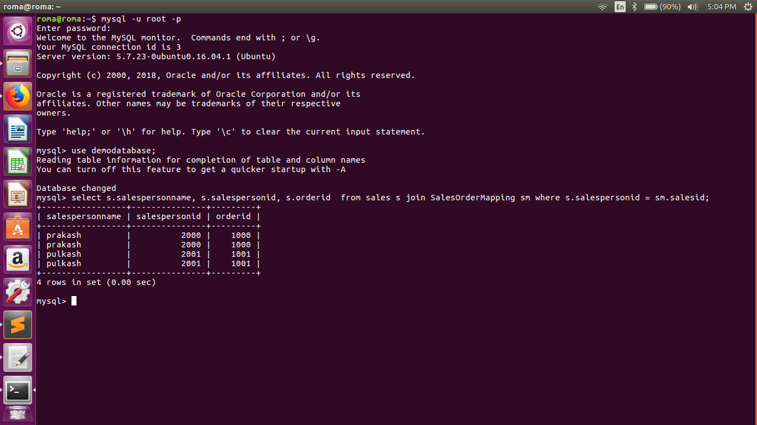

**Ans 6.**select s.salespersonname, s.salespersonid, s.orderid,o.description from sales s join SalesOrderMapping sm on s.salespersonid = sm.salesid join OrderDetails o on o.orderid = s.orderid;

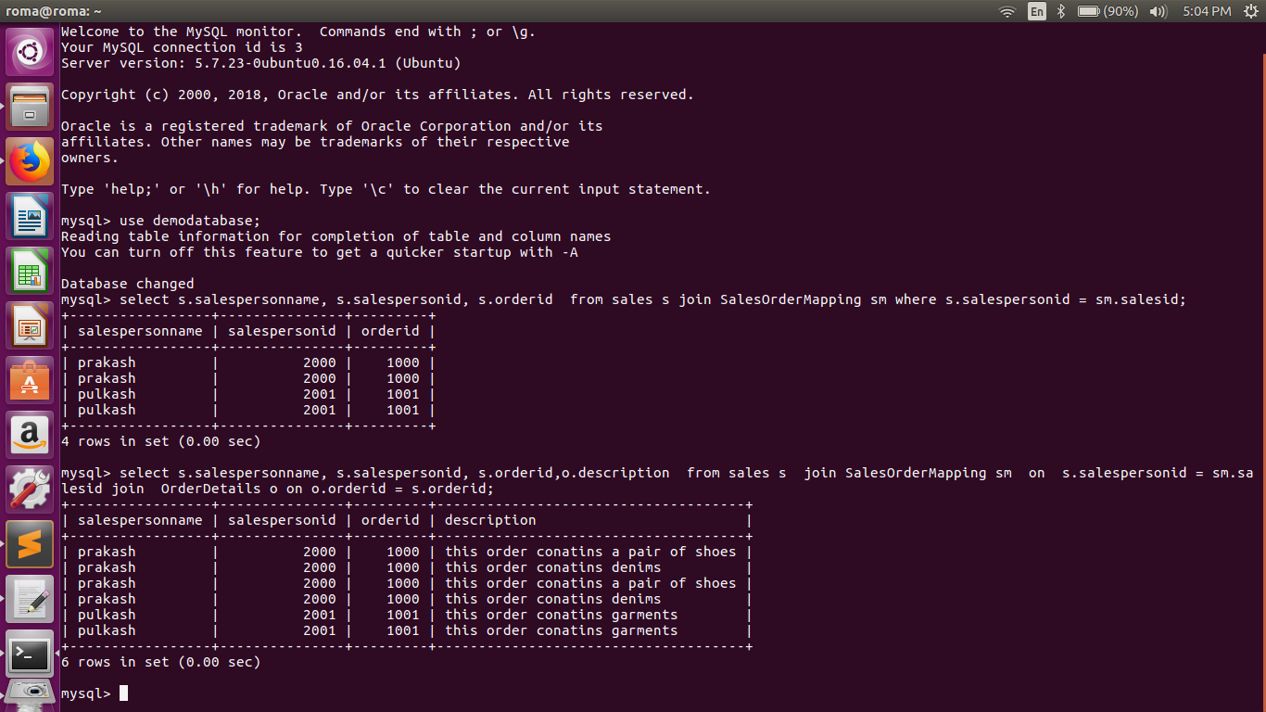

**Ans 7.**create index CustomerIndex on CustomerDetails(sno);

create index OrderIndex on OrderDetails(sno);

create index SalesIndex on SalesDetails(sno);

**Ans 8.** Show index from <tablename>;

**Ans 9.**select s.salespersonname, s.salespersonid, s.orderid,c.email,c.customerid

from sales s

join SalesOrderMapping sm on s.salespersonid = sm.salesid

join OrderDetails o on o.orderid = s.orderid

join CustomerDetails c on c.customerid = (select customerid from CustomerOrderMapping where orderid = s.orderid);

