Ans 1.

Block-level Elements

There is an invisible box around every block level element. The box takes height of the content as its default height and width of the page as its default width. Block-level elements flow top to bottom, meaning all block-level elements appear on their own line without an explicit line break (<br/>).

Examples of Block Elements:

<p>, <div>, <form>, <header>, <nav>, <ul>, <li>, and <h1-h6>.

## Inline Elements

Inline elements take height of the content and width of the content as their default height and width. The height and width of the inline elements can’t be set in CSS. Inline elements flow left to right, meaning inline elements appear on the same line unless the line wraps or there’s an explicit line break (<br/>)

Examples of Inline Elements:

<a>, <span>, <b>, <em>, <i>, <cite>, <mark>, and <code>.

Ans 2.

“display:none” means that the tag in question will not appear on the page at all.There will be no space allocated for it between the other tags.

“visibility:hidden” means that unlike display:none, the tag is not visible, but space is allocated for it on the page. The tag is rendered, it just isn't seen on the page.

Ans 3.

The float property specifies how an element should float. Elements after a floating element will flow around it. Absolutely positioned elements ignore the float property.

The clear property specifies on which sides of an element floating elements are not allowed to float. For example an element whose CSS has been set as "clear:right” would not allow would not allow elements to float on its right .

Ans 4.

Position:static

If the parent element has position: static then it will remain in the natural flow of the page. It will NOT act as anchor point for the absolutely positioned child element

Position:relative

If the parent element has position relative then it will remain in the natural flow of the page. It will also act as anchor point for the absolutely positioned child element.

Position:absolute

If the parent element has position: absolute then it will NOT remain in the natural flow of the page. It will position itself according to the closest positioned ancestor. It will also act as anchor point for the absolutely positioned child element.

Position:fixed

The parent element has position: fixed then it will NOT remain in the natural flow of the page. It will position itself according to the viewport. It will also act as anchor point for the absolutely positioned child element

Ans 5.

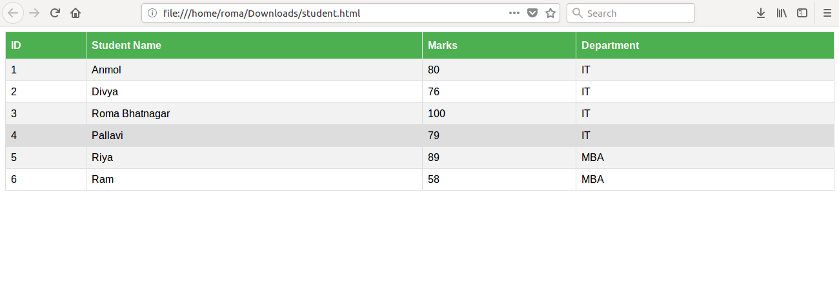

<!DOCTYPE html>

<html>

<head>

<style>

#students {

font-family: Arial, sans-serif;

border-collapse: collapse;

width: 100%;

}

#students td, #students th {

border: 1px solid #ddd;

padding: 8px;

}

#students tr:hover {background-color: #ddd;}

#students th {

padding-top: 12px;

padding-bottom: 12px;

text-align: left;

background-color: #4CAF50;

color: white;

}

</style>

</head>

<body>

<table id="students">

<tr>

<th>ID</th>

<th>Student Name</th>

<th>Marks</th>

<th>Department</th>

</tr>

<tr>

<td>1</td>

<td>Anmol </td>

<td>80</td>

<td>IT</td>

</tr>

<tr>

<td>2</td>

<td>Divya</td>

<td>76</td>

<td>IT</td>

</tr>

<tr>

<td>3</td>

<td>Roma Bhatnagar</td>

<td>100</td>

<td>IT</td>

</tr>

<tr>

<td>4</td>

<td>Pallavi</td>

<td>79</td>

<td>IT</td>

</tr>

<tr>

<td>5</td>

<td>Riya</td>

<td>89</td>

<td>MBA</td>

</tr>

<tr>

<td>6</td>

<td>Ram</td>

<td>58</td>

<td>MBA</td>

</tr>

</table>

</body>

</html>

Ans 6.

Metadata is data (information) about data.

The <meta> tag provides metadata about the HTML document. Metadata will not be displayed on the page, but will be machine parsable.

Meta elements are typically used to specify page description, keywords, author of the document, last modified, and other metadata.

The metadata can be used by browsers (how to display content or reload page), search engines (keywords), or other web services

Ans 7.

The CSS box model is an invisible box that wraps around every HTML element. It consists of:

* Content - The content of the box, where text and images appear
* Padding - Clears an area around the content. The padding is transparent
* Border - A border that goes around the padding and content
* Margin - Clears an area outside the border. The margin is transparent

Ans 8.

ID Selector

An ID selector is declared using a hash, or pound symbol (#) preceding a string of characters. The string of characters is defined by the developer. This selector matches any HTML element that has an ID attribute with the same value as that of the selector, but minus the hash symbol.

#container {

width: 960px;

margin: 0 auto;

}

Class Selector

It’s declared with a dot preceding a string of one or more characters. Just as is the case with an ID selector, this string of characters is defined by the developer. The class selector also matches all elements on the page that have their class attribute set to the same value as the class, minus the dot.

For example:

.box {

padding: 20px;

margin: 10px;

width: 240px;

}

Attribute Selector

The attribute selector targets elements based on the presence and/or value of HTML attributes, and is declared using square brackets.

For example:

input[type="text"] {

background-color: #444;

width: 200px;

}

Element Selector

The *element* selector selects all elements with the specified element name. For example:

p {

background-color: yellow;

}

Universal Selector

The universal selector works like a wildcard character, selecting all elements on a page. For example:

* {

color: green;

font-size: 20px;

line-height: 25px;

}

Descendant Combinator

The descendant combinator lets you combine two or more selectors so you can be more specific in your selection method. For example:

#container .box {

float: left;

padding-bottom: 15px;

}

Child Combinator

A selector that uses the child combinator is similar to a selector that uses a descendant combinator, except it only targets immediate child elements. For example:

#container > .box {

float: left;

padding-bottom: 15px;

}

Pseudo Class

A pseudo-class uses a colon character to identify a pseudo-state that an element might be in(the state of being hovered, or the state of being activated).For example:

a:hover {

color: red;

}

Ans 9.The <!DOCTYPE> declaration is not an HTML tag. It is an instruction to the web browser about what version of HTML the page is written in.The <!DOCTYPE> declaration must be the very first thing in an HTML document, before the <html> tag.

Ans 10.

A semantic tag introduces meaning to the web page rather than just presentation. For example, a <p> tag indicates that the enclosed text is a paragraph.

This is both semantic and presentational, because people know what paragraphs are and browsers know how to display them.Examples of semantic HTML tags include the header tags <h1> through <h6>, <blockquote>, <code> and <em>.

Ans 11.

<!DOCTYPE html>

<html>

<head>

<style>

.main

{

border:1px solid: #4d4d4d;

height:1100px;

background-color: #4d4d4d;

}

.header

{

margin-left:30px;

margin-top:1%;

border: 1px solid #333333;

margin-right:30px;

background-color: #333333;

}

.links-div

{

border: 1px solid black;

height:30px;

padding: 10px;

width: 80%;

margin-left:90px;

margin-bottom:1%;

background-color: black;

}

.link

{

margin-left: 2%;

text-decoration: none;

}

#companylbl

{

font-size: 25px;

margin-left:90px;

color: white;

margin-top: 1%;

margin-bottom:1%;

}

.body

{

margin-left:30px;

border: 1px solid white;

margin-right:30px;

height:950px;

background-color: white;

}

.body-first

{

width: 96opx;

height: 360px;

border: 1px solid black;

margin-left: 4%;

margin-right: 4%;

margin-top:2%;

background-color: #333333;

}

.body-sec

{

margin-top:2%;

margin-bottom: 2%;

border: 1px solid darkgrey;

height:89px;

margin-left: 4%;

margin-right: 4%;

background-color: darkgrey;

color:white;

text-align: justify;

}

.bodylbl-div

{

margin-left: 4%;

margin-right: 4%;

}

.cards

{

margin-top:2%;

margin-bottom: 2%;

border: 1px solid black;

float:left;

width: 215px;

height: 315px;

background-color: #333333;

}

#card-outer1

{

margin-left: 52px;

}

#card-outer2

{

margin-left: 78px;

}

#mid-card1

{

margin-left:78px;

}

#mid-card2

{

margin-left:78px;

}

</style>

</head>

<body link="white">

<div class="main">

<div class="header">

<div id="companylbl">To the New</div>

<nav>

<div class="links-div">

<a href="#" class="link">TEXT LINK</a>

<a href="#" class="link">TEXT LINK</a>

<a href="#" class="link">TEXT LINK</a>

<a href="#" class="link">TEXT LINK</a>

</div>

</nav>

</div>

<div class="body">

<div class="body-first">

</div>

<div class="body-sec">

<p>ASDFG;LKJH ASDFG ;LKHG ASDFG ;LKJJH ASDFG ;LKHG ASDFG ;LKJH ASDFG ;LKJH ASDFG ;LKJH ASDFG ;LKJH ASDFG ;LKJH ASDFG ;LKJH ASDFGF ;LKJH ASDFG ;LKJH ASDFG ;LKJH ASDFG ;LKJH ASDFG ;LKJH ASDFG ;LKJH ADSFG ;LKJH ADSFG ;LKJH ASDFG ;LJKH ASDFG ;LJKH ASDFG

ASDFG;LKJH ASDFG ;LKHG ASDFG ;LKJJH ASDFG ;LKHG ASDFG ;LKJH ASDFG ;LKJH ASDFG ;LKJH ASDFG ;LKJH ASDFG ;LKJH ASDFG ;LKJH ASDFGF ;LKJH ASDFG ;LKJH ASDFG ;LKJH ASDFG ;LKJH ASDFG ;LKJH ASDFG ;LKJH ADSFG ;LKJH ADSFG ;LKJH ASDFG ;LJKH ASDFG ;LJKH ASDFG

</p>

</div>

<div class="bodylbl-div">

<label> LATEST FROM THE GALLERY</label>

<hr>

</div>

<div class="cards" id="card-outer1"></div>

<div class="cards" id="mid-card1"></div>

<div class="cards" id="mid-card2"></div>

<div class=" cards" id="card-outer2"></div>

</div>

</div>

</body>

</html

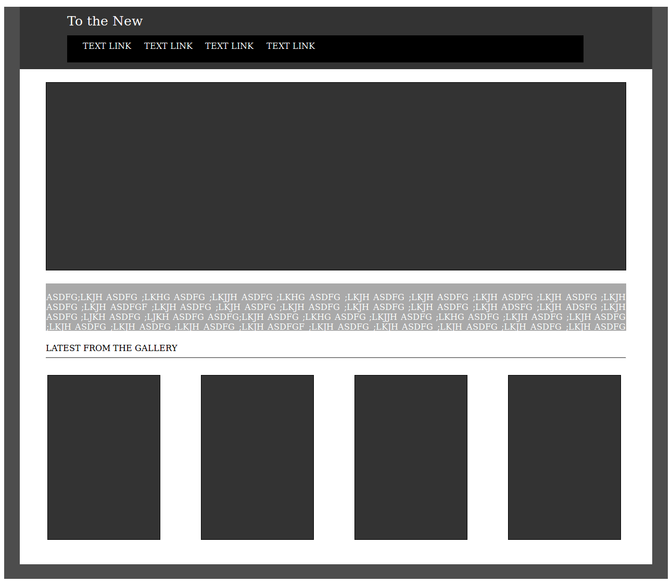

Ans 12.

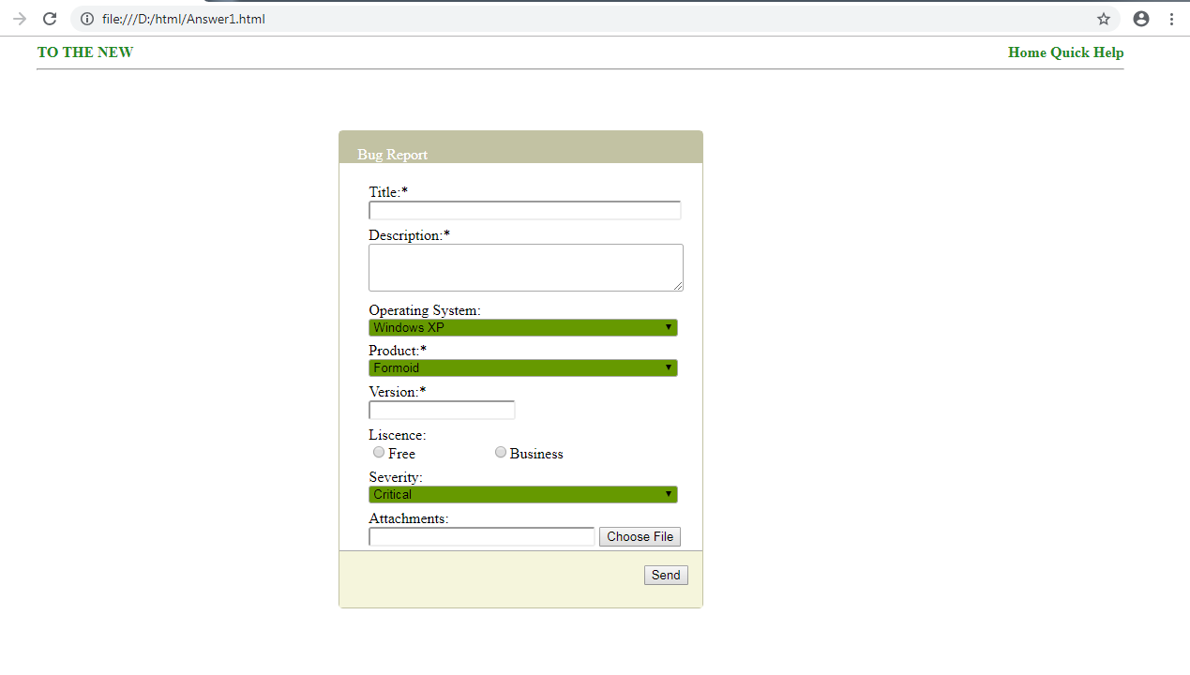

<!DOCTYPE html>

<html>

<head>

<style>

.form-main

{

border: 1px solid #c2c2a3;

width: 30%;

height: 100%;

margin-left: 30%;

margin-top: 5%;

border-radius: 5px;

}

.form-head

{

background-color:#c2c2a3;

height:5%;

padding-left: 2%;

padding-top: 4%;

color: white;

font-weight: 400;

}

#bugReportlbl

{

margin-left: 3%;

}

.form-details

{

padding-left: 8%;

padding-right: 4%;

padding-top: 4%;

}

.txt

{

width :97%;

border-radius: 3px;

}

#versiontxt

{

width:45%;

border-radius: 3px;

}

.field

{

margin-top: 2%;

}

.dropdown

{

background-color: #669900;

}

#fileTxt

{

width:70%;

}

.form-footer

{

margin-top:1%;

text-align: right;

background-color: beige;

height: 30px;

padding:15px;

border-top: 1px solid darkgrey;

}

#companyName

{

float: left;

}

#utils

{

text-align: right;

}

.head

{

width: 90%;

margin-left: 5%;

color: forestgreen;

font-weight: 700;

}

a

{

text-decoration: none;

}

</style>

</head>

<body link="forestgreen">

<div class="head">

<div id="companyName">

TO THE NEW

</div>

<div id="utils">

<a href="#">Home</a>

<a href="#">Quick Help</a>

</div>

<hr>

</div>

<div class="form-main">

<div class="form-head">

<label id="bugReportlbl">Bug Report</label>

</div>

<form autocomplete="on">

<div class= "form-details">

<div class="field">

<label>Title:*</label><br>

<input type="text" class="txt" required autofocus>

</div>

<div class="field">

<label>Description:*</label><br>

<textarea class="txt" rows="3" required></textarea>

</div>

<div class="field">

<label>Operating System:</label><br>

<select class="txt dropdown">

<option>Windows XP</option>

<option>Linux</option>

<option>IOS</option>

</select>

</div>

<div class="field">

<label>Product:*</label><br>

<select class="txt dropdown" required>

<option>Formoid</option>

<option>Xyz</option>

<option>Abc</option>

</select>

</div>

<div class="field">

<label>Version:*</label><br>

<input type="text" id="versiontxt" required>

</div>

<div class="field">

<label>Liscence:</label><br>

<input type="radio" name="one">Free

&nbsp;&nbsp;&nbsp;&nbsp;&nbsp;&nbsp;&nbsp;&nbsp;&nbsp;&nbsp;&nbsp;&nbsp;&nbsp;&nbsp;&nbsp;&nbsp;&nbsp;&nbsp;

<input type="radio" name="one">Business

</div>

<div class="field">

<label>Severity:</label><br>

<select class="txt dropdown">

<option>Critical</option>

<option>Normal</option>

</select>

</div>

<div class="field">

<label>Attachments:</label><br>

<input type="text" class="txt" id="fileTxt">

<input type="button" id="filebtn" value="Choose File">

</div>

</div>

<div class="form-footer">

<input type="submit" value= send>

</div>

</form>

</div>

</body>

</html>