### **Introduction to Java 1**

**Ans 1**

/*Write a program to replace a substring inside a string with other string

*/

**public class** MyString {

**public static void** main(String[] args) {

String str = **"Hello, Everyone"**;

String stringToReplaceWith =**"Welcome"**;

String subString= str.substring(3, 7);

System.***out***.println(**"Original string :"**+str);

System.***out***.println(str.replace(subString,stringToReplaceWith));

}

}

Output:

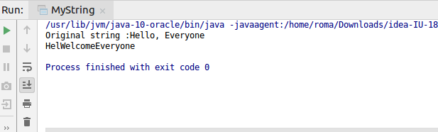

**Ans 2**

/*Write a program to find the number of occurrences of the duplicate words in a string and print them

*/

**public class** FindDuplicateWordsInString

{

**public static void** main(String[] args)

{

String string = **"Hello lets meet Hello ok will meet"**;

System.***out***.println(**"Original string: "**+string);

String[] stringWords = string.split(**" "**);

**int** found=1;

**for**(**int** i=0;i<stringWords.**length**;i++)

{

**for**(**int** j=i+1;j<stringWords.**length**;j++)

{

**if**(stringWords[i].equals(stringWords[j]))

{

found=found+1;

stringWords[j]=**"0"**;

}

}

**if**(stringWords[i]!=**"0"**)

{

System.***out***.println(stringWords[i]+**" "**+found);

found=1;

}

}

}

}

Output:

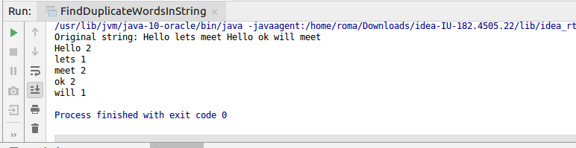

**Ans 3**

/*Write a program to find the number of occurrences of a character in a string without using loop

*/

**import** java.util.Scanner;

**public class** CountOccurances {

**public static void** main(String[] args) {

Scanner sc = **new** Scanner(System.***in***);

System.***out***.println(**"Enter a String"**);

String s = sc.next().toLowerCase();

System.***out***.println(**"Enter a character to count in the string "** + s);

**char** c = sc.next().charAt(0);

**int** countcharacters = *countCharacters*(s, c, 0, 0);

System.***out***.println(c + **" occurs "** + countcharacters + **" times in "** + s);

sc.close();

}

**private static int** countCharacters(String s, **char** c, **int** index, **int** count) {

**if** (index < s.length()) {

**if** (c == s.charAt(index)) {

count++;

}

index++;

count = *countCharacters*(s, c, index, count);

}

**return** count;

}

}

Output:

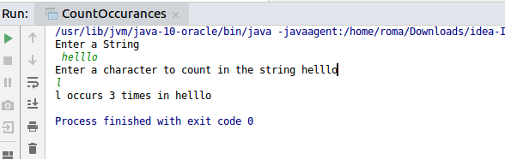

**Ans 4**

/*Calculate the number & Percentage Of Lowercase Letters,Uppercase Letters, Digits And Other Special Characters In A String

*/

**import** java.util.Scanner;

**public class** Count {

**public static void** main(String[] args) {

**int** uppercount=0;

**int** lowercount=0;

**int** digitcount=0;

**int** specialcharacter=0;

System.***out***.println(**"Please enter a string"**);

Scanner scanner = **new** Scanner(System.***in***);

String string = scanner.nextLine();

**int** length = string.length();

**for**(**int** i=0;i<length;i++)

{

**char** [] array = string.toCharArray();

**char** ch = array[i];

**if**((Character.*isUpperCase*(ch)))

{

uppercount++;

}

**else if**(Character.*isLowerCase*(ch))

{

lowercount++;

}

**else if**(Character.*isDigit*(ch))

{

digitcount++;

}

**else**

specialcharacter++;

}

System.***out***.println(**"Number of Lowercase Characters and its percentage: "**+lowercount +**" "**+(**double**)(lowercount*100)/length+**"%"**);

System.***out***.println(**"Number of Digits Characters and its percentage: "**+digitcount +**" "**+(**double**)(digitcount*100)/length+**"%"**);

System.***out***.println(**"Number of special Characters and its percentage: "**+specialcharacter+ **" "**+(**double**)(specialcharacter*100)/length+**"%"**);

System.***out***.println(**"Number of Uppercase Characters and its percentage: "**+uppercount+**" "**+(**double**)(uppercount*100)/length+**"%"**);

}

}

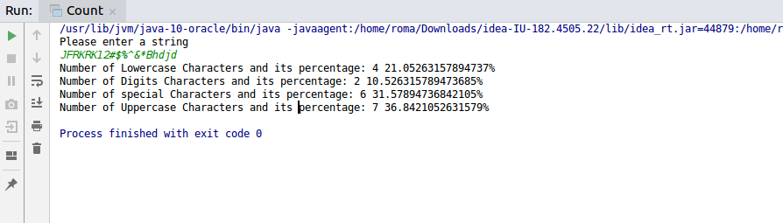

**Ans 5**

/*Find common elements between two arrays

*/

**public class** CommonArrayElements {

**public static void** main(String[] args) {

**int**[] arrayOne = {1,2,3,4,5,6,7};

**int**[] arrayTwo = {1,7,8,9,2,4};

System.***out***.println(**"Array One is"**);

**for**(**int** k=0;k<arrayOne.**length**;k++)

{

System.***out***.print(arrayOne[k]);

}

System.***out***.println(**"\nArray Two is"**);

**for**(**int** k=0;k<arrayTwo.**length**;k++)

{

System.***out***.print(arrayTwo[k]);

}

System.***out***.println(**"\nCommon elements in both arrays are:"**);

**for**(**int** i=0;i<arrayOne.**length**;i++)

{

**for**(**int** j=0;j<arrayTwo.**length**;j++)

{

**if**(arrayOne[i]==arrayTwo[j])

{

System.***out***.print(+arrayOne[i]+**" "**);

}

}

}

}

}

Output:

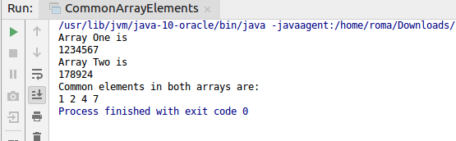

**Ans 6**

/*There is an array with every element repeated twice except one. Find that element

*/

**public class** UniqueArrayElement {

**public static void** main(String[] args) {

**int**[] array = {1, 2, 3, 4, 5, 1, 3, 4, 5};

**int** result = array[0];

**int** arraysize = array.**length**;

System.***out***.println(**"\nUnique element in the above array is "**+*findUnique*(array, arraysize));

}

**static int** findUnique(**int** ar[], **int** arraysize)

{

**int** res = ar[0];

**for** (**int** i = 1; i < arraysize; i++) {

res = res ^ ar[i];

}

**return** res;

}

}

Output:

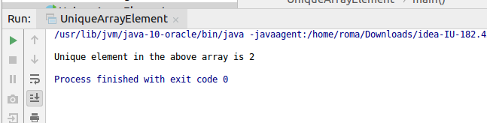

**Ans 7**

/*Write a program to print your Firstname,LastName & age using static block,static method & static variable respectively

*/

**public class** Employee {

**static** String *firstName*;

**static** String *lastName*;

**static double** *age*;

**public static void** main(String[] args) {

*getEmployeeDetails*();

}

**static**

{

System.***out***.println(**"Hello this is static block"**);

*firstName* = **"Roma"**;

*lastName* = **"Bhatnagar"**;

*age* = 23.0;

}

**static void** getEmployeeDetails(){

System.***out***.println(**"First name : "**+*firstName*+ **" Last Name: "**+*lastName*+ **" "**+**" Age is: "**+*age*);

}

}

Output:

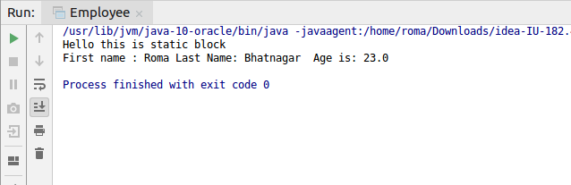

**Ans 8.**

/*Write a program to reverse a string and remove character from index 4 to index 9 from the reversed string using String Buffer

*/

**public class** ReverseString {

**public static void** main(String[] args) {

StringBuffer string= **new** StringBuffer(**"heellllo newers"**);

System.***out***.println(**"Original string is "**+string);

System.***out***.println(**"Reversed string is "**+string.reverse());

string.replace(4, 9,**""**);

System.***out***.println(**"Starting from index 4 till index 9 and replacing with blank"** +**""**);

System.***out***.println(string);

}

}

Output:

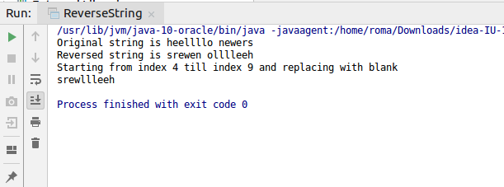

**Ans 9.**

/*Write a program to display values of enums using a constructor & getPrice() method (Example display house & their prices)

*/

**public class** HouseDetails {

HouseType **type**;

Double **price**;

String **location**;

HouseDetails(Double price, String location)

{

**this**.**price** = price;

**this**.**location** = location;

}

**public static void** main(String[] args) {

HouseDetails house1 = **new** HouseDetails(3000.89,**"Chandigarh"**);

house1.**type** = HouseType.***SMALL***;

HouseDetails house2 = **new** HouseDetails(40000.78,**"Goa"**);

house2.**type** = HouseType.***BIG***;

HouseDetails house3 = **new** HouseDetails(5000000.7,**"Malaysia"**);

house3.**type** = HouseType.***HUGE***;

System.***out***.println(**"Price of house is "**+house1.getPrice());

System.***out***.println(**"Type of house is "**+house1.**type**);

System.***out***.println(**"Price of house is "**+house2.getPrice());

System.***out***.println(**"Type of house is "**+house2.**type**);

System.***out***.println(**"Price of house is "**+house3.getPrice());

System.***out***.println(**"Type of house is "**+house3.**type**);

}

Double getPrice()

{

**return this**.**price**;

}

**enum** HouseType{ ***SMALL***, ***BIG***, ***HUGE***};

}

Output:

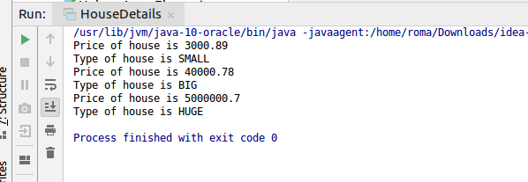

**Ans 10.**

/*Write a single program for following operation using overloading

A) Adding 2 integer number

B) Adding 2 double

C) multiplying 2 float

D) multiplying 2 int

E) concate 2 string

F) Concate 3 String

*/

**public class** Operation {

**public static void** main(String[] args) {

Operation operation1 = **new** Operation();

System.***out***.println(operation1.add(4, 29));

System.***out***.println(operation1.add(4.858494, 9.889));

System.***out***.println(operation1.multiply(4, 700));

System.***out***.println(operation1.multiply(4.65f, 70.0f));

System.***out***.println(operation1.concatStrings(**"hii "**, **"I am at TTN"**));

System.***out***.println(operation1.concatStrings(**"Ok"**, **" lets"**, **" work"**));

}

**int** add(**int** a, **int** b)

{

**return** a+b;

}

**double** add(**double** a, **double** b)

{

**return** a+b;

}

**float** multiply(**float** a, **float** b)

{

**return** a*b;

}

**int** multiply(**int** a, **int** b)

{

**return** a*b;

}

String concatStrings(String stringOne, String stringTwo)

{

**return** stringOne.concat(stringTwo);

}

String concatStrings(String stringOne, String stringTwo, String stringThree)

{

**return** stringOne.concat(stringTwo).concat(stringThree);

}

}

Output:

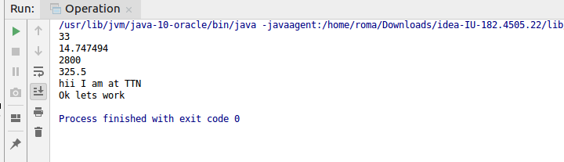

**Ans 11.**

/*Create 3 sub class of bank SBI,BOI,ICICI all 4 should have method called getDetails which provide there specific details like rateofinterest etc,print details of every banks

*/

**abstract class** Bank {

**int branchId**;

String **branchLocation**;

**double branchRateOfInterest**;

**void** getBankDetails()

{

System.***out***.println(**"Details of branch "**+(**this**.getClass()));

System.***out***.println(**"Branch ID is "**+**this**.**branchId**);

System.***out***.println(**"Branch location is "**+**this**.**branchLocation**);

System.***out***.println(**"Rate of interset is "**+**this**.**branchRateOfInterest**);

}

}

**class** SBI **extends** Bank

{

SBI()

{

**this**.**branchId** = 100;

**this**.**branchLocation** = **"East park road"**;

**this**.**branchRateOfInterest** = 3.67;

}

@Override

**void** getBankDetails() {

**super**.getBankDetails();

}

}

**class** BOI **extends** Bank

{

BOI()

{

**this**.**branchId** = 200;

**this**.**branchLocation** = **"Paharganj"**;

**this**.**branchRateOfInterest** = 4.7;

}

@Override

**void** getBankDetails() {

**super**.getBankDetails();

}

}

**class** ICICI **extends** Bank

{

ICICI()

{

**this**.**branchId** = 300;

**this**.**branchLocation** = **"noida"**;

**this**.**branchRateOfInterest** = 2.67;

}

@Override

**void** getBankDetails() {

**super**.getBankDetails();

}

**public static void** main(String[] args) {

SBI sbi = **new** SBI();

sbi.getBankDetails();

}

}

Output:

