**JQuery Exercise Solved**

1. Console "Hello Word" in document.ready function

Ans. jQuery(document).ready(function(){console.log("hello world")})

1. Select a ID name "#test" and add class "load" when DOM is loaded

Ans. jQuery(document.ready(function(){

$(“#test”).addClass(“load”);

}))

1. Change the color of element which class name end with "-new"

Ans. <html>

<head>

<title>Q3</title>

<script src="https://ajax.googleapis.com/ajax/libs/jquery/3.3.1/jquery.min.js" ></script>

</script>

<script type = "text/javascript">

$(document).ready(function(){

$("button").click(function(){

$("[class$=-new]").css("color","red");

});

});

</script>

</head>

<body>

<p class="class-new">Change Colour</p>

<button>change color of an element</button>

</body>

</html>

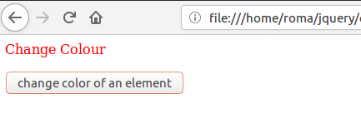

1. Disable submit button using jquery attr method

Ans.

<html>

<head>

<title>Q4</title>

<script src="https://ajax.googleapis.com/ajax/libs/jquery/3.3.1/jquery.min.js" ></script>

</script>

<script type = "text/javascript">

$(document).ready(function(){

$('#my-id').click(function(){

$(this).prop('disabled',true);

$("#content").show();

setTimeout(function(){

$('#my-div’).prop('disabled',false);

},3000);

});

});

</script>

</head>

<body>

<div>

<input type="submit" name="" value="Click me to Disable" id="my-id" class="">

</div>

<div id="content">Disable for 3 seconds.</div>

</body>

</html>

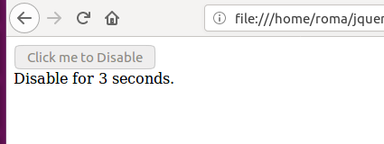

1. Change the font size of ".target" which has parent element with id name "#main"

Ans. <html>

<head>

<title>Q5</title>

<script src="https://ajax.googleapis.com/ajax/libs/jquery/3.3.1/jquery.min.js" ></script>

</script>

<script type = "text/javascript">

$(document).ready(function(){

$("button").click(function(){

$("#main").css({fontSize:"50px"});

});

});

</script>

</head>

<body>

<button>Change font size</button>

<br><b>

<div id="main">

<div>.target</div>

</div>

</div>

</body>

</html>

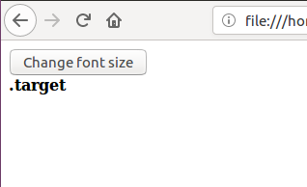 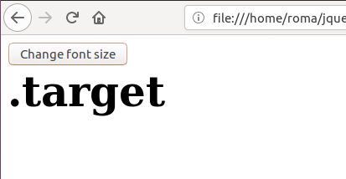

1. After page load change the HTML of div element with "p" element

Ans.

<html>

<head>

<title>Q6</title>

<script src="https://ajax.googleapis.com/ajax/libs/jquery/3.3.1/jquery.min.js" ></script>

<script type = "text/javascript">

$(document).ready(function(){

$("button").click(function(){

var el = $("<p>I am p element</p>", {class: "myClass"});

$("div.testClass").replaceWith(el);

});

});

</script>

</head>

<body>

<button>Change html</button>

<div id="main">

<div class="testClass">I am div element</div>

</div>

</body>

</html>

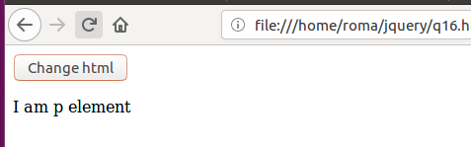

1. Bind a click function to an "click" element and append next "click" next to it.

Ans. <!DOCTYPE html>

<head>

<meta charset="utf-8"/>

<title>test of click binding</title>

<script src="https://code.jquery.com/jquery-1.12.4.min.js"></script>

<script type="text/javascript">

jQuery(function(){

link = $('<a class="add_to_this" href="#">Click here</a>');

link.bind("click", function(){

$(".nested-div").insertAfter(".add_to_this").append("click"));

});

$('.add_to_this').append(link);

});

</script>

</head>

<body>

<div class="add_to_this" >

<p>The link is created, then added here below:</p>

<div class="nested-div" style="display: inline;">

</div>

</body>

</html>

1. Click event not working on element which added dynamically or via script, make it work using .on method

Ans.

<!DOCTYPE html>

<html lang="en">

<head>

<meta charset="utf-8">

<title>jQuery Bind Click Event to Dynamically added Elements</title>

<script src="https://code.jquery.com/jquery-1.12.4.min.js"></script>

<script type="text/javascript">

$(document).ready(function(){

$("button").click(function(){

$("ol").append("<li>list item <a href='#' class='remove'>&times;</a></li>");

});

$(document).on("click", "a.remove" , function() {

$(this).parent().remove();

});

});

</script>

</head>

<body>

<button>Add new list item</button>

<p>Click the above button to dynamically add new list items. You can remove it later.</p>

<ol>

<li>list item</li>

<li>list item</li>

<li>list item</li>

</ol>

</body>

</html>

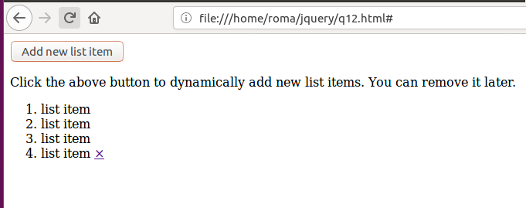

1. Get dropdown selected value on onchanage event and append in div container

Ans. <!DOCTYPE html>

<html>

<head>

<meta charset="utf-8"/>

<link rel="stylesheet" href="https://maxcdn.bootstrapcdn.com/bootstrap/3.3.7/css/bootstrap.min.css">

<script src="https://ajax.googleapis.com/ajax/libs/jquery/3.3.1/jquery.min.js"></script>

<script src="https://maxcdn.bootstrapcdn.com/bootstrap/3.3.7/js/bootstrap.min.js"></script>

<script type="text/javascript">

function GetSelectedIndex() {

var selectedText = $("#dropdown").find("option:selected").text();

var selectedValue = $("#dropdown").val();

$(".my-div").append(selectedText);

}

</script>

</head>

<body>

<div>

<select id="dropdown" onchange="GetSelectedIndex()">

<option value="0">Select</option>

<option value="1">User</option>

<option value="2">Admin</option>

<option value="3">Super Admin</option>

</select>

<div class="my-div" style="display: inline"></div>

</div>

</body>

</html>

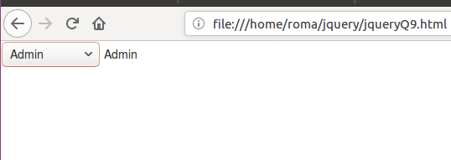

1. Create a dropdown menu using hover method in jquery
2. On clicking on "[google](https://www.google.com)" tag. It is taking us to google home page. Stop it from happening.

Ans. <html>

<head>

<title>Q5</title>

<script src="https://ajax.googleapis.com/ajax/libs/jquery/3.3.1/jquery.min.js" ></script>

</script>

<script type = "text/javascript">

$(document).ready(function(){

$("a").click(function(event){

event.preventDefault();

alert("Was preventDefault() called: " + event.isDefaultPrevented());

});

});

</script>

</head>

<body>

<div id="main">

<div class="testClass">Remove default behaviour of link</div>

<a href="https://www.google.com/">google</a>

</div>

</div>

</body>

</html>

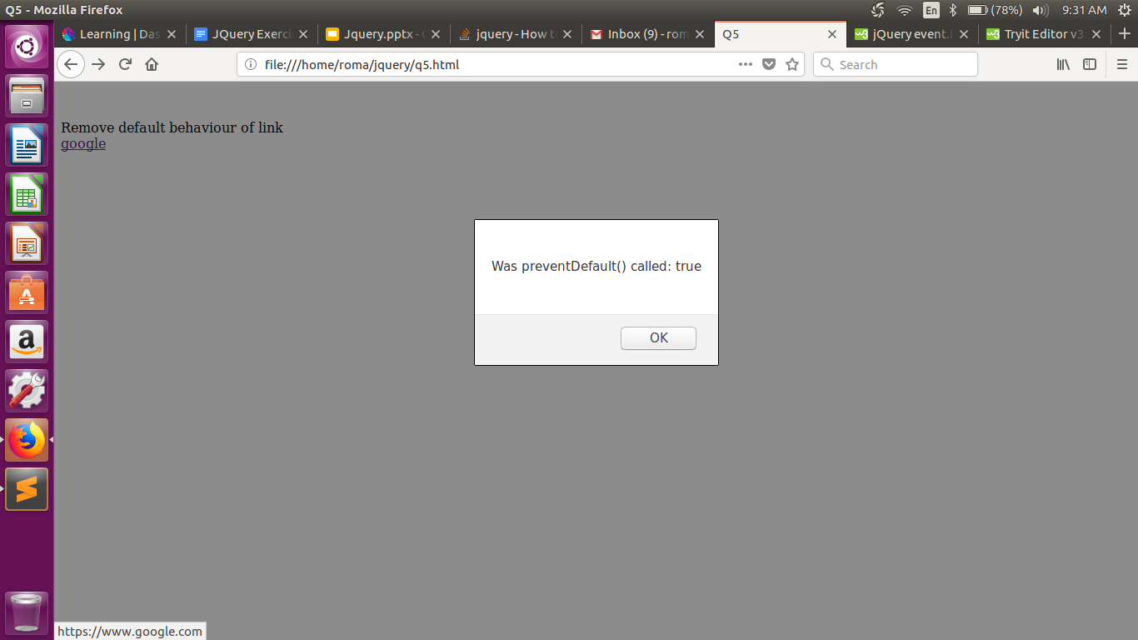

1. We have bind a click function to parent div but we want to stop it from performing when user clicks on its child li

Ans. <!DOCTYPE html>

<html>

<head>

<script src="https://ajax.googleapis.com/ajax/libs/jquery/3.3.1/jquery.min.js"></script>

<script>

$(document).ready(function(){

$("span").click(function(event){

event.stopPropagation();

alert("The span element was clicked.");

});

$("p").click(function(event){

alert("The p element was clicked.");

});

$("div").click(function()

{

alert("The div element was clicked.");

});

});

</script>

</head>

<body>

<div style="height:100px;width:500px;padding:10px;border:1px solid blue;background-color:lightblue;">

I am a div element.

<p style="background-color:yellow; height: 50px">I am a p element in the div element. <br><span style="background-color:lightgreen">I am a span element in the p and the div element.</span></p></div>

</body>

</html>

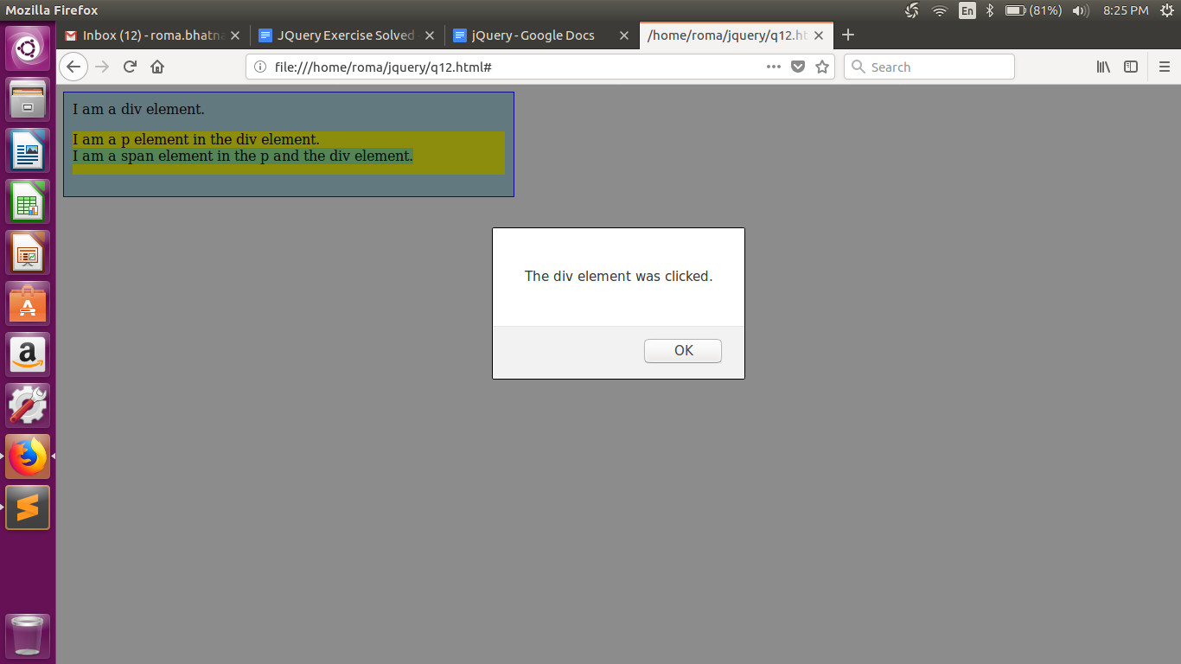

1. Get the max height of elements using jquery each method

Ans. <!DOCTYPE html>

<html>

<head>

<script src="https://ajax.googleapis.com/ajax/libs/jquery/3.3.1/jquery.min.js"></script>

<style>

#display-div

{

border:2px solid lightgreen;

border-radius: 10px;

height:200px;

width:200px;

}

</style>

</head>

<body>

<div>

<ul id="ulid">

<li>First li element</li>

<li>Second li element</li>

<li>Third li element</li>

</ul>

</div>

<div id="display-div">

&nbsp;&nbsp;Max Height:<br>

</div>

<script>

var i = 0;

$("li").each(function() {

i++;

var h = $(this).height();

$("#display-div").append("<br>&nbsp;&nbsp;&nbsp;&nbsp;"+i+".&nbsp;"+h+"<br>");

});

</script>

</body>

</html>

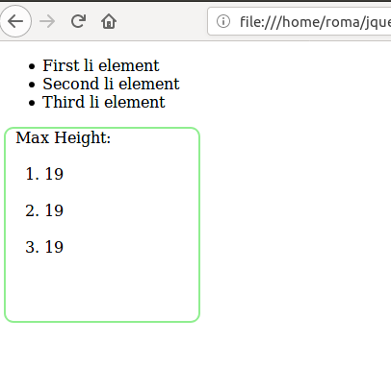

1. Change color of every cell which has number larger than 10.

Ans. <html>

<head>

<style>

.cell1 { border:1px solid black; background:#eee; padding:10px; }

</style>

<script src ="https://code.jquery.com/jquery-3.3.1.min.js"

integrity="sha256-FgpCb/KJQlLNfOu91ta32o/NMZxltwRo8QtmkMRdAu8="

crossorigin="anonymous"></script>

</head>

<body>

<table>

<tr>

<td class="cell1">20</td>

<td class="cell1">5</td>

<td class="cell1">1</td>

<td class="cell1">3</td>

<td class="cell1">10</td>

<td class="cell1">15</td>

</tr>

</table>

</body>

<script>

$('.cell1').each(function(i, n) {

if($(n).text() > 10)

$(n).css('background', 'red');

});

</script>

</html>

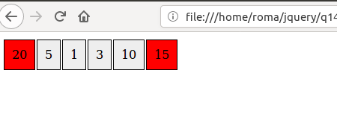

1. Retrive the data from server using ajax get call

Ans.

<html>

<head>

<script src="https://ajax.googleapis.com/ajax/libs/jquery/3.1.1/jquery.min.js">

</script>

</head>

<body>

<script>

$.ajax({

type: "GET",

url: "https://reqres.in/api/users/1",

success: function(result) {

$("#div1").text(JSON.stringify(result))

console.log(JSON.stringify(result));

}

});

</script>

<div id="div1">

</div>

</body>

</html>

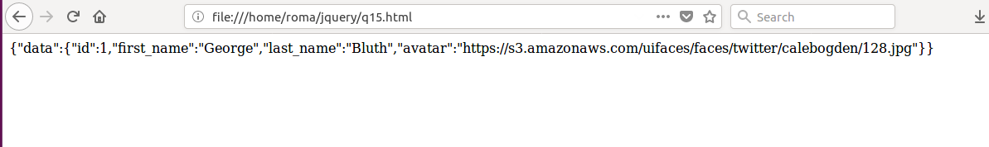

1. Add cross button on row and bind click function which make a delete request to server, after success event remove the row from dom

Ans.

<html>

<head>

<a href="http://jquery.com"></a>

<script src="https://ajax.googleapis.com/ajax/libs/jquery/3.3.1/jquery.min.js"></script>

<style>

table, th, td {

border: 1px solid black;

}</style>

</head>

<body>

<table id="table1">

<tr>

<td>12</td>

<td>42</td>

<td>86</td>

<td>123</td>

<td>41</td>

<td><img src="/home/roma/Pictures/cross.jpeg"width="20" height="40" id="btn"/></td>

</tr>

<tr>

<td>98</td>

<td>32</td>

<td>9</td>

<td>3</td>

<td>16</td>

<td><img src="/home/roma/Pictures/cross.jpeg" width="20" height="40" id="btn"/></td>

</tr>

<tr>

<td>0</td>

<td>28</td>

<td>826</td>

<td>12</td>

<td>10</td>

<td><img src="/home/roma/Pictures/cross.jpeg" width="20" height="40" id="btn"/></td>

</tr>

<tr>

<td>1</td>

<td>28</td>

<td>6</td>

<td>6</td>

<td>4</td>

<td><img src="/home/roma/Pictures/cross.jpeg" width="20" height="40"

id="btn"/></td>

</tr>

<tr>

<td>12</td>

<td>92</td>

<td>8</td>

<td>23</td>

<td>1</td>

<td><img src="/home/roma/Pictures/cross.jpeg" width="20" height="40" id="btn"/></td>

</tr>

</table>

<script type="text/javascript">

$('table').on('click',function(e){

if(e.target.id=="btn"){

$.ajax({

url: "https://reqres.in/api/users/2",

async: true,

success: function(result) {

console.log("Success");

$(e.target).closest('tr').remove();

}

,failure : function(response){

console.log("Failed");

}});

}

});

</script>

</body>

