**JavaScript Exercise Solved**

**Q 1.**Prompt for amount, interest rate and no. of years and calculate simple interest.

**Ans 1.**

<!DOCTYPE html>

<html>

<head>

<link rel="stylesheet" href="https://maxcdn.bootstrapcdn.com/bootstrap/3.3.7/css/bootstrap.min.css">

<script type="text/javascript">

function calculateInterest()

{

amount = document.getElementById("amount").value;

years = document.getElementById("years").value;

rate = document.getElementById("rate").value;

result = document.getElementById("result");

result.innerHTML = "Interest calculated is " + (amount*years*rate/100);

}

</script>

<style>

.container

{

border: 1px dotted black;

height: 30%;

width: 50%;

}

</style>

</head>

<body>

<div class="page-header">

<div class="container">

<form class="form-inline">

<div class="form-group">

<label for="amount">Amount:</label>

&nbsp;&nbsp;&nbsp;

<input type="text" name="amount" id="amount"placeholder="enter amount here">

<br><br>

<label for="rate">Rate:</label>

<input type="text" name="rate" id="rate" placeholder="enter rate here">

<br><br>

<label for="years">Years:</label>

<input type="text" name="years" id="years" placeholder="enter years here">

<br><br>

<input type="submit" name="submit" value="calculate" onclick="calculateInterest()">

<br>

<label for="result" id="result"></label>

</div>

</form>

</div>

</div>

</body>

</html>

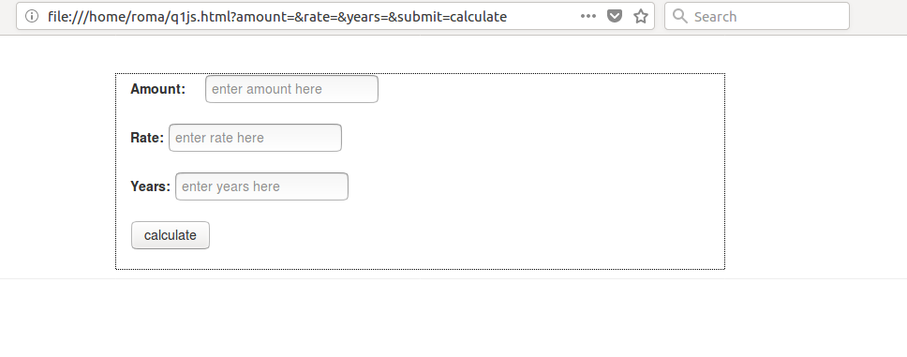

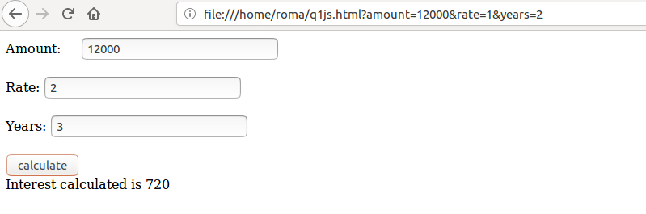

**OR [using prompt]**

<!DOCTYPE html>

<html>

<head>

<title>Simple Interest</title>

</head>

<script type="text/javascript">

function simple()

{

var p,r,t;

p=parseFloat(prompt("enter principle amount"));

r=parseFloat(prompt("enter rate amount"));

t=parseFloat(prompt("enter time(year)"));

var si=(p*r*t)/100;

document.write("simple interest is: "+si);

}

</script>

<body>

<center>

<input type="button" value="calculate simple interest" onclick="simple()"/>

</center>

</body>

</html>

**Q 2** is palindrome string

**Ans 2.**

var string = prompt("Enter string to check for palindrome");

console.log(string);

var isPalindrome = function (string) {

if (string == string.split('').reverse().join('')) {

alert(string + ' is palindrome.');

console.log(string +' is palindrome ');

}

else {

alert(string + ' is not palindrome.');

console.log(string +' is not a palindrome ');

}

}

isPalindrome(string);

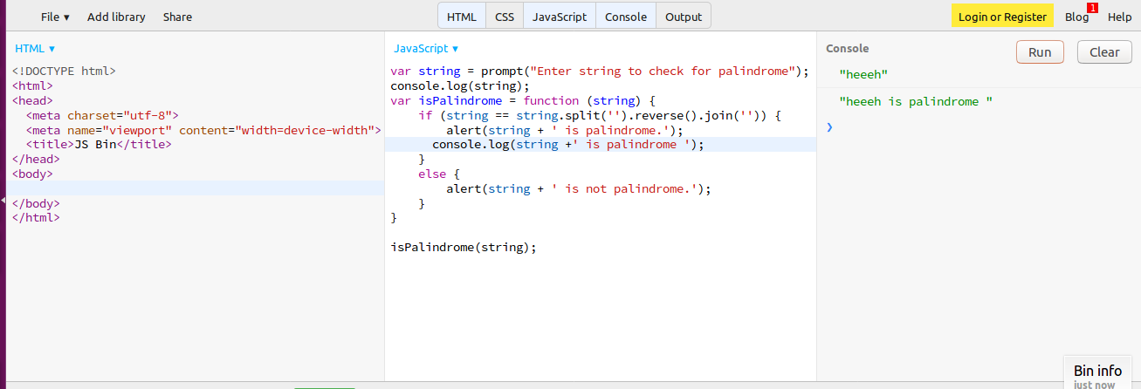

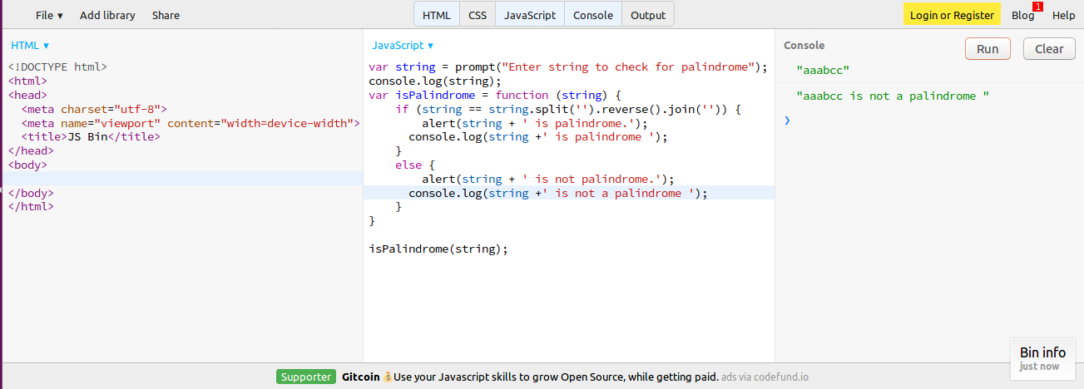

**Q 3** Area of circle

**Ans 3.**

<!DOCTYPE html>

<html>

<head>

<script src="https://ajax.googleapis.com/ajax/libs/jquery/3.3.1/jquery.min.js"></script>

<script src="https://maxcdn.bootstrapcdn.com/bootstrap/3.3.7/js/bootstrap.min.js"></script>

<script type="text/javascript">

function calculateArea()

{

radius =document.getElementById("radius").value;

result.innerHTML ="Area of circle with radius "+radius+" is " +(22/7*radius*radius);

}

</script>

</head>

<body>

<h4>AREA CALCULATOR:</h4>

<label for="radius">Radius:</label>

<input type="text" id="radius" placeholder="Enter Radius">

&nbsp;&nbsp;

<input type="submit" value="calculate" onclick="calculateArea()">

<label for="result" id="result"></label>

</body>

</html>

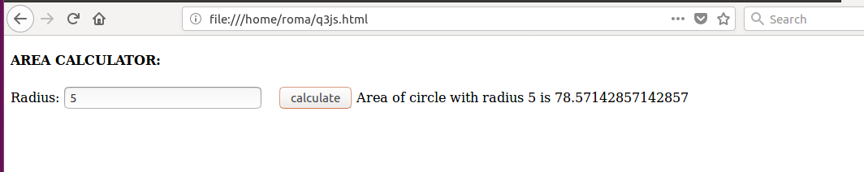

**Q 4** Copy information of one object to another and log it to console.

**Ans 4.** <!DOCTYPE html>

<html>

<head>

<script type="text/javascript">

var studentObject = {

Name:'Roma Bhatnagar',

Department: 'Delivery',

Technology: 'JVM'

};

console.log(studentObject);

var copyObject =studentObject;

console.log(copyObject);

</script>

</head>

<body>

</body>

</html>

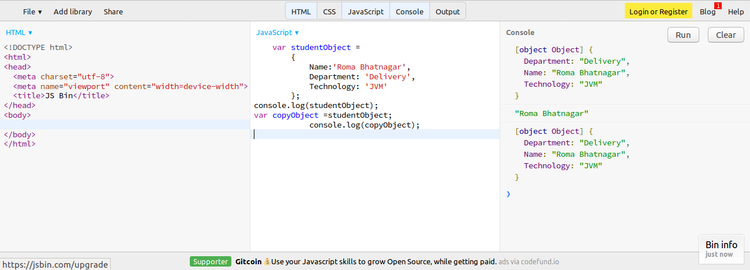

**Q5**

**Ans 5.**

**1.**create a list of objects of Employee with info as follow :

Name, age, salary ,DOB

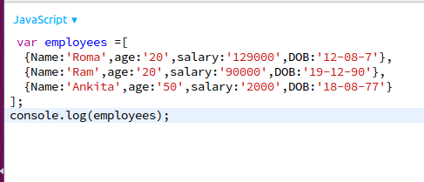

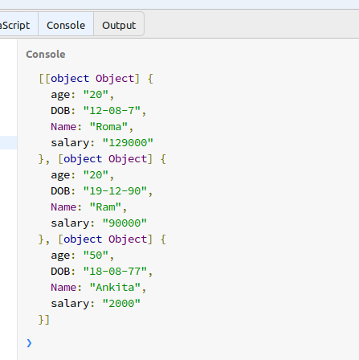

**2.** filter all employees with salary greater than 5000

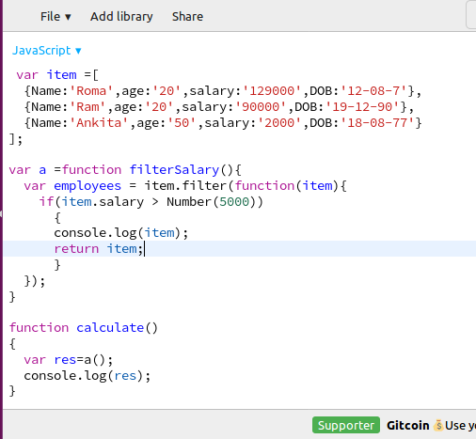

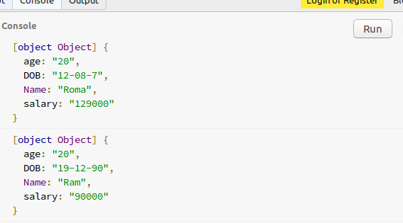

**3.** group employee on the basis of their age

var employee =[

{Name:'Roma',age:'20',salary:'129000',DOB:'12-08-7'},

{Name:'Ram',age:'20',salary:'90000',DOB:'19-12-90'},

{Name:'Ankita',age:'50',salary:'2000',DOB:'18-08-77'}

];

var groupEmployees = function()

{

var young =new Array(5);

var medium= new Array(5);

var old = new Array(5);

for(var a in employee)

{

var checkAge =25;

if(a.age >checkAge)

old.push(a.Name);

if(a.age<=25)

young.push(a.Name);

else

medium.push(a.Name);

}

};

groupEmployees();

**4.** fetch employees with salary less than 1000 and age greater than 20. Then give them an increment 5 times their salary.

var employee={

"employees":[

{"name":"Roma", "age":23,"salary":17000,"dob":19121994},

{"name":"Pravin", "age":22,"salary":200,"dob":05061994},

{"name":"Rohan", "age":24,"salary":17000,"dob":05101992},

{"name":"Subia", "age":22,"salary":15000,"dob":10115995},

{"name":"Rohan", "age":24,"salary":1700,"dob":05101992},

{"name":"Manu", "age":18,"salary":240,"dob":15101988},

{"name":"Pritu", "age":38,"salary":24000,"dob":15101988},

{"name":"Deepak", "age":28,"salary":220,"dob":15101988}

]

}

console.log(employee.employees.length);

var i=0;

for(var x=0;x< employee.employees.length;x++)

{

if(employee.employees[x].salary>5000)

console.log(employee.employees[x].name);

}

for(var x=0;x< employee.employees.length;x++)

{

if(employee.employees[x].salary<1000 && employee.employees[x].age>20)

console.log("increased salary: " + employee.employees[x].salary * 5);

}

