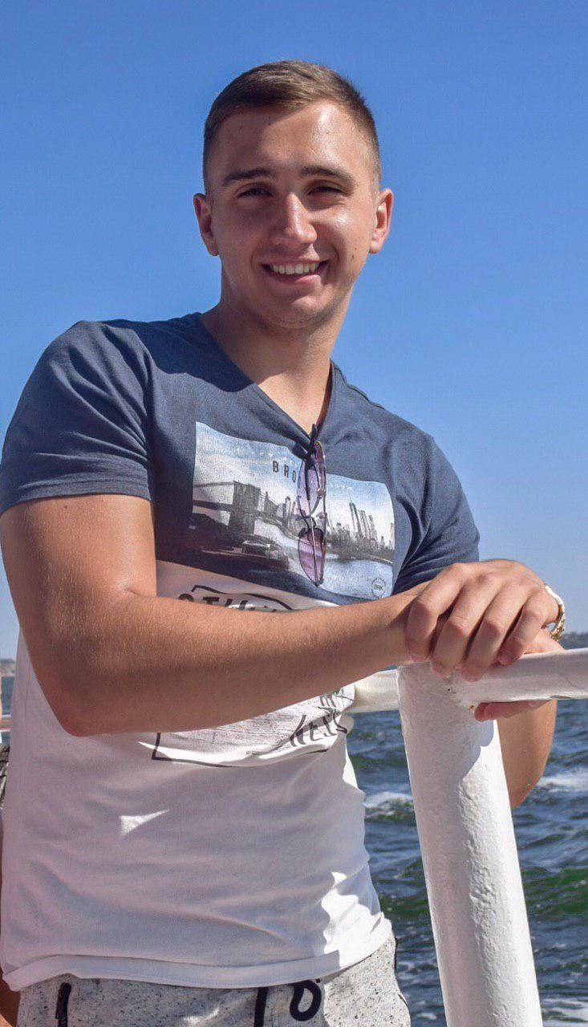

Contact information

|  |  |  |  |  |
| --- | --- | --- | --- | --- |
| Phone: +380737772873  Email: ferencrman@gmail.com  Facebook: fb.me/roma.dmn  LinkedIn: linkedin.com/in/romadmn/  Instagram: instagram.com/roma.dmn | | | Roman Ferents | |
|  | | Future software developer :) | | |
|  | | | | |
| Summary of Qualifications | Learning new programming languages and technologies and complete projects within specified deadlines. | | | |
|  | | | | |
| Soft skills | Very energetic and ready to take new challenges | | |  |
|  | | | | |
| Technical skills | — Programming languages: HTML, CSS, Javascript, C/C++/C#  — MVC, .NET Core, Console Applications, WPF, Xamarin— Development tools: Visual Studio, VS Code, Git Bash, Command Prompt— Operating systems: Windows— Database systems: MySQL, MSSQL, Entity Framework— Object modeling, Design Patterns, SOLID— Version control systems: Git | | |
|  |  | | | |
| Experience / IT related educational practice | Performed various laboratory work using various libraries etc. | | | |
|  |  | | | |
|  |  | | | |
|  |  | | | |
|  |  | | | |
| Languages | Ukrainian – Native Speaker | | | |
| Russian – Native Speaker | | | |
| English – Pre-Intermediate | | | |
|  |  | | | |
| Education | Lviv Polytechnic National University  Computer Engineering  2016 – Present. | | | |
|  | | | |
|

|  |  |
| --- | --- |
| Several facts about me | I prefer a healthy lifestyle like traveling, biking and so on. Going to the gym twice a week.  I am free of the bad habits.  I can find the optimal way from difficult situation by myself in short time period.  I have a pet. It is the dog named “Rex” 😊 |