Roman Ferents  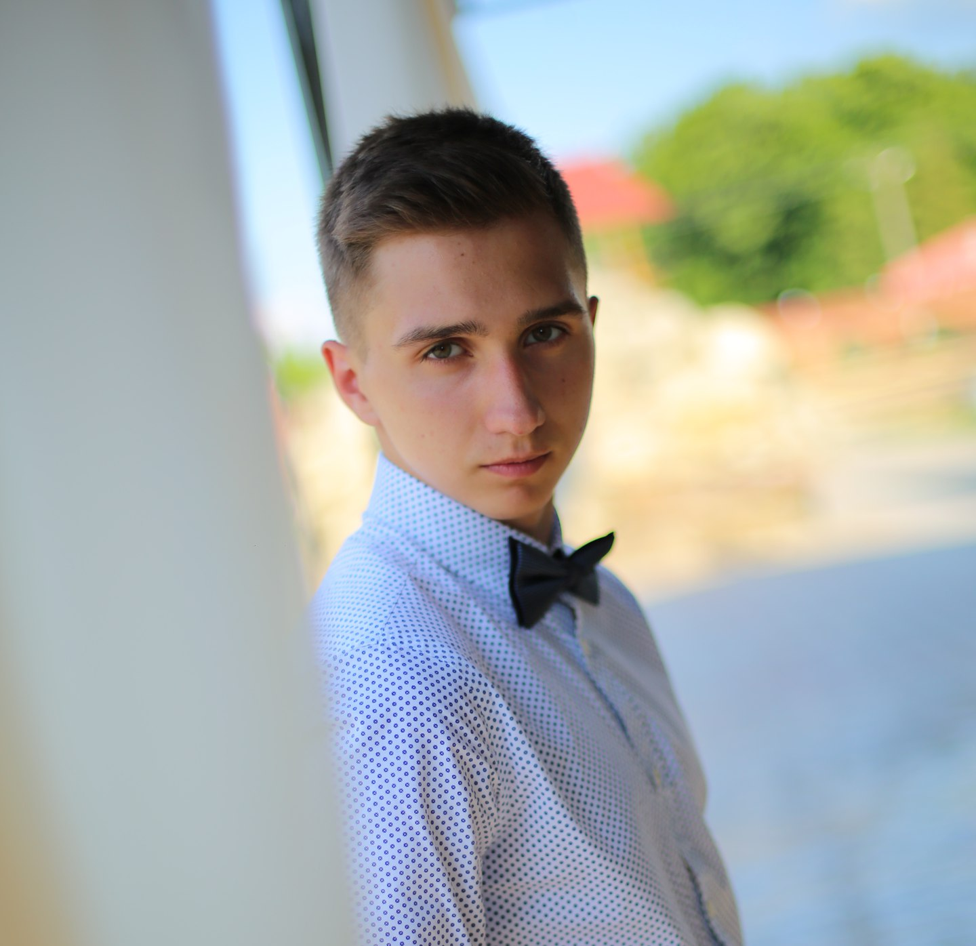  CONTACT INFORMATION  Phone:  +380 73 777 2873  Email:  ferencrman@gmail.com  Facebook: fb.me/roma.dmn  LinkedIn: linkedin.com/in/romadmn/  Github: github.com/romadmn  LANGUAGES  Ukrainian – Native speaker  Russian – Native speaker  English – Intermediate Low |  | OBJECTIVE  Future software developer ☺  Summary of Qualifications  Learning new programming languages and technologies and complete projects within specified deadlines  Soft skills  Very energetic and ready to take new challenges  Technical skills  — Programming languages: HTML, CSS, JS/TS, C#  — ASP.NET Core, .NET Core, NUnit, Angular  — Development tools: Visual Studio, VS Code, Git Bash, Command Prompt, GitKraken, ReSharper  — Operating systems: Windows, Linux  — Database systems: MSSQL, Entity Framework Core  — Object modeling, Design Patterns, SOLID  — Version control systems: Git  Experience / IT related educational practice  Performed various laboratory work using various libraries etc.  Education  Lviv Polytechnic National University  Computer Engineering  2016 – Present.  Several facts about me  I prefer a healthy lifestyle like traveling, biking and so on.  Going to the gym twice a week.  I am free of the bad habits.  I can find the optimal way from difficult situation by myself in  short time period.  I have a pet. It is the dog named “Rex” 😊

