Roma jFreeChart Module
HOW TO

Introduction
Roma Chart jFreeChart module is intended to represent POJO's as charts of different types, like pie charts, bar charts, line charts etc.
Roma Chart jFreeChart module is based on jFreeChart Open Source project (http://sourceforge.net/projects/jfreechart)

What kind of objects can be represented as charts
Chart jFreeChart module allows to represent as charts the following types of objects:
- Collection<Number>
- Collection<Collection<Number>>
- Map<Comparable<?>, Number>
- Map<Comparable<?>, Map<Comparable<?>, Number>>
- ChartRenderer
- ChartRepresentable
In the future it should be possible to also display arrays.

What kind of charts can be represented
With Roma Chart jFreeChart you can represent the following types of chars:
Area charts and stacked area charts:
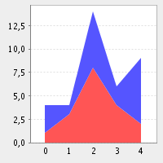
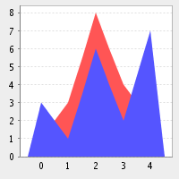

Bar charts and stacked bar charts, 2D and 3D:

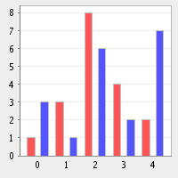
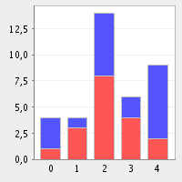

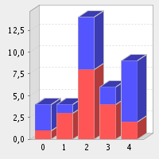
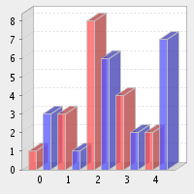

2D and 3D line charts:

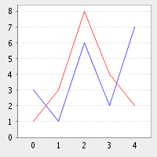
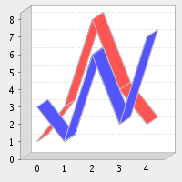

2D and 3D pie charts:

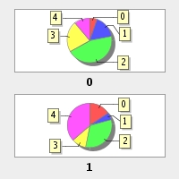
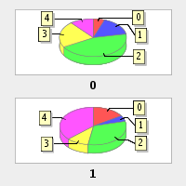

Spider charts

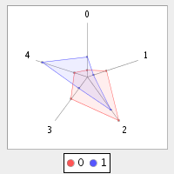

Installing the chart module
To use Chart you have to install it and to register it in your project, as for all Roma modules.
To install the Roma Chart jFreeChart module, just download the binary distribution of the module and copy it in your ROMA_HOME.
When you have your module installed, you can add it to your project, launching the following command in a shell:

roma add chart-jfreechart

Rendering a chart
When you have the module installed, you can render POJO's as charts, simply declaring RENDER_CHART as the rendering type for your object.
In the following we show a simple example that demostrates how to render a list of integers as a chart:
...

public class MyClass{

@ViewField(render = ViewConstants.RENDER_CHART)
private List<Integer> myChart;

public MyClass(){
myChart = new ArrayList<Integer>();
myChart.add(1);
myChart.add(5);
myChart.add(3);
}

// TODO add here getters and setters
....
}

Maps and Collections
As we have seen in the first example, it is possible to use Collections and Maps to build simple charts
Here we briefly describe the behaviour of Roma Chart module when a Collection or a Map is rendered as a chart.
Rendering Collection<Number>
A Collection<Number> is rendered as a 3D bar chart, where the first element of the collection is the element labeled “0” on the cart, the second element is labeled as “1” and so on.
The height of the bars is the value of each element.
Rendering Collection<Collection<Number>>
A Collection<Collection<Number>> is rendered as a grouped 3D bar char where the first group represents the first elements of each “internal” collection and so on; each sub-collection is rendered in a different color.
Rendering Map<Comparable<?>, Number>
A Map<Comparable<?>, Number> is rendered as a 3D bar chart, where each entry is used as an element of the chart, whose label il the toString() of the key and the value is the value binded to the key.

Rendering Map<Comparable<?>, Map<Comparable<?>, Number>>
A Map<Comparable<?>, Map<Comparable<?>, Number>> is represented as a 3D bar chart that is the composition of all the sub-charts of the inner maps. Each key of the “external” map is used to identify a subset of the chart (in a different color).

The ChartRenderer class
Maps and Collections are sufficient to render simple charts. However, if you want more control on the parameters of the chart (height, width, type, orientation etc.) you should use ChartRenderer.
With a simple example we are going to show how to represent a complex data set as a spider chart, and how to set its dimensions.
...

public class MyClass{

@ViewField(render = ViewConstants.RENDER_CHART)
private ChartRenderer myChart;

public MyClass(){
myChart = new ChartRendererImpl();
renderer.setPoint("x", "a", 1);
renderer.setPoint("x", "b", 2);
renderer.setPoint("x", "c", 3);
renderer.setPoint("y", "a", 4);
renderer.setPoint("y", "b", 1);
renderer.setPoint("y", "c", 2);

EditableRenderOptions options = EditableRenderOptions.newInstance();
options.setWidth(300);
options.setHeight(300);
options.setType(RenderOptions.CHART_TYPE_SPIDER);
myChart.setOptions(options);

}

// TODO add here getters and setters
....
}

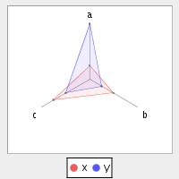
the result is the following:

The ChartRepresentable interface
It is possible to render your POJO's as charts implementing the ChartRepresentable interface:

public interface ChartRepresentable {
public ChartRenderer generateGraph();
}

The interface method must return the chart representation of your POJO. This object will be represented insetead of your POJO if you declare for that render = ViewConstants.RENDER_CHART

The ChartViewer class
The ChartViewer class is a simple cockpit that allows you to manipulate a chart representation through a simple GUI, allowing you to modify its dimensions, type, orientation etc.

Using Chart Module to build images
The Roma Chart jFreeChart module can also be used to create images that can be manipulated programmatically.
To obtain an image from a ChartRenderer object you can proceed as follows:

ByteArrayOutputStream outputStream = new ByteArrayOutputStream();
ChartRenderer renderer = getMyRenderer(); //generate a chart
renderer.render(outputStream);
byte[] image = outputStream.toByteArray();

The result is an array representation of a PNG image.
If you want to obtain a chart from a Collection or from a Map, you can use the ChartHelper class, that contains static methods to render images from Maps and Collections.

Table of Contents
Introduction 1
What kind of objects can be represented as charts 1
What kind of charts can be represented 1
Installing the chart module 3
Rendering a chart 4
Maps and Collections 4
The ChartRenderer class 5
The ChartRepresentable interface 6
The ChartViewer class 6
Using Chart Module to build images 6

